University of California, Santa Barbara

Lexical polyfunctionality in discourse: A quantitative corpus-based approach

Draft

A dissertation submitted in partial satisfaction of the requirements for the degree Doctor of Philosophy in Linguistics

by

Daniel W. Hieber

Committee in Charge: Professor Marianne Mithun, Chair

Professor Bernard Comrie Professor Stefan Th. Gries

Professor William Croft (University of New Mexico)

June 2021

The dissertation of Daniel W. Hieber is approved.

Bernard Comrie

Stefan Th. Gries

William Croft

Marianne Mithun, Committee Chair

June 2021

Lexical polyfunctionality in discourse: A quantitative corpus-based approach

Copyright © 2021 by

Daniel W. Hieber

Typeset using LATEX software and the Linux Libertine family of fonts.

Published under a Creative Commons Attribution 4.0 License (CC BY 4.0): <https://creativecommons.org/licenses/by/4.0/>

This dissertation may be downloaded at: <https://files.danielhieber.com/publications/dissertation.pdf>

The source code, data, and accompanying scripts for this dissertation are available on GitHub: <https://github.com/dwhieb/dissertation>

To Mom, Dad, & Jackie, with love

## Acknowledgments

So many people have aided me in completing this dissertation—either directly or indirectly, in ways big and small—that I cannot possibly thank them all here. To those I have omitted: Thank you. You are appreciated.

For sparking my original interest in lexical flexibility/polyfunctionality, I thank Drs. Elaine Francis (Purdue University) and Greville G. Corbett (University of Surrey), both of whom I had the privilege of taking courses from at the 2011 Linguistic Institute at the University of Colorado, Boulder.

For financial support at different stages during this project, I would like to thank the National Science Foundation’s Graduate Research Fellowship Program, the University of California, Santa Barbara, and the Department of Linguistics there. This project would not have been possible without their support.

For kindly providing me with the corpus of Nuuchahnulth, my sincere thanks go to Dr. Toshihide Nakayama (Tokyo University of Foreign Studies). The task of preparing a documentary corpus often goes underappreciated, but is in fact one of the most theoretically and analytically taxing tasks a linguist can undertake, requiring a broad understanding of many different subfields of linguistics. Thank you for your many years of meticulous work that made this project possible.

For providing me the opportunity to present an early version of this work, I would like to thank Dr. Anya Lunden, Dr. Jack B. Martin, and the linguistics department at the College of William & Mary.

I have benefitted from discussions on lexical polyfunctionality, and gotten feedback on this project, from many people. Thank you especially to Dr. Eric R. Hansen (Loyola University Chicago), Dr. Hunter T. Lockwood (Myaamia Center), Dr. Monica Macaulay (University of Wisconsin-Madison), Dr. Jack B. Martin (College of William & Mary), Phillip G. Rogers (University of California, Santa Barbara), and Dr. Sandra A. Thompson (University of California, Santa Barbara) for these discussions.

A special thanks is also due to my dissertation committee: Drs. Bernard Comrie, Stefan Th. Gries, and Marianne Mithun at the University of California, Santa Barbara, and Dr. William Croft at the University of New Mexico. Your patience with my much-delayed research process, the time you’ve dedicated to advising me and providing feedback, and your insightful comments throughout this project are all greatly appreciated.

To all the faculty at the University of California, Santa Barbara linguistics department: Thank you. I could not have asked for a better intellectual home and community of scholars. Very special thank yous are also due to some of my mentors. Marion Bittinger (Rosetta Stone) patiently helped teach me to become a professional, and provided me the opportunity to work with Native communities on language revitalization for the first time. Jack Martin (College of William & Mary) offered me invaluable professional advice throughout my career, both in industry and academia, and always took an interest in whatever I was working on. Carol Genetti (New York University Abu Dhabi) took a holistic approach to advising and taught me the importance of self-care, and supported my interest in East African languages in numerous ways. Without each of your friendships and guidance I would not be where I

am today.

A number of people have shown incredible patience with me while I worked to complete this project, putting aside some of their own goals and projects temporarily so that I could complete mine. To Antti Arppe, Erin Daniels, Jack DuBois, Monica Macaulay, Marianne Mithun, and Kimberly Walden, you have my deepest gratitude.

The degree of personal support I have received during my Ph.D. and this dissertation project is overwhelming and humbling. To Andrew Grubb†, Bobby López, Brendon Yoder, Eric Hansen, Erin Daniels, Jack Martin, James Oren, Jessi Love-Nichols, Kim Walden, Maggie Grubb-Hassett, and Morgan Sleeper, I cannot thank you enough. You have each made me better in your own way.

To Patrick and Phill: I am so glad we got to take our Ph.D. journeys together. Thank you for being there every step of the way.

To Marianne: It has been one of the greatest privileges of my life to study with you. Every conversation with you reminds me of the wonder in what we get to research and discover. You continued to believe in me and support me when things got tough both academically and personally. Thank you for helping keep my spark for language alive.

To my family: You’ve sacrificed so much for me so that this could be possible. You were there for me even in times when I didn’t know how to be there in return. I am grateful for each of you every single day. I love you.

~ Danny

## Curriculum Vitae

Daniel W. Hieber

### **Education**

June 2021 Ph.D. in Linguistics, University of California, Santa Barbara March 2016 M.A. in Linguistics, University of California, Santa Barbara

June 2008 B.A. in Linguistics & Philosophy, The College of William & Mary (magna cum laude)

### **Professional Experience**

2018–2019 Editor, Custom Language Products, Rosetta Stone

2015–2019 Teaching Assistant, Department of Linguistics, University of California, Santa Barbara

2014–2015 Research Assistant (under Prof. Carol Genetti), Department of Linguistics, University of California, Santa Barbara

2011–2013 Associate Researcher, Research Labs, Rosetta Stone 2008–2011 Editor, Endangered Languages Program, Rosetta Stone 2007–2008 Intern, Endangered Languages Program, Rosetta Stone 2006 Spanish Instructor, Nielsen Builders

2004–2006 Lab Assistant, Language Lab, The College of William & Mary 2003–2004 Latin Instructor, Bridgewater Home School Unit

### **Publications**

2023 Chitimacha. In Carmen Jany, Marianne Mithun, & Keren Rice (eds.),

*The languages and linguistics of indigenous North America: A*

*comprehensive guide* (The World of Linguistics 13). Mouton de Gruyter.

2023 Word classes. In Carmen Jany, Marianne Mithun, & Keren Rice (eds.),

*The languages and linguistics of indigenous North America: A*

*comprehensive guide* (The World of Linguistics 13). Mouton de Gruyter.

2019 The Chitimacha language: A history. In Nathalie Dajko & Shana Walton (eds.), *Languages in Louisiana: Community & culture* (America’s Third Coast Series). University Press of Mississippi.

2019 Semantic alignment in Chitimacha. *International Journal of American Linguistics* 85(3): 313–363. doi:[10.1086/703239](https://doi.org//10.1086/703239).

2018 Category genesis in Chitimacha: A constructional approach. In Kristel Van Goethem, Muriel Norde, Evie Coussé, & Gudrun Vanderbauwhede (eds.), *Category change from a constructional*

*perspective* (Constructional Approaches to Language 20), 15–46. John Benjamins. doi:[10.1075/cal.20.02hie](https://doi.org/10.1075/cal.20.02hie).

2016 *The cohesive function of prosody in Ékegusií (Kisii) narratives: A functional-typological approach*. M.A. thesis, University of California, Santa Barbara.

2013 On linguistics, language, and our times: A linguist’s narrative reviewed. *Linguistic Typology* 17(2): 291–321. Review article of *I am a linguist* by R. M. W. Dixon (Brill, 2010). doi:[10.13140/RG.2.2.13238.96329](https://doi.org/10.13140/RG.2.2.13238.96329).

2013 (with Sharon Hargus & Edward Vajda, eds.) *Working papers in*

*Athabaskan (Dene) languages 2012*. Alaska Native Language Center Working Papers 11. ANLC.

### **Awards**

2019 SSILA Best Student Presentation Award

2015 National Science Foundation (NSF) Graduate Student Research Fellowship (GRFP)

|  |  |
| --- | --- |
| 2015 | 2nd place, University of California Grad Slam |
| 2015 | Winner, University of California, Santa Barbara Grad Slam |
| 2013 | Chancellor’s Fellowship, University of California, Santa Barbara |
| 2006 | Boren Scholarship, National Security Education Program (NSEP) |

### **Fields of Study**

Major Fields: Linguistic Typology, Language Documentation & Description, Language Revitalization, Prosody, Discourse, Language Change, Language Contact, Digital Linguistics, Corpus Linguistics

Linguistic Typology with Professor Bernard Comrie & Professor Marianne Mithun

Language Documentation & Description with Professor Eric Campbell, Professor Carol Genetti, & Professor Marianne Mithun

Language Revitalization with Professor Carol Genetti

Prosody with Professor Carol Genetti, Professor Matthew Gordon, & Professor Marianne Mithun

Discourse with Professor Patricia Clancy, Professor John W. DuBois, Professor Carol Genetti, & Professor Marianne Mithun

Language Change with Professor Marianne Mithun

Language Contact with Professor Marianne Mithun

Digital Linguistics with Professor Eric Campbell & Professor Stefan Th. Gries

Corpus Linguistics with Professor Eric Campbell, Professor John W. DuBois, & Professor Stefan Th. Gries

## Abstract

Lexical polyfunctionality in discourse:

A quantitative corpus-based approach by

Daniel W. Hieber

This dissertation is a qualitative corpus-based study of lexical polyfunctionality (also known as lexical flexibility or polycategoriality) in English (Indo-European) and Nuuchahnulth (Wakashan). Polyfunctional lexical items are those which appear in more than one discourse function—reference, predication, or modification (traditionally noun, verb, or adjective) with zero coding for that function (often referred to as *conversion* or *zero derivation*).

Polyfunctional words pose a problem for many theories of parts of speech because they cross-cut traditional part-of-speech boundaries, resisting clear classification. In response to this problem, many researchers have proposed new part-of-speech schemes with a greater or fewer number of lexical categories. More recently, however, many researchers have come to treat lexical polyfunctionality as an object of study in its own right. However, our understanding of how polyfunctionality operates, how it emerges diachronically, how prevalent it is, and how much it varies across the world’s languages, is still nascent.

This study contributes new empirical data to the study of lexical polyfunctionality. I analyze approximately 380,000 tokens of English and 8,300 tokens of Nuuchahnulth for their discourse function (reference, predication, or modification) in order to determine the overall prevalence of lexical polyfunctionality in each language. I present a metric for quantitatively measuring the functional diversity of each stem in a corpus which can be applied consistently across lexemes and languages for crosslinguistic comparison. I then apply this technique to English and Nuuchahnulth.

The data suggest that English and Nuuchahnulth differ significantly not just in their overall functional diversity / degree of polyfunctionality, but also in the way that polyfunctionality

*Abstract*

is realized. Most English stems exhibit lexical polyfunctionality to a small degree, but otherwise center around a clear prototype. By contrast, most Nuuchahnulth stems exhibit a high degree of lexical polyfunctionality, but primarily between reference and predication. Nuuchahnulth stems show very few uses of modification in discourse. I also show that the functional diversity for each lexical item is synchronically fixed, suggesting that lexemes have a conventionalized set of discourse uses rather than productively appearing in whatever context is appropriate. I also investigate the relationship between lexical polyfunctionality and either relative frequency or corpus dispersion, but find no clear correlations.

In both English and Nuuchahnulth, human animates are consistently low in functional diversity, in line with the status of human animates as prototypical referents in discourse crosslinguistically. English and Nuuchahnulth display opposite tendencies for property words, however. In English, property words are among the least polyfunctional items, whereas in Nuuchahnulth quantifiers and property words are consistently among the most polyfunctional items. I suggest that this difference is due to a lack of a dedicated morphological strategy for indicating modification in Nuuchahnulth.

The findings in this dissertation present a strong case for reversing the traditional perspective on lexical polyfunctionality: rather than treating lexical polyfunctionality as a relatively exceptional problem to be solved, I argue that lexical polyfunctionality is a central and prevalent feature of the world’s languages. Lexical polyfunctionality exists anywhere a language has yet to develop dedicated morphological strategies for distinct discourse functions, or where those constructions have been diachronically leveled.

# **Table of Contents**

Acknowledgments v

Curriculum Vitae vii

Abstract x

Table of Contents xii

List of Figures xiii

List of Tables xiv

List of Abbreviations xv

List of Languages xvi

Conventions xix

1. **Introduction****1**
   1. The problem of lexical polyfunctionality 1
   2. Previous research 10
   3. Overview of this study 15
2. **Background****26**
   1. Introduction: Approaches to lexical polyfunctionality 26
   2. Traditional approaches 28
      1. Universalism 28
      2. Relativism 32
      3. Structuralism 33
   3. Flexible approaches 39
      1. Key concepts 40
         1. Lexical flexibility 40
         2. Polycategoriality 42
         3. Multifunctionality 43
         4. Precategoriality / Acategoriality 44
         5. Monocategoriality 47
         6. Transcategoriality 47
         7. Conversion / Zero derivation 48
         8. Functional shift / Functional expansion 49
      2. Themes in previous research 50
         1. Parts-of-speech hierarchy 50
         2. Reference-predication asymmetries 52
         3. Locus of categoriality 54
         4. Item-specificity 56
      3. Problems & critiques 59
         1. Methodological opportunism 60
         2. Semantic shift 61
         3. Lexical gaps 63
   4. Functional approaches 64
      1. Prototype theory 64
      2. Typological markedness theory 70
   5. Lexical polyfunctionality: A functionalist definition 76
      1. Lexical polyfunctionality 76
      2. Functional expansion 84
3. **Data & Methods****91**
   1. Introduction 91
   2. Data 93
   3. Methods 96
      1. Inclusion / exclusion criteria 97
      2. English 100
      3. Nuuchahnulth 101
   4. Analysis 115
      1. Measuring lexical polyfunctionality 115
      2. Lexical polyfunctionality and corpus size 118
      3. Frequency vs. dispersion 119
   5. Summary 122
4. **Results****124**
   1. Introduction 124
   2. Interpreting the results 125
   3. R1: Degree of lexical polyfunctionality 132
   4. R2: Lexical polyfunctionality and corpus size 139
   5. R3: Lexical polyfunctionality and frequency / dispersion 144
   6. R4: The semantics of lexical polyfunctionality 150
      1. Semantic expansion 150
      2. English 156
      3. Nuuchahnulth 159
5. **Conclusion****165**
   1. Introduction 165
   2. Summary of the study 168
   3. Discussion 173
   4. Limitations & future research 176
   5. Conclusion 179

|  |  |  |
| --- | --- | --- |
| **Appendices** |  | |
| **A 100-item samples** |  | **182** |
| A.1 English . . . . | . . . . . . . . . . . . . . . . . . . . . . . . . . . . . . . . . . . . | 182 |
| A.2 Nuuchahnulth | . . . . . . . . . . . . . . . . . . . . . . . . . . . . . . . . . . . . | 186 |
| **Backmatter** |  |  |
| **References** |  | **190** |
| **Language Index** |  | **190** |

* 1. Timeline of early grammatical descriptions of European vs. American languages 30
  2. Hengeveld’s (1992) typology of parts-of-speech systems 51
  3. Semantic map of English *run*67
  4. Crosslinguistic differences in the encoding of spatial relationships 68
  5. Typological prototypes for noun, verb, and adjective 74
  6. Monocentric vs. polycentric categories 83

3.1 The relation between word frequency and dispersion (DP) 120

* 1. Functional diversity of English *difficult*126
  2. Functional diversity of English *anything*127
  3. Functional diversity of English *childhood*128
  4. Functional diversity of Nuuchahnulth *ʔu·q* ‘good’ 129
  5. Functional diversity using frequency vs. corpus dispersion for English *favorite*131
  6. Distribution of functional diversity ratings for the 100-item samples of English

and Nuuchahnulth 133

* 1. Distribution of functional diversity ratings for the small corpus samples of English and Nuuchahnulth 134
  2. Distribution of functions for the 100-item samples of English and Nuuchahnulth 136
  3. Distribution of functions for the small corpus samples of English and Nu- uchahnulth 136
  4. Cumulative functional diversity of high-frequency lexical items in English 141
  5. Cumulative functional diversity of high-frequency lexical items in Nuuchah-

nulth 142

* 1. Cumulative mean functional diversity for English 143
  2. Cumulative mean functional diversity for Nuuchahnulth 144
  3. Interactions among frequency, dispersion, and functional diversity for English

vs. Nuuchahnulth (heat map) 147

* 1. Interactions among frequency, dispersion, and functional diversity for English

vs. Nuuchahnulth (3D map) 147

* 1. Interactions among frequency, dispersion, and functional diversity for English

vs. Nuuchahnulth, with standard deviations (3D map) 149

* 1. Semantic expansion into a new discourse function 151

* 1. Types of conversion in English (Indo-European > Germanic) 10
  2. Percentage of lexical items used as nouns, verbs, or both in Mundari (Aus- troasiatic > Munda) 11
  3. Percentage of roots used as nouns, verbs, or both in Central Alaskan Yup’ik (Eskimo-Aleut > Yupik) 12
  4. Distribution of functions of property words in English (Indo-European > Ger- manic) and Mandarin (Sino-Tibetan > Sinitic) 13
  5. Some first grammatical descriptions of European vs. American languages 30
  6. Distribution of English Verbs and Adjectives 35
  7. Distributional analysis of English (Indo-European > Germanic) temporal nouns 36
  8. Distributional analysis of Russian (Indo-European > Slavic) numerals 37
  9. Distributional analysis of French (Indo-European > Romance) verbs 38
  10. Distribution of discourse functions for a perfectly polyfunctional lexical item . 115
  11. Distribution of discourse functions for a perfectly monofunctional lexical item 116
  12. Distribution of discourse functions in Nuuchahnulth 117
  13. Stems with different distributions of discourse functions and the same func- tional diversity 125
  14. Results for the Generalized Additive Model for the English small corpus sample 146
  15. Results for the Generalized Additive Model for the Nuuchahnulth small cor-

pus sample 146

* 1. Results for the Generalized Additive Model for the English 100-item sample . 148
  2. Results for the Generalized Additive Model for the Nuuchahnulth 100-item sample 148
  3. Low functional diversity stems in English 157
  4. Highly functionally diverse stems in Nuuchahnulth 159

*List of Tables*

|  |  |  |
| --- | --- | --- |
| 4.8 Functional diversity of numerals in Nuuchahnulth | . . . . . . . . . . . . . . . . | 162 |
| 4.9 Less functionally diverse stems in Nuuchahnulth . | . . . . . . . . . . . . . . . . | 163 |
| A.1 Corpus statistics for the 100-item English sample | . . . . . . . . . . . . . . . . | 182 |

A.2 Corpus statistics for the 100-item Nuuchahnulth sample 186

# **List of Abbreviations**

The following table provides the meaning of each abbreviation used in interlinear glossed examples throughout this dissertation.

|  |  |  |  |
| --- | --- | --- | --- |
| 1 | first person | linK | linker |
| 2 | second person | mod | modifier |
| 3 | third person | mom | momentaneous |
| acc | accusative | name | proper name |
| agR | agreement | neg | negative |
| agt | agent | neut | neutral position |
| caus | causative | nf | non-first person |
| compl | completive | past | past |
| cond | conditional | pfv | perfective |
| conn | connective | pl | plural |
| def | definite | plact | pluractional |
| dub | dubitive | poss | possessive |
| dup | reduplication | pRed | predicate |
| duR | durative | pRes | present tense |
| emph | emphatic | puRp | purposive |
| ep | epenthetic | ot | quotative |
| fin | finite | Ref | referent |
| fut | future | Refl | reflexive |
| hab | habitual | Rel | relative |
| hum | human | sg | singular |
| imp | imperative | spec | specific |
| incep | inceptive | ss | same subject |
| ind | indicative | subj | subject |
| indef | indefinite | suboRd | subordinate |
| infeR | inferential | tR | transitive |
| instR | instrumental | vzR | verbalizer |
| inteR | interrogative |  |  |
| ipfv | imperfective |  |  |

# **List of Languages**

The following table provides information about each language mentioned in this dissertation: the name of the language in English (following Haspelmath [2017]) with a link to that language’s Glottolog page (Hammarström, Forkel & Haspelmath 2019), the [International Stan-](https://iso639-3.sil.org/) [dards Organization (ISO) 693-3 language code](https://iso639-3.sil.org/), and the [Glottolog](https://glottolog.org/) code. Genealogical information is taken from Glottolog.

|  |  |  |  |
| --- | --- | --- | --- |
| **Language Name (English)** | **ISO 639-3** | **Glottocode** | **Genetic Affiliation** |
| Basque | eus | basq1248 | isolate |
| Castilian Spanish | spa | cast1244 | Indo-European > Italic |
| Cayuga | cay | cayu1261 | Iroquoian > Northern Iroquoian |
| Chamorro | cha | cham1312 | Austronesian > Chamorro |
| Cherokee | chr | cher1273 | Iroquoian > Southern Iroquoian |
| Chitimacha | ctm | chit1248 | isolate |
| Central Alaskan Yup’ik | esu | cent2127 | Eskimo-Aleut > Yupik |
| Classical Greek | grc | anci1242 | Indo-European > Hellenic |
| Classical Nahuatl | nci | clas1250 | Uto-Aztecan > Nahuan |
| Dutch | nld | mode1257 | Indo-European > Germanic |
| English | eng | stan1293 | Indo-European > Germanic |
| French | fra | stan1290 | Indo-European > Italic |
| German | deu | uppe1397 | Indo-European > Germanic |
| Gooniyandi | gni | goon1238 | Bunuban |

|  |  |  |  |
| --- | --- | --- | --- |
| Indonesian | ind | indo1316 | Austronesian > Malayo-Sumbawan |
| Irish (Gaelic) | gle | iris1253 | Indo-European > Celtic |
| Latin | lat | lati1261 | Indo-European > Italic |
| Kuikuro | kui | kuik1245 | Cariban > Kuikuroan |
| Kutenai | kut | kute1249 | isolate |
| Mandarin Chinese | cmn | mand1415 | Sino-Tibetan > Sinitic |
| Mandinka | mnk | mand1436 | Mande > Western Mande |
| Middle English | enm | midd1317 | Indo-European > Germanic |
| Mixtec | various | mixt1427 | Oto-Manguean > Mixtecan |
| Mundari | unr | mund1320 | Austroasiatic > Munda |
| Munya (Muya) | mvm | muya1239 | Sino-Tibetan > Qiangic |
| Narragansett | xnt | narr1280 | Algic > Eastern Algonquian |
| Navajo | nav | nava1243 | Na-Dene > Athabaskan |
| North Efate (Nguna) | llp | nort2836 | Austronesian > Oceanic |
| Nuuchahnulth (Nootka) | nuk | nuuc1236 | Wakashan > Southern Wakashan |
| Occitan | oci | occi1239 | Indo-European > Romance |
| Old English | ang | olde1238 | Indo-European > Germanic |
| Old French | fro | oldf1239 | Indo-European > Italic |
| Proto-Indo-European | ine | indo1319 | Indo-European |
| Quechua | qwe | quec1387 | Quechuan |
| Quiché Maya | quc | kich1262 | Mayan > Quichean |
| Russian | rus | russ1263 | Indo-European > Balto-Slavic |
| Soddo | gru | kist1241 | Afroasiatic > Semitic |
| Spanish | spa | stan1288 | Indo-European > Italic |
| Standard Arabic | ara | arab1395 | Afroasiatic > Semitic |
| Sundanese | sun | sund1251 | Austronesian > Malayo-Sumbawan |
| Swahili | swa | swah1254 | Atlantic-Congo > Volta-Congo |

|  |  |  |  |
| --- | --- | --- | --- |
| Tagalog | tgl | taga1280 | Austronesian > Central Philippine |
| Tarascan (Purépecha) | tsz | tara1323 | isolate |
| Timucua | tjm | timu1245 | isolate |
| Tongan | ton | tong1325 | Austronesian > Oceanic |
| Tuscan | ita | dalm1243 | Indo-European > Italic |
| Tzeltal Maya | tzh | tzel1254 | Mayan > Cholan-Tzeltalan |
| Ute | ute | utee1244 | Uto-Aztecan > Numic |
| Wambon | wms | ketu1239 | Trans-New Guinea > Awyu-Dumut |
| Welsh | cym | wels1247 | Indo-European > Celtic |
| Wolof | wol | wolo1247 | Atlantic-Congo > North Central Atlantic |
| Yucatec Maya | yua | yuca1254 | Mayan > Yucatec |
| Zapotec | zap | zapo1437 | Oto-Manguean > Zapotecan |

## Conventions

This note documents the conventions I have adopted regarding linguistic data, terminology, and presentation of data throughout this dissertation.

### **Interlinear Examples**

It is well known that the world’s languages realize widely different sets of morphosyntactic categories (Whaley 1997: 58; Haspelmath 2007). Moreover, even when these categories bear the same name, they may differ drastically in their behavior (Dixon 2010: 9). It is the subject of much debate whether these language-specific categories can be mapped onto each other or compared in any useful way (Croft 1995; Song 2001: 10–15; Croft 2003: 13–19; Haspelmath

2010a,c; Newmeyer 2010; Stassen 2011; Hieber 2013: 308–310; Croft 2014; Plank 2016; Song 2018: 44–58). Recognizing these difficulties, I have made no attempt to standardize the linguistic terminology used in examples from different languages. I have, however, standardized the abbreviations used to refer to those terms. For example, even though one researcher may abbreviate Subject as subj and another researcher abbreviate it as sub, I nonetheless gloss all Subject morphemes as subj. See the List of Abbreviations for a complete list of glossing abbreviations.

I have not attempted to standardize the transcription systems and orthographies used in examples. All examples are given as transcribed in their original source. The reader should consult those original sources for further details regarding orthography.

In all interlinear glossed examples, I follow the formatting conventions (but not necessarily the recommended abbreviations) of the Leipzig Glossing Rules (Bickel, Comrie & Haspelmath 2015). The source of each example is always provided after the example itself.

*Conventions*

### **Prose**

It is increasingly common in typological studies to write language-particular terms and categories with an initial capital letter, and to write terms that refer to language-general or semantic/functional concepts (e.g. the crosslinguistic notion of subject) in lowercase (Comrie 1976: 10; Bybee 1985: 47 (fn. 3), 141; Croft 2000: 66; Haspelmath 2010a: 674; Croft 2014: 535). For example, the English Participle suffix *‑ing* is, obviously, specific to English, and does not exist in any other language; therefore it is capitalized and written as *Participle*. If, however, a writer is discussing the category of participles generally and crosslinguistically, not specific to any particular language, the term is written in lowercase as *participle*. I follow these same capitalization conventions in this dissertation.

### **Quotations**

Within quotations, *italics* indicate emphasis in the original, while **boldface** indicates my emphasis.

# **Chapter 1**

**Introduction**

This chapter motivates the need for research on lexical polyfunctionality by situating it within broader concerns regarding linguistic categories more generally, and categories in human cognition. The specific problem addressed is our lack of understanding regarding what lexical polyfunctionality looks like and how it varies across languages. This dissertation contributes to answering these questions via a quantitative corpus-based study of lexical polyfunctionality in English (Indo-European > Germanic) and Nuuchahnulth (Wakashan > Southern Wakashan). I analyze approximately 380,000 tokens of English and 8,300 tokens of Nuuchahnulth for their discourse function to determine the overall degree of functionality in these languages. This is the first study to examine lexical polyfunctionality using natural discourse data from corpora. This chapter provides an overview of the dissertation, including the specific research questions addressed, the data and methods used, a concise summary of the results, and a preview of the conclusions.

## **The problem of lexical polyfunctionality**

Word classes such as noun, verb, and adjective (traditionally called *parts of speech*) were once thought to be universal, easily identifiable, and easily understood. Today they are one of the most controversial and least understood aspects of language. While language scientists agree that word classes exist, there is much disagreement as to whether they are categories of individual languages, categories of language generally, categories of human cognition, categories of language science, or some combination of these possibilities (Mithun 2017: 166; Haspel-

math 2019; Hieber forthcoming). Lexical categorization—how languages assign lexical items1 to categories—is of central importance to theories of language because it is tightly interconnected with linguistic categorization generally, which in turn informs (and is informed by) our understanding of cognition. Categorization is a fundamental feature of human cognition (Taylor 2003: xi; van Lier & Rijkhoff 2013: 2–3), and lexical categorization is perhaps the most foundational issue in linguistic theory (Croft 1991: 36; Vapnarsky & Veneziano 2017a: 1).

One challenge for traditional theories of word classes is the existence of *lexical polyfunctionality*—the use of a lexical item in more than one discourse function with zero coding, whether that item is used to refer (like a noun), to predicate (like a verb), or to modify (like an adjective). Other recent terms for this phenomenon include *lexical flexibility*, *polycategoriality*, and *precategoriality* (see Section 2.3.1 for detailed explanations of the differences between these concepts). In traditional terms, polyfunctional words have been described as those which may be used for more than one part of speech with no overt derivational morphology. This has often been termed *functional shift*, *conversion*, or *zero derivation*. A more thorough and precise definition of lexical polyfunctionality is given in Section 2.5. Examples of polyfunctional lexical items in several languages are shown below. In the examples, **Ref** stands for a lexical item being used for reference, **Pred** for a lexical item being used for predication, and **Mod** for a lexical item being used for modification. The polyfunctional item in each set of examples is shown with **emphasis**. Here and throughout this dissertation, I use the terms *reference*, *predication*, and *modification* so as to focus on the functions of lexical items and avoid committing to any analysis regarding their part-of-speech classification.

* + 1. English (Indo-European > Germanic)

**Ref:** And the spots of **paint** would change every hundred degrees.

(Ide & Suderman 2005: FrancisClem)

1I use the term *lexical item* as a convenient cover term for root, stem, or fully inflected word. This term does not here refer to the phonological word, syntactic word, or any other concept of word. The reason for this vague usage is because languages vary as to which morphological level bears category information. This issue is discussed more fully in Section 2.3.2.3. I use *lexical item* instead of *lexeme* because the concept of a lexeme implies lexical unity, that is, that we are discussing a single polysemous item rather than two homophonous ones. Use of the term *lexical item* is intended to bypass this distinction in favor of a focus on form. However, I also avoid the term *(lexical) form* because some lexical items have multiple forms (in the case of suppletion).

**Pred:** One story does come to my mind though where you **painted** the foundation coating on the house and got tar all over you.

(Ide & Suderman 2005: BorelRaymondHydellII)

**Mod:** And it happened to be one of the rare **paint** jobs.

(Ide & Suderman 2005: sw2236)

* + 1. Mandinka (Mande > Manding)

**Ref: Kuuráŋ**‑o

**sick**‑def

mâŋ pfv.neg

díyaa. pleasant

‘Sickness is not pleasant.’ (Creissels 2017: 46)

**Pred:** Díndíŋ‑o

child‑def

máŋ pfv.neg

**kuraŋ**. **sick**

‘The child is not sick.’ (Creissels 2017: 46)

* + 1. Mundari (Austroasiatic > Munda)

**Ref: buru**=ko

**mountain**=3pl.subj

bai‑ke‑d‑a. make‑compl‑tR‑ind

‘They made the mountain.’ (Evans & Osada 2005: 354)

**Pred:** saan=ko

firewood=3pl.subj

**buru**‑ke‑d‑a.

**mountain‑**compl‑tR‑ind

‘They heaped up the firewood.’ (Evans & Osada 2005: 355)

* + 1. Nuuchahnulth (Wakashan > Southern Wakashan)

**Ref:** watqšiƛ

watq‑ši(ƛ) swallow‑mom completely.swallowed

ʔaƛimt …

**ʔaƛa**‑imt …

**two**‑past …

two …

‘He swallowed two of them […]’ (Louie 2003: Qawiqaalth 57)

**Pred:** wik̓aƛ

wik‑ʼaƛ not‑fin didn’t

haʔukšiƛ haʔuk‑ši(ƛ) eat‑mom ate

ʔaƛiičiƛ

**ʔaƛa**‑ʽi·čiƛ **two**‑incep

became.two

‘He (Mink) didn’t eat them and the crabs became two.’ (Louie 2003: Mink 266)

**Mod:** hiiɬtqyaap̓ up

hiɬ‑tqya·p̓ i‑up there‑back‑mom.caus put.on.the.back

ʔaƛa **ʔaƛa two** two

qʷayac̓iik qʷayac̓iːk wolf wolf

‘Two wolves put (the dead wolf) on their back.’ (Louie 2003: FoodThief 46)

* + 1. Quechua (Quechuan)

**Ref:** rikaškaː

I.saw

**hatun**‑(kuna)‑ta **big**‑(pl)‑acc

‘I saw the big one(s)’ (Schachter & Shopen 2007: 17)

**Pred:** chay

that

runa man

**hatun big**

(kaykan) is

‘that man is big’ (Schachter & Shopen 2007: 17)

**Mod:** chay

that

**hatun big**

runa man

‘that big man’ (Schachter & Shopen 2007: 17)

* + 1. Tongan (Austronesian > Polynesian)

**Ref:** naʼe

past

lele run

e spec

kau pl.hum

**fefiné**

**woman**.def

‘The women were running.’ (Broschart 1997: 134)

**Pred:** naʼe

past

**fefine woman**

kotoa all

e spec

kau pl.hum

lelé run.def

‘The ones running were all female.’ (Broschart 1997: 134)

* + 1. Central Alaskan Yup’ik (Eskimo-Aleut > Yup’ik)

|  |  |  |
| --- | --- | --- |
| a.  **Ref:** | *iqa‑*  *‑ngtak*  ***iqa‑ngtak*** | ‘dirt’; ‘be dirty’ ‘very’  ‘one that is very dirty’ |
| **Pred:** | ***iqa‑ngtaq‑*** | ‘be very dirty’ |
| b. | *tangerr‑*  *‑uaq* | ‘see’  ‘imitation, inauthentic’;  ‘pretend to, without serious purpose’ |
| **Ref:** | ***tangerr‑uaq***2 | ‘movie, vision, hallucination’ |
| **Pred:** | ***tangerr‑uar‑*** | ‘hallucinate, watch a movie’ |
| c. | *iqeq‑*  *‑mik* | ‘corner of mouth’  ‘thing held in one’s mouth’; ‘to put in one’s’ |
| **Ref:** | ***iq‑mik*** | ‘chewing tobacco’ |
| **Pred:** | ***iq‑mig‑*** | ‘put in one’s mouth’ |

(Mithun 2017: 159)

(Mithun 2017: 159)

(Mithun 2017: 160)

In the English example in (1), the predicative use of *paint* takes the English Past Tense suffix

2This form is spelled *tangrr‑* in the original, but Mithun (p.c.) confirms that this is a typo. The correct form is *tangerr‑*.

*‑ed* like any prototypical verb in English, but there is no morpheme present that explicitly indicates the shift from a referential use to a predicative use (or vice versa). The remaining examples illustrate the same situation for a variety of language families around the world. Even though in some cases inflectional morphology indicates the function of the word, none of these examples have overt derivational morphology converting the target lexical items from one discourse function to another.

Polyfunctional items like those in the examples above create an analytical problem for traditional theories of parts of speech. Traditional theories assume that lexical items can be partitioned into mutually exclusive categories based on a clear set of criteria, an approach that has its roots in the Aristotelian tradition of defining a category via its necessary and sufficient conditions. Polyfunctional items would seem to violate this assumption because at first glance they appear to be members of more than one category at once, and the criteria for classifying them yield conflicting results.

Researchers have proposed numerous solutions to this problem. One response is to analyze different uses of a polyfunctional item as instances of *heterosemy*—a special case of homonymy in which two distinct lexemes share the same form but belong to different word classes (Lichtenberk 1991). In this view, heterosemous items are related only historically, via a process of conversion or functional shift, in essence denying any synchronic connection between them (Evans & Osada 2005). However, this perspective fails to answer why polyfunctionality is rampant in some languages but not others, or why some lexemes are polyfunctional but not others, or what motivates a lexical item to expand its uses into new discourse functions. Morever, it is difficult to maintain a principled distinction between polysemy and heterosemy. Semantic, distributional, and formal similarity between words are continua, meaning that questions like “are uses X and Y of a form instances of the same or different lexemes?” cannot be answered categorically. Questions about multifunctional uses of the same form—call it polyfunctionality, lexical flexibility, conversion, or something else— merit empirical investigation irrespective of one’s analytical position on the matter.

A more common approach to analyzing polyfunctionality is to adjust the selectional criteria so that only certain features are considered definitional of a word class, allowing these researchers to dismiss other, potentially contradictory evidence as irrelevant (M. C. Baker [2003]; Dixon [2004]; Palmer [2017]; Floyd [2011] for Quechua; Chung [2012] for Chamorro). Another approach is to say that languages exhibiting polyfunctionality have only some of the traditional categories. A notable example of this is Launey’s (1994; 2004) analysis of Classical Nahuatl, which he calls an *omnipredicative* language. In this analysis, all lexical items are predicates, so there is just one giant class of verbs.

Some researchers enthusiastically embrace the existence of polyfunctionality and abandon a commitment to the traditional categories of noun, verb, and adjective. This has various realizations. One approach analyzes polyfunctional forms as *flexible*—that is, as single, multifunctional lexemes which can be productively deployed in different (traditional) parts of speech. Another approach expands the traditional slate of parts of speech to include new, broader word classes specifically for these polyfunctional forms, such as “flexibles”, “contentives” or “non-verbs”, etc. (Hengeveld & Rijkhoff 2005; Luuk 2010).

Other researchers abandon the commitment to word classes entirely. Mandarin, Tagalog, Tongan, Riau Indonesian, and Proto-Indo-European have each been analyzed as lacking parts of speech by some researchers (see Simon [1937], McDonald [2013], and Sun [2020] for discussions of early analyses of Mandarin; Gil [1995] for Tagalog; Broschart [1997] for Tongan; Gil [1994] for Riau Indonesian; Kastovsky [1996] for Proto-Indo-European). Within generative linguistics, the Distributed Morphology assumes that all roots are category-neutral (Siddiqi 2018). Farrell (2001) argues that *all* instances of polyfunctional items (which he describes as cases of “functional shift”) involve roots that are unspecified for category.

In this dissertation, the term *polyfunctionality* is intended to be neutral with respect to these approaches. Polyfunctionality merely describes the synchronic state of affairs in which a lexical item has uses in more than one discourse function with no overt coding strategy for that function. It makes no commitment as to the lexical unity of those different uses (in

other words, I purposefully avoid making any judgment as to whether different polyfunctional uses of the same lexical item are instances of polysemy or heterosemy). I present an alternate, typological-constructional analysis of polyfunctionality in Section 2.5. We can also speak of the *functional diversity* of a lexical item—that is, the degree to which it is polyfunctional. And the diachronic process by which a lexical item expands its use into new discourse functions, thus increasing its functional diversity and giving rise to synchronic polyfunctionality, is referred to in this dissertation as *functional expansion*. These terms will be clarified in more detail in Section 2.5.

Note that the different perspectives above do not arise from disagreements about the empirical facts. Researchers mostly agree on the empirical data, but disagree on the relative importance of various pieces of evidence, and on which criteria should be taken as diagnostic of a category (Wetzer 1992: 235; Stassen 1997: 32; Croft & van Lier 2012: 58). Examples of contested languages include those of the Iroquoian family (Chafe 2012), Mundari (Evans & Osada 2005; Hengeveld & Rijkhoff 2005), Quechua (Schachter & Shopen 2007: 17; Floyd 2011),

and Sundanese (Robins 1968: 352; Hardjadibrata 1985: 62–63), with many others that could be cited as well. It is rare that an argument for flexibility is refuted by linguistic facts alone (though see Mithun’s [2000] response to Sasse [1988] regarding Cayuga).

Since analyses of lexical polyfunctionality depend more on the theoretical commitments of the researchers involved rather than any crucial pieces of evidence, this leads to an intractable problem: researchers cannot agree on the criteria that should be considered diagnostic for a given category in a specific language, let alone crosslinguistically. Instead they partake in *methodological opportunism* (Croft 2001b: 30), choosing the evidence and criteria which best support their theoretical commitments. Discussions in the literature about the existence of a particular category in a particular language are therefore often unproductive, and devolve into debates about theoretical assumptions or the relevance or importance of various pieces of evidence, which are ultimately unresolvable (Croft 2005: 435).

This is particularly unfortunate because polyfunctionality is by no means an isolated or

minor phenomenon. Additional examples like those above could be provided for many or perhaps even all the world’s languages. Lexical polyfunctionality is not as rare or marginal as traditional approaches to word classes lead one to believe. In a survey of word classes in 48 indigenous North American languages (Hieber forthcoming), every language surveyed exhibits lexical polyfunctionality in at least some area of the grammar (although not all authors analyzed these cases as such). In my experience studying lexical polyfunctionality over the last decade, I have yet to encounter a language that does not exhibit a degree of polyfunctionality in at least some lexical items, however marginally. The prevalence with which different areas of the grammars of the world’s languages lack sensitivity to the distinctions between reference, predication, and modification suggests that the existence of lexical categories in a language is not necessarily a given (Hieber forthcoming).

Given what we know from both cognitive science and diachronic linguistics, it would be surprising if clear-cut categories *did* exist. Cognitive science tells us that mental categories, word meanings, and lexical categories are all prototypal3 (Taylor 2003). What it means for a category to be *prototypal* is that category membership is graded so that some members of the category are perceived as better representatives of that category than others. The prototypical meaning or concept within a category is the one that speakers conceive of as the most basic. The fact that mental categories are prototypal leads to various *prototype effects* in both everyday life and language. More prototypical members of a category are learned earlier in development and acquisition, are used more frequently, can be recalled more quickly, are more likely to be represented using a simple lexical item rather than a complex word or compound, and are more strongly primed by the name of the category itself (Croft & Cruse 2004: 78–79). Exactly which of these observed effects best picks out the most prototypical meaning of a category is an open question and an area of active research (Gries 2006: 75;

3In this dissertation, I use the term *prototypical* to mean ‘having the properties of the prototype, exemplar, or

central member of a category’ and the term *prototypal* to mean ‘having a prototype structure, with central and less central members’. The term *prototypal* is borrowed from the programming community, where it is used to describe programming languages (such as JavaScript) in which objects inherit properties from shared prototypes. Word classes may be described as prototypal, and their members as prototypical or non-prototypical.

Gries & Divjak 2009: 58–59). Regardless, given the prototypal nature of mental categories, it would be quite surprising if lexical categories did not also exhibit prototype effects.

We also know from diachronic linguistics that language change is both gradual and gradient (Hopper & Traugott 2003; Traugott & Trousdale 2010). At any given point in time a lexical item might be in a stage of transition or expansion from one function into another, meaning that it will show attributes of both. Likewise, languages develop constructions dedicated to signaling the discourse functions of reference, predication, and modification over time, but at any given point in time, a language may have more or fewer of these constructions, and they may be at various stages of development (Vogel 2000). Given these facts, the real curiosity is how discourse functions come to be grammaticalized in language over time, not why it is that some languages lack such distinctions in certain areas of their grammars. Lexical polyfunctionality is not so much a problem as it is a design feature of language. It is precisely the liminal categorial4 status of polyfunctional items that makes them interesting:

In the functionalist view, linguists should recognize the boundary status of the cases in question and try to understand why they are boundary cases. The major empirical fact that has led to concrete results for typology is the discovery that the cross-linguistic variation in such things as the basic grammatical distinctions is patterned. (Croft 1991: 23)

It is only recently that lexical polyfunctionality has become an object of study in itself, rather than a problem to be solved. As explained above, most prior studies aim to advance a particular analysis rather than to expand empirical coverage of the phenomenon. While they often provide numerous examples, they are neither quantitative nor comprehensive. As yet, there are only a small number of empirical investigations into the extent and nature of lexical polyfunctionality in individual languages (let alone crosslinguistically). What follows is a brief synopsis of the existing studies of this latter type.

4In this dissertation, I use the term *categorical* to mean ‘without exception; unconditional’ and the term

*categorial* to mean ‘having to do with categories’.

## **Previous research**

The existing studies on the empirical extent of lexical polyfunctionality are of two types: lexicon-based studies which examine dictionaries to determine whether lexical items may be used for multiple functions, and corpus-based studies which examine whether and how often lexical items are used for multiple functions in discourse.

Cannon (1985) is an early lexicon-based study of functional shift (conversion) in the history of English. Functional shift became an especially common pattern of word formation in early Middle English as inflectional paradigms were leveled (Cannon 1985: 414). Cannon examines 13,805 lexical items from three English dictionaries with etymological information, and finds that just 541 entries (3.92%) were created via conversion. Conversion from noun > verb is the most common, adjective > noun conversion the second most common, and verb

> noun conversion the third most common. The full results from the study are shown in Table 1.1.

**Table 1.1:** Types of conversion in English (Indo-European > Germanic) (Cannon 1985: 416)

|  |  |  |
| --- | --- | --- |
| from | to | count |
| noun | verb | 189 |
| adjective | noun | 121 |
| verb | noun | 114 |
| noun | adjective | 77 |
| verb | adjective | 19 |
| adjective | verb | 11 |
| adverb | adjective | 10 |
|  | Total | 541 |

Another lexicon-based study, though not explicitly focused on lexical polyfunctionality, is Croft’s (1984) study of categories of Russian roots (summarized in Croft [1991: 66]). Croft finds that Russian roots are unmarked, or among the least marked forms, when their semantic category (object, action, or property) aligns with their discourse function (reference,

predication, or modification respectively). When roots are used for discourse functions that are atypical for their meaning—in other words, when they exhibit polyfunctionality—they are marked in some way (or at least as marked as their prototypical uses). These data suggest that lexical polyfunctionality is constrained in a principled way, by what Croft calls the *typological markedness of parts of speech* (explained in detail in Section 2.4).

In a study of Mundari, Evans & Osada (2005) conduct a dictionary analysis using a focused 105-entry sample as well as a larger 5,000-entry-sample. In the 105-entry sample, 74 stems (72%) could be used as either noun or verb. In the larger sample, 1,953 stems (52%) could be used as both noun and verb. The complete figures for the large sample are shown in Table 1.2. Evans & Osada argue on the basis of these data that, because not all the items in the Mundari lexicon are polyfunctional, Mundari is not a flexible language. As with any whole-language typology, however, this is an oversimplification. To overlook the polyfunctionality of these items ignores the behavior of a vast portion of the lexicon. It is exactly this functional diversity which is of interest in this dissertation. Evans & Osada’s study nonetheless constitutes an important contribution to our knowledge of the empirical extent of lexical polyfunctionality across languages.

**Table 1.2:** Percentage of lexical items used as nouns, verbs, or both in Mundari (Austroasiatic > Munda) (Evans & Osada 2005: 383)

|  |  |  |
| --- | --- | --- |
| noun only | 772 | 20% |
| verb only | 1,099 | 28% |
| noun and verb | 1,953 | 52% |
| Total | 3,824 | 100% |

Mithun (2017: 163) also conducts a lexicon-based analysis of roots in Central Alaskan Yup’ik using Jacobson’s (2012) exhaustive dictionary, and shows that only a small minority of roots (12%) are polyfunctional, and can be used as both nouns and verbs. The results of this study are shown in Table 1.3. Mithun reports that the words in these groups cannot be characterized in any general or semantic way. Mithun’s finding that polyfunctionality in Yup’ik is rather marginal is surprising given that Yup’ik was the focus of an extensive debate

about whether the language distinguished nouns and verbs (Sadock 1999). The fixation with these marginal cases in the literature seems disproportionate to their actual frequency of occurrence, again illustrating the disconnect between research advancing a particular analysis and research aiming to improve empirical coverage of the phenomenon. Just as with Mundari, however, it would be an oversight to simply ignore these polyfunctional cases. Instead we should ask what accounts for the large difference in the functional diversity of the lexicons of Mundari versus Yup’ik.

**Table 1.3:** Percentage of roots used as nouns, verbs, or both in Central Alaskan Yup’ik (Eskimo-Aleut > Yupik) (Mithun 2017: 163)

|  |  |
| --- | --- |
| noun only | 35% |
| verb only | 53% |
| noun and verb | 12% |
| Total | 100% |

In summary, existing lexicon-based studies have yielded differing results, each contributing to our understanding of lexical polyfunctionality, but there are still too few such studies to draw any general conclusions. Since lexicon-based studies report only type frequencies, we do not know whether the polyfunctional lexemes in these studies account for a greater or lesser portion of tokens in a corpus.

Corpus-based studies of lexical polyfunctionality are also scarce. In a study of the discourse functions of property words in English and Mandarin, Thompson (1989) reports that predicative uses of adjectives are in fact more common than attributive (modifying) uses of adjectives in conversation. The resulting figures from this study are shown in Table 1.4. Some of the attributive adjectives reported in Table 1.4 have “anaphoric head nouns” (Thompson 1989: 258), meaning that they are adjectives functioning to refer, so the figures presented are not entirely representative of the discourse functions of these items. The study also does not discuss the extent to which *individual* lexical items exhibit this predicate-modifier polyfunctionality— we only have the data in aggregate—and it also excludes any prototypical nouns being used to modify. These methodological choices are appropriate for a study of the discourse uses

of prototypical adjectives, but the result is that we cannot infer much about the degree of functional diversity in English or Mandarin from this study.

**Table 1.4:** Distribution of functions of property words in English (IndoEuropean > Germanic) and Mandarin (Sino-Tibetan > Sinitic) (Thompson 1989: 253, 257)

English Mandarin

predicative adjectives 209 86% 243 71%

attributive adjectives 34 14% 97 29%

Nonetheless, Thompson’s study suggests a functional underpinning to the observed polyfunctionality in prototypical property words. She finds that property words have primarily two functions in discourse: 1) to introduce new referents; and 2) to predicate an attribute about a referent. It is therefore no surprise that property words in some languages have their own specialized constructions since they represent a unique mix of referring and predicating functions. However it is equally unsurprising that some languages encode property concepts using either referring or predicating constructions, since prototypical adjectives exhibit behavior related to both functions.

A similar study to Thompson’s is Croft’s (1991: §2.5) investigation of the frequencies with which different semantic classes of lexical items (object words, action words, and property words)5 are used for different discourse functions (reference, predication, and modification) in four languages: Quiché Maya (Mayan), North Efate (Austronesian), Soddo (Austroasiatic), and Ute (Uto-Aztecan). In all four languages, the most frequent use of lexical items is when their discourse function aligns with their semantic class. Object words are most frequently used to refer, action words are most frequently used to predicate, and property words are most frequently used to modify. Together with data from morphological markedness, semantic shifts, and combinatorial possibilities, Croft takes this as evidence that these are the most prototypical discourse functions for those semantic classes. As with other prototype

5I use the terms *object word*, *action word*, and *property word* when referring to the semantic class of a word

rather than its discourse function. Object words are object-denoting, action-words are action-denoting, and property words are property-denoting.

categories, then, lexical categories display prototype effects in grammar. This fact is a key component of Croft’s typological-markedness theory of lexical categories, to be explained fully in Section 2.4.2. Like Thompson’s (1989) study, however, Croft’s study does not tell us the distributions for individual lexemes. Additionally, Croft’s data include cases of overtly marked uses of lexical items in non-prototypical functions, which would not be considered instances of lexical polyfunctionality.

In sum, no existing studies examine the distribution of discourse functions for individual items while limiting themselves to only polyfunctional (morphologically unmarked) cases. To my knowledge, the studies just reviewed exhaust those that take an empirical approach to determining the degree of polyfunctionality in or across languages. There are numerous additional studies of lexical polyfunctionality, but these either a) focus on particular analyses or theories of polyfunctional items rather than attempt to expand the empirical coverage of them, as mentioned earlier; or b) focus on various dimensions of the *behavior* of polyfunctional items rather than studying the overall *prevalence* of polyfunctionality. This point is not a criticism, but simply a recognition of a lacuna in existing research. The emergent literature which treats lexical polyfunctionality as a phenomenon of interest in its own right and applies empirical data to the task of understanding its behavior has advanced our knowledge of the various ways lexical polyfunctionality can be realized, and what the constraints on that variation are. Existing research shows, for example, that lexical polyfunctionality is constrained and shaped by the very principles that give rise to the crosslinguistic categories of noun, verb, and adjective in the first place (Croft 2000; 2005; Croft & van Lier 2012). This literature and its many findings are reviewed in Section 2.3.

There is however still much to discover about lexical polyfunctionality. Most significantly, we do not yet know the overall prevalence of the phenomenon. Most grammatical descriptions of polyfunctionality present a relatively small set of handpicked examples, so that we do not know how representative these examples are. Croft (2001b: 70) makes this point nicely:

Does English have too few N/V lexemes to qualify as a flexible N/V language? If not,

then how many is enough? […] How do we know that when we read a grammar of an obscure “flexible” language X that the author of the grammar has systematically surveyed the vocabulary in order to identify what proportion is flexible? If English were spoken by a small tribe in the Kordofan hills, and all we had was a 150 page grammar written fifty years ago, might it look like a highly flexible language? (Croft 2001b: 70)

Equally significant (and equally unknown) is whether there are any commonalities among lexical items or languages which exhibit more polyfunctionality than others. These questions are relevant even if one adopts the position that polyfunctional uses of lexical items are truly heterosemous, related only historically. There remains the question of how such rampant heterosemy arises in the first place. Are there patterns or principles that guide the emergence of heterosemous forms? Whether one prefers to analyze this phenomenon as conversion, zero derivation, functional shift, polycategoriality, heterosemy, acategoriality, or something else, the fact is we do not yet have a strong empirical grasp of just how this phenomenon is realized in the world’s languages. This dissertation is a first foray into filling that empirical gap. The following section describes the contribution made by this dissertation to addressing this gap and gives an overview of the present study.

## **Overview of this study**

This dissertation is a quantitative corpus-based study of lexical polyfunctionality in English (Indo-European > Germanic) and Nuuchahnulth (Wakashan > Southern Wakashan). It is exploratory and descriptive, with the primary goal of describing the prevalence of lexical polyfunctionality within and across languages. The specific research questions investigated are as follows:

**R1:** How polyfunctional are lexical items in English and Nuuchahnulth?

**R2:** Is there a correlation between degree of lexical polyfunctionality and the size of the corpus?

**R3:** Is there a correlation between degree of lexical polyfunctionality for a lexical item and frequency (or corpus dispersion)?

**R4:** How do the semantic properties of lexical items pattern with respect to their polyfunctionality?

I explore each of these questions from several angles. R1, “How polyfunctional are lexical items in English and Nuuchahnulth?” is the core empirical focus of this dissertation. To answer it, I count the frequency with which stems are used for each of the three functions of reference, predication, and modification in a corpus of spoken texts for each language. In total I annotated nearly 400,000 tokens of English and 9,000 tokens of Nuuchahnulth for their discourse function. Based on these data, each stem is then given a functional diversity rating from 0 to 1 based on how evenly its uses are distributed across the three functions, computed

using a normalized Shannon diversity/entropy index (Shannon 1948). A rating of 0 indicates

that the stem is monofunctional, with all its occurrences being used for a single function; a rating of 1 indicates that the stem is maximally polyfunctional, with its occurrences evenly distributed across the three functions. By quantifying the polyfunctionality of each stem in this way, it then becomes possible to look for statistical correlations between the functional diversity of a stem and other factors, such as those addressed by the other two research questions. It also enables us to answer the question of just how pervasive polyfunctionality is in the two languages.

R2, “Is there a correlation between degree of lexical polyfunctionality and the size of the corpus?”, is motivated by claims made by some researchers that all items display polyfunctionality if you examine enough of their tokens (Mosel & Hovdhaugen 1992: 77). If true, this would lend some empirical support to the claim that all items are (or least can be) to some degree polyfunctional.

R3, “Is there a correlation between degree of lexical polyfunctionality for a lexical item and frequency (or corpus dispersion)?”, uses the functional diversity ratings calculated in R1 to consider whether the functional diversity of a stem correlates with either its overall

frequency or with its corpus dispersion. *Corpus dispersion* refers to how evenly/regularly the item appears in a corpus, a measure which is thought to more accurately capture the notion of frequency of exposure (Gries 2008; forthcoming). This question has two motivations: First, higher-frequency items often preserve irregular or atypical forms or functions (Bybee 2007: Ch. 13), such that items with higher frequencies might be more likely to retain their nonprototypical, polyfunctional uses. Second, the fact that a lexical item is polyfunctional means that there is a wider range of constructions it can appear in. This could reasonably result in a higher overall frequency for polyfunctional items. Both of these potential factors invite inquiry into the relationship between frequency and polyfunctionality.

R4, “How do the semantic properties of lexical items pattern with respect to their polyfunctionality?”, is investigated using a mix of quantitative and qualitative methods. Unlike the other two research questions, which are intended to capture the extent of lexical polyfunctionality in and across languages, R4 is an inquiry into the semantic behavior of functionally diverse (and non-diverse) lexical items. This research question is directly motivated by Croft’s (1991; 2000; 2001b; forthcoming) typological markedness theory of lexical categories, which claims among other things that lexical items used in non-prototypical functions (for example, a property word being used to refer, as a noun) will always show a semantic shift in the direction of the meaning typically associated with that function. So, if a property word is used to refer, its meaning should be more object-like than property-like; that is, it should mean something like ‘an entity with the property X’ rather than ‘the abstract property X’. Croft’s (1991) work in this area provides empirical evidence for this principle of semantic shift, but is nonetheless somewhat preliminary. Croft himself has in various places implored linguists to investigate the lexical semantics of these functional shifts further (Croft 2005: 440; Croft & van Lier 2012: 70), but as yet little research has responded to this call (though see Rogers [2016] and Mithun [2017]). Investigating the semantic patterns that appear in cases of lexical polyfunctionality is therefore another contribution of this dissertation, addressed by question R4.

A more complete description of the methods used in answering each research question is given in Chapter 3.

This study aims to be framework neutral in the sense of Haspelmath (2010b). Its findings should be interpretable and of interest to researchers working in a range of linguistic theories and with different approaches to lexical categories. As mentioned in Section 1.2, the results of this study do not depend on whether one analyzes lexical polyfunctionality as polycategoriality, conversion, or something else. While my own perspective is decidedly functionalist, this is of little relevance to how I coded the data, the procedures for which are described in detail in Chapter 3. The relevant factors in this study are operationalized in a theory-neutral way (to the extent such a thing is possible), and I expect that my coding decisions for individual data points will be found largely unobjectionable. Thus some researchers may choose to view this study as an empirical investigation into the frequency of conversion in languages rather than frequency or degree of lexical polyfunctionality.

While the methods used in this study are compatible with a variety of theories of lexical polyfunctionality, I nonetheless argue in Chapter 2 for a cognitively informed, typologicalconstructional theory of word classes and flexible items. It is cognitively informed in that it treats mental categories as *prototypal* and recognizes the existence of various prototype effects in language. I also adopt a Radical Construction Grammar approach (Croft 2001b) in which the basic categories in language are *constructions* rather than *parts of speech* (see also Langacker 1987; Fillmore, Kay & O’Connor 1988; Goldberg 1995; 2006). In construction grammar, language is viewed as a structured taxonomic network of constructions, whether those constructions are *substantive* (like words and morphemes) or *schematic* (like grammatical relations).

Several principles guided the choice of data used for this study. First, a self-imposed requirement for this project is that of empirical accountability and replicability. It should be possible for other researchers to apply the measure of lexical polyfunctionality defined in Chapter 3 to new corpora, or to replicate the results of the present study on the existing

dataset. As such, I only used data that were publicly available and, if possible, open access. Second, since the aim of this study is to investigate lexical polyfunctionality in actual language use, I rely solely on naturalistic data from spoken texts. This has the additional advantage of abetting comparison to other, less well documented languages since most corpora of minority languages consist mainly of spoken texts. Third, I sought to examine data from languages that have featured prominently in discussions of lexical polyfunctionality in the literature, with the intention of offering a more expansive empirical foundation for future discussions. With these principles in mind, I chose to focus this study on English and Nuuchahnulth.

English has at various times been described as both a highly “flexible” language with fluid category membership (Crystal 1967: 47–48; Vonen 1994; Croft 2000: 75–76; 2001b: 69; Farrell 2001; Cannon 1985) and a fairly rigid language with clearly-delineated categories (Rijkhoff 2007: 710; Schachter & Shopen 2007: 4, 11, 12; Velupillai 2012: 122, 126). It is used as a point of comparison for nearly every discussion of lexical polyfunctionality, but we do not have a clear idea of just how polyfunctional items in English are. Its inclusion in this study is therefore well justified. The data for English are from the [Open American National Corpus](http://www.anc.org/) (OANC), a 15-million-token corpus of American English comprising numerous genres of both spoken and written data, all of which is open access (Ide & Suderman 2005). This study uses just the spoken portion of the corpus, consisting of approximately 3.2 million tokens, which is itself composed of two distinct subcorpora—the [Charlotte Narrative & Conversation Collection](https://newsouthvoices.uncc.edu/) (or simply “the Charlotte corpus”) and the [Switchboard Corpus](https://catalog.ldc.upenn.edu/LDC97S62).

Nuuchahnulth (formerly referred to in the literature as Nootka) is a Wakashan language presently spoken by a hundred or so people on and around Vancouver Island, British Columbia, in the Pacific Northwest. Nuuchahnulth, together with the other members of the Wakashan family (especially Makah and Kwakʼwala / Kwakiutl), is one of the widely discussed languages in the literature on lexical polyfunctionality (Swadesh 1939b; Jacobsen 1979; Braithwaite 2015). This is due largely to the following examples of flexible items from Swadesh (1939b).

Nuuchahnulth (Wakashan > Southern Wakashan)

1. a. qo·ʔas‑ma

man‑3sg.ind

ʔi·ḥ‑ʔi large‑def

‘The large one is a man.’ (Swadesh 1939b: 78)

b. ʔi·ḥ‑ma

large‑3sg.ind

ʔo·ʔas‑ʔi man‑def

‘The man is large.’ (Swadesh 1939b: 78)

1. a. mamo·k‑ma

work‑3sg.ind

ʔo·ʔas‑ʔi man‑def

‘The man is working.’ (Swadesh 1939b: 78)

b. ʔo·ʔas‑ma man‑3sg.ind

mamo·k‑ʔi work‑def

‘The working one is a man.’ (Swadesh 1939b: 78)

Hardly a single typological survey of lexical categories or study of lexical polyfunctionality has failed to include these examples since (see especially the much-cited chapter by Schachter & Shopen [[1985] 2007: 12]). Yet we still do not know how representative these examples are of Nuuchahnulth in general. What is more, lexical polyfunctionality is an areal feature of the entire Pacific Northwest. The nearby Chimakuan, Chinookan, Coosan, Sahaptian, Salishan, and Tsimshianic families as well as the isolate Kutenai each exhibit lexical polyfunctionality to a presumably strong degree, since they have caught the attention of so many researchers in this regard (Chimakuan: Andrade [1933: 179]; Chinookan: Duncan, Switzler & Zenk [forthcoming]; Coosan: Frachtenberg [1922: 318]; Sahaptian: Wetzer [1996: 142]; Salishan: Kuipers [1968], Hébert [1983], Kinkade [1983], van Eijk & Hess [1986], Jelinek

& Demers [1994], Mattina [1996], Beck [2002: §4.1.1], Montler [2003], Beck [2013], Davis, Gillon & Matthewson [2014]; Tsimshianic: Davis, Gillon & Matthewson [2014]; Kutenai: Morgan [1991]). Again, we do not actually know whether this literature is truly representative of the pervasiveness of the phenomenon, or whether its “exotic” nature as compared to Indo-European languages has simply garnered undue attention to the topic in this geographic region. Nuuchahnulth, being the most discussed of these languages, is therefore nearly obligatory to be included in a study such as this one.

The data used for the investigation of Nuuchahnulth come from a corpus of texts collected

and edited by Toshihide Nakayama and published in Little (2003) and Louie (2003). The corpus consists of 24 texts dictated by speakers Caroline Little and George Louie, containing 2,081 utterances and 8,366 tokens (comprising 4,216 distinct wordforms). The texts cover a variety of genres, including procedural texts, personal narratives, and traditional stories. I manually retyped these texts as [scription](https://scription.digitallinguistics.io/) files for analysis. Scription is a simple text format for representing interlinear glosses in a way that is both familiar to linguists and computationally parseable (Hieber 2021a). The resulting digitally searchable corpus is available on GitHub at <https://github.com/dwhieb/Nuuchahnulth>.

Other languages that would have been obvious choices for inclusion in this study are Riau Indonesian (Austronesian > Malayo-Polynesian) (Gil 1994), Mundari (Evans & Osada 2005; Hengeveld & Rijkhoff 2005), Classical Nahuatl (Uto-Aztecan) (Launey 1994; 2004), and Central Alaskan Yup’ik (Eskimo-Aleut > Yupik) (Thalbitzer 1922; Sadock 1999; Mithun 2017). Each of these has generated contested claims about their polyfunctionality and the existence of polyfunctionality more generally. However, practicalities have limited me to examining just English and Nuuchahnulth for the time being. I leave investigations of other languages to future research and researchers.

Both the English and Nuuchahnulth corpora were converted to the [Data Format for Digital](https://format.digitallinguistics.io/) [Linguistics](https://format.digitallinguistics.io/) (DaFoDiL) (a JSON format for representing linguistic data; Hieber [2021b]) for tagging and scripting purposes. This made it possible to use the [Digital Linguistics](https://digitallinguistics.io/) (DLx) ecosystem of tools and software to more quickly tag and analyze the data. More information about Digital Linguistics may be found at [https://digitallinguistics.io](https://digitallinguistics.io/).

The datasets, scripts, and source files for this dissertation are publicly available on GitHub at <https://github.com/dwhieb/dissertation>.

Turning now to results:

Regarding R1, “How polyfunctional are lexical items in English and Nuuchahnulth?”, I find that English and Nuuchahnulth differ significantly not only in their overall degree of functional diversity, but also in how that diversity is realized. In English, the majority of items are

polyfunctional, but only to a small degree. Most lexical items of English can be used for multiple discourse functions, but there is a strong tendency for each item to be used for primarily one function. The greatest degree of polyfunctionality appears between reference and modification, with many words sitting somewhere on a cline between prototypical referents and prototypical modifiers. Overall, English shows a consistent but somewhat marginal degree of polyfunctionality. In contrast, lexical items in Nuuchahnulth often exhibit a high degree of polyfunctionality, but primarily along the reference-predication axis; Nuuchahnulth lexical items are very freely used for both reference and predication, but only infrequently used as modifiers.6 Property-denoting words appear much more frequently as referents and predicates than they do in modifying constructions. Nuuchahnulth thus shows a high degree of polyfunctionality, but primarily in just one dimension.

In relation to R2, “Is there a correlation between degree of lexical polyfunctionality and size of the corpus?”, I find that once a sufficient number of tokens are encountered to establish a reliable functional diversity rating, that rating does not change noticeably as the size of the corpus continues to grow. The exact number of tokens it takes to determine a reliable functional diversity rating varies from word to word, likely due to the fact that some words appear in a wider variety of discourse contexts than others. While larger corpora do make it more likely to encounter *some* polyfunctionality, the overall functional diversity rating of each word is synchronically fixed, suggesting that speakers know the specific functions that a word may be used for. The data for Nuuchahnulth are consistent with the findings for English, but the overall corpus size for Nuuchahnulth is too small to say with confidence that the same findings hold. The point of diminishing returns for functional diversity in Nuuchahnulth could be quite different from that of English.

For R3, “Is there a correlation between degree of lexical polyfunctionality for an item and frequency (or corpus dispersion)?”, I find no significant correlations for either English or

6Crosslinguistically, modifiers are in general less frequent in discourse than referents or predicates (Croft

1991: §3.3.2). However, Nuuchahnulth shows a low incidence of modification even when this fact is taken into account.

Nuuchahnulth. Given the available data, there is no evidence that polyfunctionality correlates with either frequency or corpus dispersion.

Lastly, R4 asks “How do the semantic properties of lexical items pattern with respect to their polyfunctionality?”. With respect to Nuuchahnulth, I find that property words and numerals and quantifiers are the most functionally diverse semantic class of items. Nearly all of the most polyfunctional items are of these semantic classes. Deictic expressions such as *this*, *that*, *here*, *there* also rank very highly in their functional diversity. I also find that there are strong correlations between morphologically marked aspect (durative, continuative, inceptive, etc.) and discourse function. In Nuuchahnulth, aspect markers may be used with either predicates or referents; they are not an exclusively verbal category. However, I find that the presence of any aspect marker does correlate strongly with predication, lending additional empirical evidence to Hopper & Thompson’s (1984) claim that items used in their prototypical function will show the inflectional behaviors typical of that function, and Croft’s (1991) behavioral potential hypothesis. The momentaneous and telic aspect markers are the only ones in Nuuchahnulth which show any sort of tendency towards use with referents, while the durative is the only aspect marker to show any sort of tendency towards use with modifiers. Since aspect is a grammatical category that expresses how speakers construe the temporal structure of an event, these data suggest that polyfunctionality has a great deal to do with how speakers conceptualize or construe concepts—as an action, object, or property—as has been suggested by Croft (1991: 99; 2001b: 104).

Nuuchahnulth also has a definite suffix *‑ʔiː* used with referents. Nakayama (2001: 48) states that this suffix is used with action words being construed as objects. This observation suggests that the definite suffix may have a clarifying function, appearing whenever an action word is used for the atypical role of reference (as predicted by Croft’s structural coding hypothesis; see Section 2.4 for more details). One hypothesis that arises from applying typological markedness theory to Nuuchahnulth is that aspect markers which correspond to more object-like construals of an item (durative, telic, momentaneous) are more likely to be marked

with the definite suffix. This turns out to be true, but only trivially so—only a tiny percentage (7.98%) of tokens with definite markers also had aspect markers. However, this leads to the interesting observation that the definite marker and the aspect markers in Nuuchahnulth are *almost* entirely mutually exclusive. They only rarely co-occur. These facts demonstrate that even in a language with rampant polyfunctionality, as this study shows Nuuchahnulth to be, that polyfunctionality nonetheless adheres to typological markedness patterns.

Each of the results reported above is discussed in more detail in Chapter 4.

To summarize, this dissertation makes contributions in several areas. The first is methodological: this dissertation lays out a procedure for quantifying the degree of polyfunctionality for individual lexical items in a corpus that can be replicated for other languages and corpora (Chapter 3). The second is empirical and descriptive: I describe the extent of lexical polyfunctionality and the way it operates in English and Nuuchahnulth (Chapter 4). The final contribution is analytical and theoretical: I argue that the data and statistical analysis presented in this dissertation support Croft’s typological markedness theory of word classes, in which lexical categories such as noun, verb, and adjective are not in fact categories of particular languages as has been historically assumed, but instead are emergent patterns that arise from how speakers use object, action, and property words for different functions in discourse (reference, predication, and modification). Lexical items used for functions that are not prototypical of their meaning *tend* to be more marked (morphologically, behaviorally, and/or frequentially), but this is not an absolute universal. Lexical polyfunctionality is the natural and expected result of the fact that these non-prototypical uses are *not* always morphologically marked, even when they are marked in other ways (Chapter 5).

The remainder of this dissertation is organized as follows: Chapter 2: Background summarizes previous definitions of lexical polyfunctionality and discusses their shortcomings. I propose an alternative, functionally-oriented definition that is consistent with cognitive and typological approaches to word classes instead. Chapter 3: Data & Methods describes in detail how the data were coded and analyzed for each of the major research questions

(and contributing subquestions) in this study. I discuss factors that influenced how the data were coded and outline the various coding decisions that were made. I present and explain a measure of corpus dispersion that is used partly in place of, and partly as a complement to, raw frequencies of items. Lastly, I set forth a procedure for operationalizing and quantifying polyfunctionality in a crosslinguistically comparable way. Chapter 4: Results presents the empirical findings from this study. I demonstrate how the methodological techniques from Chapter 3 are applied to individual lexical items, and then present aggregated views of the data for English and Nuuchahnulth respectively. Chapter 5: Discussion & Conclusion considers the implications of the results in Chapter 4 for theories of lexical categories. I argue that the data support a typological-universal theory of word classes, and that lexical polyfunctionality should be viewed as a natural result of the cognitive and diachronic processes at work in language, rather than as an exceptional phenomenon. I conclude by discussing some limitations of the present study and avenues for future research, followed by closing remarks.

# **Chapter 2**

**Background**

The focus of this chapter is to explain the concept of lexical polyfunctionality, present the various approaches which have been adopted towards it, consider some of their criticisms, and offer a more robust, functionally grounded analysis of lexical polyfunctionality instead. I first briefly describe how approaches which view lexical polyfunctionality as a kind of productive lexical flexibility developed as a response to weaknesses in traditional theories of parts of speech. I then survey the landmark studies and major themes in the previous research on polyfunctionality, along with criticisms of this research. Following that, I present the typological markedness theory of lexical categories, which states that lexical categories are epiphenomenal markedness patterns regarding how different semantic classes of words are used for different discourse functions. I conclude by offering an analysis of polyfunctionality which is in line with typological markedness theory.

## **Introduction: Approaches to lexical polyfunctionality**

The field of linguistics as a whole and the subfield of typology in particular is undergoing a radical shift in how we understand lexical categories, along primarily two dimensions. The first dimension is our understanding of what lexical categories are a property *of*. Early researchers viewed categories as universal properties of both language generally and specific languages. I call this the *universalist* position. After Boas, many researchers then came to view categories as language-specific, with patterned similarities across languages. I call this the *relativist* approach. Most recently, some researchers view categories as typological pat-

terns rather than properties of any particular language. This is the *typological* position, and the one I adopt here.

The second dimension of historical change in linguistic theories of categories is in the *nature* of the categories themselves. In the Classical tradition, categories were thought to be categorical and well-defined by a set of necessary and sufficient conditions in the tradition of Aristotle. After the cognitive turn in the 1960s and 1970s, many linguists came to view categories as prototypal, with some members of a category being more central, or better exemplars, than others. Cognitive research into the nature of idioms then led to the development of construction grammar, which sees language as consisting of a network of constructions rather than monolithic categories. I adopt a constructional approach to categories in this dissertation.

These theoretical paradigm shifts are summarized in (10). At each stage of development, there has not been a wholesale displacement of previous theories. There are still many who regard word classes as universal and categorical, and the typological-constructional approach is still nascent.

1. a. universal > language-specific > typological

b. categorical > prototypal > constructional

Section 2.2 gives a synopsis of these theoretical positions and shows how research on lexical polyfunctionality developed in recognition of the shortcomings of traditional approaches. Section 2.3 summarizes the key concepts and themes that have arisen from the research on lexical polyfunctionality. Such research, however, is not without its own shortcomings. Sec- tion 2.3 also presents the main criticisms that have been leveled against analyses of polyfunctionality as lexical flexibility in particular. Section 2.4 then presents an alternate, functionallyoriented approach—the typological-constructional perspective. The final section of this chapter (Section 2.5) then applies this functional perspective to formulate an improved understanding of lexical polyfunctionality.

## **Traditional approaches**

This section is a necessarily brief history of approaches to lexical categories up until the cognitive turn of the 1960s. It covers the universalist position that developed in the Classical tradition, the relativist position that developed as a result of Boas’ cultural relativism, and the structuralist (or “distributionalist”) position that developed in the tradition of Saussure. Depending on how one understands and applies these different perspectives, none of them are mutually exclusive. It is especially common for linguists to simultaneously hold that lexical categories must be identified on the basis of language-internal evidence alone (the relativist position) and that lexical categories are universal in some sense or another (the universalist position).

### **Universalism**

Historically and still presently, many researchers assumed that a small set of lexical categories are basic and universal to all languages (Bolinger & Sears 1981: 81; Croft 1991: 2; Payne 1997: 32; Stassen 2011: 95). The set typically consists of some variation of the following: Noun, Verb, Adjective, Adverb, Pronoun, Adposition, Conjunction, Numeral, and Interjection (Haspelmath 2001: 16538). This list has its origins in the *Τέχνη Γραμματική* / *Tékhnē Grammatikḗ* (‘The art of grammar’) of the 2nd century B.C.E. grammarian Dionysius Thrax. The *Tékhnē* synthesizes the work of Dionysius’ predecessors, describing eight parts of speech for Classical Greek. These parts of speech were based largely on morphological (especially inflectional) criteria (Rauh 2010: 17–20). The *Tékhnē* was then translated and its model applied to Latin in the *Ars Grammatica* of Remnius Palaemon. The *Ars Grammatica* initiated a tradition wherein the languages of Europe and eventually the world (e.g. Mandarin [McDonald 2013]) were described using both Dionysius’ categories (with occasionally additions / subtractions) as well as his method of identifying those categories on the basis of morphological criteria (Rauh 2010: 20). Because of the strong association of the term *parts of*

*speech* with this Classical perspective, I prefer the term *lexical categories* in this dissertation.

Implicit in the Classical method is the assumption that lexical categories are universal in the sense of being instantiated in all languages. However, as European scholars began to encounter non-Indo-European languages (or even non-Romance languages) in both Europe and abroad, this assumption was challenged, as early as the first grammatical descriptions of Irish in the 7th century. At first, these languages either had Classical grammar imposed upon them or were deemed grammatically deficient (Suárez 1983: 3). Nonetheless, missionary linguists in the early colonial era were aware of the significant grammatical differences between these languages and Latin and made their best attempts at describing them (Suárez 1983: 3– 4). It is also important to realize that the project of describing the languages in the Americas and other zones of colonial influence was partially contemporaneous with the publication of the first grammars of the vernacular languages of Europe, as illustrated in Figure 2.1, the data for which are given in Table 2.1. Between 1524 and 1572, over 100 catechisms, manuals for confession, collections of sermons, grammars, and vocabularies were written in or about ten languages within the Viceroyalty of New Spain alone (an area smaller than present-day Mexico), mostly by Spanish Franciscan and Jesuit missionaries (Suárez 1983: 2). The task of converting the indigenous peoples to Christianity via the medium of their own languages was so important to the Spanish crown that the first bishop of Mexico, Francisco de Zumárraga, brought a printing press to Mexico in 1534 (just 15 years after the arrival of the first Spaniards in Mexico in 1519). The first book printed in Mexico was a Spanish-Nahuatl catechism by Alonso de Molina (Suárez 1983: 2). All this is merely to illustrate that language scholars in the colonial era were still in the early stages of discovering the complexities of the world’s languages and how much they differed from Latin and Greek, and yet there has nonetheless been an awareness of the challenges that non-Indo-European languages pose to Classical theories of parts of speech from these early stages of language documentation and research.

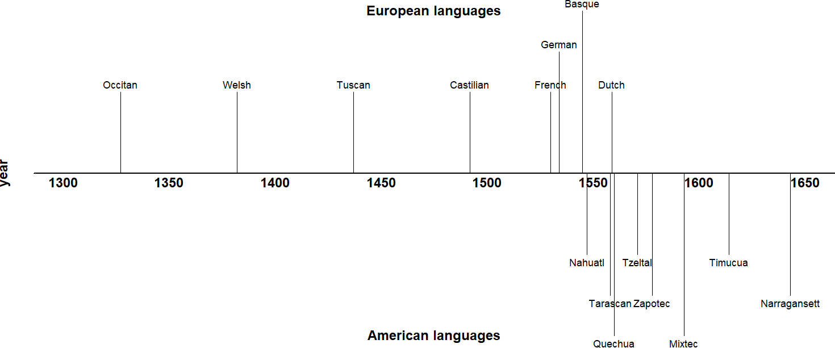

**Figure 2.1:** Timeline of early grammatical descriptions of European vs.

American languages

**Table 2.1:** Some first grammatical descriptions of European vs. American languages

Language Year Title Author

Irish 600s *Auraicept na n-Éces*

‘The scholars’ primer’

Occitan 1327 *Leys d’amors*

‘Laws of love’

Welsh 1382–1410 *Llyfr Coch Hergest*

‘Red book of Hergest’

Tuscan 1437–1441 *Grammatica della lingua toscana*

‘Grammar of the Tuscan language’

Castilian 1492 *Gramática de la lengua castellana*

‘Grammar of the Castilian language’

French 1530 *L’Éclaircissement de la langue fran-*

*coyse*

‘Explication of the French language’

German 1534 *Ein Teutsche Grammatica*

‘A German grammar’

Longarad Guilhèm Molinièr unknown

Leon Battista Alberti Antonio de Nebrija John Palsgrave

Valentin Ickelsamer

**Table 2.1:** Some first grammatical descriptions of European vs. American languages

Language Year Title Author

Basque 1545 *Linguæ Vasconum Primitiæ*

‘First fruits of the Basque language’

Totonac 1539–1554 *Arte de la lengua totonaca*

‘Grammar of the Totonac language’

Nahuatl 1547 *Arte para aprender la lengua mexicana*

‘Grammar for learning the Mexican language’

Tarascan 1558 *Arte de la lengua tarasca de Michoacán*

‘Grammar of the Tarascan language of Michoacán’

Dutch 1559 *Den schat der Duytsscher Talen*

‘The treasure of the Dutch language’

Quechua 1560 *Grammatica o arte de la lengua gen-*

*eral de los Indios de los Reynos del Peru* ‘Grammar or Art of the General Language of the Indians of the Royalty of Peru’

Tzeltal Maya 1571 *Ars Tzeldaica*

‘Tzeltal Grammar’

Zapotec 1578 *Arte en lengua Zapoteca*

‘Grammar in the Zapotec language’

Bernard Etxepare Andrés de Olmos Andrés de Olmos

Maturino Gilberti

John III van de Werve Domingo de Santo Tomás

Fray Domingo de Hara Juan de Córdova

English 1586 *Pamphlet for Grammar* William Bullokar

Mixtec 1593 *Arte de lengua Mixteca*

‘Grammar of the Mixtec language’

Timucua 1614 *Gramatica de la lengua Timuquana de Florida*

‘Grammar of the Timucua language of Florida’

Antonio de los Reyes Francisco Pareja

Narragansett 1643 *A key into the language of America* Roger Williams

As documentary linguistics turned its attention to North American (as opposed to Mesoamer-

ican) languages, lexical polyfunctionality in particular became a more prominent issue. In fact, even the first comprehensive survey of North American languages contains an entire section on “Conversion of nouns into verbs” (Gallatin 1836: 174–177), in which Gallatin depicts lexical polyfunctionality as a rampant feature of all languages on the continent:

It is the substantive [i.e. copula / auxiliary] verb which we [speakers of Indo-European languages] conjugate; whilst the [Native American] conjugates what we call the adjective and even the noun itself, in the same manner as [s/he] does other intransitive verbs. […] I believe it must appear sufficiently obvious, that this general if not universal character of the [Native American] languages, the conversion into verbs and the conjugation, through all the persons, tense, and moods, of almost all the adjectives and of every noun which, without a palpable absurdity, is susceptible of it, is entirely due to the absence of the substantive verb. (Gallatin 1836: 175–176)

As evidenced by the above passage, increasing familiarity with non-Indo-European languages prompted some writers to abandon the universalist commitment for word classes. However, categorial universalism is still a widely-held position today, either in the sense of a) categories being universally instantiated in all languages (commonly assumed by most generative frameworks; although see Culicover [1999]), or b) categories being available to all languages, but only instantiated in some (sometimes called the “smörgåsbord” or “grab bag” approach, as exemplified by Dixon’s Basic Linguistic Theory framework [2010: 9, 11, 14, 27,

50; 2011: 26]; see Hieber [2013: 298] and Croft [2001b: 10] for discussion).

### **Relativism**

American ethnographers in the tradition of Franz Boas questioned the universalist assumption in a programmatic and comprehensive way. Writing on grammatical categories, Boas states, “Grammarians who have studied the languages of Europe and western Asia have developed a system of categories which we are inclined to look for in every language” (Boas 1911: 35). He concludes that this endeavor is a folly, and that “in a discussion of the characteristics of various languages **different fundamental categories** will be found” (Boas 1911: 35). Discussing lexical categories specifically, he notes the following:

We might perhaps say that American languages have a strong tendency to draw the dividing line between denominating terms and predicative terms, not in the same way that we are accustomed to do. In American languages many of our predicative terms are closely related to nominal terms, most frequently the neutral verbs expressing a state, like *to sit*, *to stand*. These, also, often include a considerable number of adjectives. (Boas 1911: 76)

Boas’ students all adopted his grammatical relativism, and it became a foundational principle of the American linguistics tradition. His student Edward Sapir, writing on lexical categories specifically, makes one of the best-known and strongest statements of this position in his influential textbook *Language*: “[N]o logical scheme of the parts of speech—their number, nature, and necessary confines—is of the slightest interest to the linguist. Each language has its own scheme. Everything depends on the formal demarcations which it recognizes.” (Sapir 1921: 125).

Many linguists today hold to Boas’ grammatical relativism in some fashion or another. Textbooks and typological surveys commonly state that languages have varying numbers of lexical categories, though usually with the caveat that all languages seem to differentiate at least noun and verb (e.g. Velupillai 2012: §6.2). Some researchers, especially those working in typology, argue that linguists are still not rigorous *enough* in their application of grammatical relativism; they criticize certain kinds of crosslinguistic comparisons for imposing the categories of one language onto another (Croft 2001b; Gil 2001; Haspelmath 2010a; 2012; LaPolla 2016). This position is discussed further in Section 2.4.

### **Structuralism**

Developing alongside the early anthropological linguistics of Boas was the linguistic structuralism of Ferdinand de Saussure. His work informed both the Prague school under Nikolay Trubetzkoy and Roman Jakobson, and the distributional method of Leonard Bloomfield. The term *structuralism* has any number of uses (P. Matthews 2001: Ch. 1); here I refer to the idea that “language is a […] self-contained, self-regulating system, whose elements are defined by their relationship to other elements” (P. H. Matthews 2014: 383). In particular, I am referring

to the positivistic flavor of structuralism as practiced by Bloomfield, which focused on the structural relations between elements, and on establishing a set of rigorous scientific discovery procedures for linguistic structures (Bloomfield 1933). Bloomfield saw lexical categories as something to be empirically discovered in the different syntactic distributions of words, rather than imposed on a language a priori (Rauh 2010: 33). Zellig Harris later refined and expanded this methodology (Harris 1951).

The signature methodological feature of this form of structuralism is the *distributional method*, a procedure for defining categories in terms of the set of contexts in which its words can appear—that is, their distributions (Harris 1951: 5; Croft 2001b: 11). As an illustration of distributional analysis applied to lexical categories, Croft (1991: 11–12) considers the distributions of the English words *cold*, *happy*, *dance*, and *sing* in two constructions: in the Predicate construction after *be*, and in the 3rd Person Singular Present Tense (*‑s*) construction. Example data are shown below.

1. English (Indo-European > Germanic)
2. i. Jack is cold.
   1. * Jack colds.
3. i. Jack is happy.
   1. * Jack happies.
4. i. * Jack is dance.
   1. Jack dances.
5. i. * Jack is sing.
   1. Jack sings.

We can see that *cold* and *happy* have the same distributions in these tests (both may appear in the Predicate construction but not the Person-Tense inflection construction), while *dance* and *sing* have the same distribution (the inverse situation as *cold* and *happy*). The results of these two distributional tests are summarized in Table 2.2. Data like these are used to justify categories like Adjective and Verb in English.

As applied in practice, however, the distributional method suffers from one serious draw-

**Table 2.2:** Distribution of English Verbs and Adjectives (adapted from Croft [2001b: 12])

Predicate Inflectional

Construction Construction

|  |  |  |
| --- | --- | --- |
| **Adjective**: *cold*, *happy*, etc. | ✔ | ✘ |
| **Verb**: *sing*, *dance*, etc. | ✘ | ✔ |

back when used to argue for large, traditional categories like noun, verb, and adjective: distributional tests yield conflicting and overlapping results. Perhaps no two lexical items behave the same way in every distributional test. Each new test that is introduced therefore partitions the lexicon into smaller and smaller classes. This fact has been demonstrated empirically for English temporal nouns (Crystal 1967: 54), Russian numerals (Corbett 1978), and French verbs (Gross 1979). Distributional tables from each of these studies are reproduced in Table 2.3, Ta- ble 2.4, and Table 2.5 respectively. It is clear from these studies that distributional analysis does *not* lead to large, unified categories like noun, verb, and adjective, but rather a myriad of small constructions (Crystal 1967: 27; Croft 2005: 434). Each distributional test is in fact its own construction (Croft 2005: 436). This fact is a major motivation underlying constructional approaches to language.

Many scholars nonetheless choose to retain lexical categories as a necessary component of their linguistic theories or descriptions, at the expense of consistent application of the distributional method. Rather than considering all possible distributional contexts for a word, these scholars instead treat certain constructions as definitional of the category. Other distributional tests which yield cross-cutting results are either ignored or treated as evidence of subcategories instead of categories. Many researchers even prefer the term *syntactic categories* over *lexical categories* for this reason, focusing on just the syntactic evidence for categories (M. C. Baker 2003; Rauh 2010). A severe methodological problem for this approach is that there are no generally agreed-upon principles for determining which distributional tests should be considered definitional. In this regard, Schachter & Shopen (2007: 4) note, “there may be considerable arbitrariness in the identification of distinct parts of speech rather than

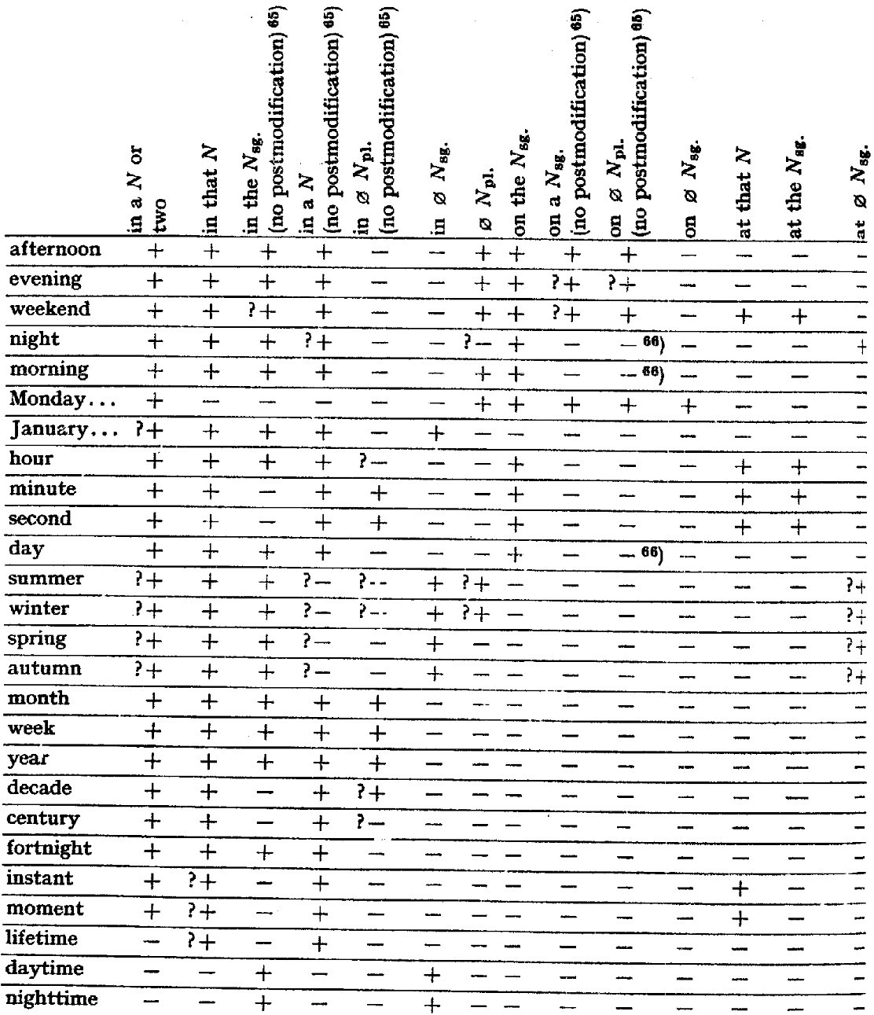

**Table 2.3:** distributional analysis of English (Indo-European > Germanic) temporal nouns (Crystal 1967: 54)

subclasses” (see also Crystal [1967]). Different scholars choose or prioritize different kinds of evidence for lexical categories over others based on their theoretical commitments. This is the reason, as stated in Section 1.1, that disagreements about the existence of particular lexi-

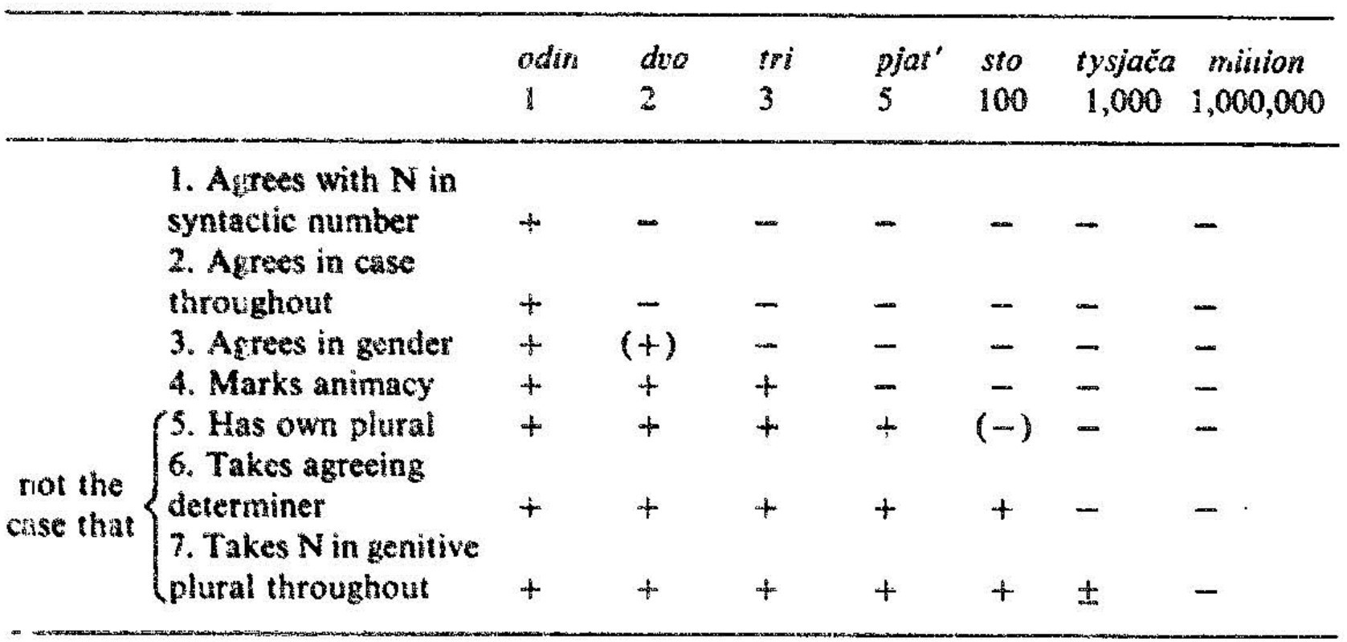

**Table 2.4:** distributional analysis of Russian (Indo-European > Slavic) numerals (Corbett 1978: 359)

cal categories in particular languages are typically *not* about the empirical facts. The results of a given distributional analysis are not usually controversial (though see Aarts [2007]); the choice of distributional tests used to support one’s analysis is. Unsurprisingly, then, debates over how to analyze lexical categories in various languages have been largely unproductive and unresolved (Croft 2005: 435). The problem only worsens when scholars attempt to apply the same criteria across languages. Distributions of lexical items with similar meanings vary drastically across languages (Croft 2001b: §1.4.1).

The real methodological problem here is *not* that we have yet to ascertain the correct principles for selecting the right distributional tests. The problem is being selective regarding which tests to apply in the first place. If we take the distributional method seriously, then we must apply it consistently, without ignoring distributional evidence that contradicts our theoretical or pretheoretical assumptions. To do otherwise is a kind of *methodological opportunism* (Croft 2001b: 30, 41).

Other scholars treat polyfunctional items as members of *hybrid* or *mixed* categories simultaneously possessing properties of more than one part of speech (Lois et al. 2017: 149; Malouf 1999; Nikolaeva & Spencer 2020). Adjectives are frequently described as a hybrid category

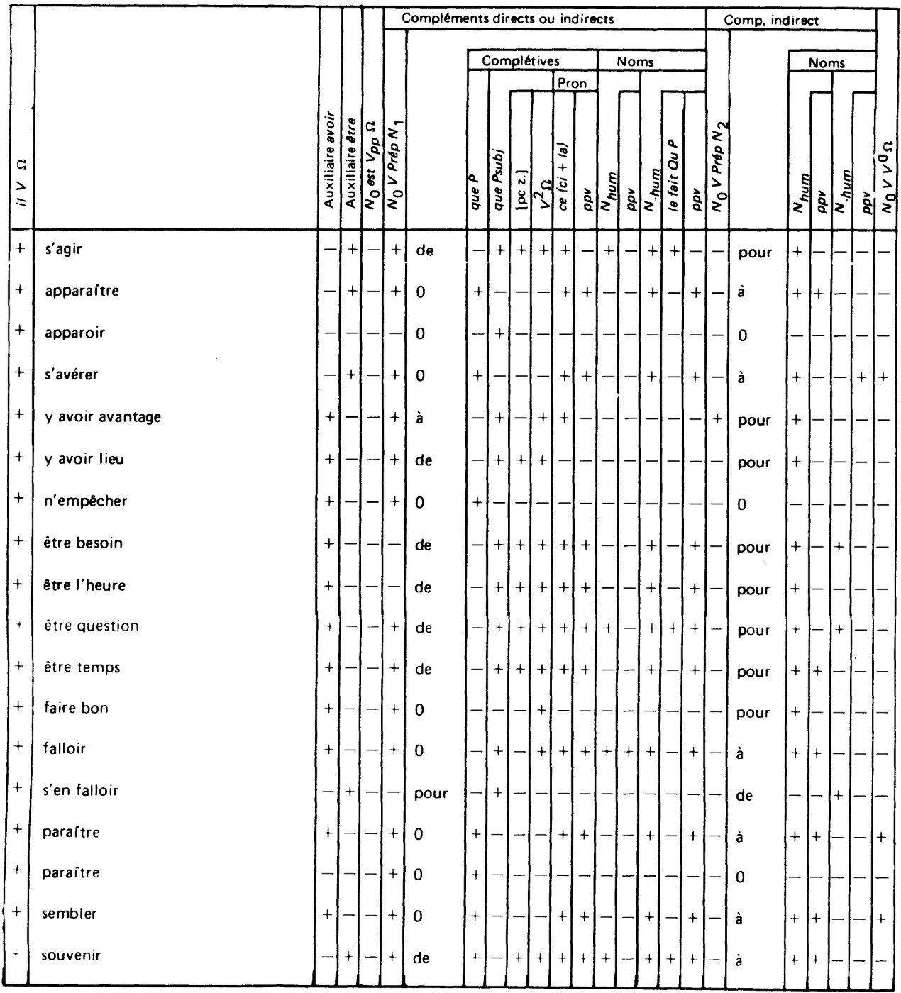

**Table 2.5:** distributional analysis of French (Indo-European > Romance) verbs (Gross 1979: 860)

(Wetzer 1996; Stassen 1997: 343; Pustet 2003: 13–16; Genetti & Hildebrandt 2004: 95; van Lier 2017), as are participles (Hopper & Thompson 1984: 704) and gerunds (Denison 2001). Lois et al. (2017: 149) also distinguish hybridity from polycategoriality, stating that polycategoriality applies to roots or stems, while hybridity is a matter of the syntactic context that a word

appears in.

An analysis couched in mixed categories does not avoid the problem of methodological opportunism, however. The existence of a mixed category implies that there are other, more basic categories that the mixed category is a hybrid of. Hybrid models of parts of speech merely exacerbate the distributional problem. There is however a sense in which thinking of minor lexical categories as “mixed” categories is useful: typological markedness theory states that lexical categories are epiphenomenal patterns that arise from combinations of the semantic classes of object, action, or property words with the discourse functions of reference, predication, and modification. Categories frequently discussed as “mixed” in the literature are precisely those combinations which are non-prototypical and therefore more likely to be typologically marked. Section 2.4.2 explains this approach to lexical categories in more detail. Partly in response to these problems, a growing cadre of linguists in the last 30 years have adopted one of various *flexible* approaches to word classes. Flexible analyses of word classes come in many flavors, some of which arguably still commit methodological opportunism, and others of which introduce new difficulties. These flexible approaches are reviewed in the

following section.

## **Flexible approaches**

In this section I summarize the key concepts (§2.3.1), research themes (§2.3.2), and criticisms (§2.3.2) of research on lexical polyfunctionality. Section 2.3.1 surveys the wide variety of definitions and theoretical perspectives on lexical polyfunctionality. This review of the literature reveals that there is little consensus as to what exactly constitutes lexical polyfunctionality; as such, there are numerous alternative terms for the phenomenon. Despite these incongruities, a few major themes do consistently surface across different empirical studies. These are summarized in Section 2.3.2. One tradition in particular views lexical polyfunctionality as productive, adopting the term *lexical flexibility*. Section 2.3.3 looks at criticisms of such

flexible analyses.

### **Key concepts**

It is only a small exaggeration to say that there are as many definitions and terms for what I am here calling “lexical polyfunctionality” as there are scholars who research it. The analytical or theoretical perspective adopted by each researcher generally determines their choice of terminology. The remainder of this section is devoted to explaining these perspectives in more detail.

Generally speaking, there are two ways researchers have analyzed polyfunctional items. The first method assigns flexible items to members of specific categories in a language, whether those categories are the canonical four major classes (Noun, Verb, Adjective, Adverb), or a new large supercategory subsuming multiple discourse functions (e.g. Contentives, NonVerbs, Flexibles), or a smaller subcategory of an existing major lexical category (e.g. Adjectival Verbs, Verbonominals). The second method of analysis assumes that lexical items are uncategorized at some level (root, stem, or inflected word), and that items receive their categorial assignment from context. Different researchers posit different mechanisms for how lexical items receive their categorization in context.

The traditional approaches to lexical polyfunctionality summarized in Section 2.2 are all instances of the former method of analysis, while the flexible approaches outlined in this section are a mix of categorial and acategorial analyses.

* + - 1. **Lexical flexibility**

The term *lexical flexibility* is typically taken to imply that lexical items can be used productively across different lexical categories—in other words, that these different uses are all part of one unified, polysemous lexeme, and that the category information is then inferred from context. The term *lexical flexibility* itself seems to have originated with Hengeveld (1992: Ch. 4). This publication, perhaps because it was the first to assign a technical term to the

concept, marks a shift in how scholars frame the concept of lexical polyfunctionality. Previously, the issue was framed in terms of whether particular languages (especially those of the Pacific Northwest) distinguished noun from verb (Kuipers 1968; Jacobsen 1979; Hébert 1983; Kinkade 1983; van Eijk & Hess 1986; Jelinek & Demers 1994). After this point, an increasing number of publications began to ask whether lexemes were *flexible* instead. Though the difference in emphasis seems subtle, this change constitutes a turning point because it fostered an increased interest in lexical polyfunctionality as a grammatical phenomenon in its own right instead of just a problem for traditional categorization schemes.

Hengeveld’s (1992: Ch. 4) typology of parts-of-speech systems is a whole-language typology wherein languages are either *specialized*, with one morphosyntactic category for each of the functions of reference (“Noun”), predication (“Verb”), referent modification (“Adjective”), and predicate modification (“Adverb”1), or *non-specialized*. Non-specialized languages deviate from the four-category canon in one of two ways: one part of speech may assume more than one function with no additional morphosyntactic marking, in which case the language is considered *flexible*; or the language may lack a dedicated part of speech for that function entirely and use other, marked constructions instead, in which case the language is considered *rigid*.

Hengeveld gives examples from Dutch and Wambon to illustrate the distinction between rigid and flexible languages. In the Dutch examples in (12), the same word *mooi* is used for both referent modification (12a) and predicate modification (12b), with no function-indicating morphology in either case. Wambon on the other hand uses medial verbs for manner expressions and must take the overt verbalizing suffix *‑mo* shown in (13). In Hengeveld’s framework, Dutch is a flexible language because one category subsumes both the functions of referent modification and predicate modification, while Wambon is a rigid language because derivational morphology (here, the verbalizing suffix *‑mo*) is required to indicate the function of predicate modification.

1Note that Hengeveld’s typology only includes manner adverbs, not other semantic types of adverbs.

1. Dutch (Indo-European > Germanic)
2. een indef

**mooi beautiful**

kind child

‘a beautiful child’ (Hengeveld 1992: 65)

1. het def

kind child

dans‑t dance‑3sg.pRes

**mooi**

**beautifully**

‘the child dances beautifully’ (Hengeveld 1992: 65)

1. Wambon (Trans-New Guinea > Greater Awyu)

jakhov‑e they‑conn

**matet‑mo good‑vzR.ss**

ka-lembo go‑3pl.past

‘did they travel well?’ (de Vries [1989: 49], cited in Hengeveld [1992: 65])

Hengeveld’s analysis is of the categorial type discussed at the beginning of Section 2.3.1, specifically the supercategory kind. Each lexeme is assumed to have a category, and new supercategories are introduced for lexemes which have multiple functions: *Contentives* for lexemes which perform all four functions, *Non-Verbs* for lexemes which perform all nonpredicating functions, and *Modifiers* for lexemes which perform referent modifier and predicate modifier functions.

Hengeveld’s parts-of-speech typology and the subsequent research it inspired (Don & van Lier 2013; Hengeveld & Rijkhoff 2005; van Lier 2006; Hengeveld & van Lier 2012; Luuk 2010; van Lier & Rijkhoff 2013; van Lier 2016) constitute important empirical contributions to the study of lexical polyfunctionality. However, Hengeveld’s definition of flexible languages and his parts-of-speech typology still rely on large, language-specific categories of the kind that have been problematized by Croft (2001b: §2.2.2) and Croft & van Lier (2012), and are therefore subject to the same difficulties as traditional approaches to parts of speech. However, numerous scholars have since adopted Hengeveld’s term *lexical flexibility* to describe cases where lexical items serve more than one discourse function, regardless of their theoretical commitments or analysis of flexible items. As a convenient cover term, *lexical flexibility* is now well established. Nonetheless, I retain the use of *lexical polyfunctionality* here for its precision, and since I do not adopt a flexible analysis to polyfunctional forms.

* + - 1. **Polycategoriality**

Vapnarsky & Veneziano (2017b: 4) introduce the alternative term *polycategoriality* as their preferred characterization of polyfunctional items. (The term is also used by Carter [2006], but he does not give a precise definition for it.) While Vapnarsky & Veneziano use this term mostly interchangeably with *lexical flexibility*, there are important differences between the two concepts. Hengeveld’s use of *lexical flexibility* is meant to imply the existence of large, flexible supercategories that subsume multiple discourse functions, whereas Vapnarsky & Veneziano are not committed to any particular schema for parts of speech. Central to their notion of polycategoriality is the idea that lexical categories exist, but that “there are lexical forms that are not specified for lexical category (or are not specified fully, or univocally) on some level of representation.” (Vapnarsky & Veneziano 2017b: 4). In other words, one lexeme may belong simultaneously to multiple lexical categories. Under this definition, a language could still have all four major lexical categories but nonetheless exhibit rampant polycategoriality; this is not a possibility in Hengeveld’s framework. Like Hengeveld, however, Vapnarsky & Veneziano are committed to the existence of large lexical categories in particular languages. Their analysis is therefore also of the categorial kind discussed at the beginning of Section 2.3.1.

* + - 1. **Multifunctionality**

Another term for our phenomenon of interest, introduced by (van Lier 2012), is *multifunctionality*, in which a single lexical item can have multiple discourse functions. An advantage of this analysis is that it takes no theoretical position on the issue of whether lexical items are categorial or acategorial; it just focuses on their functions. The term *multifunctionality* is meant to stand in contrast with *conversion* or *zero derivation*. Van Lier takes conversion to be idiosyncratic and unproductive, producing meanings for forms in alternate discourse functions that are not predictable (see Section 2.3.2.4 and Section 2.3.3.2 for further discussion). Multifunctionality is also distinct from zero derivation from a common root. Instead,

multifunctional lexemes are those whose semantic interpretation is entirely predictable from context, and whose uses in different contexts are productive. Their meanings should be *compositional*. For example: when an action word is used in a referring construction its predicted meaning is that of an *action nominalization*, ‘(the act of) X‑ing’; and when an object word is used in a predicate construction its predicted meaning is that of a *predicate nominal*, ‘be an X’. Examples of these predictable, compositional meanings for polyfunctional items in Chamorro are shown in (14).

1. Chamorro (Austronesian > Malayo-Polynesian)
2. para fut

**batångga‑n shed‑linK**

karabåo carabao

esti this

‘this is going to be a carabao shed’ (Chung 2012: 8)

1. para fut

**gatbesa**

**decoration**

ha’ emph

‘[she] is going to be a decoration’ (Chung 2012: 20)

In the two examples above, the meaning of the object words ‘shed’ and ‘decoration’ are predictable when used in a predicative context: ‘be a shed/decoration’. However, lexical items used in their non-prototypical functions very frequently do not have predictable meanings. Consider the example in (15).

1. Chamorro (Austronesian > Malayo-Polynesian)

ma agR

**se’si’ knife**

i the

babui pig

‘they stabbed the pig’ (Chung 2012: 29)

In this example, the meaning ‘stab’ cannot be predicted from the meaning of the object word ‘knife’. It could have just as easily meant ‘be a knife’ or ‘cut’.

Van Lier takes examples like those in (14) to be instances of genuine multifunctionality, and those in (15) to be cases of conversion. Others have also adopted a position similar to van Lier’s, in which only the semantically compositional / predictable uses of a lexical item in different discourse functions are considered flexible (Croft 2001b: §2.2.2–§2.2.3; Evans & Osada 2005: §3.2).

* + - 1. **Precategoriality / Acategoriality**

The various approaches which analyze polyfunctional items as being at some level uncategorized until they receive their interpretation from context may be lumped together under the umbrella terms *precategoriality* or *acategoriality*. Hopper & Thompson’s influential (1984) paper is an early application of the concept of acategoriality to the analysis of polyfunctional items:

[L]inguistic forms are in principle to be considered as *lacking categoriality* completely unless nounhood or verbhood is forced on them by their discourse functions. To the extent that forms can be said to have an apriori existence outside of discourse, they are characterizable as *acategorial*; i.e. their categorical classification is irrelevant. Categoriality-the realization of a form as either a N or a V-is imposed on the form by discourse. (Hopper & Thompson 1984: 747)

The term *precategorial* has become a somewhat more common term for roughly the same concept (though some researchers use the term in more strictly-delineated ways) (Evans & Osada 2005: 357, 362–364; Bisang 2008; 2013). It is especially preferred by morphological models that presuppose stages of derivation, such that lexical items are precategorial before they reach a certain stage of the derivation (Halle & Marantz 1994; Arad 2005; McGinnisArchibald 2016; Siddiqi 2018). Vapnarsky & Veneziano (2017b: 5) distinguish polycategoriality from acategoriality by defining acategoriality as implying “no primitive / original categorial marking at all”, and polycategoriality as allowing a lexical item “to be only partially unspecified for category, with possible constraints on the relevant categories”. Languages for which precategorial analyses have been advanced include Cherokee (Haag 2017), Gooniyandi (McGregor 2013), Kuikuro (Franchetto & Santos 2017), Mundari (Hengeveld & Rijkhoff 2005). Pfeiler (2017) also presents psycholinguistic evidence that the earliest utterances of L1 learners of Yucatec Maya are acategorial.

A central concern in precategorial approaches is the precise mechanism by which a lexical item receives its categorization in context (Hengeveld, Rijkhoff & Siewierska 2004: §3.7). There are two main theories of semantic indeterminacy in flexible items: *underspecificity*

(Farrell 2001; Rijkhoff & van Lier 2013) and *vagueness* (Tuggy 1993; Hengeveld, Rijkhoff & Siewierska 2004; Hengeveld & Rijkhoff 2005). The essential difference is that underspecificity entails semantic minimalism, while vagueness entails semantic maximalism. An underspecified lexeme has a minimal, core meaning, and receives its categorial meaning from the discourse context it appears in; a vague lexeme has a maximal, broad meaning that covers all the possible discourse contexts it appears in. (There is of course quite a deal of variation in the literature as to how scholars use these terms, with many researchers conflating the two.) Hengeveld & Rijkhoff (2005: 414) offer the example of English *cousin* as a word that is semantically underspecified for gender, such that the gender of the referent must be understood from context. Denison (2018) argues that the English word *long* exhibits adjective ~ adverb underspecification in Old English and Middle English.

In contrast, Hengeveld, Rijkhoff & Siewierska (2004: 539–541) outline a theory regarding exactly how vagueness operates in the context of precategoriality:

[E]ach flexible lexeme has a single (vague) sense. By placing the flexible lexeme in a particular syntactic slot or by providing it with certain morphological markers, the speaker highlights those meaning components of the flexible lexeme that are relevant for a certain lexical (verbal, nominal, etc.) function. Thus we contend that the meaning of a flexible lexeme always remains the same, and that morphosyntactic and other contextual clues signal to the addressee how to interpret this lexeme in an actual utterance. In other words, it is the use of a vague lexeme in a certain context (an actual linguistic expression) that brings out certain parts of its meaning, giving the category-neutral lexeme a particular categorial (verbal, nominal, etc.) flavour. (Hengeveld & Rijkhoff 2005: 541)

(Note that Hengeveld & Rijkhoff distinguish *vagueness* and *ambiguity* by reserving the term

*ambiguity* for cases of distinct, homophonous lexemes.)

Evans & Osada (2005: 363–364) and Kihm (2017) criticize both precategorial approaches for their imprecision, claiming that it would be impossible to formulate a definition for many precategorial items that is broad enough to encompass all their uses. Kihm (2017: 87) illustrates this difficulty with the various meanings of the Arabic root *s‑q‑ṭ*, which could arguably be glossed fall. A selection of stems containing this root are given in (16).

1. Standard Arabic (Afroasiatic > Semitic) saqaṭa ‘to fall’

saqiiṭ ‘hail’

saqqaaṭa ‘door latch’

masqaṭ ‘place where a falling object lands; waterfall’

isqaaṭ ‘overthrow; shooting down; miscarriage; substraction’ tasaaquṭ ‘fall of hair’

saaqiṭa ‘fallen woman; harlot’ suquuṭ ‘fall; crash; collapse’ saqṭ ‘dew’

siqṭ ‘miscarried fetus’

suqṭ ‘sparks flying from a flint’

saqaṭ ‘offal; rubbish’

saqṭa ‘tumble; slip; mistake’

saaqiṭ ‘fallen; mean; missing’

It is difficult to imagine a single definition of *s‑q‑ṭ* which could adequately demarcate just this set of meanings.

* + - 1. **Monocategoriality**

In the extreme case where all lexical items in a language are precategorial, the language could be considered *monocategorial*, possessing a single, open syntactic category. This is effectively the same as saying that the language lacks lexical categories altogether, the difference being primarily one of emphasis. David Gil analyzes both Tagalog (1995) and Riau Indonesian (1994) as being of this extreme monocategorial type. Moreover, he argues that monocategoriality must have been typical of an earlier stage of language evolution in which dedicated morphological strategies for different discourse functions had yet to evolve (Gil 2005; 2006; 2012). He names this abstract language type an *isolating-monocategorial-associational* (IMA) language.

* + - 1. **Transcategoriality**

It is also worth briefly mentioning *transcategoriality*, since the term arises occasionally in connection with lexical polyfunctionality and is potentially easily confused with other terms mentioned above. Robert (2003) uses *transcategoriality* to describe the ability of a single form

to serve both lexical and grammatical functions. This is common in grammaticalization scenarios in which the original, lexical use of a form continues to exist alongside its newer, functional use. This is commonly referred to in the grammaticalization literature as *divergence* (Hopper & Traugott 2003: 118). Since the focus of lexical polyfunctionality is on *lexical* items and categories rather than *functional* ones, the concept of transcategoriality is not directly relevant to the study of lexical polyfunctionality.

* + - 1. **Conversion / Zero derivation**

*Conversion* is the process whereby a lexical item simply changes its word class with no overt morphological marker of that change (Crystal 2008: 114). *Zero derivation* is an alternate analysis of the same phenomenon that posits the presence of a derivational marker with no phonological realization. Since the literature on conversion and zero derivation is extensive and the concepts are well-established, I will treat them only summarily here, focusing on their relationship to lexical polyfunctionality.

The concept of conversion is based on the premise that lexical items in a language are fully categorized for part of speech, meaning that an analysis of lexical polyfunctionality as conversion falls under the categorial (as opposed to acategorial) analyses mentioned at the beginning of Section 2.3.1. Conversion is generally characterized as a kind of word formation, implying that a new lexeme has been created. Therefore, conversion and lexical flexibility are mutually exclusive analyses of multifunctional items: lexical flexibility implies the existence of one polysemous lexeme which can fulfill multiple discourse functions, while conversion implies the existence of two homonymous / heterosemous lexemes with different discourse functions. Remember too from Section 2.3.1.3 that van Lier (2012) distinguishes conversion from multifunctionality, where conversion is reserved for unproductive / unpredictable derivations. Not all scholars would delimit conversion in this way, however.

Conversion also implies directionality. In cases of conversion, one of the two uses of a form is in some way basic or prior to the other (Mithun 2017: 156; Vapnarsky & Veneziano

2017b: 5). Under a flexible analysis, by contrast, the different functions of a single flexible item have equal theoretical status. If it could be shown that certain putatively flexible uses of a lexical item were in some way marked in relation to each other, this would therefore constitute potentially disconfirming evidence against a flexible analysis. This is in fact one of the major arguments presented against flexible analyses, to be discussed in Section 2.3.3. There are at least four ways in which one member of a putatively flexible set of polyfunctional items might be considered more basic than the others: 1) diachronically, in which one use of the lexical item appears before the others historically; 2) semantically, in which the meaning of the derived item is more semantically complex than that of the basic one; 3) morphologically, in which the more basic item is irregularly inflected but the derived item is regularly inflected; or 4) frequentially, in which derived lexical items are used less frequently than their more basic counterpart (Plag 2003: 108–111). Speakers themselves also have intuitions about which member of a polyfunctional set is basic and which are derived (Mithun 2017: 166). As will be explained in Section 2.4.2, the idea that certain uses of a lexical item are marked in relation to each other is also central to the typological markedness theory of lexical categories.

* + - 1. **Functional shift / Functional expansion**

Especially among researchers in North America, another common term for conversion is *functional shift* (Cannon 1985). In most research, the term is used essentially interchangeably with *conversion* or *zero derivation*. However, functional shift can be usefully distinguished from conversion by its emphasis on function over category, paralleling the distinction between polycategoriality (implying language-specific categories) and polyfunctionality (with no such implication). In its literal interpretation, the term suggests a shift in the meaning of a lexical item from one discourse function to another, an analysis amenable to a constructional approach, and one that is not committed to the existence of language-particular categories. A slight improvement on this term would be *functional expansion*, since it emphasizes the expansion of a linguistic form into new functions / contexts as opposed to the wholesale shift

from one function to another implied by *functional shift*. I adopt the term *functional expansion*

in this dissertation, and discuss the concept in detail in Section 2.5.2.

### **Themes in previous research**

The emergence of lexical polyfunctionality as an object of study has yielded a number of edited collections or journal volumes (Vogel & Comrie 2000, Evans & Osada 2005 (target article), Ansaldo, Don & Pfau 2010, Lois & Vapnarsky 2003, Rijkhoff & van Lier 2013, Simone & Masini 2014, Błaszczak, Klimek-Jankowska & Migdalski 2015, Vapnarsky & Veneziano 2017a, van Lier 2017 (target article), Vapnarsky & Veneziano 2017b, Cuyckens, Heyvaert & Hartmann 2019), plus any number of individual articles (see especially Farrell [2001], Rijkhoff [2007], van Lier [2012], and Mithun [2019]). Out of these collections have emerged several recurring themes, each of which is summarized in this section.

It should be noted at the outset that many of these findings cannot be straightforwardly reinterpreted in the typological-constructional approach adopted here. In particular, much previous research relies heavily on large, language-specific categories, which I problematize in Section 2.2.3 above. I discuss some of the other criticisms that have been leveled against these approaches in Section 2.3.3 below. My use of terms like *Noun*, *Verb*, and *Adjective* in this section should therefore not be taken as an endorsement of large, language-particular word classes, but instead as arising from a desire to accurately represent the perspectives of other researchers.

* + - 1. **Parts-of-speech hierarchy**

In addition to laying out a theory of flexible categories, Hengeveld (1992) presents the results of a 30-language survey of parts of speech in which he finds that the categories which are most likely to occur as an independent class in a language are subject to an implicational hierarchy, shown in (17), which Hengeveld refers to as the *parts-of-speech hierarchy*.

1. Verb > Noun > Adjective > Adverb

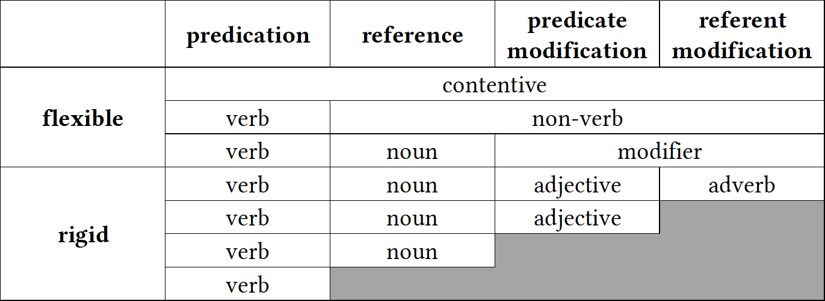Categories to the left of the hierarchy are more likely to occur as a distinct part of speech than categories to the right. Applying this hierarchy to Hengeveld’s flexible vs. rigid distinction yields the parts-of-speech typology in Figure 2.2 (adapted from Hengeveld [1992: 69] and Rijkhoff [2007: 718]). The terms for the different categories in flexible languages are from Hengeveld, Rijkhoff & Siewierska (2004). Hengeveld points out that this is not a strict classification scheme; languages may sit at the boundaries between types and exhibit exceptions.

**Figure 2.2:** Hengeveld’s (1992: 69) typology of parts-of-speech systems

As mentioned in Section 2.3.1.1, Hengeveld’s typology could be criticized for its reliance on large, language-specific lexical categories instead of constructions. One could however reframe Hengeveld’s implicational hierarchy in terms of functions rather than categories, as in (18). I call this the *hierarchy of discourse functions*.

1. predicate > referent > predicate modifier > referent modifier

In (18), functions to the left of the hierarchy are more likely to have dedicated morphological strategies for expression than those to the right. This reformulation avoids a commitment to any language-particular categories while still capturing the implicational trend observed by Hengeveld.

This hierarchy of discourse functions has proven to be a fairly robust finding in the literature on lexical polyfunctionality, now supported by a number of subsequent studies (Anward 2000; Rijkhoff 2000; Vogel 2000; Beck 2002; Rijkhoff 2002; 2003; Hengeveld, Rijkhoff &

Siewierska 2004; van Lier 2006; Hengeveld 2007; Hengeveld & van Lier 2012; Hengeveld & Valstar 2010; Beck 2013; Bisang 2013; Hengeveld 2013).

* + - 1. **Reference-predication asymmetries**

The hierarchy of discourse functions also hints at another important feature of lexical categories: there is something privileged about the predicating function. A survey of the literature on lexical polyfunctionality reveals patterned asymmetries in the behavior of lexical items with regard to predication vs. reference, even in highly polyfunctional. For starters, while it is quite common for languages to freely allow object words to be used as predicates with zero coding, the reverse case is much less likely (Hopper & Thompson 1984: 745). The functional expansion of an item’s uses from predication into reference always seems to be more marked (or at least as marked) as the shift from a referring function to a predicating function.

This fact has been observed independently by numerous researchers. For example, Stevick (1968: 251) and Marchand (1969: 373–374) both observe that conversion from noun to verb in English has always been more common than from verb to noun, and Kastovsky (1996: 98) points out that English does not even have a native noun > verb derivational suffix—any affixes of this type are borrowed from Romance languages. Central Alaskan Yup’ik is another example of a language with very many nominalizers but few verbalizers (Mithun 2017: 158).

Polyfunctionality itself is frequently *unidirectional*, meaning that any object word may be used for predication, but that action words used for reference are marked (Croft 2001b: 69; Evans & Osada 2005: §3.3; Beck 2013). Nakayama (2001: 44) frames polyfunctionality in Nuuchahnulth in terms of a stem’s ability to predicate, reporting that “all inflectional stems are potentially predicative”, but the reverse is not true. Discussing Classical Nahuatl, Launey (1994; 2004) introduces the term *omnipredicativity* to describe languages in which all lexical items are potentially predicative. However, no corresponding term *omnireferentiality* has appeared in the literature. That said, languages which have undergone *insubordination* (in

which subordinate clauses are reanalyzed as main clauses [Evans 2007; Mithun 2008; Evans & Watanabe 2016]) do often exhibit noun-oriented polyfunctionality in the sense that verbal inflection mirrors nominal inflection. This is because one common insubordination pathway is when nominalized subordinate clauses are reanalyzed as main clauses, so that nominal inflection marking is reanalyzed as verbal inflectional marking. This process of insubordination famously led to the claim that all lexical items in Eskimo languages are fundamentally nominal in nature (Sadock 1999). However, cases of insubordination do not constitute counterexamples to the predicating tendency in language. Even in these languages, the use of action words for reference is still less marked than the use of object words for predication.

Kastovsky (1996) argues that this asymmetry arises from the fact that “deverbal nouns have a much more diversified semantics than denominal verbs” (Kastovsky 1996: 96), meaning that the range of possible meanings for a deverbal noun (a noun derived from a verb) is broader than for a denominal verb (a verb derived from a noun). Examining data from English, Kastovsky shows that when an object word is used to predicate, its possible meanings are limited to combinations of be, be liKe, be in, become, have, do, do with, and cause. When an action word is used as a referent, however, the range of meanings include any abstract representation of the event itself (an action nominalization), or any one of the arguments associated with the verb, which come in a variety of semantic roles.

A similar, cognitively oriented explanation for reference-predication asymmetries is given by Hopper & Thompson (1984: 745):

[Deverbal] nominalization names an event taken as an entity; however, a “verbalization” does not name an “entity taken as an event”, but simply names an event associated with some entity. In other words, a nominalization still names an event, albeit one which is being referred to rather than reported on in the discourse; it is, accordingly, still in part a [verb], and not a “bona fide” [noun]. However, a denominal [verb] no longer names an entity at all, and thus has no nominal “stains” to prevent its being a bona fide [verb]. (Hopper & Thompson 1984: 745)

Hopper & Thompson (1984: 746) analyze nominalizations as a kind of metaphor following Lakoff & Johnson (1980: 3a), in which an abstract event is conceptualized as a concrete ob-

ject. However, they argue that verbalizations are not a type of metaphor but rather a kind of metonymic extension, thereby explaining the asymmetry in the directionality of lexical polyfunctionality.

* + - 1. **Locus of categoriality**

The morphological level at which a language exhibits polyfunctionality—the root, the stem, or the fully inflected word—differs from one language to the next. In some languages, roots are strongly associated with a particular discourse function, but stems are polyfunctional; in other languages, the reverse is true. I refer to the linguistic level at which a language associates different discourse functions as its *locus of categoriality*. Some linguistic theories include a premise that the locus of categoriality in every language always sits at a certain level (Halle & Marantz 1994; M. C. Baker 2003; 2015; Booij & Audring 2018; Siddiqi 2018), but the evidence from research on lexical polyfunctionality gives strong empirical support to the position that locus of categoriality varies from language to language. In contrast to either of these positions, Błaszczak, Klimek-Jankowska & Migdalski (2015) argue that category information is distributed across different levels of representation.

As one illustration of how polyfunctionality depends on grammatical level, we have seen that roots in Central Alaskan Yup’ik are generally categorical: except for 12% of roots, they are typically strongly associated with just one discourse function, and derivational affixes select for roots of a particular category (Mithun 2017: 162–167). While many derived stems are also strictly associated with just one discourse function, a large but indeterminate number have both referential and predicative uses. Examples of such polyfunctional stems have already been shown in (7) in Section 1.1. Fully inflected words in Central Alaskan Yup’ik, however, never exhibit polyfunctionality (Mithun 2019: 6). So Central Alaskan Yup’ik displays partial polyfunctionality at the root and stem level but not the inflected word level.

As another example, in Mandinka all stems are polyfunctional. No Mandinka stem except for *sǎa* ‘die’ is used in just one discourse function (Creissels 2017: 46). At the level of the

inflected word, however, lexical items in Mandinka belong unambiguously to one category or another (Creissels 2017: 37). Mandinka therefore shows total polyfunctionality at the stem level but total monofunctionality at the inflected word level. (Creissels does not include an analysis of roots in his discussion.)

Some languages display polyfunctionality even at the level of the fully inflected word. In many North American languages, it is common for fully morphological verbs to function as referents (Hieber forthcoming), as shown in the following examples.

1. Chitimacha (isolate)
2. dzampuyna dza‑ma‑(p)uy‑na thrust‑plact‑hab‑nf.pl

‘they usually thrust / spear with it’

‘spear’ (Swadesh 1939a: 56)

1. pamtuyna pamte‑(p)uy‑na ford‑hab‑nf.pl

‘they usually cross (it)’

‘bridge’ (Swadesh 1939a: 17)

1. Cayuga (Iroquoian > Lake Iroquoian)
2. ǫtekhǫnyáʔthaʔ ye‑ate‑khw‑ǫni‑aʔt‑haʔ indef.agt.Refl‑meal‑make‑instR‑ipfv ‘one makes a meal with it’

‘restaurant’ (Mithun 2000: 200)

1. kaǫtanéhkwih ka‑rǫt‑a‑nehkwi neut.agt‑log‑ep‑haul.ipfv ‘it hauls logs’

‘horse’ (Mithun 2000: 200)

1. Navajo (Na-Dene)
2. tsinaaʼeeɬ tsi(n)‑naaʼeeɬ

wood‑it.moves.about.floating

‘ship, boat’ (Young 1989: 316)

1. chahaɬheeɬ it.is.dark

‘darkness’ (Young 1989: 316)

Each of these polyfunctional uses of a morphological verb sits somewhere on a continuum between being fully lexicalized as a referent, so that its predicating use is no longer available, to being a fully productive predicate, with both predicative and referential uses (Mithun 2000: 413).

The reason that lexical items may exhibit polyfunctionality at one level of analysis but not another is because “*categorial* shift is often not *categorical*” (Mithun 2019: 1). When an item expands its use into new contexts, not all the morphological, syntactic, and semantic properties of the item shift to accommodate that new use at the same time. It takes time before the morphosyntactic properties of an item adjust to reflect its new use, a process referred to as *actualization* in the grammaticalization literature (De Smet 2012) and *post-constructionalization constructional changes* in the framework of diachronic construction grammar (Traugott & Trousdale 2013: 27).

It is in part because the locus of categoriality can vary from language to language that I have used the vague term *lexical item* throughout this dissertation, which is intended to be a convenient cover term for root, stem, or inflected word.

* + - 1. **Item-specificity**

A final significant finding to emerge from the empirical research on lexical polyfunctionality is the fact that polyfunctionality is *item-specific* and even *sense-specific*. Individual lexical items or even individual senses of an item that are otherwise very similar in their meanings and morphosyntactic behavior can nonetheless differ in terms of their functional diversity.

This fact is nicely illustrated by both Mithun’s (2017) study of lexical polyfunctionality in Central Alaskan Yup’ik and Creissels’s (2017) study of Mandinka. Mithun (2017: 163–164), for example, considers roots for meteorological concepts, and shows that even within this small semantic domain, roots vary as to whether they exhibit polyfunctionality. In (22a) the

meteorological roots have predicative counterparts but in (22b) the meteorological roots do not.

1. Central Alaskan Yup’ik (Eskimo-Aleut > Yupik)

|  |  |  |  |
| --- | --- | --- | --- |
| a. *amirlu* | ‘cloud’ | *amirlu‑* | ‘be cloudy’ |
| *kaneq* | ‘frost’ | *kaner‑* | ‘be frosted’ |
| *aniu* | ‘snow on ground’ | *aniu‑* | ‘to snow’ |
| b. *taituk* | ‘fog, mist’ | \**taitug‑* | ‘be foggy’ |
| *kavtak* | ‘hailstone’ | \**kavtag‑* | ‘to hail’ |
| *mecaliqaq* | ‘sleet’ | \**mecaliqar‑* | ‘to sleet’ |

(Mithun 2017: 163)

Mithun also provides similar data illustrating functional gaps for the domains of clothing and instruments:

1. Central Alaskan Yup’ik (Eskimo-Aleut > Yupik)

|  |  |  |  |
| --- | --- | --- | --- |
| a. *taqmak* | ‘dress’ | *taqmag‑* | ‘put on a dress’ |
| *nacaq* | ‘hat, parka hood, cap’ | *nacar‑* | ‘put on a hat, hood’ |
| *atkuk* | ‘parka’ | *atkug‑* | ‘put on a parka’ |
| b. \**piluk* | ‘footwear’ | *pilug‑* | ‘put on footwear’ |
| \**at’e* | ‘clothing’ | *at’e‑* | ‘don, put on clothing’ |
| \**kive* | ‘pants’ | *kive‑* | ‘pull down pants’ |

1. Central Alaskan Yup’ik (Eskimo-Aleut > Yupik)
2. *ay’uytaq* ‘hockey stick’ *ay’utar‑* ‘play hockey’

*iqsak* ‘fishhook’ *iqsag‑* ‘to jig for fish’

*kapkaanaq* ‘trap’ *kapkaanar‑* ‘to trap, get trapped’ *keviq* ‘plug, cork, stopper’ *kevir‑* ‘to plug, stuff, caulk’ *kuvya* ‘fishnet’ *kuvya‑* ‘fish by driftnetting’

1. \**kagi* ‘broom’ *kagi‑* ‘sweep’

\**ipuk* ‘ladle’ *ipug‑* ‘ladle, move with bow of boat high in air’

\**pangeq* ‘double-bladed

paddle’

*panger‑* ‘paddle with a double-bladed paddle’

On the basis of data like these and discussion with speakers, Mithun observes, “Speakers simply know whether a given root functions as a noun and what its meaning is, and whether it functions as a verb and what its meaning is. Gaps are not predictable[.]” (Mithun 2017:

163). These gaps also vary from dialect to dialect. While the dialect in the above examples has no predicative counterpart for *taituk* ‘fog’, the Nunivak Island dialect does have a pair of roots *nugu* ‘fog’ and *nungu‑* ‘be foggy’.

Creissels’s (2017) study of Mandinka is another good illustration of the item-specific nature of polyfunctionality. While Mandinka has nominal and verbal constructions that allow the predicative and referring functions of inflected words to be distinguished unambiguously, it is not as easy to separate stems into similar classes. In Mandinka, all items are polyfunctional, but the *way* in which items are polyfunctional varies. Stems in Mandinka may be divided into three classes based on their semantic behavior with regards to polyfunctionality:

* *verbal* lexemes are those whose meaning is predictable when used to refer and therefore analyzable as a case of “morphologically unmarked nominalization”; these are always event nominalizations
* *verbo-nominal* lexemes are those whose meaning in referring constructions is idiosyncratic and therefore not predictable
* *nominal* lexemes are those whose meaning when used as predicates is predictable and limited to ‘provide someone with X’

In Mandinka, therefore, polyfunctionality must be assessed on an item-by-item basis since the behavior of each item with regard to polyfunctionality may differ.

In fact, polyfunctional behavior in Mandinka is not just item-specific, but sense-specific as well. Creissels (2017: 54) reports that polysemous lexemes may show different behavior for their different senses. The stem *díŋ*, for example, has two senses: ‘child, young (of an animal)’ and ‘fruit’. However, only the ‘fruit’ sense is available for predication: when used as an intransitive verb, *díŋ* may only mean ‘bear fruit’, not ‘give birth’, even though ‘give birth’ is a perfectly conceivable meaning of this stem in predication. In the sense of ‘child, young (of an animal)’, *díŋ* behaves as a nominal lexeme, but in the sense of ‘fruit’ it behaves as a verbo-nominal lexeme.

When lexical items undergo functional expansion into new discourse functions, it is also only specific senses that do so, not every one of its senses. More evidence for this comes from

the diachronic development of the word *run* in English: though the word *run* when used as a predicate has numerous senses, the earliest attestations of *run* used referentially are by and large with just the prototypical sense of ‘fast pedestrian motion’ (the exceptions to this stem from just one corpus file) (Gries 2006: 76). Other referential uses of *run* did not develop until later.

The existence of dialectal differences in lexical polyfunctionality as well as the unpredictable meanings of lexical items when used in various discourse functions show that the development of polyfunctionality depends on conventionalization—whether a given form has assumed a conventionalized meaning in its role for a specific discourse function. These conventionalizations are language-specific, dialect-specific, item-specific, and even sense-specific (Croft 2000: 97). Speakers can and do playfully use existing lexical items for new discourse functions, and these constitute cases of genuine lexical *flexibility*, but it is not until that combination of form and discourse function is conventionalized with a specific meaning in a community of speakers that we can say the lexical item has undergone functional expansion and become polyfunctional. (This point is discussed further in Section 2.5.) Speakers must memorize individual pairings of meaning and syntactic distributions (Beck 2013: 217). An excellent illustration of this is the word *friend* in English. Prior to the widespread adoption of the social networking sites MySpace and Facebook around 2006, the use of *friend* as a predicate had not been widely conventionalized. The growth of social networking sites then led to the specific use of *friend* to mean ‘add as a connection on a social networking site’. Note that it does *not* have the more general sense of ‘be a friend’ or ‘befriend’. Like with Yup’ik and Mandinka, this shows not just that polyfunctionality is item-specific, but that the meanings of polyfunctional uses are often item-specific as well; in many cases the meaning is unpredictable and must be memorized by speakers.

### **Problems & critiques**

Many researchers have challenged the notion of lexical flexibility, and/or its presence in various languages. Some of these challenges stem from the fact that certain conceptions of lexical flexibility are based on traditional ideas about the existence of large, language-specific parts of speech, and therefore subject to the same set of criticisms. Other challenges stem from precisely the facts presented in the previous section, namely that both polyfunctionality and the meaning of polyfunctional words are item-specific and often unpredictable, such that these words are not actually flexible. Moreover, languages must indicate the discourse function of their lexical items somehow—this is basic to our ability to communicate. In a certain sense, the idea that there are items which are fully ambiguous in their discourse function is doomed at the outset. The question is really where these indications of discourse function live—the root, the stem, the inflected word, or the clausal context. This section summarizes the main criticisms that scholars have raised against flexible analyses. In Section 2.4, we then look at alternative theories of word classes and their approach to polyfunctionality.

* + - 1. **Methodological opportunism**

A methodological problem with certain theories of flexible items is that they, like traditional theories, commit the fallacy of *methodological opportunism* (Croft 2001b: 30, 41) presented in Section 2.2.3. They do not apply the distributional method consistently. Instead, the criteria which separate lexical items into categories are determined on the basis of additional theoretical commitments. Croft (2001b: §2.2.2) criticizes Hengeveld’s parts-of-speech typology on this basis, noting that Hengeveld ignores distributional evidence for classes smaller than the ones he posits in his typology (noun, contentive, etc.). Evans & Osada (2005) raise similar concerns for Hengeveld’s theory as applied to Mundari. They state that in order for two lexical items to be members of the same lexical class, they must have *equivalent combinatorics*, which is to say that their distributions should be identical (Evans & Osada 2005: 366). Evans

& Osada also state that for a language to flexible, that flexibility must be *exhaustive* in the sense that all members of a putatively flexible class must show equal degrees of flexibility and *bidirectional* in the sense that nouns may be used as verbs and vice versa. Both these criteria are merely different ways of reframing the broader principle that items in a class should share the same distributions (Croft 2005: 434). Evans & Osada proceed to show various ways in which these criteria are not applicable to Mundari, and that Mundari is therefore not a flexible language. At the same time, however, Evans & Osada use these facts to argue for the existence of the equally problematic categories of Noun and Verb in Mundari, using just a “canonical subset of distributional facts” (Evans & Osada 2005: 434, fn. 17). Croft’s (2005) commentary on Evans & Osada’s (2005) target article is partially devoted to critiquing them on this point. The problem of methodological opportunism is present for any analysis which assumes that languages have a small set of large lexical categories—whether that analysis is flexible or traditional.

* + - 1. **Semantic shift**

Broadly speaking, however, the primary argument against theories of flexible word classes is that they ignore a great deal of item-specific knowledge that speakers have about lexical items and their uses in different functions (Evans & Osada 2005: §3.2; Beck 2013: 216). This issue has already been discussed in some detail in Section 2.3.2.4, but it bears explaining precisely why such item-specific knowledge constitutes a problem for theories of lexical flexibility.

For starters, when a lexical item expands into a new discourse function, there is a *semantic shift* in the direction of the meaning typically associated with the new context (Croft 1991: 74–77; 2001b: 73). For example, when a property word is used in a referring expression, its meaning shifts to a person or thing possessing that property, not a reference to the abstract property itself. The precise meaning that results from these shifts, however, cannot be attributed to some broader pragmatic principles—they are a matter of convention and require broader uptake in a community of speakers in order to be conventionalized (as illustrated

with the English word *friend* above). Because the meaning that results from this semantic shift is conventional, language-specific, and often idiosyncratic, flexible items cannot be truly productive, as is implied by the term “flexible”. There is always a conventionalized component to their meanings.

Examples of idiosyncratic and unproductive shifts in the meaning of polyfunctional items abound in the literature. Consider again the examples from Mundari in (3), repeated here as (25).

1. Mundari (Austroasiatic > Munda)
2. buru=ko mountain=3pl.subj

bai‑ke‑d‑a. make‑compl‑tR‑ind

‘They made the mountain.’ (Evans & Osada 2005: 354)

1. saan=ko firewood=3pl.subj

buru‑ke‑d‑a. mountain‑compl‑tR‑ind

‘They heaped up the firewood.’ (Evans & Osada 2005: 355)

As a predicate, the stem *buru* means ‘heap up’, but this meaning is not predictable from just the combination of the nominal sense ‘mountain’ and its predicative use. The word could have just as easily meant ‘climb a mountain’ or ‘overcome’ or simply ‘be a mountain’. No general pragmatic principles could have predicted this meaning. Likewise consider the Central Alaskan Yup’ik examples in (7c) from Chapter 1. Why does the combination of *iqeq‑* ‘corner of mouth’ + *‑mik* ‘thing held in one’s mouth’, ‘to put in one’s mouth’ result in *iqmik* ‘chewing tobacco’? Why not ‘oral thermometer’ or ‘toothpick’? Mithun provides many more unpredictable examples, shown in (26).

1. Central Alaskan Yup’ik (Eskimo-Aleut > Yupik)
2. *mecur‑* ‘get blood poisoning’

*mecuq* ‘liquid part of something, sap, juice, green/waterlogged wood’

1. *melug‑* ‘suck; eat roe directly from the fish’

*meluk* ‘fish eggs, roe, fish eggs prepared by allowing them to age and become a sticky mess’

1. *qager‑* ‘explode, to pop’

*qageq* ‘blackfish which is boiled, allowed to set in its cooled, jelled broth’

1. *qumig‑* ‘hold inside (of clothing)’

*qumik* ‘enclosed thing, thing inside, fetus’

1. *aveg‑* ‘divide in half, to halve’

*avek* ‘half’; also ‘half-dollar; person who is half Native’

1. *napa‑* ‘stand upright’

*napa* ‘tree’

1. *yuurqar‑* ‘sip’

*yuurqaq* ‘hot beverage, tea’

Or consider the example from Cayuga in (20b), repeated here as (27).

1. Cayuga (Iroquoian > Lake Iroquoian) kaǫtanéhkwih

ka‑rǫt‑a‑nehkwi neut.agt‑log‑ep‑haul.ipfv ‘it hauls logs’

‘horse’ (Mithun 2000: 200)

Of all the possible nominal meanings that could reasonably derive from ‘it hauls logs’—cart, tractor, ox—the fact that its nominal use means ‘horse’ is specific to Cayuga and must be memorized by speakers.

Conventionalizations of lexical items used in new discourse functions also vary across languages. While the principle of semantic shift still broadly holds, the specific meanings of these conventionalizations are unpredictable. Croft exemplifies this point by comparing English *school* with Tongan *ako* ‘school / study’.

English *school* used predicatively does not mean the same thing as Tongan *ako* used predicatively, namely ‘study’. Going in the opposite direction, English *study* used referentially does not mean the same thing as Tongan *ako* used referentially, namely ‘school’. Finally, English *small* used referentially does not mean the same thing as Tongan *si’i* ‘childhood’ used referentially. (Croft 2000: 71)

Since the meanings of putatively flexible items in different discourse functions are not predictable, many scholars reason that these lexical items cannot be truly “flexible” in the sense of polycategorial or precategorial.

* + - 1. **Lexical gaps**

Just as unpredictable in polyfunctional cases is which sense of a item will be co-opted into the new discourse function. In Wolof, for example, the referential use of the word *ndaw* can only mean ‘young’, whereas the predicative use may mean either ‘be young’ or ‘be little, small’ (Kihm 2017: 91). Not all senses of a lexical item are available in all its discourse functions. Moreover, not all lexical items within a morphosyntactic or semantic class necessarily have the same range of discourse functions. We have already seen these kinds of lexical gaps for Central Alaskan Yup’ik and Mandinka in Section 2.3.2.4 above. If a polyfunctional lexical item lacks any conventionalized use in different discourse functions, than it cannot rightly be considered flexible.

## **Functional approaches**

Functionalism as an approach to linguistic explanation is multifaceted. It looks to factors outside of the structural form of language as an explanation for that form—most especially cognition, usage effects from frequency, and information structuring in discourse (Croft 2001a: 6323–6324). In this section I present Croft’s (1991; 2000; 2001b) functional theory of lexical categories, which explains crosslinguistic patterns in the coding of reference, predication, and modification as arising from the interaction between our mental categories and the needs of discourse. I then use this theory as a framework for defining lexical polyfunctionality in Sec- tion 2.5. I begin with a brief discussion of prototype theory as it pertains to lexical categories (§2.4.1), before expounding upon typological markedness theory (§2.4.2).

### **Prototype theory**

It has long been recognized that the categories of human cognition are prototypal. In a series of studies, Eleanor Rosch and colleagues demonstrate that category membership is a matter of degree, and that there are better and worse representatives of any given mental category (E. Rosch 1973; E. H. Rosch 1973; E. Rosch 1975; Rosch & Mervis 1975; Rosch et al. 1976; E. Rosch 1978). Prototype theory was then popularized in linguistics by Lakoff (1987), Langacker (1987), Taylor ([1989] 2003), and Croft ([1990] 2003; 1991), among others.

The evidence for prototypal structure in mental categorization is robust (Taylor 2003: 46– 47). When asked to rate whether an item is a good example of a category, participants consistently rate prototypical members as better examples of the category than non-prototypical ones. In listing experiments where participants are asked to list members of a category, prototypical members are listed earlier and more frequently than non-prototypical members. Finally, prototypical members of a category are identified by participants as being members of the category more quickly than non-prototypical members. Each of these effects is scalar, such that individual members of a category sit anywhere on a scale of more to less prototypical.

Prototype effects arise from the basic human need to interpret the world around us: “Strictly speaking, every entity and every situation that we encounter is uniquely different from every other. In order to function in the world, all creatures, including humans, need to be able to group different entities together as instances of the same kind. […] [C]ategorization serves to reduce the complexity of the environment.” (Taylor 2003: xi). This fact is often referred to as the *principle of cognitive economy*, whereby we group simlar stimuli together in order to maximize information while minimizing cognitive effort (Evans & Green 2006: 255). The gradience within these groupings results from the fact that “concepts function as mental reference points. When we come across new phenomena, we tend to interpret them in terms of existing categories” (Lewandowska-Tomaszczyk 2007: 149).

Linguistic constructions are also subject to prototype effects (Taylor 2003: Ch. 12). Hopper & Thompson (1980), though not yet working in a prototype framework, nonetheless demonstrate that transitivity is very much a prototype category, with individual clauses showing greater or lesser degrees of transitivity depending on their features. Ross (1972) shows that lexical items are graded in their ability to undergo various transformations, with human beings being close to prototypical noun phrases, while inanimates, events, abstract concepts are less prototypical. Taylor (2003: §12.5) likewise points out that the transitive construction in English has steadily expanded its functions over time “to encode states of affairs which diverge increasingly from prototypical transitivity” (Taylor 2003: 235). The result of this diachronic development is significant gradation as to which verbs now lend themselves to transitivization. Taylor (2003: 236) gives the example of the transitive construction being used to imply a semantic path, in lieu of an explicit preposition. Compare the pairs of English sentences in (28).

1. English (Indo-European > Germanic)

*Preposition Transitive*

He regularly **flies across** the Atlantic. He regularly **flies** the Atlantic. He **swam across** the Channel. He **swam** the Channel.

She **swam across** our new swimming pool. ?She **swam** our new swimming pool. We **drove across** the Alps. ?We **drove** the Alps.

The child **crawled across** the floor. *The child **crawled** the floor.

(Taylor 2003: 236)

These examples illustrate that there are indeed better and worse members of the English Transitive Path construction.

Individual lexemes are also a type of construction, and therefore also subject to prototype effects. This is unsurprising, since language forces speakers to map a non-discrete cognitive representation of the world onto discrete linguistic entities—we are forced to cut up and categorize the world around us into discrete objects and events/states so that we can refer to them and predicate statements about them. Reality, however, is not so neat. The result of this mapping is a linguistic form that imperfectly demarcates a portion of our mental world,

centered on a clear prototype but with imprecise boundaries. Using a topological metaphor, we typically call some portion of our mental representation of the world a *semantic space* or *conceptual space* (Croft 2001b: 92), and that space can be graphically represented using a *semantic map* (Croft 2001b: §2.4.3; Haspelmath 2003). Though semantic maps are most often used to represent a *functional* space for grammatical morphemes, they are equally applicable to lexical spaces as well. Gries (2006: 74) provides one such semantic map for the meanings of the English word *run*, shown in Figure 2.3, based on a comprehensive corpus analysis. As another example, Bowerman & Choi (2001: 485) present a semantic map of spatial relations based on data from 38 languages (25 families), with a relation indicating prototypical support from below (on) at one end and a relation indicating prototypical containment (in) at the other. As pictured in Figure 2.4, lexical items in different languages cut up this semantic space in different ways.

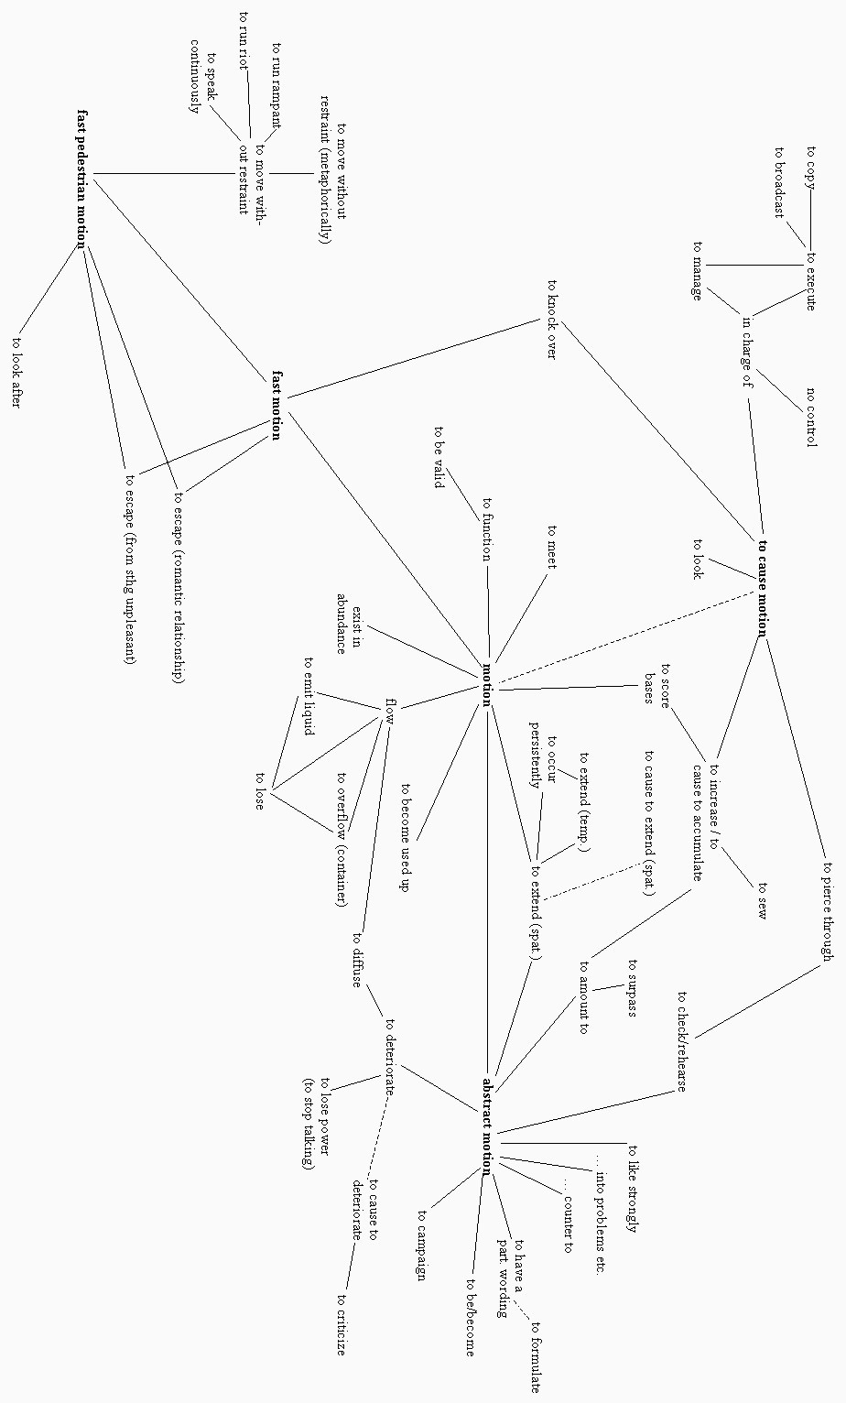

**Figure 2.3:** Semantic map of English *run* (Gries 2006: 74)

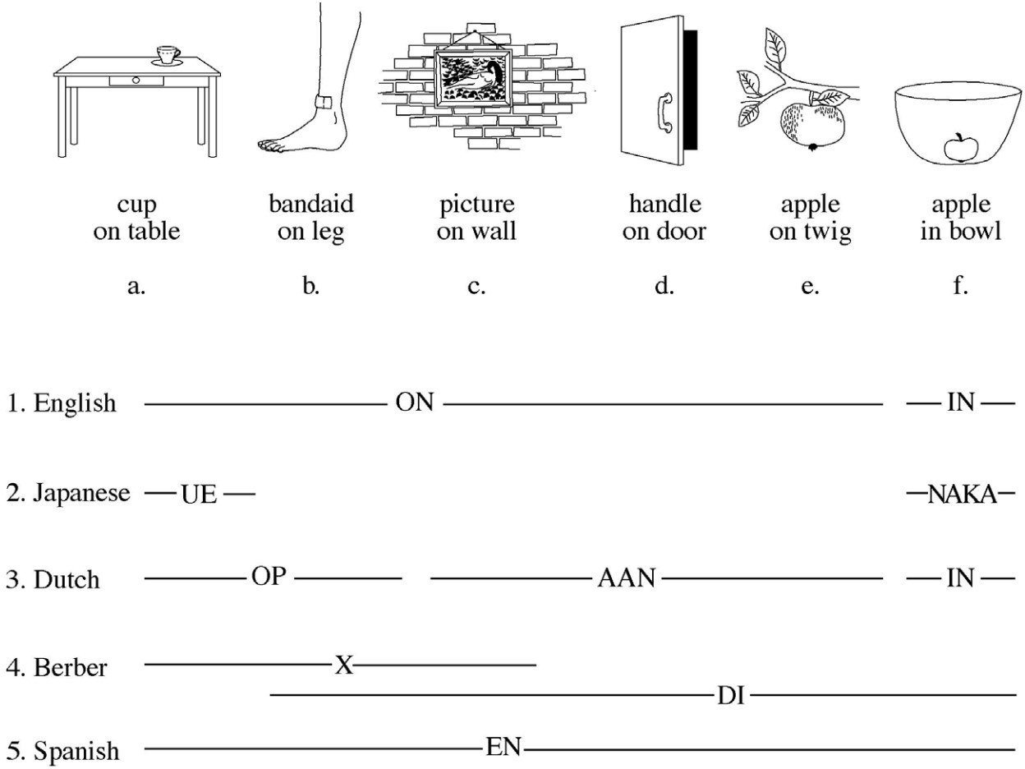

**Figure 2.4:** Crosslinguistic differences in the encoding of spatial relationships (Bowerman & Choi 2001: 485)

These examples illustrate that word meanings are polycentric and cover a range of possible uses, as mentioned in Section 2.3.1.4. Some of these uses may be more prototypical than others. The English expression *apple on a twig* is a slightly less prototypical use of *on* than *apple on a table*. The fact that lexical items cover a range of uses, and that some of these uses are more prototypical than others, is an important component of the typological markedness theory of lexical categories.

Even the formal categories that linguists use to describe linguistic structure tend to be prototypal (Taylor 2003: xii, 201). Taylor (2003: §11.1) argues that linguists’ conceptions of the formal labels *word*, *affix*, and *clitic* are prototypal in nature, with better and worse members of the category. Haspelmath (2005) likewise shows that simple structural definitions of these categories are inadequate and reframes the word–affix continuum in functional terms instead.

Much research in the Canonical Typology framework (Corbett 2005) also demonstrates the prototypal nature of linguists’ categories. Though Corbett is careful to distinguish between a *canon* and a *prototype* / *exemplar* (Corbett 2010: 142), his accumulated work nonetheless shows that linguists view phenomena in the world’s languages as better or worse instances of various descriptive categories.

What type of category are lexical categories then? Are word classes categories of human cognition, categories within particular languages, categories of languages generally, or analytic categories of linguists? Or some combination of these? Typological markedness theory posits that parts of speech like noun, verb, and adjective are not categories of particular languages. Languages have constructions, not parts of speech. Speakers, however, have *mental prototypes* of objects, actions, and properties. And although there is no *one* Noun construction in English that would correspond to the mental category of object, there are numerous constructions in English which have the function of indicating *reference to an object*, such as the Definite Article construction or the Transitive Subject construction. Likewise, there is no one construction—in English or any language—that can be definitively called the Verb construction or the Adjective construction, but there are plenty of constructions which have the function of predicating or attributing properties. Naturally, then, speakers are more likely to use referring constructions when talking about something which they mentally categorize as an object, predicating constructions when talking about something they conceive of as an action, and modifying constructions when talking about something they conceptualize as a property.

Speakers’ conceptualizations, however, are fluid. Speakers often conceptualize things in non-prototypical ways. They may construe events as bounded entities that they can refer to, or objects as properties with duration. As a result, speakers often use lexical items in constructions that do not align particularly well with the item’s meaning, such as the appearance of an action word like *sing* in a referring construction like the Gerund in the phrase *his singing was beautiful*. When speakers use words in this atypical manner, those uses are much

more likely to be marked in some way—whether morphologically, behaviorally, frequentially (Croft 1991: §2.2). Non-prototypical uses of words also show a semantic shift in the direction of the discourse function they are being used for. As a consequence, clear asymmetries emerge between the prototypical vs. non-prototypical uses of object words, action words, and property words. It is the unmarked use of these lexical items that most closely aligns with linguists’ traditional conceptions of noun, verb, and adjective. Parts of speech as traditionally conceived are nothing more than the emergent effects of our cognitive prototypes on language. They do not have any real status in grammar or individual grammars. This is the fundamental idea behind typological markedness theory. Section 2.4.2 lays out this theory in more detail.

A last clarifying point is in order. Recognizing the existence of prototype-based categories, many linguists have described parts of speech as prototypal. Dixon (2004: 1–2), for example, says that the word classes noun, verb, and adjective each have a “prototypical conceptual basis” and “prototypical grammatical functions”. Taylor (2003: 217) states, “A prototype view of noun entails that some nouns are better examples of the category, while others have a more marginal status.” But languages have constructions, not parts of speech, and individual constructions are not gradient (Croft 2007). What linguists are in fact observing when they say that parts of speech are prototypal is not gradation in *linguistic categories* like noun, verb, and adjective (since those are not categories of particular languages), but rather gradation in the *mental categories* of objects, actions, and properties, which do indeed exhibit prototype structures, and which therefore have emergent effects on the organization of constructions in languages.

### **Typological markedness theory**

I have already previewed various aspects of typological markedness theory at different points in this dissertation. In this section I present a concise overview of the specific claims made by this theory, and some of the evidence for those claims. The phrase *typological markedness*

or *typological markedness asymmetries* simply refers to an implicational universal regarding the behavior of basic versus non-basic members of a conceptual category. At its simplest, the theory posits that less basic or prototypical members of a category are marked in some way; basic or prototypical category members are unmarked by comparison (Greenberg 1966). This *cognitive* markedness is then realized *linguistically* in several ways. The marked member of a category may be literally marked with an affix or other overt morphological indicator, but this is just one of the ways an item can be a marked member of a category. The marked member of a category may also be less frequent, or have a smaller range of inflectional / distributional possibilities, or show a semantic shift in the direction of the word’s prototypical function. It is important to emphasize that typological markedness does not always entail formal markedness. Typological markedness is an implicational universal rather than an absolute universal. The more marked members of a category must be *at least as marked* as the unmarked member, but this does not preclude the possibility of all members being equally marked. Formal markedness is merely an emergent tendency of structures to reflect cognitive markedness.

As applied to word classes, typological markedness theory states that the most unmarked discourse functions for object, action, and property words are reference, predication, and modification, respectively. Therefore, when a lexical item is used for a function that does not align with its prototypical meaning, typological markedness theory predicts that it will be marked. Again, it must be emphasized that not every instance of a lexical item being used in a non-prototypical function will be marked in comparison to its prototypical function; but it will always be *at least as* marked. This theory of typological markedness for the major discourse functions is laid out in detail by Croft in various publications (Croft 1991; 2000; 2001b; Croft & van Lier 2012). It is also important to understand that typological markedness theory is not a theory of parts of speech in the sense of large partitionings of the lexicon into categories like noun, verb, and adjective. Instead, noun, verb, and adjective are epiphenomenal, crosslinguistic markedness patterns that arise from the interaction of semantic prototypes (object, action, property) and their use in different discourse functions (reference, predica-

tion, and modification). They are not categories of particular languages.

Throughout this dissertation, I have used the term *discourse function* to refer to the functions of reference, predication, or modification. These are what Croft (1991: 51) calls *pragmatic functions* or *propositional act functions* following the tradition of pragmatics and speech act theory in philosophy (Austin 1962; Searle 1969). These three functions are taken as fundamental to human communication, arising out of the communicative intent behind what speakers are attempting to *do* with language. This perspective was articulated early on by Sapir:

There must be something to talk about and something must be said about this subject of discourse once it is selected. This distinction is of such fundamental importance that the vast majority of languages have emphasized it by creating some sort of formal barrier between the two terms of the proposition. (Sapir 1921: 87)

A similar point is made by Croft while articulating his theory of typological markedness as applied to lexical categories: “[N]o matter how complex a given situation is in terms of the number of entities involved and the number and kinds of relations that hold between them, a human being attempting to describe it in natural language must split it into a series of reference-predication pairs[.]” (Croft 1991: 124)

Modification is generally seen as less central a function than reference and predication, as illustrated by its lack of mention in the quotes above. For example, Hengeveld (1992: 55) takes the reference-predication dichotomy to be fundamental, yielding the major categories of noun and verb, while the modification function then combines with these two functions to yield the major categories of adjective and adverb, respectively. The primacy of the reference-predication distinction also appears to be reflected structurally in the world’s languages, which do not always have dedicated morphological means for encoding modification but appear to always have morphological strategies dedicated to reference and predication.

Croft (1991: 123) defines the pragmatic functions in terms of their discourse functions, following work in the discourse-functional tradition (Chafe 1976; Hopper & Thompson 1984;

Chafe 1987; Du Bois 1987). Previous research defines *referents* as “discourse-manipulable participants” (Hopper & Thompson 1984: 711; Kibrik 2011), *predicates* as reported events (Hopper & Thompson 1984: 726), and *modifiers* as a mix of these two functions (Thompson 1989). Croft (1991: 123) synthesizes ideas from this body of research and offers the following revised definitions instead:

* the act of *reference* identifies a referent and establishes a cognitive file for that referent
* the act of *predication* ascribes something to a referent
* the act of *modification* enriches the cognitive image of the referent with an additional feature

The exact pragmatic function chosen for any given mention of a concept is then just a matter of how the speaker chooses to portray or construe that concept—whether as a referent, predicate, or modifier (Croft 1991: 100); as Croft & van Lier note, “apparent instances of ‘fuzziness’ are actually variable construals” (Croft & van Lier 2012: 63).

With this understanding of discourse functions in mind, we can restate the thesis of typological markedness theory as applied to lexical categories: Noun, verb, and adjective are epiphenomenal markedness patterns that arise from the use of different semantic prototypes (objects, actions, and properties) in different discourse functions (reference, predication, modification). Uses of these semantic classes in non-prototypical functions are typologically marked. As mentioned, there are three ways in which non-prototypical uses can be marked: structurally, behaviorally, and/or frequentially.

The first type of marking, *structural coding* or *formal marking*, refers to the fact that nonprototypical uses of lexical items are at least as formally marked as prototypical ones. Structural coding in this context refers specifically to “dedicated formal markers in a specific language that indicate a lexeme’s syntactic function” (Croft & van Lier 2012: 62). Figure 2.5 is a schematic representation of some of the formal realizations of these markedness patterns. It indicates the different morphosyntactic means that languages tend to develop for marking

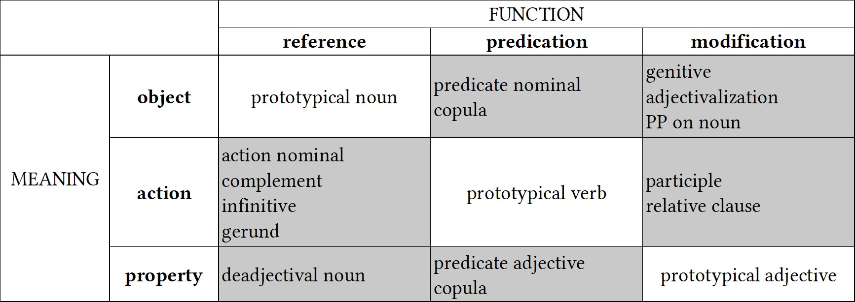each of the non-prototypical uses of lexical items. For instance, participle constructions are one way that languages have of indicating the non-prototypical case of an action word being used for modification.

**Figure 2.5:** Typological prototypes for noun, verb, and adjective (adapted from Croft (2000: 89) and van Lier (2012: 62))

The second way in which non-prototypical uses of lexical items can be marked is in terms of their *behavioral potential*, that is, the range of combinatorial possibilities for that lexical item. This is most clearly illustrated with an example from inflection: in many languages, property words used in predicate constructions are limited in their inflectional possibilities. In Munya, for example, property words functioning as predicates cannot inflect for person and number of the subject, and cannot take the imperfective marker, perfective marker, or direct evidential marker (Bai 2019: 96–97). The only grammatical markers allowed in property predication clauses are the stative aspect marker, a clause-final particle, and an egophoric marker. Hopper & Thompson’s (1984) study of the discourse functions of different parts of speech is largely a study of behavioral potential. They conclude that “the closer a form is to signaling this prime [prototypical] function, the more the language tends to recognize its function through morphemes typical of the category—e.g. deictic markers for [Nouns], tense markers for [Verbs].” (Hopper & Thompson 1984: 703, abstract). Croft advances a cognitive explanation for these behavioral markedness patterns:

In general, only the core members of the syntactic category will display the full gram-

matical behavior characteristic of their category because only they have all the semantic characteristics that the characteristic inflections tap into. This is to say that the inflectional categories of the major syntactic categories have been “tailored” to their semantically core members. This is an example of a processing constraint: languages inflect only for those properties that are of relevance to core members of the category; they do not inflect for properties of peripheral members of the category that are not of relevance to the core members of the category. (Croft 1991: 86)

Non-prototypical uses of lexical items also exhibit a *semantic shift* in their meaning towards the semantic class prototypically associated with the discourse function they are found in (Croft 2000: 96; 2001b: 73; Croft & van Lier 2012: 68). I have already discussed the semantic shifts that occur in functional expansion in some detail in Section 2.3.3.2. Croft (2001b: 73) makes the even stronger claim that non-prototypical uses of lexical items will *always* exhibit semantic shifts:

If there is a semantic shift in zero coding of an occurrence of a word (i.e. flexibility) in a part-of-speech construction, even if it is sporadic and irregular, it is always towards the semantic class prototypically associated with the propostional act function. (Croft 2001b: 73)

These semantic shifts are caused by a combination of conventionalization and *coercion*, wherein the meaning of the constructional context is imposed on the meaning of the lexical item (Pustejovsky 1991; Croft 1991: 69, 108; Panther & Thornburg 2007: 252; Audring & Booij 2016). For example, predicate nominals (where an object word is used in a predicate construction) involve coercion of lexical items from denoting objects to denoting classifying or equational relations (Croft 1991: 69). In Nuuchahnulth, for instance, nominal predicates are always semantically durative and interpreted as either existential, classifying, or identifying expressions (Nakayama 2001: 47).

The final way in which lexical items used in atypical functions may be marked is in terms of their frequency. Croft (1991: 59, 87) also refers to this as *textual markedness*. Frequential markedness predicts that lexical items are used more frequently in their prototypical functions than in non-prototypical ones. This means that object words should be most frequent in their

use in referring constructions, and that referring constructions should most frequently denote objects (Croft 1991: 87).

The field of linguistics has accumulated a good deal of empirical evidence in support of the typological markedness theory of lexical categories. Croft (1991) provides empirical evidence from 12 languages for each of these markedness patterns. Dixon (1977) also provides evidence of typological markedness patterns as they relate to property words, using a combination of structural and behavioral evidence. As mentioned, Hopper & Thompson’s (1984) study also provides empirical support from a variety of languages for markedness in terms of behavioral potential. Stassen (1997) is a massive study of intransitive predication in 410 languages, demonstrating the marked behavior of non-action words when used in predicate constructions.

Having explicated the basic tenets of typological markedness theory, I now turn to reframing the concept of lexical polyfunctionality in a way that utilizes this framework.

## **Lexical polyfunctionality: A functionalist definition**

In Section 2.5.1 I provide a functional definition of *lexical polyfunctionality* within the framework of typological markedness asymmetries. Lexical polyfunctionality is understood synchronically as the functional diversity of a lexical item. By contrast, *functional expansion* is the diachronic process whereby a lexical item expands into new discourse contexts and becomes polyfunctional. Section 2.5.2 lays out a theory of functional expansion based on *conventionalization*. It also discusses some of the known diachronic pathways by which lexical polyfunctionality arises.

### **Lexical polyfunctionality**

Within the framework of typological markedness asymmetries, we can provide a structural definition of lexical polyfunctionality as follows:

**lexical polyfunctionality** The use of a lexical item (root, stem, or inflected word) in more than one discourse function (reference, predication, or modification) with zero coding.

This definition qualifies as a valid *comparative concept* in the sense of Haspelmath (2010a) because it is couched in terms of universal *functions* rather than language-specific *structures* (Croft 2016). It also has the advantage of being intentionally equivocal with respect to the morphological level (root, stem, or inflected word) at which the polyfunctionality is realized, and with respect to the lexical and cognitive unity of the item. In some cases when a single lexical form appears in more than one discourse function, speakers may have a close cognitive association between the two uses, and so those uses are highly lexically unified. This is most likely the case for the predicative and referential uses of the word *run* in the phrases *I run every morning* and *I’m going for a run* respectively. In other cases, speakers may have little to no awareness of the diachronic connection between uses of a form. For example, the use of *run* in the sense of *to run a print job* is extremely distant from the prototypical “fast pedestrian motion” sense in the semantic network for that form (Gries 2006: 74; see also Figure 2.3). It is unlikely that these two senses are closely cognitively connected by most speakers, even though they both share a predicating function.

This definition is also neutral with respect to the degree of semantic shift that occurs between polyfunctional uses of a lexical item. The definition of polyfunctionality simply delimits those cases where a language does not provide formal indicators of discourse function, specifically the constructions that use a zero coding strategy (no derivational affixes, no copulas, no overtly marked forms like gerunds, participles, infinitives, etc.). It is largely a structural definition. Once such cases are delimited structurally, it becomes possible to examine the semantic relationships involved within them. Indeed, describing the semantic shifts involved in polyfunctional cases is an important descriptive *desideratum*.

Moreover, by focusing on just those cases where use across multiple discourse functions is zero-coded, we are then in a position to make explicit comparisons between cases of polyfunctionality and cases of overt derivation. For example, an intriguing question is whether

the semantic shifts that occur in polyfunctional cases differ in principled ways from those of overt derivation. This dissertation does not explore that question, but Mithun (2017: 165) shows that for Central Alaskan Yup’ik the types of semantic relationships between polyfunctional uses of words mirror those between basic and derived words. This would suggest that functional expansion follows the same principles as overt derivation, but much more research is needed in this area.

A frequent question that arises in discussions of lexical polyfunctionality is whether any two given uses of a form constitute part of the same lexeme or distinct lexemes—in essence, whether those uses constitute heterosemy or polysemy. I call this the *problem of lexical unity*. Here, I would like to propose that the question of lexical unity is an unproductive one that dichotomizes a gradient phenomenon. Moreover, making a determination of the lexical unity of a given bundle of uses of a form is not necessary to an understanding of lexical polyfunctionality and the diachronic process by which it emerges.

Let us consider the common arguments for analyzing polyfunctionality as conversion / heterosemy. Pointing out that functional expansion involves both semantic shifts and functional gaps is generally intended to show that lexemes cannot be truly flexible in the sense of being multifunctional (§2.3.1.3) or precategorial (§2.3.1.4), and/or that uses of the same lexical item for different discourse functions should therefore be considered cases of conversion— that is, homonymy or heterosemy. As an argument against flexibility, this criticism is a sound one. As justification for a categorical distinction between heterosemy and polysemy, however, there are two important issues with this argument.

The first and most important point is that it creates a false dichotomy between homonymy and polysemy, when in fact the two phenomena are opposite endpoints on a continuum. Debates over the lexical unity of an item arise from an Aristotelian desire to neatly sort those uses into distinct lexemes, when in fact reality is much more complex. If this problem sounds familiar, that is because it is the same methodological problem that arises when trying to exclusively categorize lexical items into different classes that was discussed in Section 2.2.1.

The complex adaptive nature of language makes categorical classification at either level impossible.

As discussed in Section 2.3.1.4, we know from cognitive research that mental categories are prototypal, and that the meanings of words display a polycentric, family resemblance structure. Two senses of a lexical item are often related only tenuously through a network of intervening semantic connections or meaning chains. Langacker (1988) calls this the *network model* of category structure. Taylor points out that “[o]ne consequence of adopting the network model is that the question of whether a lexical item is polysemous turns out to be incapable of receiving a definite answer.” (Taylor 2003: 167)

Over time, as this lexical network expands, the meanings of a lexical item can diverge so drastically that speakers no longer have a direct cognitive association between them. Mithun exemplifies this nicely for both Cayuga and English. Discussing morphological Verbs used as referents in Cayuga, she notes the following:

If asked the meaning of *kaǫtanéhkwih* [lit. ‘it hauls logs’], Cayuga speakers normally respond ‘horse’. Though it has the morphological structure of a verb, it has been lexicalized as a nominal. The literal meanings of many verbal nominals are still accessible to speakers, but the origins of others have faded, and speakers express surprise at discovering them. Similarly, when asked “What would you like for breakfast?”, most English speakers do not think about breaking their night-time fast, though they can usually be made aware of the literal meaning of *breakfast*. (Mithun 2000: 413)

Lexicalization is a process and a continuum. Words can be lexicalized in new discourse functions to varying degrees. The first use of a lexical item in a new discourse function is innovative; each subsequent use then contributes further to its conventionalization in that function (Mithun 2017: 166). This point is discussed further in Section 2.5.2 below.

Pointing out that functional expansion often creates idiosyncratic and unpredictable meanings essentially amounts to saying that senses of lexical items can be highly divergent. This point is not in itself an argument for or against lexical unity. polyfunctional items may sit anywhere on the continuum from having closely connected, productive and predictable meanings, to having extremely divergent, idiosyncratic, and unpredictable meanings. Importantly,

this is not a special fact about polyfunctional items—it is simply true of words generally.

The second significant problem with using semantic shift as a diagnostic for heterosemy is that it proves too much. If semantic shift is taken as evidence against the lexical unity of polyfunctional items, then it must also be taken as evidence against the lexical unity of nonpolyfunctional items. Put simply, semantic shift is an analytical problem for all words, not just polyfunctional ones.

This fact becomes clear when we ask, “What counts as a semantic shift? Just how ‘large’ of a change in meaning (if it were even possible to quantify such a thing) does a semantic shift require?” To illustrate this problem, consider the semantic contribution of plural marking crosslinguistically. In the canonical case, plural marking is considered inflectional rather than derivational (Corbett 2000: 2), meaning that it does not create a new lexeme. Instead, it modifies the meaning of the existing lexeme slightly, in line with the classic distinction between inflection vs. derivation. However, there are numerous cases of lexical items in English with more or less drastic differences in meaning between the singular and plural, and/or senses that are only available in one of the two numbers. Consider the examples in (29).

1. English (Indo-European > Germanic)
2. *air* ‘atmosphere’

*airs* ‘affected manners’

1. *arm* ‘upper limb; anything resembling a limb’

*arms* ‘weapons, firearms’

1. *blind* ‘unable to see’

*blinds* ‘screen for a window’

1. *custom* ‘tradition; socially accepted behavior’

*customs* ‘department which levies duties on imports’

1. *force* ‘strength, energy’

*forces* ‘collection of military units’

1. *good* ‘excellent, high quality’

*goods* ‘merchandise or possessions’

1. *manner* ‘way of doing something’

*manners* ‘social conduct; socially acceptable conduct’

1. *spectacle* ‘visually striking performance or display’

*spectacles* ‘pair of glasses’

1. *wood* ‘fibrous material in the trunk of trees or shrubs’

*woods* ‘area of land covered with trees’2

Semantic shifts for plural marking in English are not limited to just a handful of specific lexical items. Generic uses of the plural as in the expression *foxes are cunning* create a semantic shift away from a concrete entity (*a/the fox*) to a generic, unperceivable one—a use which strays from the prototypical function of nouns as concrete perceptible entities (Hopper & Thompson 1984: 708).

As with polyfunctional items, the semantic shifts that occur with plural marking can become so substantial that speakers no longer cognize the morphological singular and plural as members of the same lexeme. Such is the case in the historical development of *brother* vs. *brethren* in English. The word *brethren* became so strongly conventionalized with its religious meaning in the plural that it was independently lexicalized as a plural-only (*plurale tantum*) noun, and the original plural underwent renewal with the emergence of the form *brothers*. This is exactly the kind of lexicalization process that occurred for many morphological verbs reanalyzed as nouns in Cayuga and many other North American languages.

A similar example comes from Chitimacha, which has a pluractional marker *‑ma* indicating verbal number (plural agents, plural patients, or repeated action). In some cases the use of *‑ma* is purely compositional, so that it can be considered merely an inflectional marker of verbal number. In other cases *‑ma* so significantly alters the meaning of the word that it must be considered derivational. Compare the uses of *‑ma* in each of the pairs of verbs in (30) (note that (30b) and (30c) are phrasal verbs with a preverbal particle).

1. Chitimacha (isolate)
2. *kow‑* ‘call’

*kooma‑* ‘call multiple people’

1. *qapx cuw‑* ‘come back; go about’

*qapx cuuma‑* ‘travel; wander’

1. *qapx qiy‑* ‘turn together; mix, join’

*qapx qiima‑* ‘give a prayer, benediction; perform magic’

(Swadesh 1939a)

In (30a), the use of *‑ma* is entirely compositional. The presence of *‑ma* indicates that the verb has a plural patient argument. In (30b), the use of *‑ma* is still arguably compositional, though perhaps somewhat lexicalized given the high frequency with which the stem appears in the texts. ‘travel, wander’ could reasonably be interpreted as a continued repetition of ‘go about’. In (30c), however, *qapx qiima‑* has become lexicalized with a new meaning not directly related to that of *qapx qiy‑*. The diachronic connection between the two meanings is that prayers and magical incantations were traditionally accompanied by circling gestures with the arms. *qapx qiima‑* originally meant ‘turn/circle around repeatedly’, but over time lexicalized with its new religious meaning in the pluractional, ‘give a prayer, benediction’. This lexicalization process parallels that of *brethren* in English. Such a range of inflectional vs. derivational uses of pluractionals is quite common crosslinguistically (Mithun 1988; Mattiola 2020).

Finally, there are many languages which do not typically mark plurality on nouns (Dryer 2013), and yet have senses available in semantically plural contexts but not singular ones (where the semantic number can be understood from the clausal context, usually through verbal number marking). For example, the word *soq* in Chitimacha may mean ‘foot’ or ‘paw’ in a singular context and ‘feet’ or ‘paws’ in a plural context, but may also mean ‘tracks’ (e.g. animal tracks) in a plural context—a significant and idiosyncratic shift in meaning, and one that is both language-specific and item-specific and thus conventional. This use constitutes a *morphologically unmarked semantic shift* in the meaning of the word, just as idiosyncratic meanings of words in cases of functional expansion also constitute morphologically unmarked semantic shifts. If we take such unmarked semantic shifts as evidence against lexical unity in the cases of polyfunctional items, then we must also say that the ‘foot’ and ‘tracks’ meanings of *soq* constitute two distinct lexemes as well.

What then are we to make of the often extremely divergent meanings that occur within polyfunctional items? We should first loosen the requirement that the meaning of a lexical item be unitary. Word meanings are *polycentric*, where different senses of an item are related through *meaning chains* rather than all through a single, central member (Taylor 2003: 110). This is often referred to as a *family resemblance* structure for categories. The difference between monocentric and polycentric categories is illustrated schematically in Figure 2.6. In both diagrams, each letter A–E represents a sense of a lexical item. In the monocentric case, all the senses of the lexical item are related through its core sense A. In the polycentric case, senses A and E are related only through their intervening connections.3

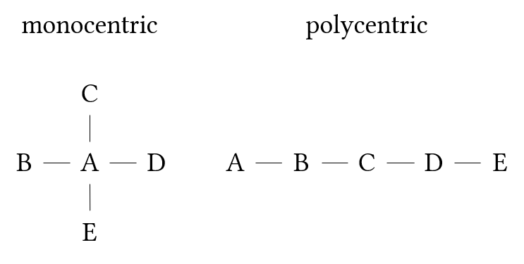

**Figure 2.6:** Monocentric vs. polycentric categories

Recognizing that word meanings are polycentric addresses the problem of lexical unity because it shows that the disparate senses of a lexical item can be related without having to share any core component of their meanings. The use of a lexical item in a certain context then profiles one of these senses over others.

The issue of lexical unity is exactly analogous to the problem of lumping vs. splitting in the context of lexical categories. The Radical Construction Grammar solution to this problem is to abandon the commitment to larger groupings of items (the major lexical categories) and acknowledge that languages consist of an interconnected network of smaller items (constructions) instead (Croft 2001b). This approach has the major advantage of sidestepping unproductive debates about the existence or unity of lexical categories in particular languages,

3The terms *monothetic* and *polythetic* are sometimes used for this distinction instead (Lewandowska-

Tomaszczyk 2007: 146).

and shifts the focus instead to understanding the relationships and patterns among individual constructions. This is precisely what I propose to do for lexemes as well. If we abandon the idea that all the meanings associated with a form must be in some way grouped into lexemes based on their morphosyntactic contexts of occurrence, and instead see meaning as a network of more-or-less-distantly related senses, we sidestep unproductive debates regarding homonymy vs. polysemy, and can instead focus on the relationships and patterns among the various senses associated with that form.

In sum, the existence of idiosyncratic semantic shifts does not invalidate the concept of polyfunctionality, even though it does provide evidence against flexible analyses of polyfunctionality.

### **Functional expansion**

This section addresses the question of how lexical polyfunctionality arises in language. I begin by defining the diachronic process which gives rise to lexical polyfunctionality as *functional expansion*, and then describe how lexical flexibility and conventionalization interact to create polyfunctional lexical items over time. I conclude by examining a few specific diachronic pathways by which a language can either increase or decrease its overall degree of lexical polyfunctionality.

As we have seen, a great abundance of evidence shows that the meaning of any given combination of form and discourse function is a matter of convention, and often highly idiosyncratic (§2.3.2.4; §2.3.3.2). This suggests that polyfunctional items are not in fact flexible in the sense that speakers can use any lexical item for any discourse function and expect hearers to be able to infer their meaning from context. We know that item-specific gaps in usage exist.

Yet we know that speakers *do* in fact use words flexibly, or else it would not be possible for functional shift to happen in the first place. A word like *friend* cannot have gotten its predicative use meaning ‘add someone as a contact on social media’ unless at some point one

or more speakers began creatively used the word *friend* as a predicate rather than a referent. Because this early innovation would have preceded the point at which its use had become widely adopted in the broader English-speaking community, those early speakers had to have relied on the ability of their interlocutors to infer their intended meaning from context. In other words, they used the word *friend* flexibly. Flexible uses of words occur because of speakers’ need to construe concepts in different ways—as objects, actions, or properties. The semantic shifts that occur during functional expansion are the result of coercion by the new constructional context. If there is sufficient uptake of this novel use by other members of the community, that resultant meaning then becomes the conventionalized meaning for that particular form in that particular discourse function (Croft 1991: 108).

These innovative or flexible uses are restrained by existing linguistic conventions (Croft 2000: Ch. 4)[102]CroftCruse2004. For example, the presence of an existing, synonymous form in a language will *pre-empt* or *block* certain flexible uses of a lexical item (Clark & Clark 1979). The reason that English speakers do not use *hospital* as a predicate meaning ‘to place in a hospital for medical care’ is because there is already the synonymous form *hospitalize*. However, in cases where the preexisting form is *not* synonymous with the intended novel meaning of a form, that novel use is generally acceptable. Consider again the word *friend*: prior to the rise of social networking platforms the use of *friend* as a predicate was preempted by the existence of the word *befriend*. This is because the only obvious contextual interpretation of *friend* as a predicate at the time was ‘to make friends with’, and this meaning is synonymous with that of *befriend*. The predicative use of *friend* was therefore blocked. After the advent of social networking sites, however, a new social context appeared in which another obvious contextual interpretation of *friend* as a predicate became possible—‘to add someone as a contact on social media’. Since this meaning was no longer synonymous with the existing form *befriend*, its use was no longer pre-empted.

Flexible uses of lexical items are also restrained by the cognitive limits on our ability to deal with ambiguity. If it were truly the case that any lexical item could be used in any

discourse function at any time, it would scarcely be possible for hearers to interpret the intended pragmatic effects of each word. In order to stick around after those first innovative uses, polyfunctionality requires a degree of conventionalization. Innovative uses of words in new discourse functions are by no means guaranteed uptake in the community. Polyfunctional lexical items only arise when a new combination of form and discourse function is conventionalized in a community of speakers. Conventionalization in turn implies *time*—it is a diachronic process. Thus lexical polyfunctionality can be understood as a *synchronic* pattern resulting from the *diachronic* process of functional expansion, where *functional expansion* is defined as follows:

**functional expansion** A diachronic expansion in the range of uses of a lexical item (root, stem, or inflected word) into a new discourse function (reference, predication, or modification) with zero coding for that new function.

Functional expansion is a multi-stage process in which an initial, innovative use of a lexical item for a new discourse function gradually becomes conventionalized as an accepted semantic meaning for that form. Each additional usage of the novel form-meaning combination gradually adds to its conventionalization; or, to use an apt metaphor: “Conventionalizations are sedimentations of innovation events over the history of the speech community[.]” (Croft, p.c.). A novel usage gradually spreads along the continuum from the pragmatics of the immediate discourse context to the conventions of the speech community as a whole (Clark & Clark 1979; Croft 2000: 100). This gradual change is sometimes even rapid, as in cases where technological innovations foster frequent use of new form-meaning combinations, such as the words *friend* and *text* used as predicates.

The first stage of the process of functional expansion is, as stated above, the initial innovative use of a lexical item in a new discourse function. This phenomenon is not rare or exceptional by any means. Each time a hearer encounters a novel use of a lexical item for the first time, they must accomplish the difficult task of discerning its meaning. This is no less true for flexible uses as it is for non-flexible uses. *Every* use of a word is an instance of

functional expansion because every use of a word is always in a slightly different discourse and social context than the one before. As Croft notes, “The chief reason why even conventional language use is innovative is that there cannot be a word or phrase to describe every experience that people wish to communicate.” (Croft 2000: 104). Moreover, the meaning of a word in a given context is highly socially and situationally dependent, and that context can change completely from one utterance to the next. Croft makes this point well:

The degree to which ordinary language use, apparently conforming to linguistic convention, requires nonconventional coordination devices makes it clear that virtually all language use involves nonconventional coordination. […] In other words, virtually every noun, verb and adjective in virtually every sentence requires nonconventional coordination in order to establish reference to the specific object, property and event being talked about. (Croft 2000: 104)

Every token of a word thus necessarily appears in a new pragmatic context, and that pragmatic context slightly shapes its meaning (Croft 2010: 99–105). Language use *is* language change.

After this initial stage of innovation, the novel meaning gradually conventionalizes first as part of the pragmatic meaning of the form, and then finally part of the semantic meaning of the form. Of course, the spread of any given innovation might cease at any one of these stages. While functional innovation in everyday speech is ubiquitous, only a small fraction of these innovative uses ever become fully conventionalized as part of the semantic meaning of a word, creating polyfunctional items.

To summarize, polyfunctionality arises because speakers must use the limited linguistic resources at their disposal to convey an infinitude of experiences, and are thus constantly innovating in everyday language use. Most of these innovations never spread beyond the local discourse context in which they were first used, but occasionally a novel use is adopted by other speakers, and over time this usage may become conventionalized as part of the pragmatic and later the semantic meaning of the word.

With these understandings of lexical polyfunctionality and functional expansion in place, we are now in a position to reframe the major research question of this dissertation: How

often, diachronically, have words in English and Nuuchahnulth become conventionalized in new discourse functions with zero coding? Answering this question generates new research questions in turn, just a few of which are mentioned below.

* Why do some languages have so many more words that underwent functional expansion than other languages? What diachronic processes give rise to rampant lexical polyfunctionality?
* Are there semantic commonalities to the lexical items which frequently undergo functional expansion across languages?
* Are the semantic shifts in cases of functional expansion more productive or predictable for certain semantic classes of words than others?

This understanding of lexical polyfunctionality also makes a prediction regarding the interaction of polyfunctionality and frequency. Though I know of no studies on the matter, it seems empirically true that functional *expansion* is drastically more common than functional *shift*. That is, it is relatively common for a lexical item to expand from one disourse function into another, but it is rare for a lexical item to undergo a wholesale shift from one function to another. Functional expansion therefore increases the number of contexts that a lexical item appears in. It is thus a reasonable hypothesis that the overall frequency of the lexical item will increase as well, being the sum of the individual senses across different discourse functions. More functionally diverse items may have a higher overall frequency than less functionally diverse items. Of course, this is merely a hypothesis. It may be that functional expansion into new contexts is offset by a concommitant decrease in frequency for the original function, or that this varies depending on the lexical item. These questions are explored quantitatively in Section 4.5.

Returning to the first question above: If lexical polyfunctionality is the result of a diachronic process, it should be possible to enumerate some of the specific pathways which give rise to it. Here I will mention just a few. One pathway is insubordination, whereby

subordinate clauses in a language are reanalyzed as main clauses (Evans 2007; Mithun 2008; Evans & Watanabe 2016) (see also Section 2.3.2.2). Insubordination frequently results in formal similarities between noun phrases and verb phrases, and this formal ambiguity can abet the functional expansion of lexical items from referential to predicative uses and vice versa.

A second pathway to lexical polyfunctionality is relexicalization (or more precisely, reconventionalization). This is the process that occurred in the case of morphological verbs being reanalyzed as nouns in many North American languages (see §2.3.2.3) and certain English plurals like *brethren* or *arms*. In these cases, the conventionalized meaning associated with the form changed (e.g. from Cayuga ‘it hauls logs’ to ‘horse’), and that meaning is reflected by its use in the new discourse context.

A third pathway is topicalization, exemplified in the Wakashan family. Jacobsen (1979: 122, 142) observes the formal similarity between the Definite Article and the Third Person Singular Indicative markers in Wakashan languages, and argues for a diachronic connection between the two. It is likely that cleft constructions such as ‘it was the dog that ran’ became so common that speakers started to reanalyze the topicalized cleft as a definite noun phrase, ‘the dog’, thereby creating a formal similarity between referring expressions and predicating expressions.

Each of these pathways results in the functional expansion of lexical items into new discourse contexts with no new overt structural coding. Of course, functional expansion can also occur without any other accompanying grammatical changes. This happens in any instance where speakers simply use stems in new discourse functions. Lexical polyfunctionality is the natural and expected result of the fact that non-prototypical uses of lexical items are *not* always structurally marked—as allowed for by the fact that typological markedness is implicational and not absolute—even if they are marked in other ways. The use of additional structural coding in cases of functional expansion is not obligatory, but merely a statistical tendency. Lexical polyfunctionality occupies the theoretical space where structural coding asymmetries fail to apply.

When viewed in this light, *lexical polyfunctionality is not so much a problem as it is a design feature of language*. The presence of lexical polyfunctionality should be *expected* in every language, not treated as exotic. The cognitive-typological approach outlined in this chapter inverts the lexical polyfunctionality question: the interesting question is not why some languages fail to make distinctions in parts of speech (thereby framing lexical polyfunctionality as a *deficit* in a way similar to how colonial researchers framed non-Indo-European languages as deficient in their parts of speech), but rather why languages develop specialized constructions for different discourse functions in the first place (see Gil [2012] for an attempt to answer this question for predication). Lexical polyfunctionality exists in any area of the grammar where specialized discourse-function–indicating morphology has yet to develop, or where such distinctions have been leveled as a result of diachronic changes. Lexical polyfunctionality should therefore be considered the default state of affairs for language. Gil (2005; 2006) has in fact argued, partially on the basis of data from highly polyfunctional languages, that early human language must have been *isolating-monocategorial-associational* before the development of dedicated function-indicating morphology.

The idea that the “natural state” of language is monocategorial or acategorial would seem to conflict with the point made above that lexical polyfunctionality can result from diachronic processes, but the two positions are not mutually exclusive. Languages develop strategies for indicating different discourse functions, but languages are also subject to counteracting pressures. This is a classic case of competing motivations: on the one hand, the frequency with which speakers need to perform the discourse functions of reference, predication, and modification all but ensures the development of strategies dedicated to indicating those functions; on the other hand, speakers need to construe states of affairs in various ways—as objects, actions, or properties—creating pressures which have the potential to level or cut across those formally marked distinctions. Reconventionalization and the reanalysis of cleft constructions could both be viewed as diachronic processes motivated by this latter pressure.

In sum, lexical polyfunctionality is a natural result of the cognitive and diachronic forces

at work in language. Defining lexical polyfunctionality in terms of typological markedness (or more accurately, the lack of formal marking for otherwise marked uses) provides a crosslinguistically applicable definition of the phenomenon which avoids methodological opportunism while still recognizing that lexical polyfunctionality requires some degree of semantic shift and conventionalization. This cognitive-typological definition of lexical polyfunctionality is a key theoretical contribution of this dissertation. With this definition in place, the remainder of this dissertation turns to exploring the prevalence of lexical polyfunctionality in English and Nuuchahnulth.

# **Chapter 3**

**Data & Methods**

This chapter describes the data used for this study and how those data were analyzed. It covers the languages chosen, the corpora used, and how samples from each corpus were created and annotated (Section 3.2). I describe the methods used to annotate the data, and the factors that influenced annotation decisions (Section 3.3). I also discuss the specific statistical measures used in this study in Section 3.4. Section 3.4.1 introduces a metric for quantifying the functional diversity of individual lexical items in a corpus. This quantitative formulation of lexical polyfunctionality is a key methodological contribution of this dissertation. Section 3.4.2 explains how I examine the relationship between lexical polyfunctionality and corpus size by studying the cumulative diversity rating for each stem as the size of each corpus grows. Finally, Section 3.4.3 presents and motivates a measure of corpus dispersion (Deviation of Proportions, or *DP* ) that is used partly in place of, and partly as a complement to, raw token frequencies.

## **Introduction**

The process of collecting, annotating, and analyzing the data for this study adheres to several self-imposed principles. First and foremost, the data in this study consist of naturalistic discourse data rather than elicited data. This principle has two motivations: First, as discussed in

Section 1.2, few studies examine token frequencies of lexical items used for different discourse functions, and those that do only report aggregated results. Most extant research consists of lexicon-based counts. This study therefore explores a previously unexamined aspect of lexical polyfunctionality. Second, corpus-based methods study real-world instances of language in use, rather than made-up examples or examples produced by introspection, which are subject to various cognitive and social biases (P. Baker 2018: 168). Corpus data are also more likely to reveal prototype effects through statistical tendencies. For this study, I rely on specialized corpora of spoken narratives and conversational texts only. This ensures greater comparability between the corpora used in this study and other documentary corpora that these methods may be applied to in the future, since most documentary corpora likewise consist of spoken narratives and conversations.

The second self-imposed requirement for this study is adherence to the [Austin principles](https://site.uit.no/linguisticsdatacitation/) [of data citation in linguistics](https://site.uit.no/linguisticsdatacitation/) (Berez-Kroeker et al. 2018). In particular, the source for each data point discussed in this dissertation is uniquely identified with its location in the corpus, and the data used in this study are made freely available on GitHub at [https://github.com/](https://github.com/dwhieb/dissertation) [dwhieb/dissertation](https://github.com/dwhieb/dissertation). All of the data and my annotations on that data may be viewed there.

Finally, as a matter of scientific accountability, this study is designed to be replicable using the same or other datasets. All of the technical details regarding how to acquire the data, annotate it, and run statistical analyses for those data are documented in the GitHub repository for this project, which may be viewed at <https://github.com/dwhieb/dissertation>. The remainder of this chapter details the methods used to answer each of the major research questions presented in Chapter 1. The core empirical question addressed by this study is R1: “How polyfunctional or *functionally diverse* are lexical items in English and Nuuchahnulth?” The other research questions build on this one. To answer this core question, I count the frequency with which stems are used for each of the three functions of reference, predication, and modification in corpora for each language. Section 3.2 describes the corpora used,

where to acquire the data, and how lexical items in the corpora were selected for annotation. Section 3.3 describes the details of this annotation procedure. Finally, Section 3.4 explains the specific statistical measures used in this study. Section 3.4.1 describes how to use the annotated data to calculate a measure of functional diversity for each of the lexical items in the sample. This procedure for quantifying lexical polyfunctionality based on corpus data is the primary methodological contribution of this dissertation. Section 3.4.3 then discusses some shortcomings in the use of token frequencies, and presents a measure of corpus dispersion (Deviation of Proportions, or *DP* ) as an alternative.

## **Data**

In Section 1.3, I discussed the motivations for using English and Nuuchahnulth as the languages of focus in this study. Both languages have featured prominently in the literature on lexical polyfunctionality. Some researchers have called these languages “flexible”, while others have claimed that they are rigid. For English, I opted to use the [Open American Na-](http://www.anc.org/) [tional Corpus](http://www.anc.org/) (OANC), a 15-million-token open access corpus of American English (Ide & Suderman 2005). I restricted my analysis to just the spoken portion of the corpus, comprising approximately 3.2 million tokens, so that the data would be comparable to the spoken corpus of Nuuchahnulth and other documentary corpora. The spoken portion of the corpus itself consists of two distinct subcorpora—the [Charlotte Narrative & Conversation Collection](https://newsouthvoices.uncc.edu/) (the “Charlotte corpus”) and the [Switchboard Corpus](https://catalog.ldc.upenn.edu/LDC97S62). The Open American National Corpus can be obtained for free at <http://www.anc.org/>.

The data for Nuuchahnulth come from a documentary corpus compiled by Toshihide Nakayama and published in Little (2003) and Louie (2003). The corpus consists of 24 texts by two speakers (Caroline Little and George Louie), containing 2,081 utterances and 8,366 tokens. The texts are personal narratives, traditional stories, and procedural texts. I manually retyped the corpus in [scription](https://scription.digitallinguistics.io/) format (Hieber 2021a), which is a simple way of formatting

interlinear texts so as to make them computationally parsable. I then converted the corpus to the Data Format for Digital Linguistics (DaFoDiL) (Hieber 2021b), which is a way of representing interlinearized data in JSON, allowing programmers to easily and programmatically work with linguistic data. The resulting corpus is available in both formats on GitHub at <https://github.com/dwhieb/Nuuchahnulth>.

The sheer size of the Open American National Corpus—even when considering just the smaller, spoken portion of 3.2 million tokens—made it practically impossible to tag every token in the corpus for its discourse function for the time being. At the opposite end of the spectrum, the Nuuchahnulth corpus is small enough (*∼*8,300 tokens) that it was possible to tag every single lexical token in the corpus. Given this size disparity, it was important to sample lexical items from each corpus in such a way as to make them reasonably comparable. I did this by extracting two kinds of samples from each corpus: 1) a 100-item sample of lexemes randomly selected from different frequency bins, and 2) a small corpus sample (*<*10,000 tokens) for which all lexical items in the sample were annotated.

To create the 100-item samples, I first *lemmatized* each corpus. For every lexical token in the corpus, I programmatically determined the lemma associated with that particular wordform. For example, the English wordforms *knows* and *knew* are associated with the lemma *know*. For English, lemmatization was accomplished with the [Natural Language](http://www.nltk.org/) [Toolkit](http://www.nltk.org/) for Python (Bird, Klein & Loper 2009), using the Wordnet lemmatizer. The OANC includes Penn tags for parts of speech, so I was able to use those part-of-speech tags with Wordnet’s lemmatize() method to improve lemmatization. For Nuuchahnulth, lemmatization simply involved programmatically stripping away the inflectional morphology from each token, leaving just the stem. For example, the token in (31) is lemmatized as an instance of the stem *ʔam‑umɬ‑* ‘first‑be.born’. Since the entire Nuuchahnulth corpus is interlinearized with glosses and stored in DLx JSON format (Hieber 2021b), this was accomplished with a simple Node (JavaScript) script.

1. Nuuchahnulth (Wakashan > Southern Wakashan)

ʔaamumɬʔaƛquu ʔam‑umɬ‑ʼaƛ‑quː first‑be.born‑fin‑cond when.first.born

‘when [a baby] was born’ (Little 2003: Afterbirth 1)

It is important to mention that annotating the Nuuchahnulth corpus for discourse function would not have been practical without the detailed descriptive work of Toshihide Nakayama. The creation of text collections is often underappreciated as a worthwhile academic endeavor, but this process requires a high level of analytical skill and theory creation / testing. Moreover, this is the only way we gain new corpora of naturalistic discourse for minority languages. The empirical and theoretical findings of this project would not have been possible without this important work.

After lemmatizing each corpus, I calculated the raw frequencies for each lexeme. I then grouped lexemes into 100 bins based on their frequencies, and randomly selected one lexeme from each bin. This produced a sample of lexemes from a range of different frequencies. The frequencies of lexemes in the English sample, for instance, ranged from 44,687 for the word *know* to 53 for the word *central*. Lexemes with a frequency *<*4 were excluded, because the lexical polyfunctionality measure described in Section 3.4.1 requires a minimum token frequency of 4 in order to return a statistically significant value.

Various other types of words were excluded from this process as well:

* words written using numeric characters (e.g. *12%* or *117* )
* obvious cases of code-switching or code-mixing (e.g. *union mančiʔaƛ* ‘became a union man’)
* transcategorial words (those with both lexical and grammatical uses) (e.g. *be*, *do*)
* discourse markers (e.g. *uh*, *well*)

Some types of items that were *not* excluded are compounds written as a single word (e.g. *guidepost*) and proper names (e.g. *San Francisco*), although neither of these wound up in the final list.

The output of this selection process was a list of 100 lexical items in each language to be examined for lexical polyfunctionality. The list of 100 lexical items for each corpus is given in Appendix A, along with statistics about their frequencies, corpus dispersions, and functional diversity. I then created a list of every instance of these 100 lexical items in each corpus. For English, this resulted in a list of 382,512 tokens to be annotated. For Nuuchahnulth, there were just 1,632 tokens to annotate. I annotated each one of these approximately four hundred thousand tokens for discourse function by hand. This procedure is described in the following section.

Having created the 100-item samples, I next created a small corpus sample (*<*10,000 to-

kens) for each language. The smaller size of these samples allowed me to annotate every single lexical item in the sample for its discourse function. The Nuuchahnulth sample simply consists of the entirety of the corpus (8,300 tokens), while the English sample consists of the first four texts in the corpus, totaling *∼*9,700 tokens. These two subcorpora are both available in the GitHub repository for this study at <https://github.com/dwhieb/dissertation>.

With the two samples prepared, I next turned to the process of annotating each lexical item in the sample for its discourse function. This annotation procedure is described in the following section.

## **Methods**

Within each of the samples, not every token was annotated for its discourse function. This section discusses the various reasons why tokens might be excluded from the analysis (§3.3.1), and how the discourse function of each token was determined, first for English (§3.3.2) and then Nuuchahnulth (§3.3.3).

### **Inclusion / exclusion criteria**

There were several factors which determined whether a lexical token was included in this study. First, I only annotated lexical uses of words. Grammatical/functional words and discourse markers were ignored. Among lexical words, adverbial uses were also excluded. Ignoring adverbial uses of words sometimes results in lexical items with a very high overall corpus frequency, but very low occurrences of use for reference, predication, or modification. For example, the English word *never* has a high overall frequency (3,024 tokens), but has exactly 1 modifying use (*that’s a* ***never*** *touch*). The rest of its uses are adverbial. Proper names *were* included, a decision which turned out to be fortuitous since proper names displayed polyfunctional, non-referential uses in both English and Nuuchahnulth, as in (32) and (33).

1. English (Indo-European > Germanic)

they settled down in the **Chicago** suburbs (Ide & Suderman 2005: JamiesonSean)

1. Nuuchahnulth (Wakashan > Southern Wakashan)

qʷaa qʷaː thus thus

y̓ uuqʷaa y̓ uːqʷaː also also

**w̓iikinanišitquu w̓iːkinaniš‑it‑quː**

**name‑past‑cond.3 who.was.W̓ iikinaniš**

‘So was the one whose name was *W̓ iikinaniš*’ (Louie 2003: GL 19)

Compound words were included in the analysis, but individual components of compound words were not. For example, when annotating tokens of the word *back*, instances within the compounds *backyard*, *hardback book*, *backburner* were excluded from the analysis. Instances of lexical items within noun-verb compounds (“noun incorporation”) were also excluded, such as *pie* in *pie baking*. However, compound words as a whole *were* included in the analysis. For example, the term *backyard* was treated as a lexical unit and analyzed for its discourse function. Therefore I analyze *backyard* as a referent in *we were sitting in the [backyard]Ref* and a modifier in *it was a [backyard]mod party*.

Determining when a complex term is a compound rather than a phrase is admittedly not a straightforward task. I operationalized the distinction between compound and phrase in a

simplistic but consistent way: if the term is written as a single word, I treat it as a compound; if the term is written with space between the two elements, I treat it as nominal modification. This is obviously an imperfect operationalization. However, it allows me to rely on the judgments of the original compilers and transcribers of the corpus, who were presumably much better acquainted with the context of each potential compound and the intended meaning.

Note that the issue of compounding is primarily relevant to English. Nuuchahnulth does have a construction which Nakayama (2001: 90) calls *nominal concatenation*, exemplified in (34), but this is quite rare.

1. Nuuchahnulth (Wakashan > Southern Wakashan)
2. tiičma

heart

muwač deer

‘deer heart’ (Nakayama 2001: 90)

1. ʕiniiƛ dog

tiič life

‘dog life’ (Nakayama 2001: 90)

Nuuchahnulth and the other languages of the Pacific Northwest are also well known for having *lexical affixes*, i.e. affixes with concrete lexical meanings. Nuuchahnulth has over 400 such lexical suffixes, a sample of which are shown in (35).

1. Nuuchahnulth (Wakashan > Southern Wakashan)
2. Actions / Events

*‑ḥw̓ aɬ* ‘using …’

*‑ʼi·c* ‘eating …’

*‑n̓ a:ḥ* ‘seeking …’

*‑ʔatu* ‘sinking into the water’

1. States

*‑yuʔa:ɬ* ‘being aware of …’

*‑maḥsa* ‘desiring to …’

*‑ḥtin* ‘being made of …’

*‑ḥta* ‘being apart’

1. Entities

*‑ʔaq* ‘animal hide’

*‑mapt* ‘plant’

*‑qimɬ* ‘round object’

*‑ʼaqsup* ‘female from …’

1. Locations

*‑ʽis* ‘being on the beach’

*‑ʼas* ‘being on the ground’

*‑ʼa·* ‘being on the rock’

*‑ʽiɬ* ‘being in the house’

Nakayama (2001: 18) notes that, “[t]he range of meanings represented in the lexical suffixes is as wide as those of roots”, and that lexical suffixes must always be attached to a stem; they do not occur in isolation. Most lexical suffixes do not have independent, etymologically-related forms. Examples of lexical suffixes in use in discourse are shown in (36).

1. Nuuchahnulth (Wakashan > Southern Wakashan)
2. ḥaaw̓ iiḥaƛiiɬʔaqƛʔick

ḥa:w̓ i:ḥaƛ‑**(č)i:ɬ**‑ʔaq(ƛ)‑ʔick sons‑**making**‑fut‑ind.2sg

‘You are going to have sons.’ (Nakayama 2001: 19)

1. muutyiiqcukʷit mu:t‑**yi:q**‑cuk‑it

boat‑**traveling.on**‑needing.to‑past

‘[In order to get there] we needed to take a boat.’ (Nakayama 2001: 19)

1. ʔayaʔinɬit ʔaya‑**ʼinɬ**‑it

many‑**distributing**‑past

k̓acḥaq k̓acḥaq blanket

‘He gave out many blankets.’ (Nakayama 2001: 20)

While lexical affixes are superficially similar to noun-verb compounds (i.e. noun incorporation), and some research has historically treated them as noun-verb compounds, this analysis is incorrect:

A complex word formed with lexical suffixation may bear a surface resemlance to ‘noun incorporation’, mainly because both involve multiple lexical morphemes within a morphologically defined word. However, polysynthesis based on lexical suffixation and that based on noun incorporation should be clearly distinguished. With lexical suffixation, a word consists of a single root and suffixes that have lexical meanings, whereas noun

incorporation is essentially a compounding of noun and verb roots (see Sapir [1911: 251 fn.]; Mithun [1984]). […] [Lexical affixes] are suffixes because they cannot occur as, and are not etymologically related to, roots. (Nakayama 2001: 18)

Lexical affixes are therefore excluded from analysis because they are components of the stem rather than independent lexical items. However, stems containing lexical affixes were treated as a unit and included in the analysis. For example, the stem *ʔaƛ‑c̓iq* ‘two‑canoe’ was annotated for use in different discourse functions, but the suffix *‑c̓iq* ‘canoe’ by itself was not.

### **English**

The function of each lexical item was determined in relation to its most immediate syntactic constituent. As an illustration, consider how to analyze the word *time* in the phrase *all time favorite*. The phrase *all time* is functioning to modify the referring expression *favorite*, with the syntactic structure *[[all time] favorite]*. However, within the context of *all time*, the word *time* is a referent, not a modifier. Compare this to the expression *all time slots*, which has the syntactic structure *[all [time [slots]]]*, and where *time* is indeed modifying the referent *slots* directly. Thefore I annotated *time* as a referent in the phrase *all timeRef favorite* and as a modifier in the phrase *all timemod slots*. As another example, when annotating tokens of the word *woman* I excluded its appearance in the phrase *anti‑women statements*, because it forms one part of the complex word *anti‑women*, with the structure *[[anti-women]mod statements]*. If the phrase had been just *women statements* instead, I would have analyzed *women* as a modifier.

The following principles also guided the annotation of the English data.

* + - * Words related through stress shifts (e.g. *conˈduct* and *ˈconduct*) were treated as separate lexical items since their phonological forms are distinct. In the corpus, context always made it possible to determine which use was intended.
      * Lexicalized phrasal verbs such as *back up* were treated as a lexical unit, such that it was possible for the lexical item to appear in different discourse functions: *he doesn’t [back up]pRed that point* vs. *please make a [back up]Ref* vs. *you have a fairly good [back up]mod quarterback*.
      * Tokens used as gerunds, infinitives, or predicate nominals / adjectives were tagged separately and ultimately excluded from the analysis, since most researchers would consider these to be instances of morphologically marked conversion in English.
      * Adverbial uses of participles that were not coreferential with an argument in the main clause (similar in function to the Latin ablative absolute) were excluded from analysis,

e.g. *talking about the golf thing, what do you think about […]?*.

* + - * Stative (modificational) versus dynamic (predicational) uses of past participle forms required special consideration. It was not always possible to discern with certainty whether a given token of a past participle form was being used statively or dynamically. Compare the use of the word *relieved* in the phrases *she was relieved of duty* vs. *she was relieved to find her car*. The first use is arguably predicative while the second seems more like a predicate adjective. In cases where the discourse context does not make the intended use clear, I opted to code the data as a predicate, since this is the more conservative, historically prior form. Stative, predicate adjective uses were excluded from the analysis.

What follows is a sample annotation of some of the data from the English corpus, applying the principles above.

1. English (Indo-European > Germanic)

Well lifeRef there in the countryRef is nice and tranquil. I livedpRed workingmod all of my lifeRef with livestockRef. I always had to getpRed up early milkpRed the cowsRef and uh runpRed runpRed them as we saypRed because it’s a— to the pasturesRef until timesRef gotpRed pretty bad and onemod dayRef I sentpRed my daughterRef to to the pastureRef to bring in the cowsRef. We broughtpRed them back in the afternoonRef when I sawpRed that behind her there camepRed a bigmod groupRef of they lookedpRed like soldiersRef but in streetmod clothesRef. Then she camepRed my daughterRef camepRed almost green pale and she saidpRed to me “Mama” she saidpRed to me “Those are guerillasRef!” That was the firstmod timeRef I sawpRed them the gue— the guerillasRef.

(Ide & Suderman 2005: ArguetaBertila-ENG)

The complete set of annotations for the English corpus may be found at [https://github.com/](https://github.com/dwhieb/dissertation) [dwhieb/dissertation](https://github.com/dwhieb/dissertation).

### **Nuuchahnulth**

The analysis of discourse functions in Nuuchahnulth faces a different set of issues. A first difficulty arises from the holophrastic nature of Nuuchahnulth, in which it is extremely com-

mon for a single word to constitute an entire clause (52.2% of the time according to Nakayama [2001: 149]). While an individual lexical item may be functioning as a predicate within its clause, the clause itself may be functioning to refer or to modify. Since the inflected word and the clause are coterminous, however, the potential for ambiguity arises. For example, Nakayama (2001: 113) states that “[i]n *modification* one predicate restricts the interpretation of the other semantically main predicate.” (Nakayama 2001: 113) This simultaneously treats a word as both a modifier and a predicate. This problem is exacerbated by the fact that, even though Nuuchahnulth is highly polysynthetic, it is nonetheless quite common for stems to appear with no inflectional morphology indicating their discourse function. To the researcher not familiar with Nuuchahnulth morphosyntax and discourse patterns, it can seem at first glance as though determining clausal boundaries with any certainty in the language is near impossible.

Thankfully, this impression is just superficial. While there are indeed tokens that are ambiguous as to their discourse function, this is generally not the case. Converging evidence from morphology, word order, topic continuity, word-level translations, and utterance-level translations is typically sufficient to determine the discourse function of any token with a high degree of confidence. What follows is a summary of the relevant factors for determining the discourse function of a given token in Nuuchahnulth.

A few features of Nuuchahnulth grammar in particular are extremely helpful in determining the discourse function of words. First, Nuuchahnulth is strongly predicate-initial. When a lexical argument is present, the predicate precedes the argument 84.9% of the time (Nakayama 2001: 149). Examples of basic predicate-initial clauses are in (38).

1. Nuuchahnulth (Wakashan > Southern Wakashan)
2. **ʔacšiʔathɬquuč**

**ʔac‑ši(ƛ)‑ʼaƛ‑quː‑č**

**go.out.hunting‑mom‑fin‑cond.3‑infeR would.go.out.hunting**

**pRed**

čaakupiiḥ. čaːkupiːḥ men

men Ref

‘Men would go hunting.’ (Louie 2003: Qawiqaalth 008)

1. **ʔaya**

**ʔaya many pRed**

ḥaaw̓ iiḥaƛ. ḥaːw̓ iːḥaƛ young.men Ref

‘There were many young men [in the village].’ (Louie 2003: Qawiqaalth 027)

1. **ʔuqsʔaƛquuč**

**ʔu‑qs‑ʼaƛ‑quː‑č**

**it‑in.a.vessel‑fin‑cond.3‑infeR would.bring.fish.in.a.vessel**

**pRed**

kuukuḥʷʼisa. kuːkuḥʷʼisa hair.seal hair.seal

Ref

‘They would bring in hair seals in their canoes.’ (Louie 2003: Qawiqaalth 010)

Lexical arguments precede their predicates only in pragmatically marked situations like contrast, disambiguation, or question focus. This is often made clear by an accompanying topicalization construction in the English translation, and/or by marked prosody in the accompanying audio. In example (39b), for instance, the referent appears first because it is the answer to a question directly preceding it (‘Where were you born?’) (Nakayama 2001: 149).

1. Nuuchahnulth (Wakashan > Southern Wakashan)
2. **ʔaʔiiḥ nuučyuu ʔaʔiːḥ nuːčyuː**

**large mountain.range large mountain.range Ref**

qacqasaƛquuč, qacqas‑ʼaƛ‑quː‑č disappear‑fin‑cond.3‑infeR would.disappear

pRed

ʔuušyuuya. ʔuːš‑yuːya some‑at.the.time sometimes

pRed

‘Sometimes the large mountains would become out of sight.’

(Louie 2003: Qawiqaalth 092)

1. **maaqtusiis maaqtusiis name**

**Ref**

hiistmaɬits. hist‑maɬ‑it‑s

get.there‑being.born‑past‑1sg pRed

(Nakayama 2001: 149)

Next, Nuuchahnulth speakers have a strong dispreference for using more than one lexical argument in a clause. In a sample of 734 clauses, only 39 (5.3%) have two lexical arguments, and none have three (Nakayama 2001: 149). This disinclination is so strong that speakers often express a single event in successive clauses, repeating the predicate (Nakayama 2001: 75). Consider the examples in (40).

1. Nuuchahnulth (Wakashan > Southern Wakashan)
2. **hinaačiʔaƛ**

**hin‑a·či(ƛ)‑ʼaƛ**

**there.mom‑go.out.to.meet‑fin went.out.to.meet**

minwaaʔathʔi minwaːʔath‑ʔi· British.soldiers‑def the.British.soldiers

ƛaʔuukʷiʔatḥ ƛaʔuːkʷiʔatḥ Clayoquot Clayoquot

**hinaačiƛ**

**hin‑a·či(ƛ)**

**there.mom‑go.out.to.meet went.out.to.meet**

‘The Clayoquots went [in their canoes] out to sea to meet the British soldiers.’

(Nakayama 2001: 75)

1. **sukʷiƛ**

**sikʷi(ƛ) take**

**take**

ḥaw̓ iɬuk ḥaw̓ iɬ‑uk chief‑poss their.chief

ƛaʔuukʷiʔatḥ ƛaʔuːkʷiʔatḥ Clayoquot Clayoquot

[…]

[…]

[…]

[…]

**sukʷiƛ sukʷi(ƛ) take**

**take**

miimixt miːmixt name name

‘The Clayoquot chief took Miimixt.’ (Nakayama 2001: 75)

In (40a), the arguments *ƛaʔuukʷiʔatḥ* ‘Clayoquot’ and *minwaaʔathʔi* ‘the British soldiers’ are distributed over two clauses, with the predicate *hinaačiƛ* repeated in each clause. Example (40b) follows a similar pattern.

Sequences of clauses each containing a single predicate are also extremely common, as in (41). The pitch trace for example (41a) utterance makes it clear that each predicate—*qiiʔaƛ*, *qiit̓an̓ aƛ*, and *qʷis*—has its own intonation unit and is part of a distinct clause. The same is true for the two predicates in (41b) as well.

1. 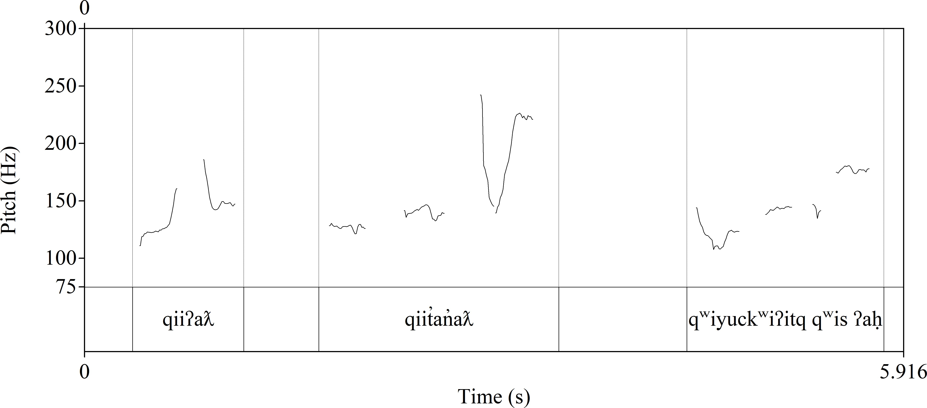Nuuchahnulth (Wakashan > Southern Wakashan)

a.

qiiʔaƛ, qiː‑ʼaƛ

for.a.long.time‑fin happened.long.ago pRed

qiit̓an̓ aƛ, qiː‑t̓an̓ a‑ʼaƛ

for.a.long.time‑slightly‑fin quite.a.while.ago

pRed

qʷiyuckʷiʔitq qʷiyu‑ckʷi·‑ʔi·tq time‑done‑Rel.3 when.it.occurred Ref

qʷis qʷis

happen.thus happen.thus pRed

ʔaḥ. ʔaḥ this this Ref

‘This happened a long time ago.’ (Louie 2003: Kingfisher 001)

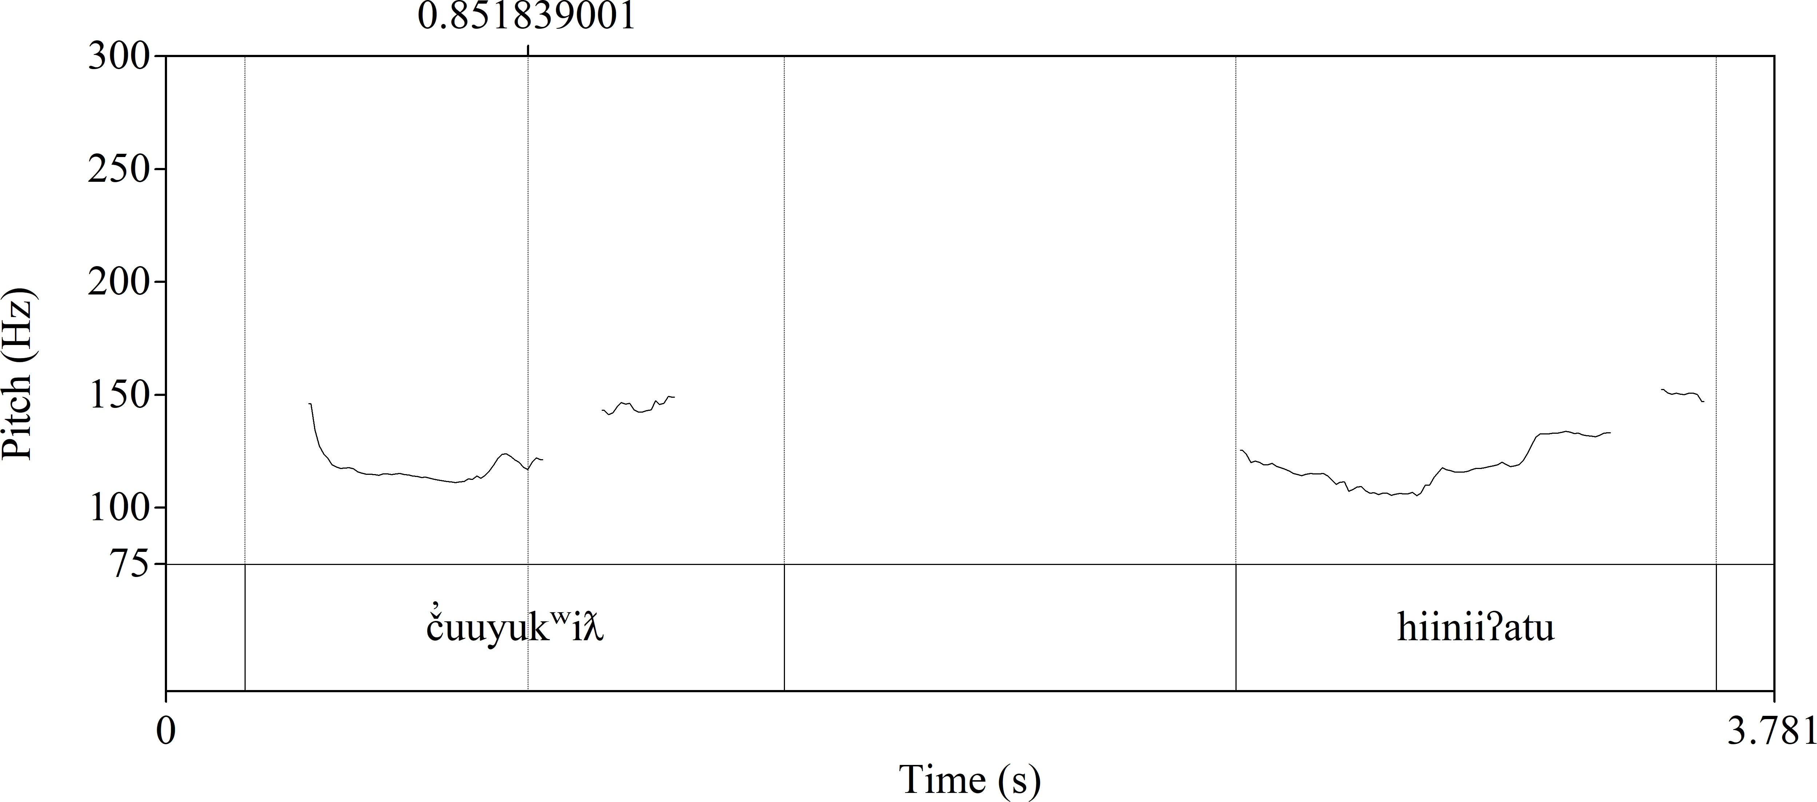b.

č̓uuyukʷiƛ. č̓u‑(y)ukʷi(ƛ) move‑incep started.migrating pRed

hiiniiʔatu. hin‑ʔi·ʔatu

there.mom‑get.to.be.under.water dive

pRed

‘(The sea lions) started migrating under the water.’ (Louie 2003: Qawiqaalth 046)

It is important to distinguish these cases of *clause combining* from *serialization*. Nakayama (2001: 98) explains that in cases of serialization, the state of affairs is conceptualized and expressed as a single event, and that in clause combining the state of affairs is conceptualized and expressed as separate events. The same scene can be expressed using either serialization or clause combining, depending on the speaker’s choice. Structurally, serialization is distinguished from clause combining by the fact that only the initial predicate will carry person and mood suffixes in cases of serialization. The other members of the serialization immediately

follow the main predicate as bare stems. In cases of clause combining, each predicate may take its own mood and participant marking. Nakayama (2001: 99) provides the following examples showing the contrast between serialization and clause combining respectively.

1. Nuuchahnulth (Wakashan > Southern Wakashan)
2. Serialization

mamuukšiƛna mamuːk‑ši(ƛ)‑na· working‑mom‑1pl we.worked

pRed

ʔuyi ʔuyi

at.the.time at.that.time pRed

February

February February

‘We worked in February.’ (Louie 2003: GL 108)

1. Clause Combining

ḥayuqʔičḥʔaƛits ḥayu‑qʔičḥ‑ʼaƛ‑it‑s ten‑year‑fin‑past‑1sg I.was.ten.years.old pRed

qʷiyaakiis qʷiyu‑ʔa·k‑(y)iːs when‑poss‑indef.1sg when.mine.did

pRed

qaḥšiƛ qaḥ‑ši(ƛ) dead‑mom died

pRed

ʔumʔiiqsu. ʔumʔi·qsu mother mother Ref

‘I was ten years old when my mother died.’ (Nakayama 2001: 98)

Prosody provides additional evidence that speakers conceptualize serialization as a unitary state of affairs, as the pitch traces for (43a) and (43b) show. The two predicates in (43a) fall under the same intonational contour, whereas in (43b) they are divided into distinct intonational contours.

1. Nuuchahnulth (Wakashan > Southern Wakashan)
2. Serialization

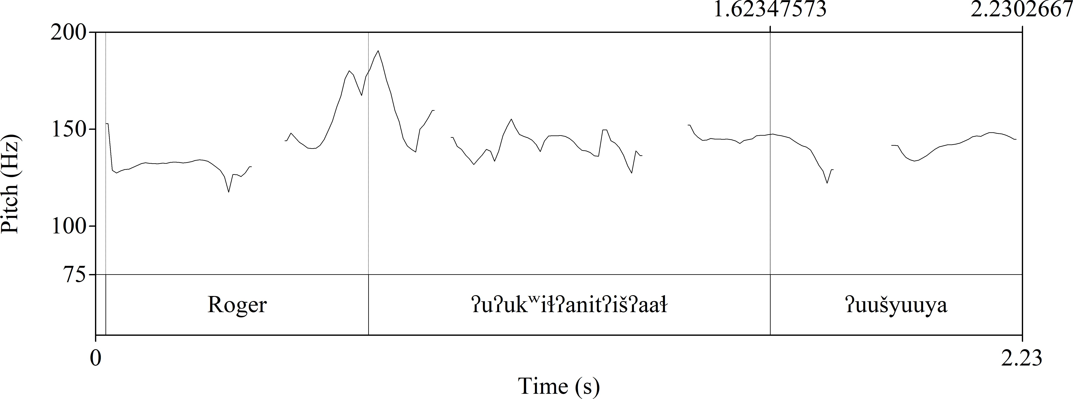

Roger Roger name Roger Ref

ʔuʔukʷiɬʔanitʔišʔaaɬ dup‑ʔu‑kʷiɬ‑ʼat‑it‑ʔi·š‑ʔaːɬ dup‑he‑doing.to‑shift‑past‑ind.3‑always they.used.to.do.it.to.him

pRed

ʔuušyuuya, ʔuːš‑yuːya some‑at.the.time sometimes

pRed

‘sometimes people called him Roger’ (Louie 2003: GL 006)

1. 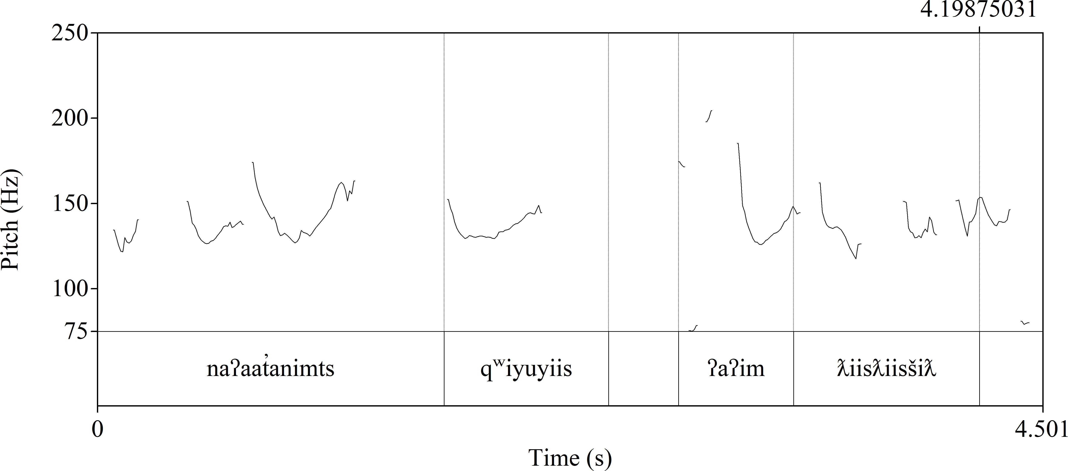Clause Combining

naʔaat̓animts naʔaːt‑ʼat‑imt‑s understand‑shift‑past‑1sg I.sort.of.understood

pRed

qʷiyuyiis qʷiyu‑(y)iːs when‑indef.1sg whenever.I pRed

ʔaʔim ʔaʔim first.time first.time pRed

ƛiisƛiisšiƛ ƛiːsƛiːs‑ši(ƛ) go.to.school‑mom started.school pRed

‘I sort of understood (English) when I first went to school.’ (Louie 2003: GL 040)

Additional examples of serialization are below.

1. Nuuchahnulth (Wakashan > Southern Wakashan)
2. t̓iqʷiɬ

t̓iqʷ‑ʽiɬ sit‑in.the.house sit.on.the.floor pRed

hiiɬ. hiːɬ

there.in.the.house there.in.the.house pRed

(Louie 2003: Kingfisher 074)

1. wikst̓iiḥʷʼit̓as wik‑st̓iːḥ‑w̓ it̓as

not‑take.direction‑about.to without.taking.direction pRed

kamatquk kamatq‑uk running‑duR be.running pRed

‘He was going to run frantically.’ (Louie 2003: Mink 135)

1. hiikʷaɬšiʔat hiːkʷaɬ‑ši(ƛ)‑ʔa·ɬ nearly‑mom‑pl they.almost.did pRed

k̓ʷačšiʔat. k̓ʷač‑ši(ƛ)‑ʼat

hit.the.right.spot‑mom‑shift hit.the.right.place

pRed

‘They almost made a direct hit.’ (Louie 2003: Wolf 132)

It is also important to keep in mind that property concepts and numerals/quantifiers are very often predicates in Nuuchahnulth, as shown in the following examples. Note that (45b) is a serialized predicate construction.

1. Nuuchahnulth (Wakashan > Southern Wakashan)
2. **ʔaya ʔaya many many pRed**

tukuuk. tukuːk sea.lion sea.lion Ref

‘There were many kinds of sea lions.’ (Louie 2003: Qawiqaalth 181)

1. **ʔaƛac̓asqi**

**ʔaƛa‑c̓as‑qi·**

**two‑at.the.crown‑on.top**

**two.at.the.crown.of.the.head pRed**

**ƛ̓iḥuk ƛ̓iḥ‑uk**

**red‑duR red**

**pRed**

ʕiyaaɬ ʕiyaːɬ feather feather Ref

t̓uḥc̓iti, t̓uḥc̓iti head head head

‘There are two red feathers at the crown of his head.’ (Louie 2003: Canoe 013)

1. **p̓išaqʔiš p̓išaq‑ʔi·š**

**bad‑ind.3 it.is.bad** pRed

ʔiiqḥy̓ ak. ʔiːqḥ‑y̓ ak

telling‑instrument news

Ref

‘There is bad news.’ (Louie 2003: Kingfisher 098)

Rarely, however, property words or numerals/quantifiers will be combined into a single intonational contour with the following referent, and in this case they function to modify. Modifiers always precede their referents. One such case is shown in (46).

1. Nuuchahnulth (Wakashan > Southern Wakashan)

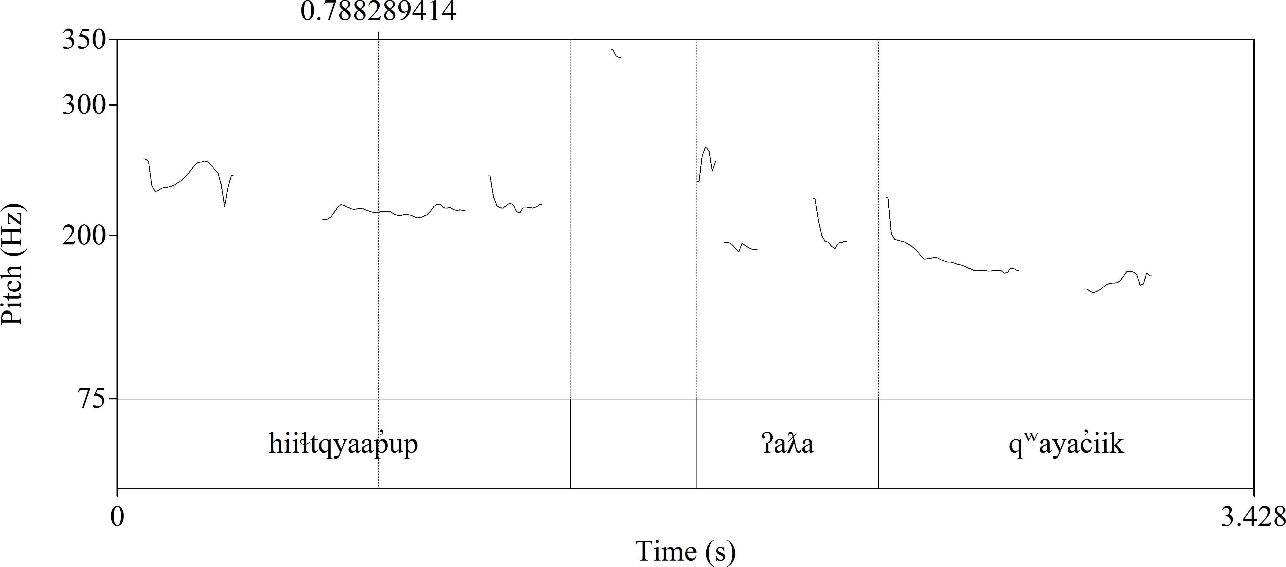

hiiɬtqyaap̓ up hiɬ‑tqya·p̓ i‑up there‑back‑momcaus put.on.the.back

**ʔaƛa ʔaƛa two two**

qʷayac̓iik. qʷayac̓iːk wolf

wolf

‘Two wolves put [the dead wolf] on their back.’ (Little 2003: FoodThief 046)

“Adverbials” (that is, predicate modifiers) are also encoded via predicate constructions in Nuuchahnulth. Nakayama states, “It is, however, difficult to distinguish the structural behavior of such ‘adverbs’ and that of other intransitive verbals in serialization” (Nakayama 2001: 51). Examples of this kind of serialization are in (47).

1. Nuuchahnulth (Wakashan > Southern Wakashan)
2. sayaʔii

saya‑ʔiː far.off‑reach went.far pRed

ʔuušyuuya, ʔuːš‑yuːya some‑at.the.time sometimes

pRed

‘He went far sometimes.’ (Louie 2003: Mink 221)

1. ʔin ʔin

although although

č̓uuy̓ iiḥanit č̓u‑y̓ i·ḥa‑ʼat‑it

having.an.odor‑suffering.excessively?‑shift‑past they.smelled.him

pRed

ʔaʔum. ʔaʔum at.first at.first pRed

‘even though they smelled him at the beginning.’ (Louie 2003: Qawiqaalth 087)

1. ʔaʔums ʔaʔum‑s at.first‑1sg I.first pRed

waɬaak waɬaːk go went pRed

ʕaʔuknak ʕaʔuknak name Auknak Ref

1919

‘I first went to Auknak in 1919.’ (Louie 2003: GL 029)

1. qiičiʔaƛs qiː‑či(ƛ)‑ʼaƛ‑s for.long‑mom‑fin‑1sg
   1. have.been.doing.for.long pRed

suutiɬ sut‑(č)iɬ you‑doing.to to.you

pRed

ḥaaḥuupa ḥaːḥuːp‑(y)a· teaching‑cont teaching

pRed

‘I have been teaching you (how to fish) for a long time.’ (Louie 2003: GL 115)

Certain inflectional markers, when present, also unambiguously indicate the discourse function of the word they appear with. Words which take the definite suffix *‑ʔi·* (glossed as def) or one of the relative suffixes (glossed as Rel) always function to refer. Except when they co-occur with either the definite or relative markers, the following kinds of mood suffixes always indicate a predicate. In Nuuchahnulth, most mood suffixes are fused with the following person suffixes, so each of the suffixes in this list has multiple realizations depending on the person and number of the clausal arguments.

* conditional (cond)
* dubitive (dub)
* imperative (imp)
* indicative (ind)
* interrogative (inteR)
* purposive (puRp)
* quotative (ot)
* subordinate (suboRd)

In serial verb constructions (discussed above), these mood suffixes only appear on the first (main) stem in a serial verb construction (Nakayama 2001: 42). Main predicates are also predominantly marked for person even if mood marking is not present (over 90% of main

predicates in the first person) (Nakayama 2001: 29). Aspect markers, however, are not a completely reliable indicator of predication. Though it happens infrequently, aspect markers may occur with referents or modifiers as well (Nakayama 2001: 47–50).

Certain distributional behaviors also abet identification of the discourse function of a word. Nakayama notes the following in regard to referents: “Nominals can be modified with expressions of property concepts, quantity, or quantifiers, but not directly with qualifying expressions like *hiikʷaɬ* ‘almost’ or *ʔanatʼuu* ‘barely’.” (Nakayama 2001: 49). Syntactic patterns are also helpful: Negation is accomplished by means of a negative predicate *wik‑*, which takes another predicate as its complement. Modifiers generally precede their heads, whether the head is a referent or predicate. As mentioned above, in serial verb constructions, only the main predicate takes person and mood marking, and the other members of the serialization immediately follow the main predicate as bare stems.

Finally, discourse-level considerations play an important role in determining the pragmatic function of each word. Most helpful is topic continuity, wherein a referent is already established in the discourse. This is accomplished either directly via an overt referent in a lexical argument or bound person marker, or indirectly via other kinds of inflectional affixes or features of a word that imply the existence of a referent (what Kibrik [2011] calls *referential aids*). Each successive lexical item encountered in a text must be interpreted in the context of the previously established discourse referents, so that certain interpretations of the item are much more sensible than others. Lastly, I consulted the audio files accompanying the corpus in order to take prosodic information into account. Clear prosodic breaks in the discourse are a strong sign of clausal boundaries.

What follows is a sample annotated abstract from the beginning of the Kingfisher story (Louie 2003), with each relevant lexical item annotated for its discourse function. Lexical items that are excluded from this study for one of the reasons discussed in Section 3.3.1 are not given an annotation.

1. Nuuchahnulth (Wakashan > Southern Wakashan)

qiiʔaƛ qiː‑ʼaƛ

for.a.long.time‑fin happened.long.ago pRed

ʔaḥ ʔaḥ this this Ref

qiit̓an̓ aƛ qiː‑t̓an̓ a‑ʼaƛ

for.a.long.time‑slightly‑fin quite.a.while.ago

pRed

qʷiyuckʷiʔitq qʷiyu‑ckʷi·‑ʔi·tq time‑done‑Rel.3 when.it.occurred Ref

qʷis qʷis

happen.thus happen.thus pRed

‘This happened a long time ago.’

siikc̓inƛ siːk‑c̓inƛ

sailing‑into.a.bay sail.into.a.bay pRed

siikaa siːk‑(y)a· sailing‑cont sailing

pRed

hitac̓inƛ hita‑c̓inƛ

there.mom‑into.a.bay entered.into.a.bay pRed

maaqtusiis maːqtusiːs name name

Ref

‘They sailed into the bay of Maaqtusiis.’

yuupickʷimatak yuːpi‑ckʷi·‑matak breeze‑done‑probably probably.there.was.a.breeze pRed

yuupi yuːpi breeze breeze Ref

yuksaaʔa yu‑ksa·ʔa

blowing‑come.to.land breeze.along.the.shoreline pRed

‘There probably was a little wind, blowing towards the land.’

qʷiyimtii qʷiyu‑imt‑(y)iː when‑past‑indef.3 whenever.it.was pRed

n̓ aas n̓ aːs day day Ref

hitac̓inƛ hita‑c̓inƛ

there.mom‑in.a.bay entered.a.bay

pRed

‘They came into the bay one day.’

hitac̓u hitac̓u name name

ʔukɬaakʔakna ʔu‑kɬa·‑ak‑ʔa·k‑na· it‑called‑duR‑poss‑1pl we.also.call.it

pRed

y̓ uuqʷaa y̓ uːqʷaː also also pRed

‘We also call it (the bay) “*hitac̓u*”.’

waɬyuu waɬ‑yu· go.home‑done gone.home pRed

maaqtusiis maːqtusiːs name name

Ref

wiiḥaaqsusiis wiːḥaːqsusiːs name

name

‘They went to Maaqtusiis — [to be exact,] *Wiiḥaaqsusiis*.’

ʔuʔiiyačištckʷi ʔu‑ʔi·ya‑ačišt‑ckʷi· it‑reach‑on.the.sea‑done reached

pRed

wiiḥaaqsusiis wiːḥaːqsusiːs name

name Ref

t̓ayuukʷiƛ t̓ayuː‑kʷi(ƛ) anchored‑mom anchored pRed

kuunaa kuːnaː schooner schooner Ref

‘The schooner reached *Wiiḥaaqsusiis* and dropped anchor.’

wik wik not not pRed

ʔiiḥ ʔiːḥ large large pRed

wikckʷii wik‑ckʷi· not‑done was.not pRed

ʔiiḥ ʔiːḥ large large pRed

‘It (the schooner) was not so big.’

ʔaƛa ʔaƛa two two pRed

ʔaƛista ʔaƛa‑ista

two‑people.on.board two.people.on.board Ref

qacc̓istamitquu qacc̓a‑ista‑mit‑quː

three‑people.on.board‑past‑cond.3 there.could.have.been.three.people.on.board pRed

‘There were two crewmen, or there could have been three, on the ship.’

hinaačiƛ̓aɬ hin‑a·či(ƛ)‑ʔa·ɬ

there.mom‑go.out.to.meet‑pl they.go.out.to.meet

pRed

yaqitii yaq‑it‑(y)iː

who‑past‑indef.3 whoever.it.was Ref

‘Some people went out to meet them (the people on the schooner).’

ʔin ʔin since since

ʔutwiickʷiʔaaɬ ʔutwiː‑ckʷi·‑ʔaːɬ first‑done‑always they.were.the.first.one pRed

hinaačiƛ hin‑a·či(ƛ)

there.mom‑go.out.to.meet go.out.to.meet

pRed

wiʔakʔi wiʔak‑ʔi· brave‑def the.brave.one Ref

wiiʔaksaʔi wiʔak‑sa‑ʔi· brave‑real‑def the.bravest.one Ref

ḥaaʔak̓atʔi ḥaːʔak‑ʼat‑ʔi· strong‑poss‑def the.one.with.strong.one Ref

ɬim̓ aqsti ɬim̓ aqsti mind mind Ref

‘The first ones to go out were the bravest ones, the ones with strong minds.’

ʔin ʔin

⁇

⁇

naʔaackʷaƛ naʔaː‑ckʷi·‑ʼaƛ hear‑done‑fin understood pRed

ʔaya ʔaya many many mod

mamaɬn̓ i mamaɬn̓ i white.man white.man Ref

hisiickʷiʔitqʔaɬ hisiː‑ckʷi·‑ʔi·tq‑ʔa·ɬ

⁇‑done‑Rel.3‑pl the.way.they.spoke Ref

hiistiƛ hiːstiƛ from from pRed

ciqy̓ ak ciq‑y̓ akʷ

speak‑instrument language

Ref

čiinuukʔatḥ č̓iːnuːk‑ʼatḥ Chinook‑belonging.to Chinook

pRed

‘Many white men could understand Chinook Jargon.’

čiičiinukʷackʷaƛ dup‑čiːnu·k‑(y)a‑ckʷi·‑ʼaƛ distR‑speak.Chinook‑Rep‑done‑fin spoke.Chinook.Jargon

pRed

‘Some of them spoke Chinook Jargon.’

hist̓atḥckʷaƛukʔaɬ hist‑ʼatḥ‑ckʷi·‑ʼaƛ‑uk‑ʔa·ɬ there‑belonging.to‑done‑fin‑poss‑pl they.got.theirs.from.there

pRed

ʔuuš ʔuːš some some Ref

ʔaḥ ʔaḥ this they Ref

[Hudson Bay]

‘They got theirs (= their knowledge of Chinook Jargon) from Hudson Bay Company.’

yaqʷiiyii yaqʷ‑wi·‑(y)iː who‑first‑indef.3

the.ones.who.were.first Ref

yaqʷacʔitq yaqʷ‑ac‑ʔi·tq who‑belonging.to‑Rel.3 owner.of

Ref

naʔaaʔaƛ naʔaː‑ʼaƛ hear‑fin understood pRed

šipʔii šip‑ʔi· ship‑def the.ship Ref

Captainmitquu Captain‑mit‑quː captain‑past‑cond.3 one.who.was.Captain pRed

‘Among the first ones that [learned to] understand the language might have been the Captain who was taking command of the ship.’

(Louie 2003: Kingfisher)

The complete set of annotations for the Nuuchahnulth corpus may be found at [https://github.com/](https://github.com/dwhieb/dissertation) [dwhieb/dissertation](https://github.com/dwhieb/dissertation).

## **Analysis**

This section discusses the specific statistical measures used in this study. In Section 3.4.1, I present the measure used to quantify the lexical polyfunctionality of individual items in a corpus, and in Section 3.4.3 I discuss the use of token frequencies versus dispersion.

### **Measuring lexical polyfunctionality**

Once the lexical tokens in a corpus are annotated for their discourse functions, it is possible to calculate the functional diversity of each lexical item using a measure known as Shannon’s diversity index. This section summarizes the rationale for using this metric and the procedure for calculating it.

Intuitively speaking, a lexical item is most functionally diverse when it is used with equal frequency for reference, predication, and modification. A perfectly polyfunctional lexical item which appears 300 times a corpus would therefore have a distribution like that in Table 3.1. By contrast, a perfectly monofunctional lexical item with the same overall frequency would have a distribution like that in Table 3.2. What is needed is a metric that captures how evenly distributed the tokens of a lexical item are across the different discourse functions. A perfectly polyfunctional item like that in Table 3.1 should receive a high rating (say, 1), while a perfectly

monofunctional item like that in Table 3.2 should receive a low rating (say, 0).

**Table 3.1:** Distribution of discourse functions for a perfectly polyfunctional lexical item

lexical item reference predication modification

*stem* 100 100 100

I elected to use Shannon’s diversity index (*H*) for this purpose (Shannon 1948; 1951). Originally devised as a measure of entropy in text (uncertainty or information content), the Shannon index has also become a popular measure of species diversity in ecology (Avolio et al. 2012) and attention diversity in political science (Boydstun, Bevan & Thomas 2014).

**Table 3.2:** Distribution of discourse functions for a perfectly monofunctional lexical item

lexical item reference predication modification

*stem* 300 0 0

Here I am using it as a measure of the functional diversity of lexical items. The normalized version of Shannon’s *H* yields a value between 0 (low diversity) and 1 (high diversity). For a categorical variable with *n* possible values, *Hnorm* is calculated using the formula in (49), where *pi* corresponds to the percent frequency of the *i*th possible value of the variable.

1. *Hnorm* =

*n*

(*pi* ln *pi*)

∑*− ·*

*i*=1

ln *n*

For this study, *n* will always be 3 (reference, predication, and modification). Future researchers may wish to adjust this number depending on the number of discourse functions examined (for example, if the predicate modifier function were included).

Frequently there will not be any instances of a lexical item being used in one discourse function or another. Since log 0 is undefined, the above formula cannot be resolved in these cases. One common workaround to this problem is to increment the frequencies of each discourse function by 1 before performing the calculation. Another is to simply treat log 0 as equal to 0 (Gries 2013: 120–121). I use the latter procedure in this study.

Applying Shannon’s *H* to the fabricated data in Table 3.1 and Table 3.2 produces the desired results: a value of 1 for *H* in the perfectly polyfunctional case and a value of 0 in the perfectly monofunctional case.

One limitation of the Shannon diversity index as applied to this study stems from the fact that there are so few discourse functions under consideration (just three: reference, predication, and modification). This means that at low frequencies there are a limited number of possible values of Shannon’s *H*. For example, a lexical item with a frequency of 2 will either have an *H* value of 0 or *.*63, because there are only two ways those tokens can be distributed across discourse functions (2 0 0 or 1 1 0). A lexical item with a frequency of 3 will have an *H*

value of 0, *.*58, or 1, because there are only three ways those tokens can be distributed across discourse functions (3 0 0, 2 1 0, or 1 1 1), and so on.

To address this issue, I only included lexical items in the samples that had a raw frequency of at least 4. This cutoff was established based on the fact that 4 is the smallest frequency that can theoretically return a significant result for Shannon’s *H* when a lexical item is maximally functionally diverse, in one of the two ways one can compute a multinomial test (probabilities vs. a χ2 test).

Another consideration when determining how to calculate lexical polyfunctionality is whether the counts of each function type (reference, predication, and modification) should first be normalized to their overall incidence in the corpus before being used for the calculation of Shannon’s *H*. For example, Nuuchahnulth displays a relatively low overall incidence of modification, as Table 3.3 shows.

**Table 3.3:** Distribution of discourse functions in Nuuchahnulth

|  |  |  |
| --- | --- | --- |
| discourse function | token frequency | percentage |
| modification | 81 | 1.07% |
| predication | 5,049 | 67.17% |
| reference | 2,387 | 31.75% |
| total | 7,517 | 100.00% |

Since the language overall displays significantly fewer cases of modification, we expect that individual lexical items will also display fewer cases of modification. (In fact, languages in general show fewer cases of modification than reference or predication [Croft 1991: §3.3.2].) A reasonable intuition is that we should therefore give any occurrences of modification more weight when it comes to calculating lexical polyfunctionality. Normalizing functional diversity ratings for the overall incidence of each function in this way could either increase or decrease the functional diversity of any given token, depending on whether the functions of each lexical item are underrepresented or overrepresented compared to their overall incidences.

On the other hand, a language like Nuuchahnulth, which has relatively few instances of modification even when taking into account that modification is less frequent for languages generally, *is* skewed in terms of the frequency with which each function is used. The language as a whole is less polyfunctional precisely because there is an uneven distribution of tokens across discourse functions. Normalizing the functional diversity ratings thus makes languages like Nuuchahnulth look more polyfunctional than they actually are. To frame this another way: Nuuchahnulth’s lopsided distribution of discourse functions is something to represent faithfully in the functional diversity ratings, rather than something that should be normalized away. Thus I opted to use raw function frequencies when calculating lexical polyfunctionality, rather than normalizing those frequencies to their overall incidence in the corpus.

Using the procedure outlined above, I calculated Shannon’s *H* for each of the lexical items

in the samples from both corpora to produce a functional diversity rating for each item. The resulting functional diversity ratings for the 100-item samples are provided in Appendix A.

One final methodological point is merited: many common constructions recognized by all speakers nonetheless do not appear in even a 1.5-million-word corpus. For example, in the spoken portion of the Open American National Corpus, the word *hate* occurs as a predicate and a modifier but never as a referent. We know that referential uses of *hate* are possible (for instance in phrases like *five‑minute hate* or *don’t spread hate*), but they are not attested in the OANC. As a consequence, the English stem *hate* in this study shows no polyfunctionality in the reference dimension, even though we know such cases are possible. The functional diversity ratings in this study are necessarily approximations, based on a representative sample.

### **Lexical polyfunctionality and corpus size**

As discussed in Section 1.3, some researchers suggest that lexical polyfunctionality should increase as a function of corpus size. The intuition behind this claim is that the larger the corpus, the more likely there are to be polyfunctional uses of any given lexical item. This is

the basis for R2, “Is there a correlation between degree of lexical polyfunctionality and size of the corpus?”. To test this claim, I calculated the functional diversity of each stem each time a new token of that stem was encountered in the corpus, thereby collecting data on the *cumulative* functional diversity of each stem as the size of the corpus grows. For English I used the 100-item sample, and for Nuuchahnulth I used the entire corpus. Only stems with a frequency greater than 4 were included (see Section 3.4.1 for the motivation behind this restriction). The resulting data allow us to examine how the functional diversity ratings of each stem change as the corpus increases in size.

### **Frequency vs. dispersion**

Research question R3 asks, “Is there a correlation between degree of lexical polyfunctionality for a lexical item and its frequency?”. The intuition behind the notion of frequency, however, can be understood and quantified in different ways. In this study I examine two different metrics and their relationship to lexical polyfunctionality: relative token frequency and corpus dispersion. This section describes the rationale and procedures for each of these metrics.

*Token frequency* is by far the most common statistic used in corpus linguistics (Gries 2008: 403), and is central to usage-based theories of language (Bybee 1985; Tomasello 2003; Goldberg 2006; Bybee 2007; 2010; Diessel 2019). It is computed by simply counting the number of instances (tokens) of a lexical item in a corpus. When working with multiple corpora it is important to normalize this statistic because the sizes of corpora vary. An item that occurs a large number of times in a million-word corpus may nonetheless be relatively infrequent compared to other items in the corpus. In order to compare the English and Nuuchahnulth corpora (which are drastically different in size), I report both the raw token frequency of lexical items as well as their *relative token frequencies*, calculated as the number of occurrences per 1,000 tokens in the corpus. Both metrics are reported for each lexical item in the 100-item samples in Appendix A.

Token frequencies can be misleading, however (Gries 2008; 2021; forthcoming). There

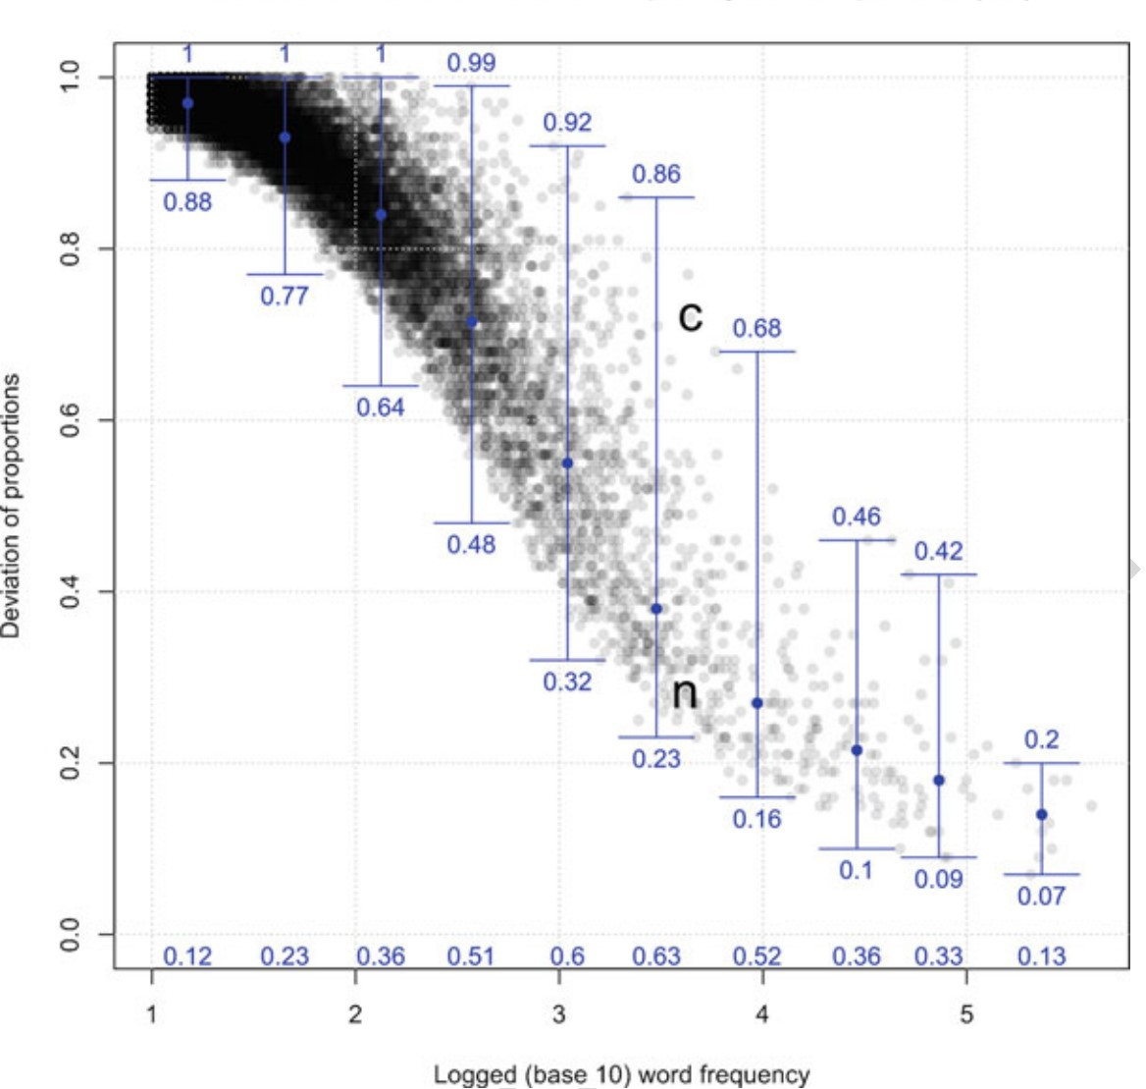

**Figure 3.1:** The relation between word frequency and dispersion (*DP* ) (from Gries [2021: 112])

is often a great deal of within-corpus and between-corpus variability in the frequency of a lexical item. Moreover, words with the same token frequencies may differ significantly in how evenly distributed or dispersed they are in a corpus. For example, while the words *enormous* and *staining* both occur 37 times in the Brown corpus, all 37 instances of *staining* are clustered within just one corpus part. By contrast, the tokens of *enormous* are distributed mostly evenly across 36 corpus parts, with 35 of those parts containing a single use of *enormous* (Gries 2021: 100).

Disparities between token frequency and dispersion are especially common for lexical

items in the middle frequencies (between 1,000 and 10,000 tokens), as demonstrated in Fig- ure 3.1 from Gries (2021: 112). In this plot, word frequency is shown on the x-axis (logged to the base of 10), and dispersion is shown on the y-axis (measured using *Deviation of Proportions* [*DP* ]; see below for details). Each word in the corpus is represented by a gray point. Lexical items are divided into 10 bins based on frequency, and the blue whisker in each bin represents the range of dispersion values in that frequency bin. The plot makes clear just how widely words within the same frequency bin can vary in terms of their dispersion, especially in the middle frequencies.

If what we are intending to capture with these statistics is some idea of the regularity with which speakers encounter a word, it is clear that raw frequency is a deceptive measure. Instead, recent work has shown that *corpus dispersion*—how evenly an item is distributed in a corpus—more accurately represents frequency of exposure or lexical access (Gries 2008; 2010; forthcoming). Corpus dispersion correlates more strongly with reaction time data than does frequency, for example (Gries forthcoming).

Thus for this project I report a measure of corpus dispersion in addition to relative token frequency. I use a measure called *Deviation of Proportions* (*DP* ), created by Gries (2008). In a review of various measures of corpus dispersion, Gries (2008) discusses shortcomings with existing measures and proposes Deviation of Proportions as a conceptually simple alternative; it is also this measure which most strongly correlates with reaction time data, as mentioned above. In essence, Deviation of Proportions measures how much the frequency of an item within the various parts of a corpus deviates from what one would expect if the item were evenly distributed in the corpus. The procedure for calculating *DP* for a given lexical item is as follows:

1. Determine the sizes of each part of the corpus as a percentage of the overall corpus. These values represent the *expected* percentage of the time that one would expect the item to appear in each corpus part, if it were evenly distributed.
2. Determine the frequencies with with the target item occurs in each part, as a percentage

of its overall frequency of occurrence. These values represent the *actual* or *observed*

percentage of the time that the item apperas in each corpus part.

1. Compute the pairwise absolute differences between the expected and observed percentages, sum them up, and divide the result by two.
2. The result is *DP* , which theoretically ranges from 0 (the item is evenly distributed across the corpus, given the size of the parts) to 1 (the item is unevenly distributed across the corpus, given the size of the parts).

The mathematical formulization of *DP* is shown in (50), where *n* is the number of corpus parts, *v* is the frequencies of the target item in each corpus part, *f* is the overall frequency of the target item in the corpus, and *s* is the percent size of each corpus part.

*n*

(50) *DP* = 0*.*5 *×*

∑*i*=1

*vi*

*| f −*

*si|*

A more detailed explanation of this calculation, with examples, is in Gries (2008: §3). Note that while the theoretical range of *DP* is between 0 and 1, it will never actually reach these two limits because a particular proportion of the lexical item was expected to occur in each corpus part anyway. This issue is only noticeable in corpora with a very small number of parts.

For this study, each text within the selected corpora is treated as a single corpus part. The spoken portion of the Open American National Corpus contains 2,410 texts, each contained within its own separate file. The Nuuchahnulth corpus contains 24 texts, also each contained within its own file.

Both the token frequencies and corpus dispersions of each lexical item in the 100-item samples are reported in Appendix A.

## **Summary**

This chapter has presented the methodological tools necessary for answering the research questions put forth in Chapter 1. The methods adopted in this study are novel for several reasons. First, this is the first study to utilize naturalistic discourse data from corpora to examine lexical polyfunctionality at the level of the individual lexical item. Second, this is the first study to *quantify* the lexical polyfunctionality of individual lexical items, in a crosslinguistically applicable way. The calculation of functional diversity using Shannon’s *H* is intended as the main methodological contribution of this dissertation. Finally, this study incorporates findings from recent research in corpus linguistics which suggest that corpus dispersion is a better measure of frequency of exposure than just raw token frequency. As such, I report on both token frequency and corpus dispersion and examine their interaction as they relate to lexical polyfunctionality in Section 4.5. With these methodological prerequisites in place, I now turn to answering this study’s research questions in Chapter 4.

# **Chapter 4 Results**

This chapter reports the results of applying the procedures described in Chapter 3: Data & Methods. I begin by demonstrating for the reader how to interpret the ternary plots used to visually represent the degree of lexical polyfunctionality for individual items (R1) (Section 4.2). Next I look at the polyfunctionality of lexical items in English and Nuuchahnulth, both independently and in comparison (Section 4.3). I then investigate whether polyfunctionality depends on corpus size (R2) (Section 4.4), followed by the relationship between the degree of lexical polyfunctionality and frequency / dispersion (R3) (Section 4.5). Finally, I discuss the behavior of polyfunctional items with respect to their semantics (R4) (Section 4.6).

## **Introduction**

This chapter presents the empirical findings of this study, answering the research questions posed in Chapter 1. I employ a useful visualization for displaying information about lexical polyfunctionality called a *ternary plot* or *triangle plot*; I explain how these ternary plots are to be read in Section 4.2. Section 4.3 focuses on answering R1, “How functionally diverse are lexical items in English and Nuuchahnulth?”, both individually and in comparison. Section 4.4 is dedicated to answering R2, “Is there a correlation between degree of functional diversity and size of the corpus?”, and Section 4.5 answers R3, “Is there a correlation between degree of functional diversity for a lexical item and frequency (or corpus dispersion)?”. In the final section (§4.6), I look at the semantic behavior of more and less polyfunctional items (question

R4).

## **Interpreting the results**

In Section 3.4.1 I describe the procedure for quantifying the functional diversity of an item in a corpus using a Shannon diversity index (*H*). While the resulting values nicely align with our intuitions about when a lexical item is more or less polyfunctional, some information is lost in the process. Reducing the lexical polyfunctionality of an item to a single number obscures the fact that items can be equally polyfunctional in different ways. Consider the fictional frequency data for two different stems in Table 4.1. Stem A displays a great deal of reference-predicate polyfunctionality, but no instances of use as a modifier. Stem B, in contrast, displays extensive reference-modifier polyfunctionality, but no instances of use as a predicate. However, the overall functional diversity ratings of the two stems are the same.

**Table 4.1:** Stems with different distributions of discourse functions and the same functional diversity

|  |  |  |  |  |
| --- | --- | --- | --- | --- |
| stem | reference | predication | modification | functional diversity |
| Stem A | 25 | 25 | 0 | 0.631 |
| Stem B | 25 | 0 | 25 | 0.631 |

One way to address this reduction in fidelity is to report frequencies and corpus dispersions for each function in addition to the overall functional diversity rating for each stem. I provide this information in Appendix A alongside each item’s functional diversity rating. However, it is also possible to visualize the relative usage of an item for each discourse function in an intuitive way by using a *ternary plot* (also called a *triangle plot* or *simplex plot*). A ternary plot depicts the ratios of three variables as points within an equilateral triangle. Each corner of the triangle corresponds to one of the three possible categories (in this case, reference, predication, or modification). The closer a data point is to a particular corner, the larger the ratio of that category is. To illustrate with an example: Figure 4.1 is a ternary plot for the functions of the word *difficult* in English, along with the underlying frequency data and

**Figure 4.1:** Functional diversity of English *difficult*

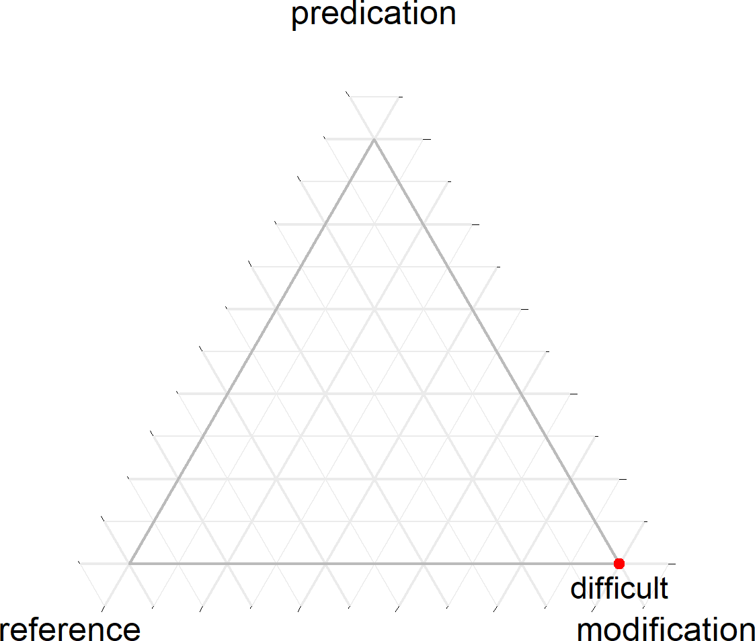

reference predication modification functional diversity 0 0 54 0.000

resulting functional diversity rating. Because the word *difficult* only appears as a modifier in the corpus, it has a functional diversity rating of 0. In the ternary plot, this is evident from the fact that the plot point for *difficult* sits in the modification corner of the triangle.

Compare the plot for *difficult* in Figure 4.1 to that of *anything* in Figure 4.2. The stem *anything* also has a functional diversity rating of 0 because all of its tokens are used for reference. Even though its functional diversity rating is the same as that of *difficult*, it is plotted in a different corner of the ternary plot (reference).

Figure 4.3 shows a case where a stem (*childhood*) is polyfunctional between reference and modification, but not predication. Finally, a perfectly polyfunctional item which has equal use as a referent, predicate, and modifier, would sit exactly in the center of the triangle. The Nuuchahnulth stem *ʔu·q* ‘good’ is one such case, shown in Figure 4.4. The closer a point is

**Figure 4.2:** Functional diversity of English *anything*

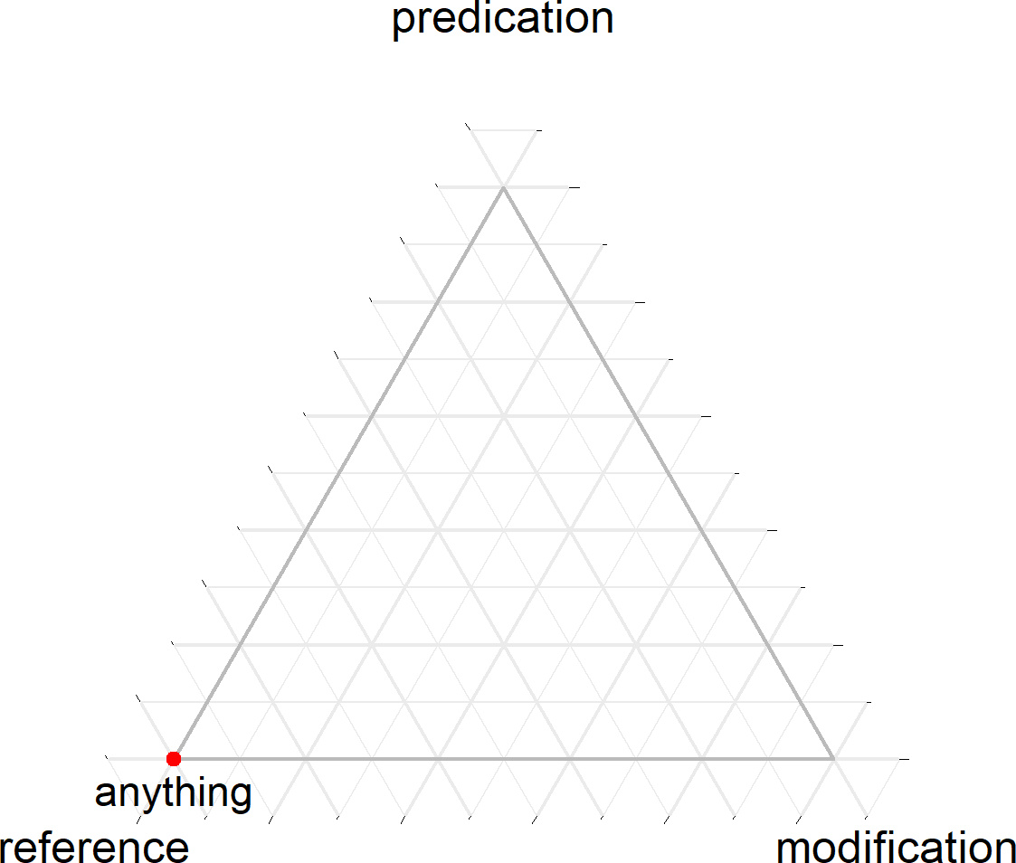

reference predication modification functional diversity 2,081 0 0 0.000

**Figure 4.3:** Functional diversity of English *childhood*

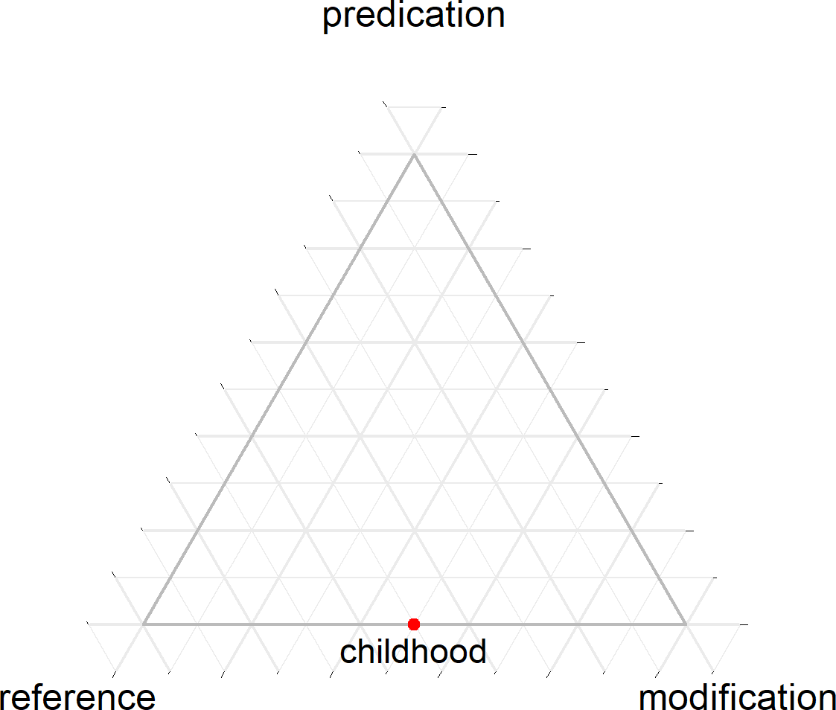

reference predication modification functional diversity 2 0 2 0.631

towards the center of the triangle, the more functionally diverse it is.

Also remember from Chapter 3 that corpus dispersion is a better measure of frequency of exposure than just raw frequency. Thus in addition to relative frequency data, I also report corpus dispersions for the discourse functions of each lexical item in Appendix A. Note that the corpus dispersions are calculated separately for each discourse function (in addition to the overall corpus dispersion of the lexical item). A particular lexical item might be used for one function evenly throughout the corpus, and thus have a low *DP* for that function, but might only be used for another function in one or two texts, thus giving that function a high *DP* . The ratios of these corpus dispersions for each function can be plotted on a ternary plot just like frequency. Plots based on corpus dispersions are sometimes notably different from plots based on frequencies, as Figure 4.5 illustrates for the English word *favorite*. In most cases

**Figure 4.4:** Functional diversity of Nuuchahnulth *ʔu·q* ‘good’

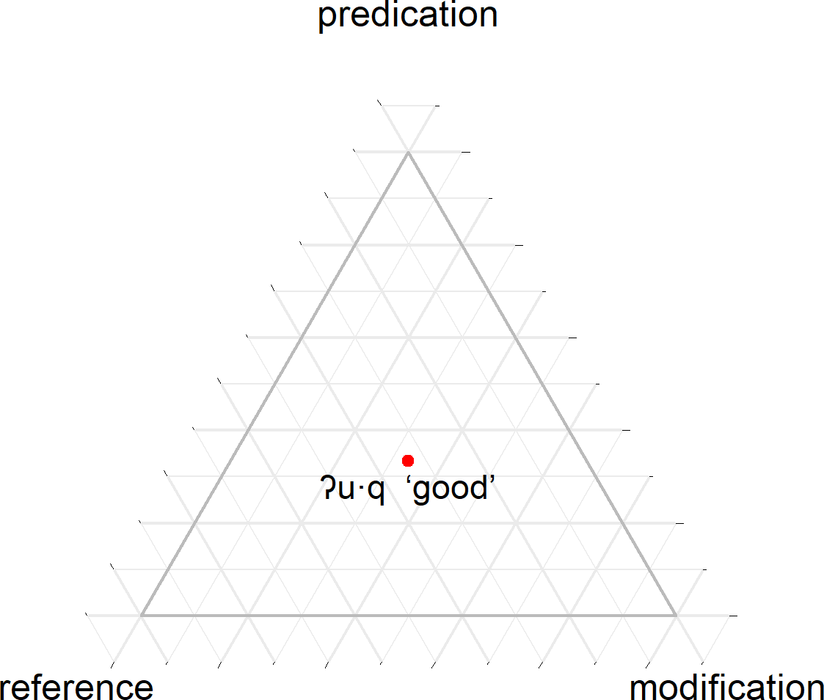

reference predication modification functional diversity 1 1 1 1.000

however the plots are identical or near-identical. As such, for the remainder of this study I will use ternary plots based on corpus dispersion rather than frequency, noting where the two diverge only when relevant.

133

**Figure 4.5:** Functional diversity using frequency vs. corpus dispersion for English *favorite*

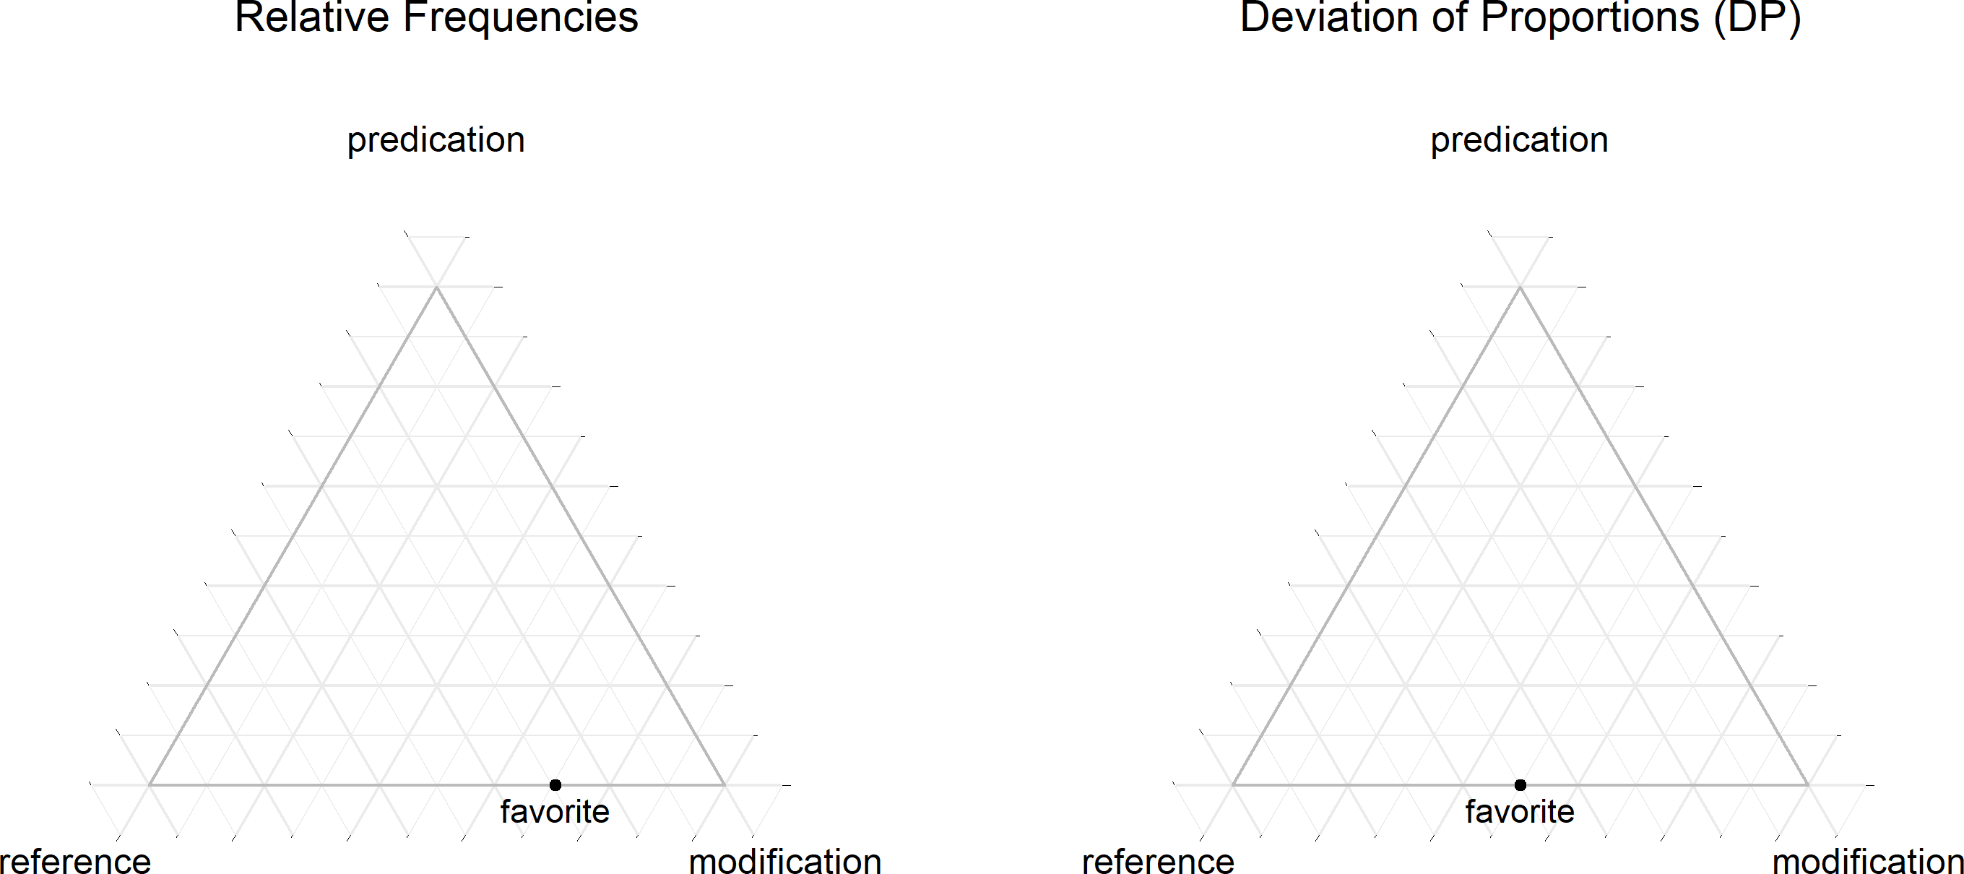

Frequency Functional Diversity Dispersion Frequencies Dispersions (*DP* ) (Shannon’s *H*) (*DP* ) Reference Predication Modification Reference Predication Modification

17 0.551 0.999 5 0 12 0.999 1.000 0.999

## **R1: Degree of lexical polyfunctionality**

In this section I examine the degree of lexical polyfunctionality for words in English and Nuuchahnulth from several angles, both independently and in comparison, using the functional diversity ratings calculated with the methods in Section 3.4.1. The result of these calculations for the 100-item samples are shown in Appendix A.

Figure 4.6 visualizes the distributions of the functional diversity ratings for the 100-item samples from English (lefthand side) and Nuuchahnulth (righthand side). The top portion of each figure is a histogram showing the number of lexical items at different functional diversity ratings. Beneath the histograms are boxplots showing the median functional diversity rating for each language. Figure 4.7 shows the same visualizations for the small corpus samples.

If we set out by asking, “Can it be shown empirically and quantitatively that some lexical items are more polyfunctional than others, as many linguists have claimed?”, the above data show that the answer is clearly “yes”. If we want to evaluate the claim that some languages are more or less polyfunctional than others, it must be possible to quantify that functional diversity at the level of the individual lexical item and compare them in a meaningful way. The data and methods in this dissertation show that this is indeed possible, and that we can provide clear empirical answers to these kinds of questions.

One immediately obvious observation to be made from these functional diversity ratings is that individual lexical items may vary widely in their polyfunctionality, both within and across languages. While this finding is entirely unsurprising, the results very well could have been otherwise. The way Nuuchahnulth is often described, one might expect all the lexical items in the language to fall within a more limited range of highly polyfunctional values. This is clearly not the case. Functional diversity ratings for Nuuchahnulth range from the theoretical minimum of 0 to a maximum of 0*.*920 (100-item sample) or 0*.*985 (small corpus sample). However, 282 of 483 stems in the small corpus Nuuchahnulth sample (69.97%) have a functional diversity rating of 0 (58 of stems in the 100-item sample), potentially challenging

**Figure 4.6:** Distribution of functional diversity ratings for the 100-item samples of English and Nuuchahnulth

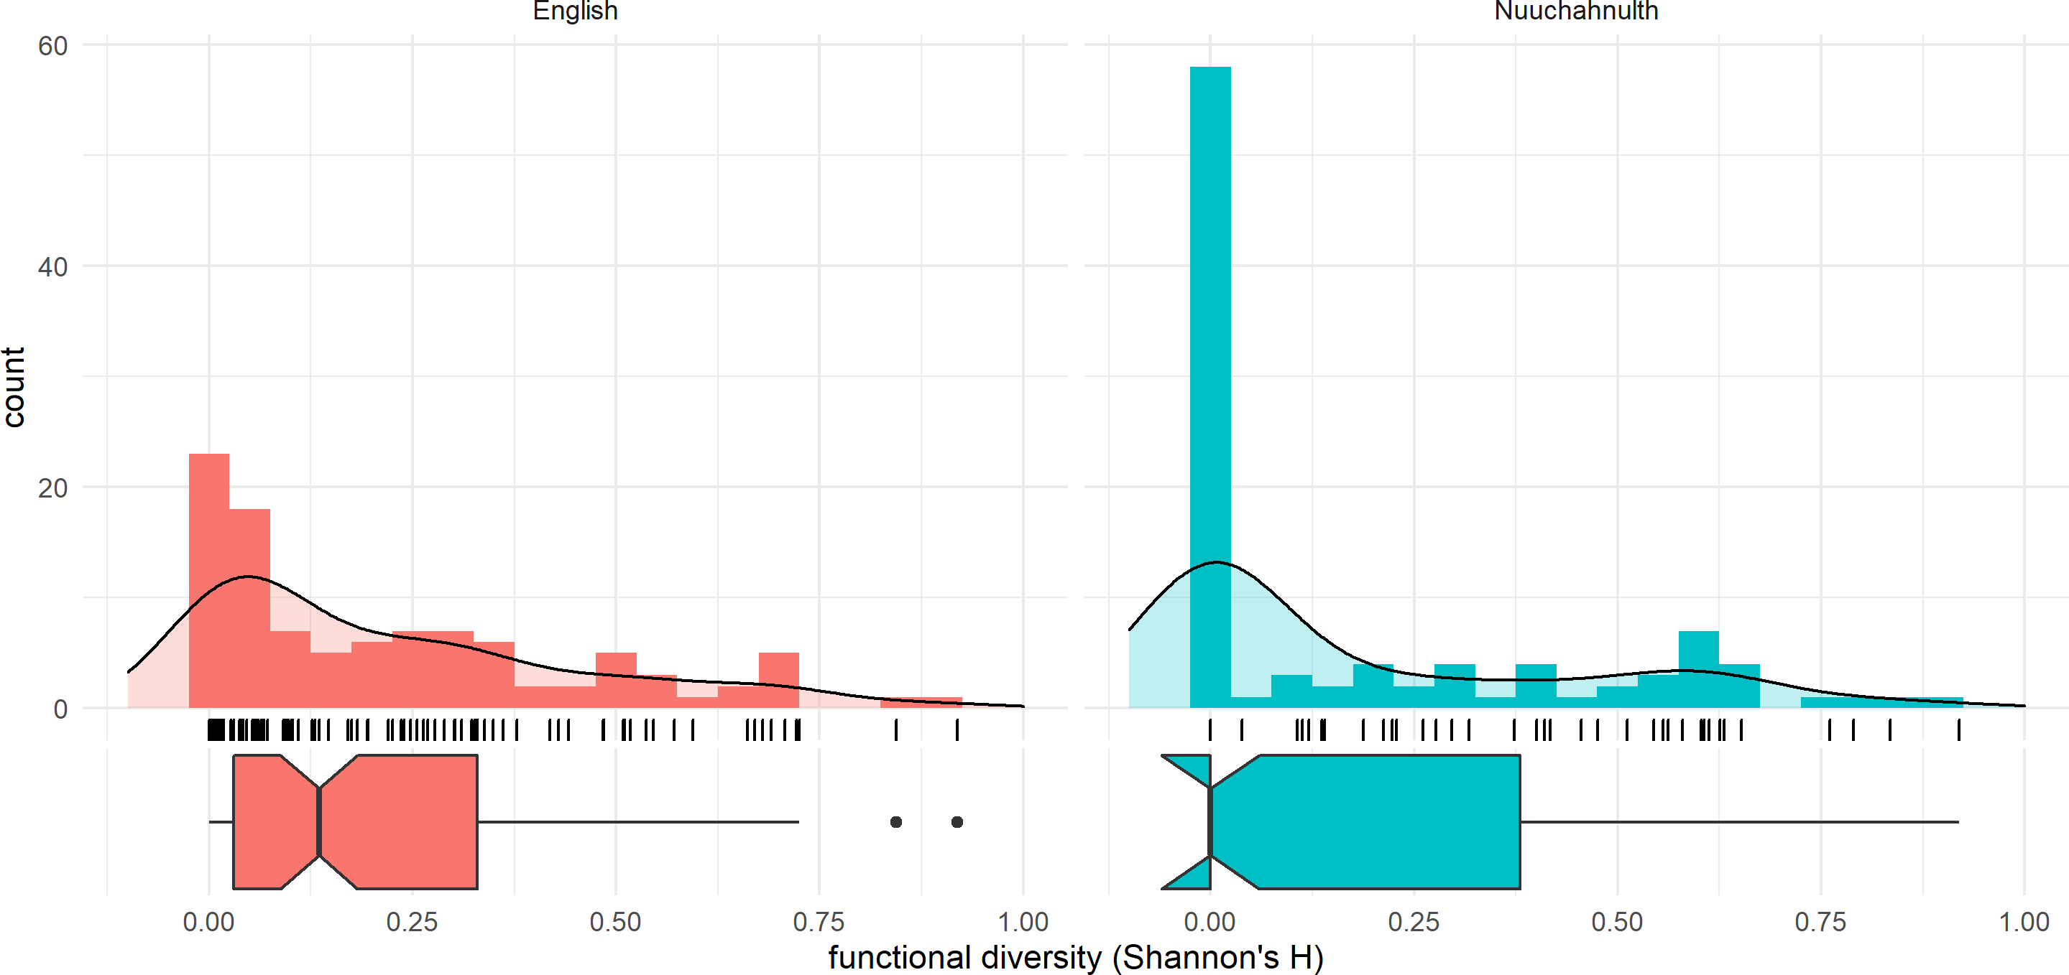

|  |  |  |
| --- | --- | --- |
|  | English | Nuuchahnulth |
| mean | 0.223 | 0.183 |
| median | 0.134 | 0.000 |
| standard deviation | 0.230 | 0.259 |

**Figure 4.7:** Distribution of functional diversity ratings for the small corpus samples of English and Nuuchahnulth

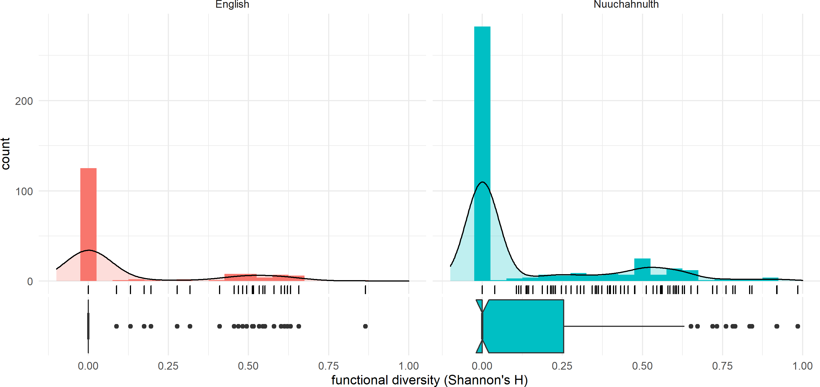

|  |  |  |
| --- | --- | --- |
|  | English | Nuuchahnulth |
| mean | 0.122 | 0.143 |
| median | 0.000 | 0.000 |
| standard deviation | 0.226 | 0.243 |

the claim that all Nuuchahnulth stems are polyfunctional.

Likewise, those who claim that English parts of speech are well-defined must confront the fact that the range of functional diversity values for English is nearly the same as for Nuuchahnulth for both samples: 0 on the lower end and *.*919 (100-item sample) or 0*.*865 (small corpus sample) on the upper end. In fact, in the 100-item samples there are fewer English stems with a functional diversity rating of 0 (8 stems out of 100) than there are Nuuchahnulth stems with a functional diversity rating of 0. The percentage of zero-diversity stems in the small corpus samples are about equal (125 of 166 stems for English, or 75.30%). In this respect, then, English could be viewed as similarly functionally diverse to Nuuchahnulth. Of course, it may be that this difference is due to the large difference in corpus sizes between English and Nuuchahnulth, an issue which is explored in Section 4.4. Thus the answer to the question, “Are some lexical items more polyfunctional than others?” is unsurprisingly “yes”.

Another question to ask of these data is whether English and Nuuchahnulth differ in their overall polyfunctionality. The answer to this is not immediately obvious, given how similar the mean and median functional diversity ratings for English and Nuuchahnulth are in Figure 4.6 and Figure 4.7. But to reduce the entire lexicon of a language to a single measure of central tendency obscures important details. The *way* in which the two languages exhibit polyfunctionality is arguably more interesting.

How then is lexical polyfunctionality realized in English and Nuuchahnulth? In addition to the histograms in Figure 4.6 and Figure 4.7, the ternary plots in Figure 4.8 and Figure 4.9 illustrate the way that polyfunctionality operates in these two languages. In these figures, each lexical item is represented by a single point on the ternary plot.

Beginning with English, we can see in the large corpus sample that most lexical items exhibit some polyfunctionality, but to a relatively small degree. First, note that there are many cases of lexical items with zero functional diversity, whose dots appear exactly in the corners. Because these points overlap, these ternary plots do not accurately represent just how much of the data exhibit no functional diversity whatsoever. Instead, the ternary plots

**Figure 4.8:** Distribution of functions for the 100-item samples of English and Nuuchahnulth

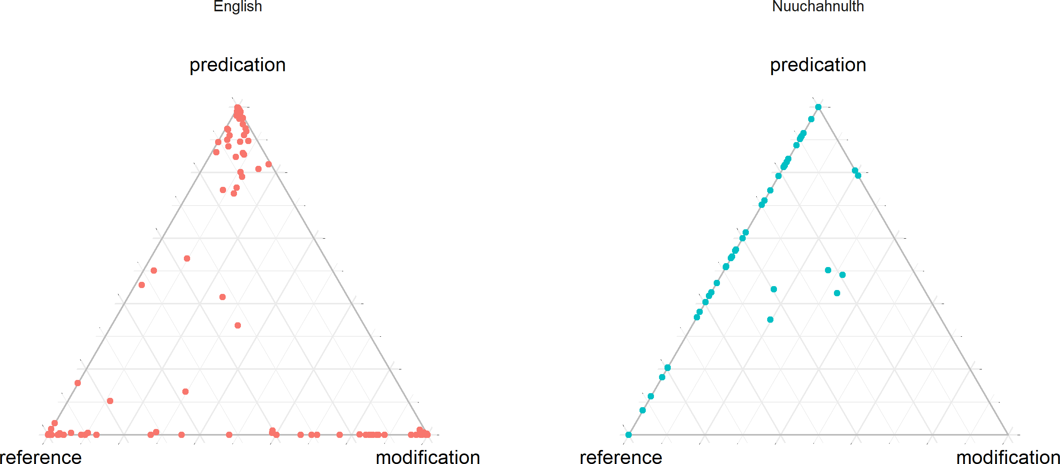

**Figure 4.9:** Distribution of functions for the small corpus samples of English and Nuuchahnulth

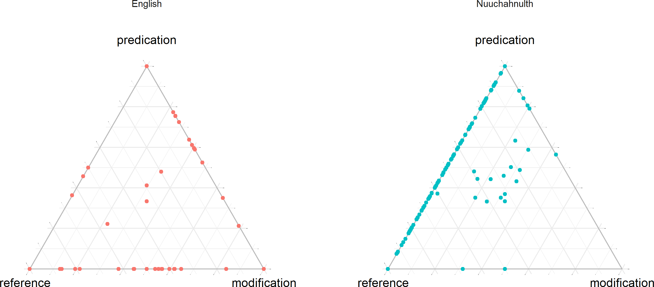

help visualize the distribution of functions for lexical items which do exhibit at least some degree of polyfunctionality.

After zero-diversity cases, the next most frequent functional diversity rating is in the 0–

0*.*05 range. The median functional diversity rating for the sample is 0*.*134 and the mean is

0*.*223. This is also evident from the ternary plots, where lexical items tend to cluster near the corners for their most prototypical functions. English does exhibit a fair amount of polyfunctionality between reference and modification in both samples, however, perhaps representative of the frequency with which nominal modifiers are used in English discourse. Interestingly, the small English corpus appears to show *more* functional diversity than the 100-item sample. This could be an effect of the specific words chosen, but it could also be the case that it takes a certain number of tokens for the prototypical function of an item to become evident. This possibility is examined further in Section 4.4.

Nuuchahnulth differs from English in several notable ways. First, a much higher proportion of items display no functional diversity whatsoever. Again, these occur in the far corners and are thus not really visible. However, for those items which do exhibit polyfunctionality, the average functional diversity rating is generally higher than that of English stems. In both samples, the biggest cluster of items with non-zero functional diversity ratings have ratings around 0*.*6. English items with non-zero functional diversity, by comparison, generally have

ratings closer to 0*.*2. Thus for Nuuchahnulth lexical items are either totally monofunctional

or generally strongly polyfunctional.

This bifurcation of the data is very likely due to the small size of the Nuuchahnulth corpus, as will be discussed in Section 4.4. Most words in the Nuuchahnulth corpus don’t occur enough times in the corpus to get a clear assessment of whether they’ve been conventionalized in multiple functions. However, for those that do occur with sufficient frequency, there is a strong tendency for the word to have multiple discourse functions. It may be that Nuuchahnulth words are generally highly polyfunctional, but that more tokens are needed to see this trend. Alternatively, it may be that certain Nuuchahnulth stems are strongly associated with a specific discourse function and thus monofunctional, while others are generally polyfunctional. This would suggest a probabilistic division of Nuuchahnulth stems into two classes: those that are productively polyfunctional (flexible), and those that are not.

This second possibility would challenge existing analyses of Nuuchahnulth. The exis-

tence of a productively flexible class of stems would be counterevidence to the many claims that Nuuchahnulth word classes can in fact be clearly defined using selectional criteria such as ability to take possession or the definite suffix (Jacobsen 1979; Davis, Gillon & Matthewson 2014; Braithwaite 2015). Similarly, Nakayama (2001: 57) characterizes word classes in Nuuchahnulth as strong statistical tendencies in discourse. For many Nuuchahnulth stems, however, there is no clear prototypical use. The data show that many stems are used roughly equally for predication as they are for reference, making it difficult to assess which use is basic / unmarked.

As the ternary plots for Nuuchahnulth in Figure 4.8 and Figure 4.9 make clear, the distribution of lexical items across functions in Nuuchahnulth differs strongly from that of English. For starters, there is very little clustering around prototypical functions in the corners, in direct contrast to English. Secondly, Nuuchahnulth shows very little polyfunctionality in the modification direction, but a great deal of polyfunctionality along the reference-predication axis. For the small corpus sample in particular, there is a smooth cline of values between reference and predication. Nuuchahnulth stems sit anywhere on a continuum from prototypical referents to prototypical predicates, but none show prototypical modifier behavior. English shows a similar but not quite as robust cline of polyfunctionality, but on the referencemodification axis rather than the reference-predication axis.

These findings nicely reflect the intuitions of many researchers about these two languages. English is mostly rigid, but most words exhibit a marginal degree of polyfunctionality. English words are *primarily* associated with one discourse function, but not exclusively so. Nuuchahnulth, by contrast, shows a very high degree of reference-predicate polyfunctionality. However, Nuuchahnulth stems are not frequently used for modification. This is in line with the analysis of most researchers regarding lexical categories in Nuuchahnulth. Nakayama (2001: 50), for example, says that the categories Noun and Verb must be recognized for Nuuchahnulth, but that there is not sufficient evidence to justify an Adjective category, even as a statistical tendency. He instead treats “Adjectivals” as a subclass of Verbs. My point here

is not to say that the present study supports an analysis of Nuuchahnulth as having large word classes like Noun and Verb—this approach is deconstructed in Chapter 2. Instead, the data in this study show why Nakayama structures his word-class–based analysis the way he does. However, the central location of the points in the Nuuchahnulth plot in Figure 4.9 suggests that Nuuchahnulth modifiers are as “nounlike” as they are “verblike”. The low frequency with which stems are used for modification also mirrors the results from Croft’s (1991: 88–89) four-language survey of the textual frequency of different lexical classes. He also finds that “the overall frequency of roots denoting properties and occurrences of modifiers is extremely low compared to the frequencies of object and action roots and of referring expressions and predications” (Croft 1991: 88–89).

## **R2: Lexical polyfunctionality and corpus size**

It seems intuitively plausible that the more tokens of a word one encounters, the more likely one is to find polyfunctional uses of a word. With a large enough corpus, all items would exhibit polyfunctionality. This has been claimed by Mosel & Hovdhaugen (1992: 77). It may be the case that larger corpora are statistically more functionally diverse than smaller corpora. However, to my knowledge this claim has never been tested empirically. In this study, we have already seen some evidence suggesting that this may be the case. The one sample which shows a median functional diversity greater than 0 (the 100-item sample of English) is the sample with the largest token counts (up to *∼*11,000 in the case of the word *know*). This suggests that a fairly large sample is needed in order to reliably detect polyfunctionality. In this section I examine the results of comparing the number of tokens encountered for a stem to its cumulative functional diversity rating, the question being, “Does the cumulative functional diversity for the lexical item increase as one encounters more tokens?”.

Only stems with a frequency of at least 4 were studied (see Section 3.4.1 for the motivation behind this restriction). For English, I examined the 100-item sample, and for Nuuchahnulth

I used the entire corpus. Using a script and going sequentially through the corpora, I recalculated the overall functional diversity of each word each time I encountered a new token of that word, and recorded the functional diversity rating and token frequency at that point in the corpus. I then randomized the order of the texts and repeated this process for a total of 100 times, so as to avoid any ordering effects, thereby providing a sort of “confidence interval” for the cumulative functional diversity ratings.

Figure 4.10 shows the result of these calculations for the ten most frequent words in the English corpus, and Figure 4.11 shows the same for Nuuchahnulth. The number of tokens encountered is shown on the x-axis, and the cumulative functional diversity is shown on the y-axis. In other words, these plots show how the functional diversity of the lexical item changes as the size of the corpus grows.

The first thing to notice from the plots of high-frequency words is that it takes a certain number of tokens for the functional diversity of a word to become evident and stable. For English, the trend lines are generally no longer stochastic after *∼*1,000 tokens encountered. If we take 1,000 tokens as a reliability threshhold for determining the functional diversity of a lexical item, then no Nuuchahnulth item appears with sufficient frequency in the corpus to be certain of its functional diversity. That said, the functional diversity of some of the ten words in the Nuuchahnulth sample appears to be relatively stable after even a small number of tokens. There are some words in the English sample which achieve a relatively stable functional diversity rating as early as 100 tokens as well. One way to interpret these data is that, since some stems appear in a wider range of discourse contexts than others, it takes a larger number of tokens before the overall functional diversity of those stems becomes evident; in contrast, the functional diversity of stems that appear in a relatively small range of discourse contexts should become clear right away.

The central point to observe regarding these data is that, once the trend line for cumulative functional diversity becomes smooth, it stays flat. This shows that corpora do not become more functionally diverse as they increase in size. If this were true, we would expect to see

items in English

* + 1. *good* **(b)** *know*

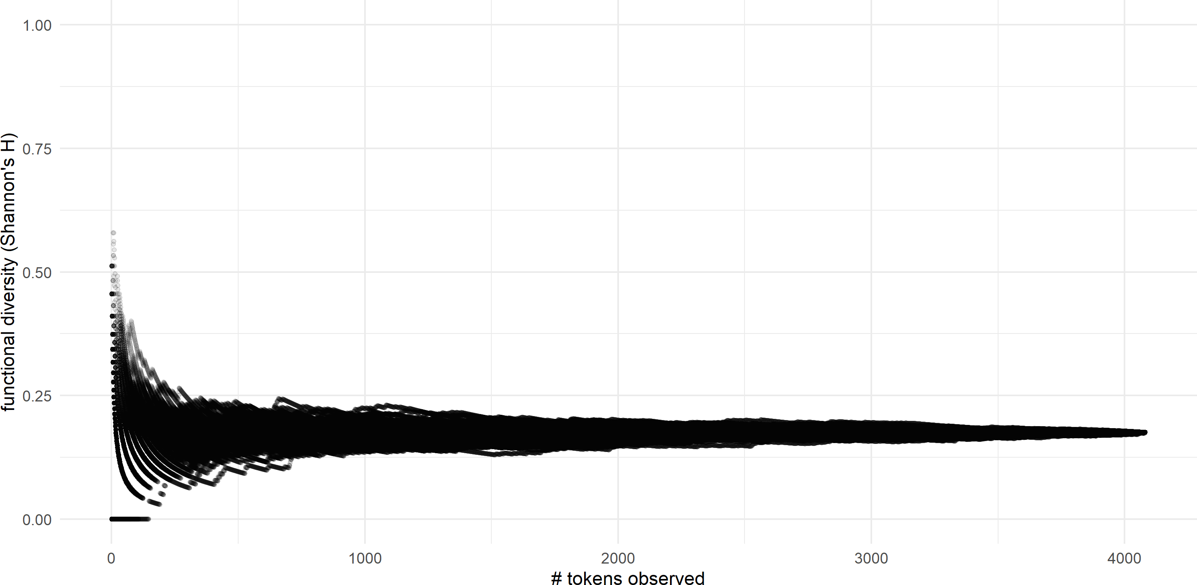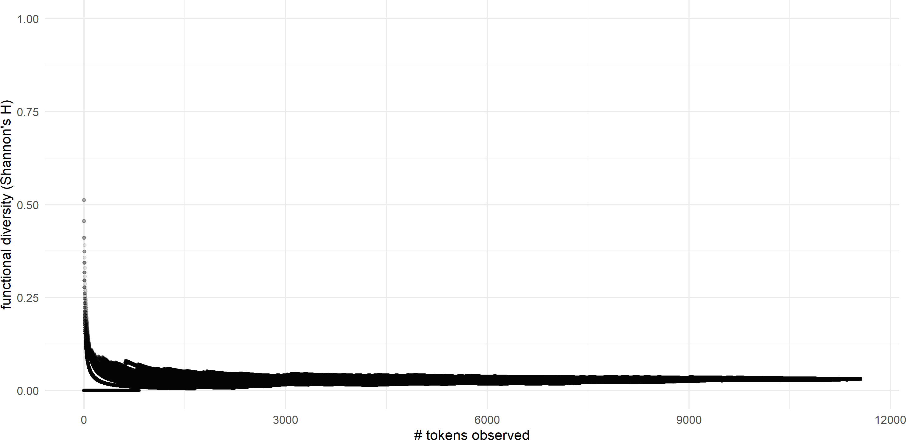

**(c)** *one* **(d)** *right*

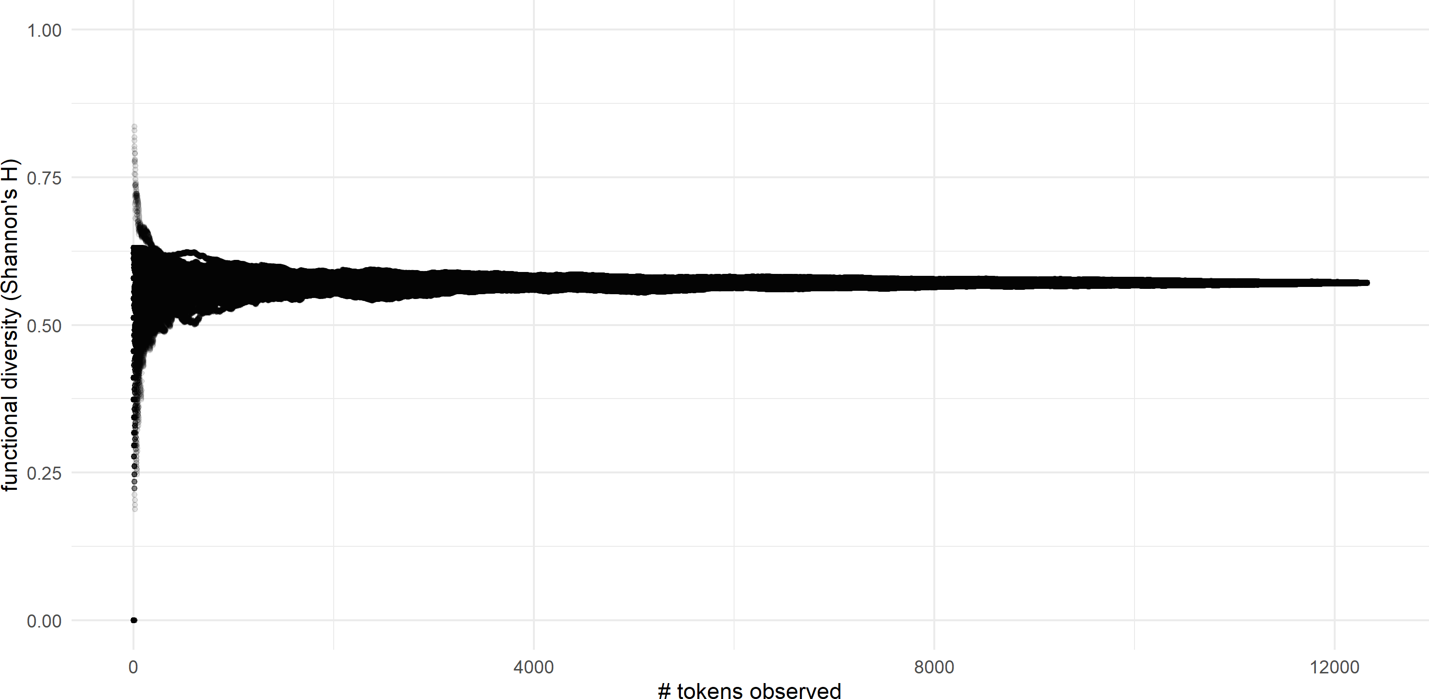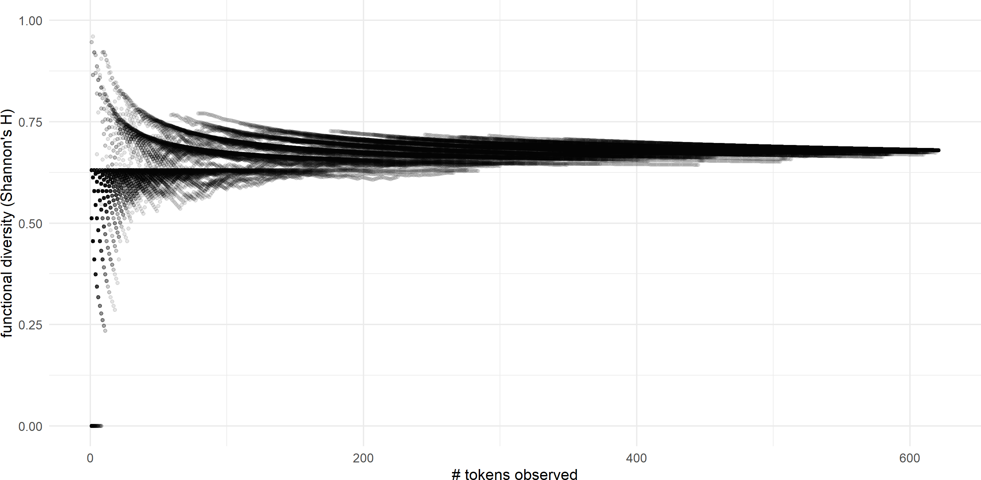

**(e)** *say* **(f)** *see*

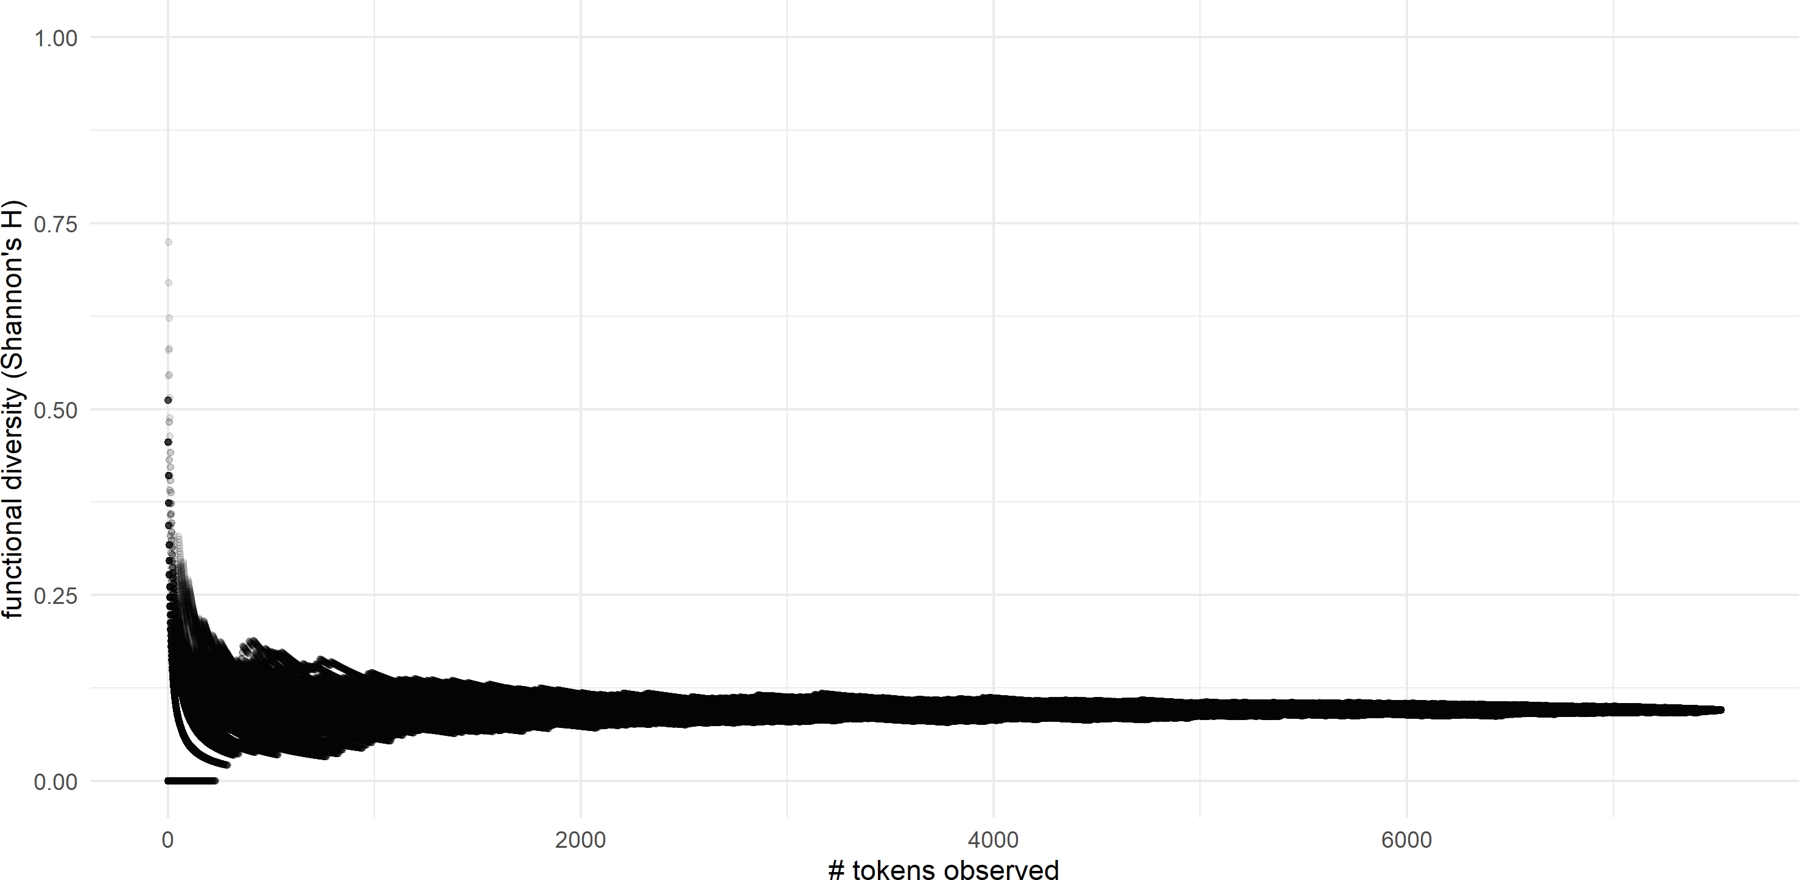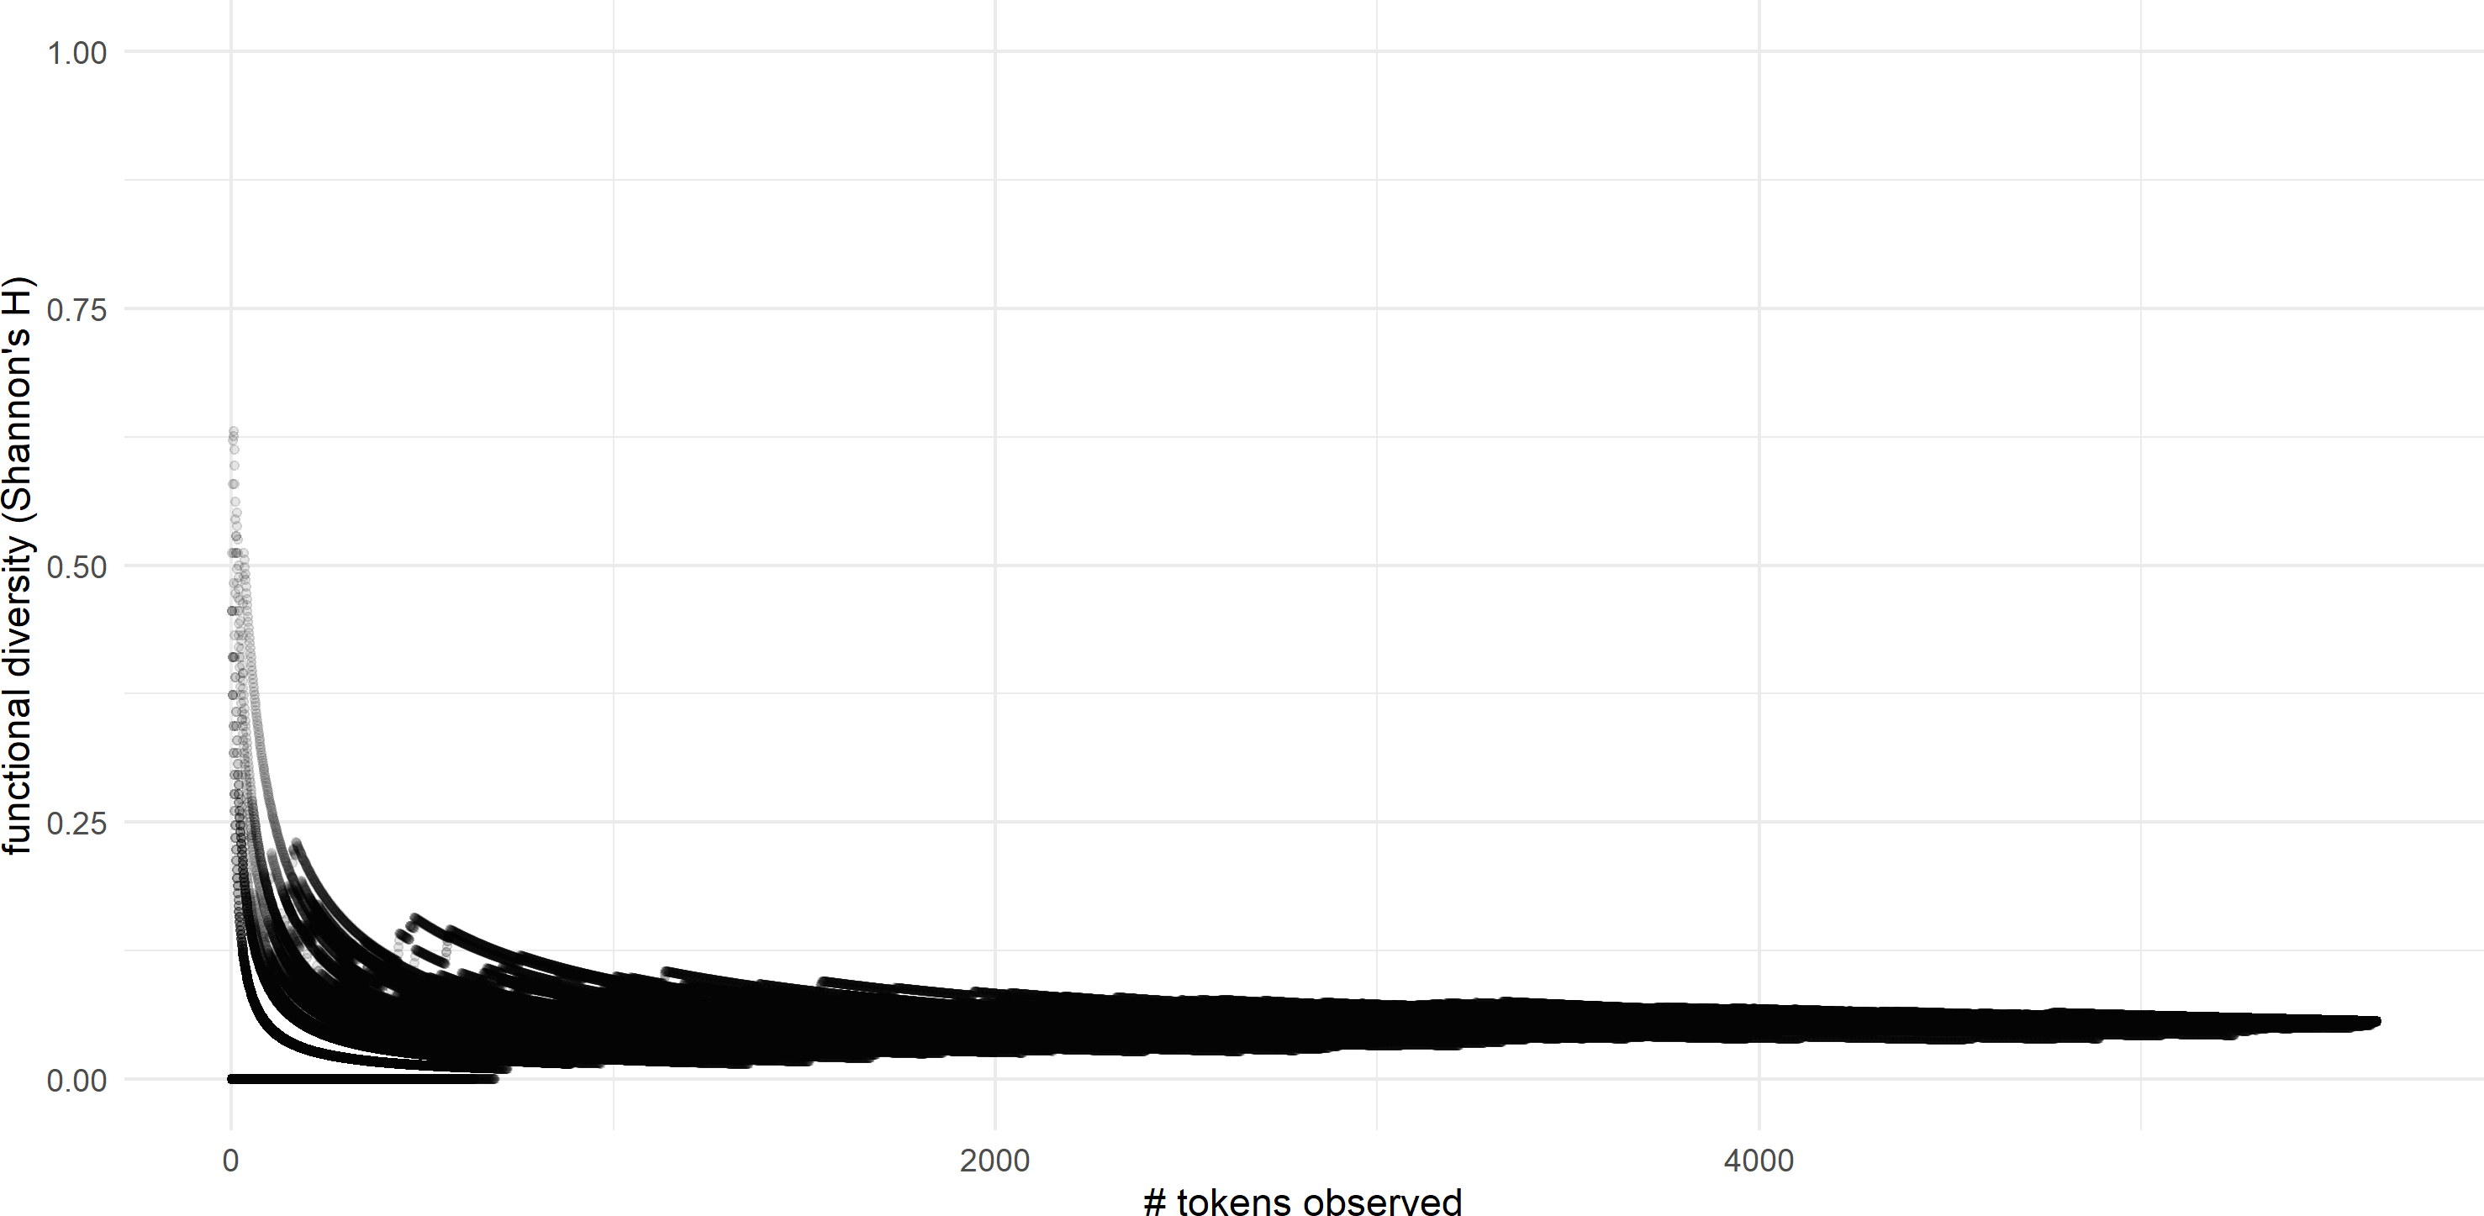

**(g)** *thing* **(h)** *think*

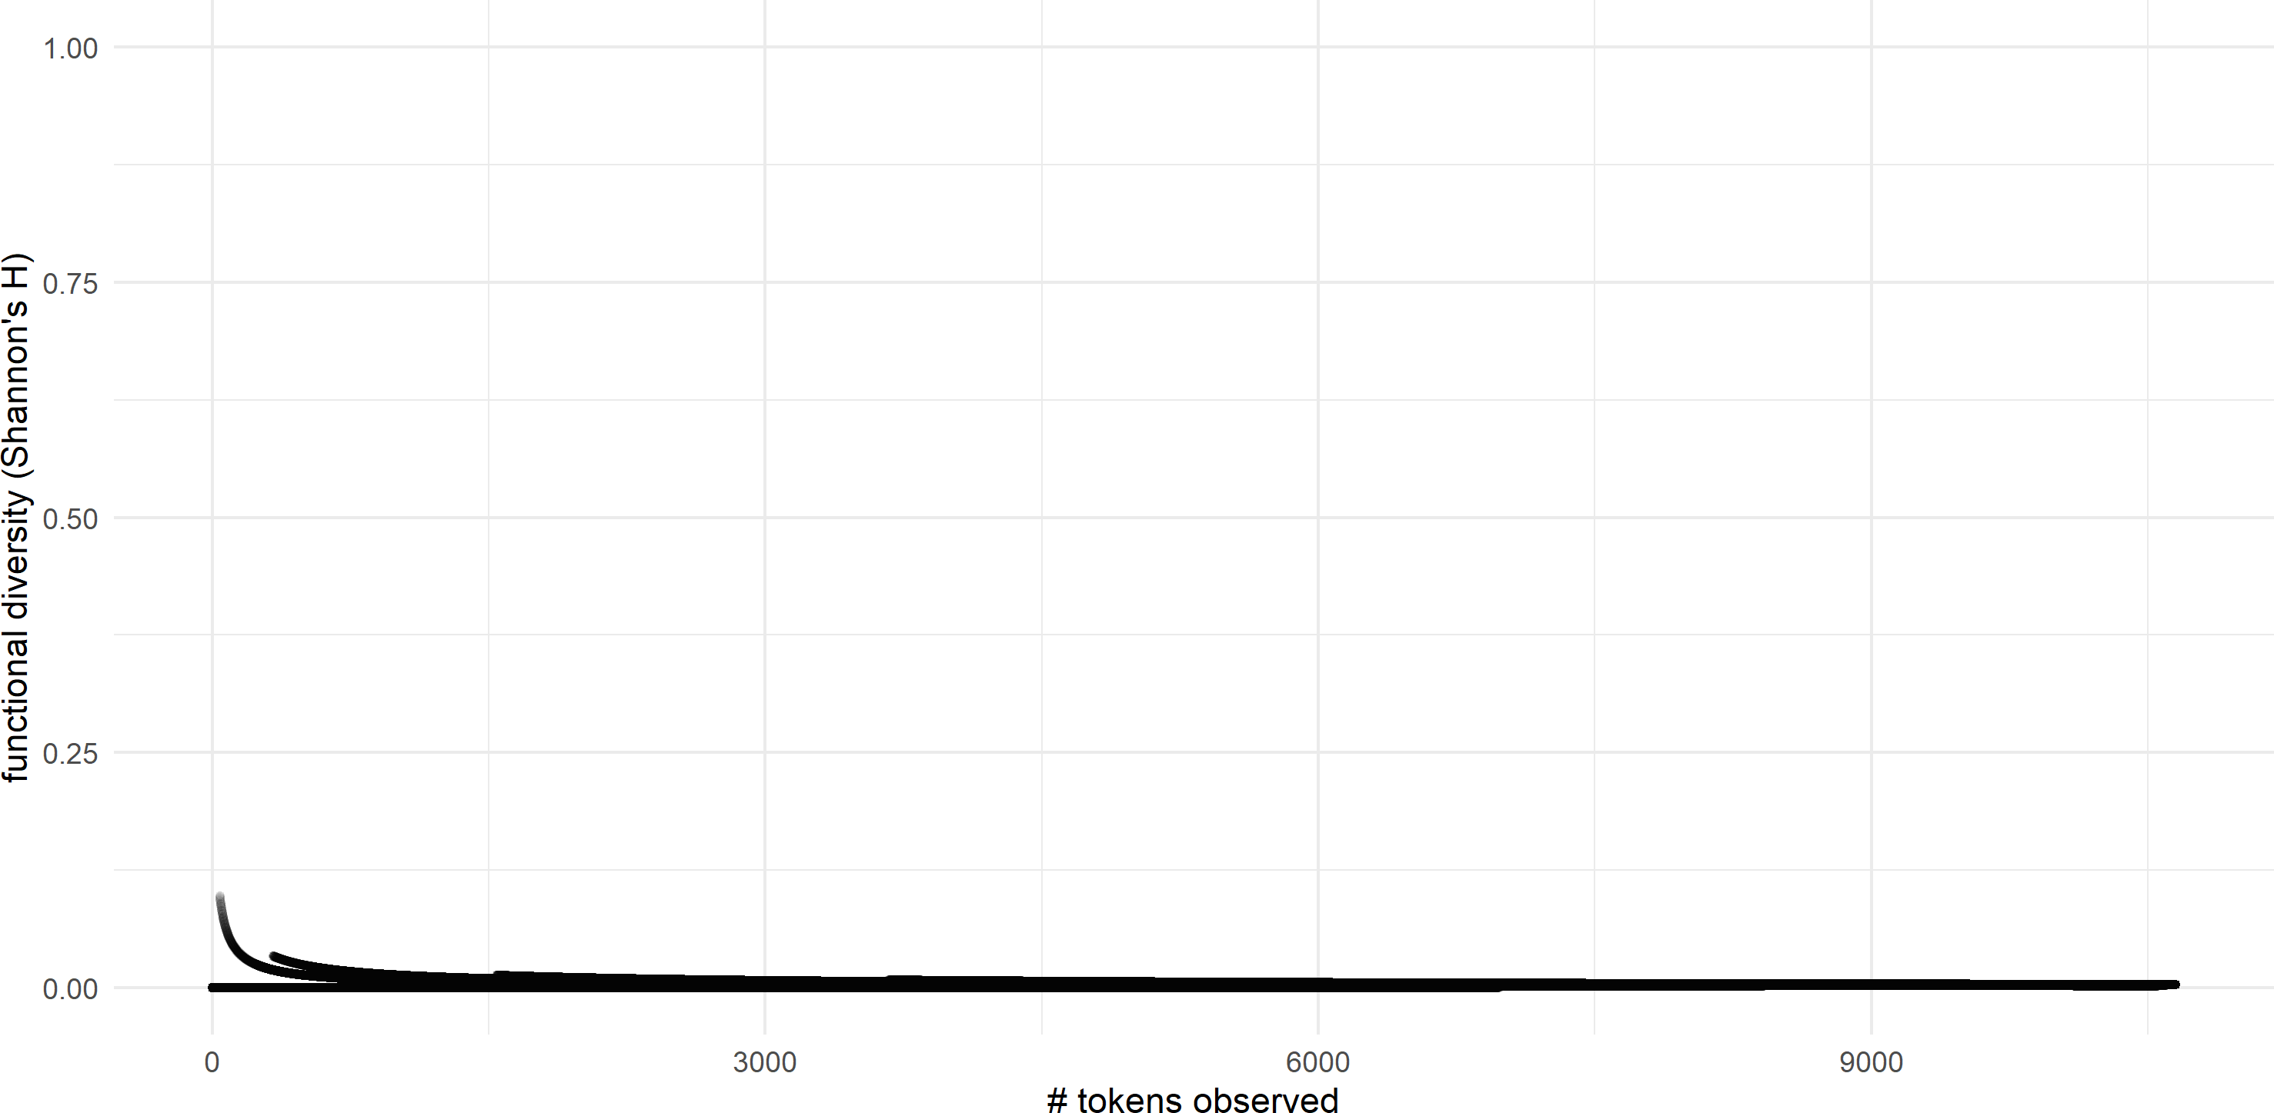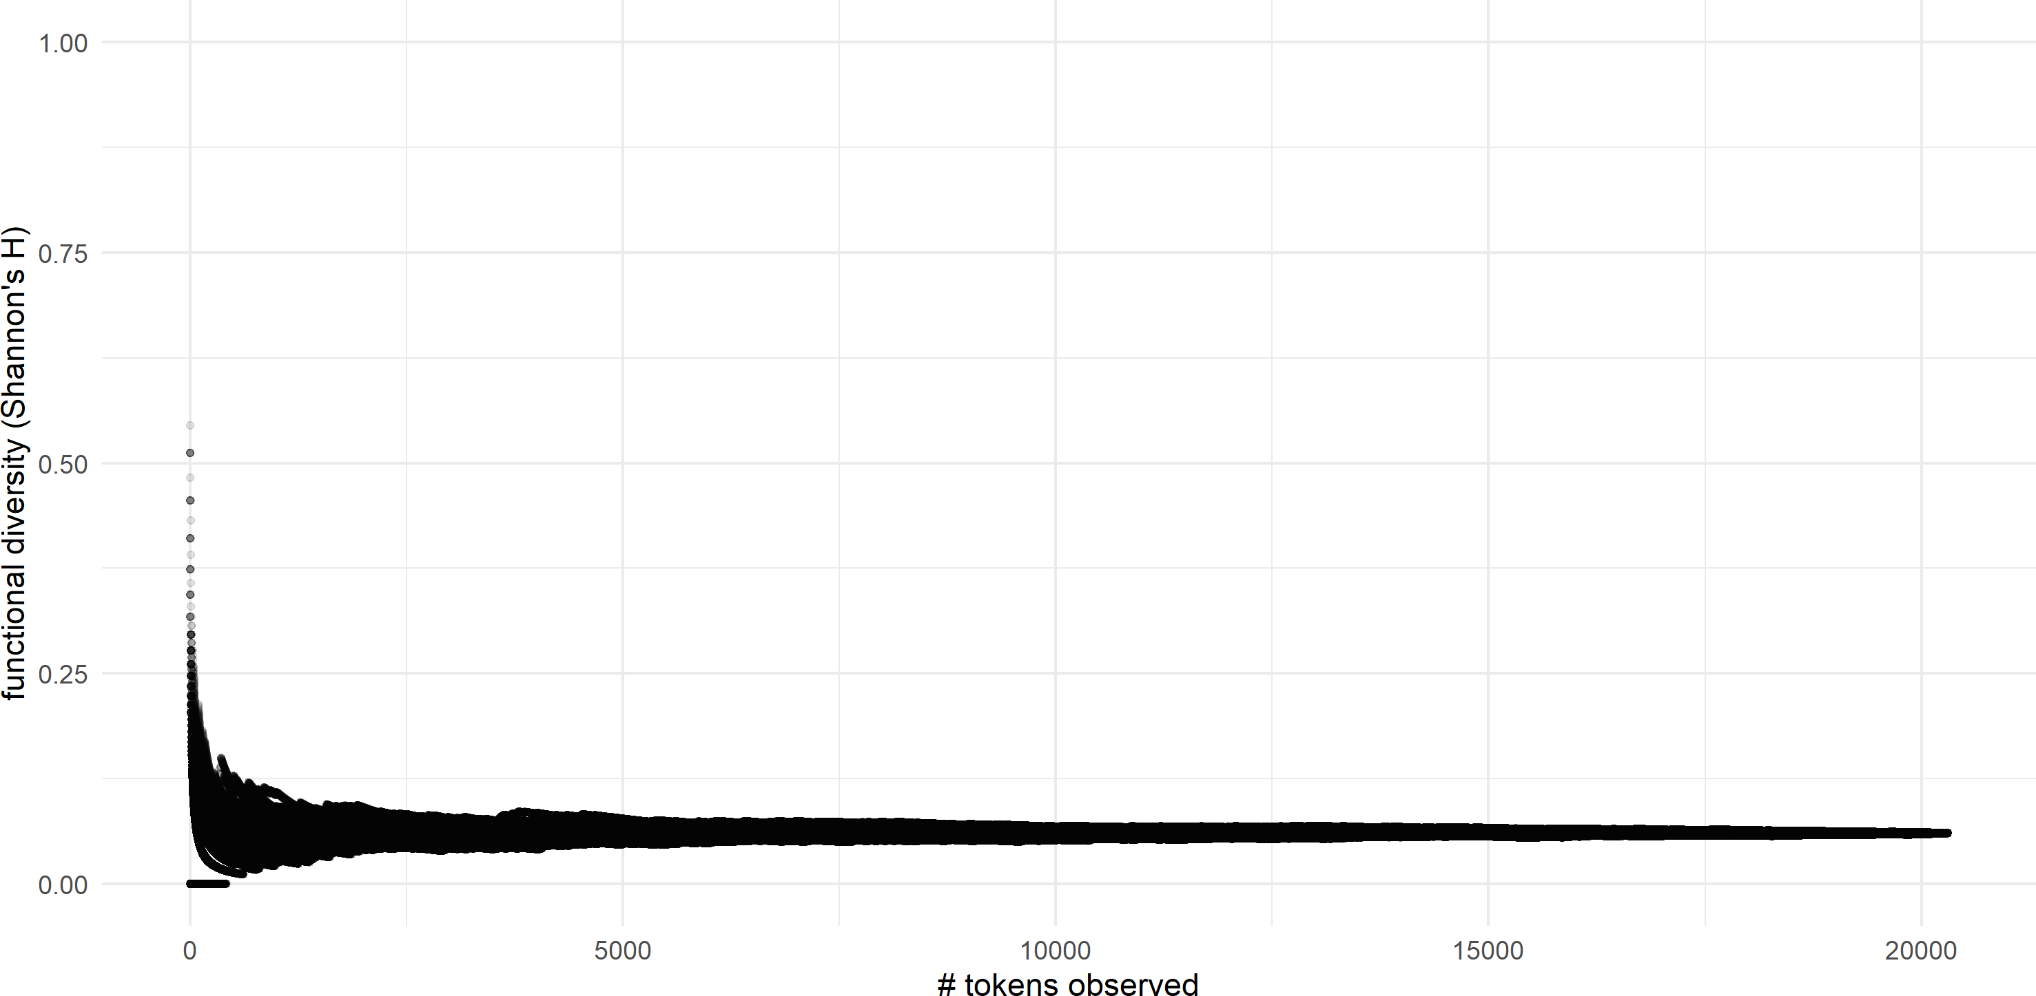

**(i)** *time* **(j)** *year*

**Figure 4.11:** Cumulative functional diversity of high-frequency lexical items in Nuuchahnulth

**(a)** *ḥaw̓ iɬ* ‘chief’ **(b)** *qaḥ* ‘dead’

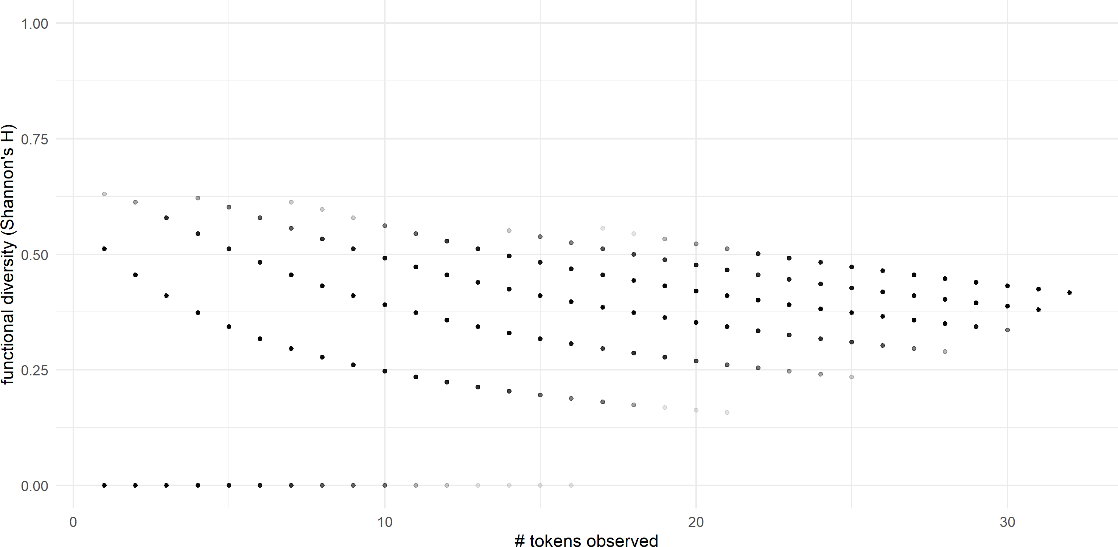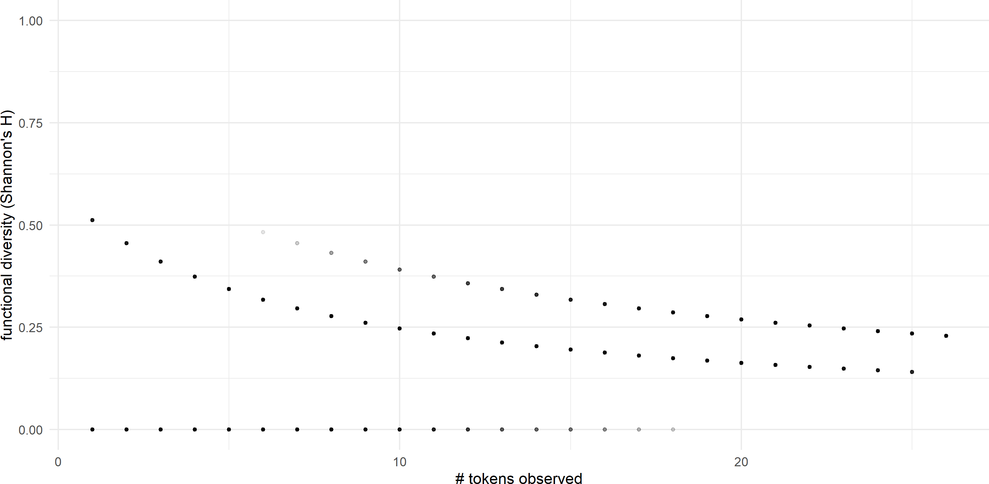

**(c)** *qʷis* ‘do so’ **(d)** *huḥtak* ‘know’

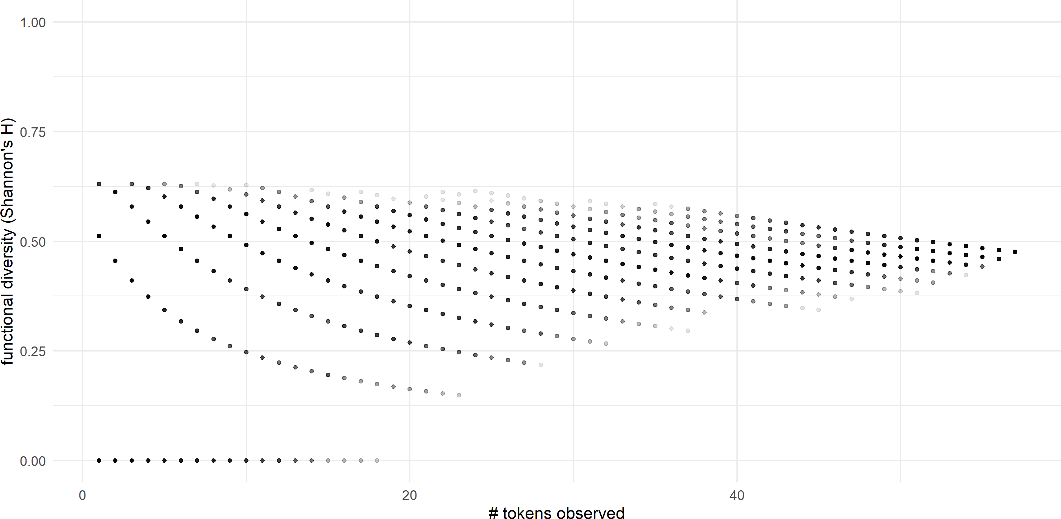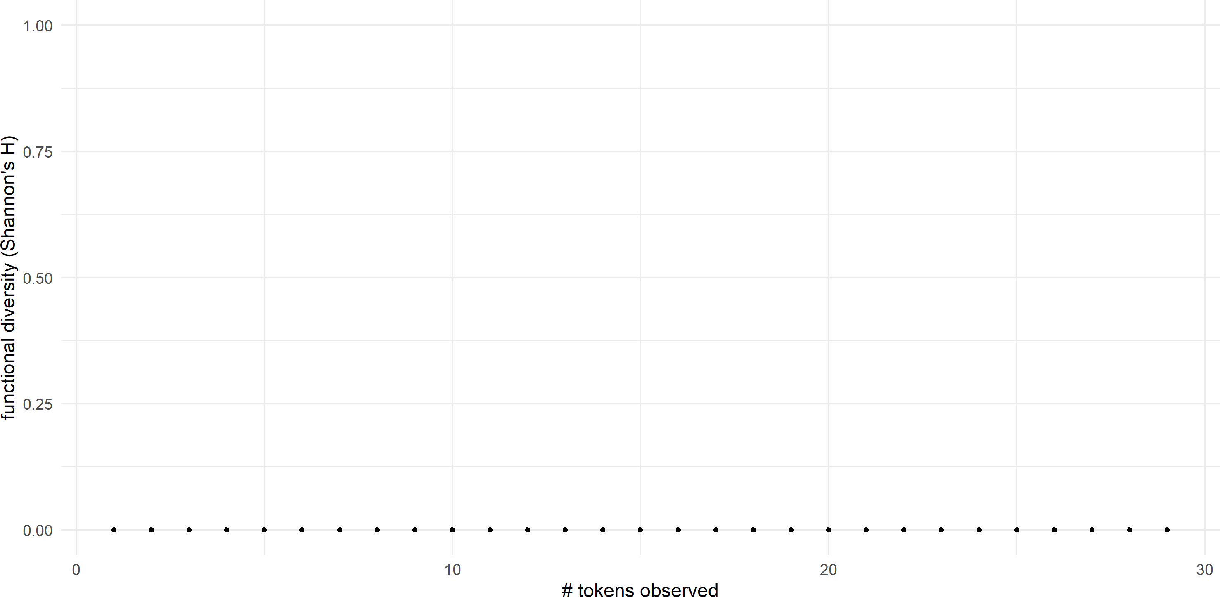

**(e)** *huːʔak* ‘long ago’ **(f)** *ʔaya* ‘many’

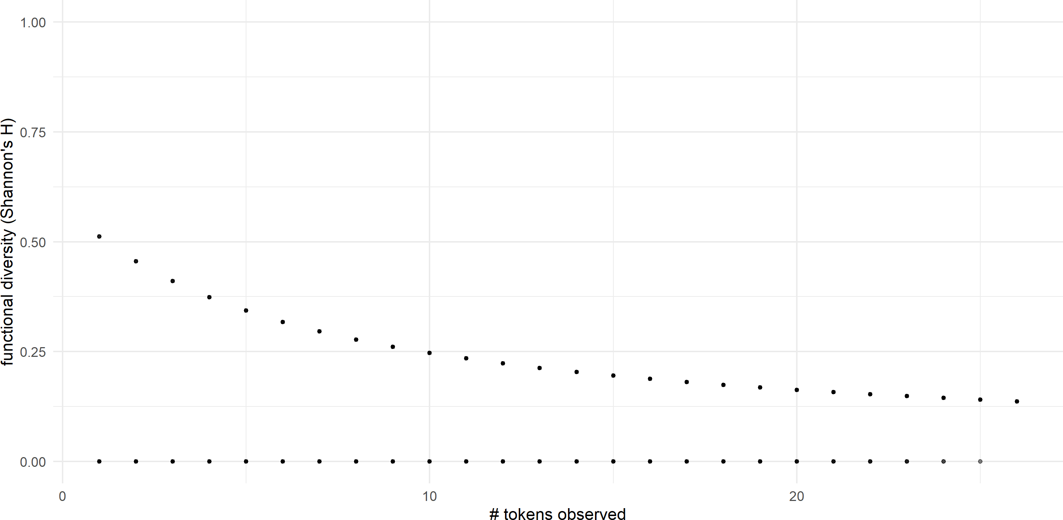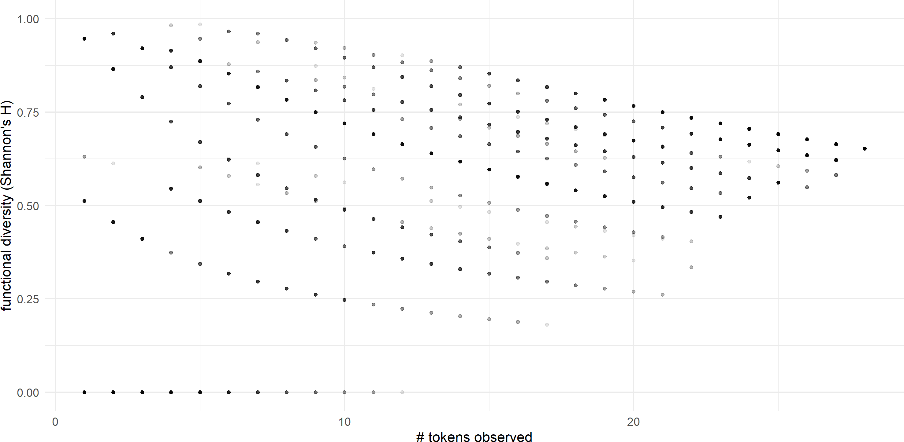

**(g)** *wik* ‘not’ **(h)** *quːʔas* ‘person’

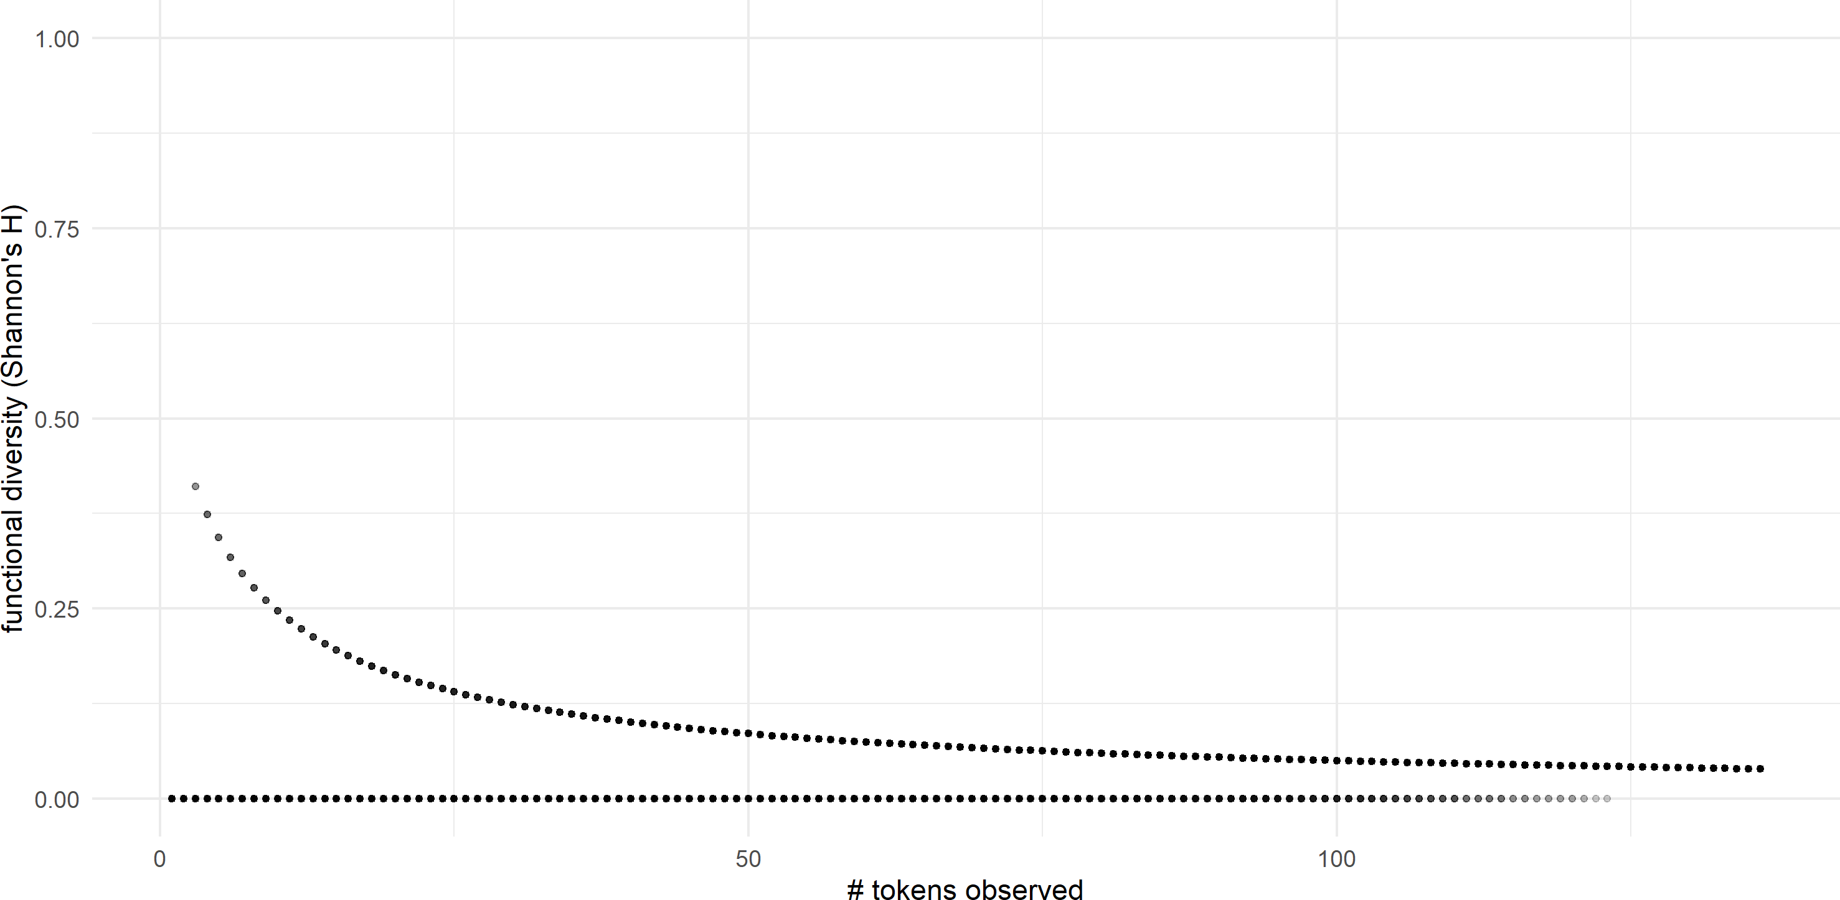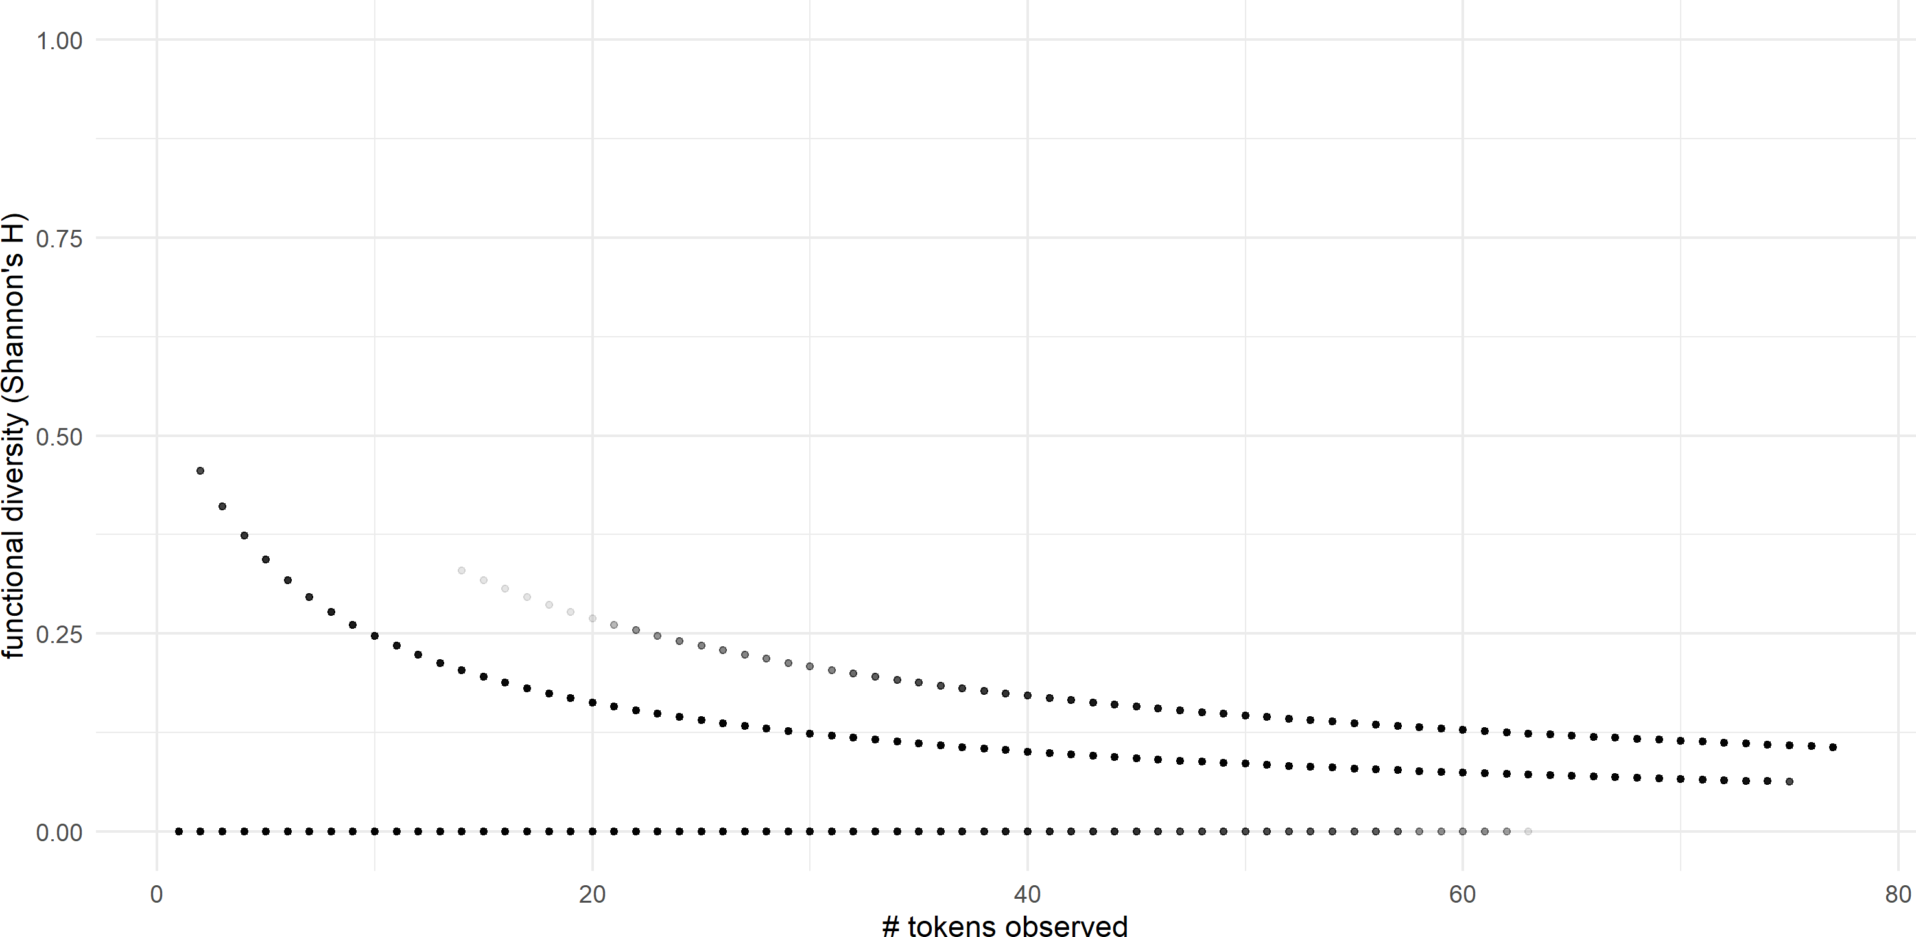

**(i)** *wa·* ‘say’ **(j)** *hiɬ* ‘there’

a continual and gradual increase in functional diversity for many of the stems in the dataset, and this is not the case.

On the other hand, by the time one encounters 5,000 tokens of a word in English, there are no stems with a functional diversity rating of zero. English functional diversity ratings cluster in the lower range (*∼* 0*.*3), but when sufficient tokens are encountered, there do not seem to be any truly monofunctional words. Therefore it does seem to be true (for English at least) that words will eventually display *some* polyfunctionality as the size of the corpus increases, but not that the overall functional diversity of the word will increase.

We can also look at the data for each language in aggregate. Figure 4.12 shows the cumulative mean functional diversity for English per token encountered. Each time a new token of a lexical item was encountered, I determined the current functional diversity ratings of each lexical item encountered up to that point, and calculated their average. The resulting plot shows number of tokens encountered on the x-axis and cumulative mean functional diversity for the entire corpus up to that point on the y-axis. Figure 4.13 shows parallel data for Nuuchahnulth. Both graphs clearly show that the average functional diversity of the corpus does not increase as the corpus grows larger. Instead it remains flat after a sufficient number of tokens are encountered.

To summarize, once enough tokens of a word are encountered to give a reliable functional diversity rating, that functional diversity rating does not increase as the number of tokens encountered continues to grow. Lexical items appear to have (synchronically) fixed degrees of polyfunctionality, that vary from word to word. This suggests that the discourse functions of any given stem are conventionalized, so that speakers know which uses a word has, and generally use them with the same proportionate frequency. Logically, aggregating the data at the language level produces the same result: languages have (synchronically) fixed degrees of polyfunctionality, that vary from language to language.

**Figure 4.12:** Cumulative mean functional diversity for English

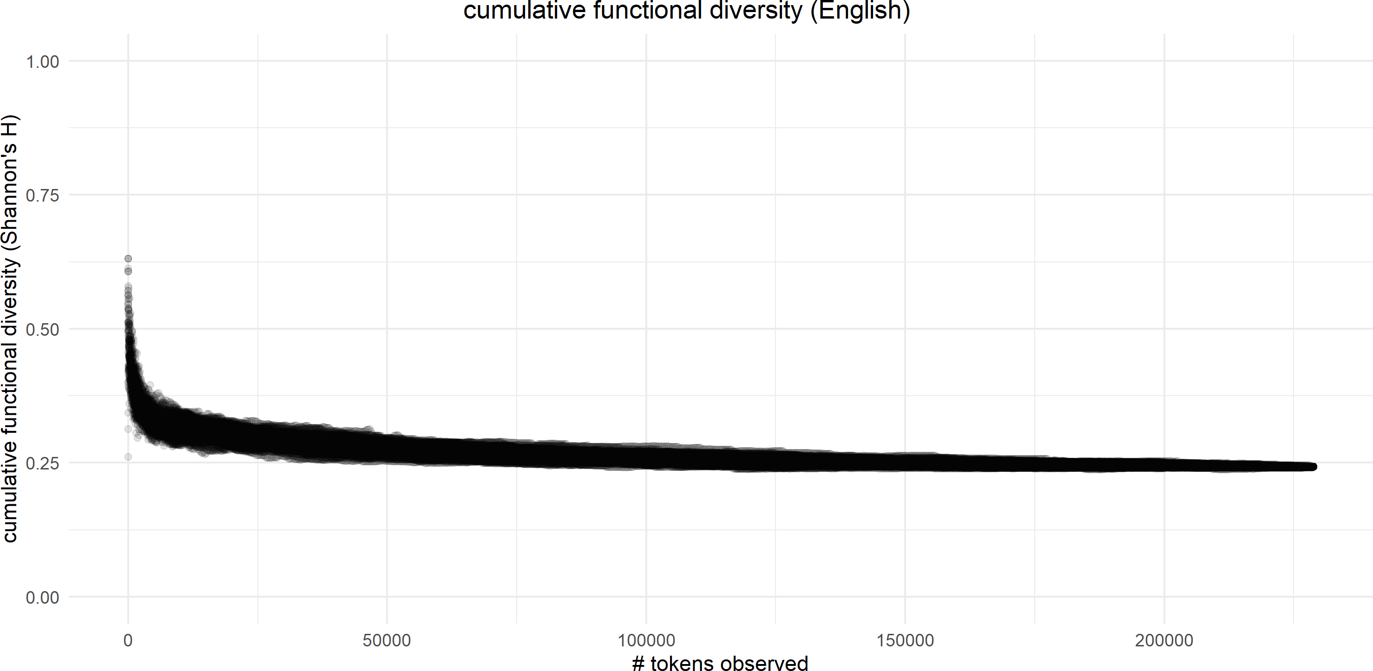

**Figure 4.13:** Cumulative mean functional diversity for Nuuchahnulth

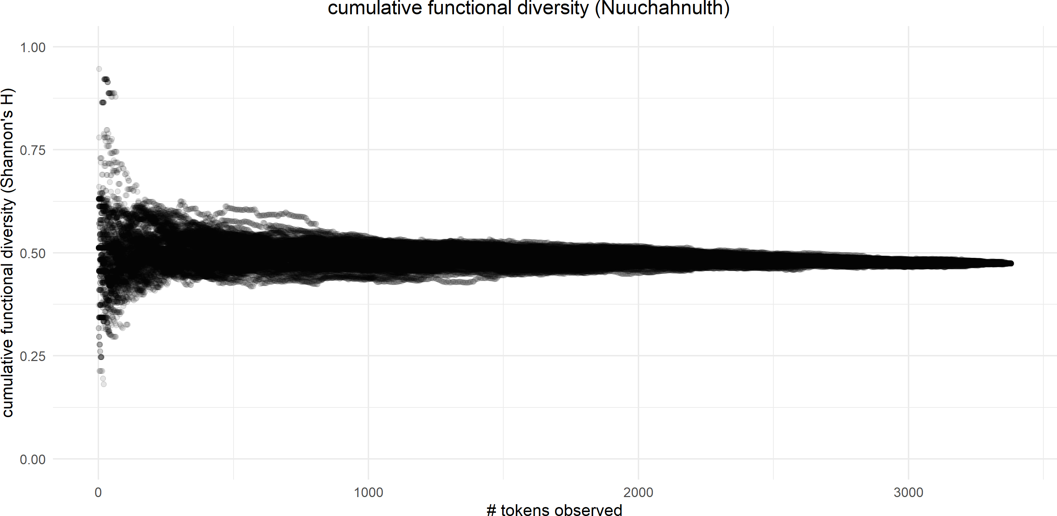

## **R3: Lexical polyfunctionality and frequency / dispersion**

In this section I examine the interactions between lexical polyfunctionality, token frequency, and corpus dispersion for individual lexical items. Since functional expansion entails that a lexical item will appear in a growing range of discourse contexts, a reasonable hypothesis is

that highly polyfunctional words will show a higher frequency and/or corpus dispersion than marginally polyfunctional or monofunctional words. This is an interesting question in part because if such a correlation were found the direction of causation could go in either direction. It may be that stems are more frequent precisely because they are more polyfunctional—there is a wider range of discourse contexts that they can occur in. On the other hand, it could be that high frequency words are more cognitively accessible and therefore more prone to novel uses in discourse. Or, in contrast, a higher frequency could also result in a greater degree of entrenchment, so that high frequency words are less likely to be polyfunctional.

To investigate the possible interactions among lexical polyfunctionality, frequency, and dispersion I deploy a Generalized Additive Model (GAM) in order to account for the possibility of interactions not just between polyfunctionality and frequency / dispersion, but for interactions between frequency and dispersion as well. For example, it may be the case that there are correlations between lexical polyfunctionality and dispersion, but only for high frequency words. A Generalized Additive Model allows for the exploration of multiple interactions in this way.

Frequency is represented in this model as log2 of the relative frequency of the stem. Since relative frequency and corpus dispersion utilize different scales, I also use a tensor smooth to examine the combined contribution of frequency and dispersion to lexical polyfunctionality, over and above their individual contributions. The models were run in R using the mgcv package with the following formula:

functional_diversity ~ s(log_rel_freq) + s(dispersion)

+ ti(log_rel_freq, dispersion)

The results of each of the four models are shown in Table 4.2 through Table 4.5.

Figure 4.14 shows heat maps of the interactions of the three variables for the 100-item English sample and the entire corpus for Nuuchahnulth. The x-axis shows *log*2 of relative frequency, and the y-axis shows corpus dispersion as Deviation of Propotions (*DP* ), with

**Table 4.2:** Results for the Generalized Additive Model for the English small corpus sample

* + 1. Coefficients for linear predictors

Estimate Standard Error t-value p-value intercept 0.12475 0.01856 6.72 < 0.001 ***

* + 1. Coefficients for smooth terms and tensors

|  |  |  |  |  |
| --- | --- | --- | --- | --- |
|  | edf | Ref.df | F | p-value |
| s(log_rel_freq) | 1.000 | 1.000 | 0.482 | 0.488 |
| s(dispersion) | 2.423 | 3.102 | 1.483 | 0.220 |
| ti(log_rel_freq,dispersion) | 1.000 | 1.000 | 0.153 | 0.696 |

* + 1. Explanatory value

*R*2 Deviance Explained 0.0153 4.17%

**Table 4.3:** Results for the Generalized Additive Model for the Nuuchahnulth small corpus sample

1. Coefficients for linear predictors

Estimate Standard Error t-value p-value intercept 0.21806 0.02995 7.28 < 0.001 ***

1. Coefficients for smooth terms and tensors

|  |  |  |  |  |  |
| --- | --- | --- | --- | --- | --- |
|  | edf | Ref.df | F | p-value |  |
| s(log_rel_freq) | 1.000 | 1.000 | 2.019 | 0.1586 |  |
| s(dispersion) | 1.000 | 1.000 | 1.818 | 0.1806 |  |
| ti(log_rel_freq,dispersion) | 1.000 | 1.000 | 4.274 | 0.0413 | * |

1. Explanatory value

*R*2 Deviance Explained 0.0857 11.3%

more evenly dispersed items to the bottom of the scale and less evenly dispersed items to the top of the scale. Light-colored areas indicate a high degree of functional diversity, while dark-colored areas indicate a low degree of functional diversity.

Figure 4.15 shows 3D representations of the same data, rotated for ease of visualization. log2 relative frequency is shown on the x-axis (with higher relative frequency to the left—the

**Table 4.4:** Results for the Generalized Additive Model for the English 100item sample

1. Coefficients for linear predictors

Estimate Standard Error t-value p-value intercept 0.22529 0.03848 5.854 < 0.001 ***

1. Coefficients for smooth terms and tensors

|  |  |  |  |  |
| --- | --- | --- | --- | --- |
|  | edf | Ref.df | F | p-value |
| s(log_rel_freq) | 1.000 | 1.000 | 0.235 | 0.629 |
| s(dispersion) | 1.724 | 2.258 | 0.222 | 0.733 |
| ti(log_rel_freq,dispersion) | 1.000 | 1.000 | 0.005 | 0.942 |

1. Explanatory value

*R*2 Deviance Explained

-0.00362 3.38%

**Table 4.5:** Results for the Generalized Additive Model for the Nuuchahnulth 100-item sample

1. Coefficients for linear predictors

Estimate Standard Error t-value p-value intercept 0.21806 0.02995 7.28 < 0.001 ***

1. Coefficients for smooth terms and tensors

|  |  |  |  |  |  |
| --- | --- | --- | --- | --- | --- |
|  | edf | Ref.df | F | p-value |  |
| s(log_rel_freq) | 1.000 | 1.000 | 2.019 | 0.1586 |  |
| s(dispersion) | 1.000 | 1.000 | 1.818 | 0.1806 |  |
| ti(log_rel_freq,dispersion) | 1.000 | 1.000 | 4.274 | 0.0413 | * |

1. Explanatory value

*R*2 Deviance Explained

-0.00362 11.3%

reverse of Figure 4.14), functional diversity is shown on the y-axis (with higher functional diversity at the top of the scale), and corpus dispersion is shown on the z-axis (with more evenly dispersed values further away).

In English, high frequency evenly dispersed items appear to have low functional diversity ratings, while low frequency unevenly dispersed items appear to have high functional diver-

**Figure 4.14:** Interactions among frequency, dispersion, and functional diversity for English vs. Nuuchahnulth (heat map)

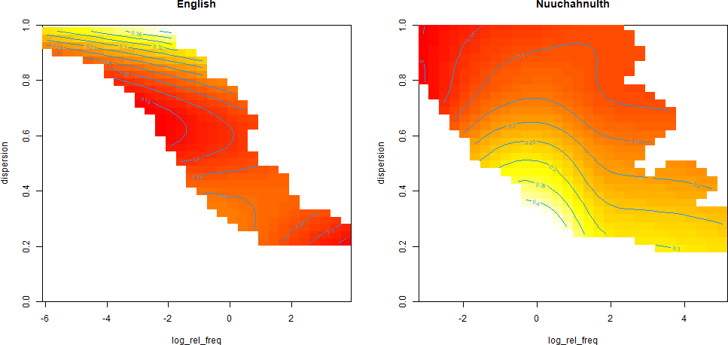

**Figure 4.15:** Interactions among frequency, dispersion, and functional diversity for English vs. Nuuchahnulth (3D map)

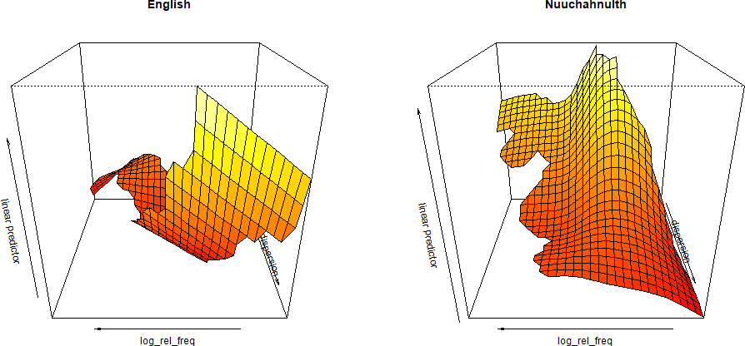

**Figure 4.16:** Interactions among frequency, dispersion, and functional diversity for English vs. Nuuchahnulth, with standard deviations (3D map)

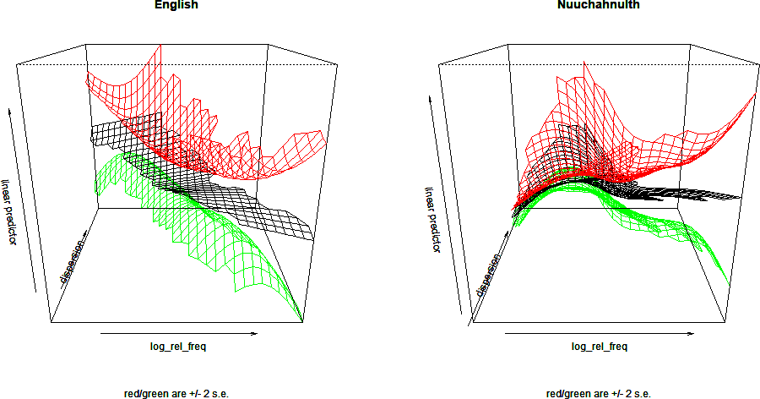

sity ratings. However, none of the interactions for either of the English models are significant. The reason for this becomes apparent when we look at the same 3D interaction plot but with maps added at a standard deviation of 2, as in Figure 4.16. There is so much variability in the data that the results are largely uninterpretable. In both English models, *R*2 is tiny / negative, and the deviance explained is extremely small (4.17% and 3.38% for the small corpus sample and the 100-item sample respectively). No conclusions can be drawn from the data.

In Nuuchahnulth, high-frequency evenly-dispersed items appear to have high functional diversity ratings. However, the models for both Nuuchahnulth samples also fail to show any significant interactions, with one exception: the combined effect of log relative frequency and dispersion (above and beyond their individual contributions) is significant for both models at p < 0.05. However, the *R*2 values for both models are again extremely small. The deviance explained for both models is 11.3%. Like with English, no conclusions can be drawn from the data.

In summary, the data on lexical polyfunctionality and frequency / corpus dispersion show no notable evidence for any interactions among the three variables.

## **R4: The semantics of lexical polyfunctionality**

In this section I briefly examine the semantics of lexical polyfunctionality. I begin by exemplifying the kinds of semantic changes that are possible in the process of functional expansion, and show that there are no general principles that can predict the outcome of this semantic expansion. I argue based on this that polyfunctionality requires conventionalization; polyfunctional items cannot be truly flexible as is often claimed (see also Section 2.3.3.2).

Next, I examine whether there are semantic commonalities among highly polyfunctional or highly monofunctional words. I restrict myself here to aspects of the semantics of lexical items which can be discerned from the existing data and annotations used to answer other research questions for this project. Little additional data coding or annotation was done for the specific purpose of answering this research question. This section is therefore primarily exploratory, with the aim of discovering just what conclusions can be drawn about the semantics of lexical polyfunctionality using merely the simple annotations of discourse functions prepared for this study. I begin with English before moving on to Nuuchahnulth.

### **Semantic expansion**

When a lexical item expands into new discourse functions, the network of semantic meanings associated with that item expands in unison. That particular combination of form + discourse function now has a new meaning associated with it. This is illustrated schematically in Fig- ure 4.17. In this figure the existing, referential meanings for a lexical item are shown on the left. As this particular lexical item undergoes functional expansion into the domain of predication, a new, predicative meaning emerges, represented by the dashed box on the right. Croft (1991: 74–77; 2001b: 73) calls this process *semantic shift*. Similar to the difference between the terms *functional shift* as compared to *functional expansion*, the term *semantic expansion* is a slightly more precise description of this diachronic process of semantic change, and so I adopt the term *semantic expansion* instead of *semantic shift* here.

**Figure 4.17:** Semantic expansion into a new discourse function

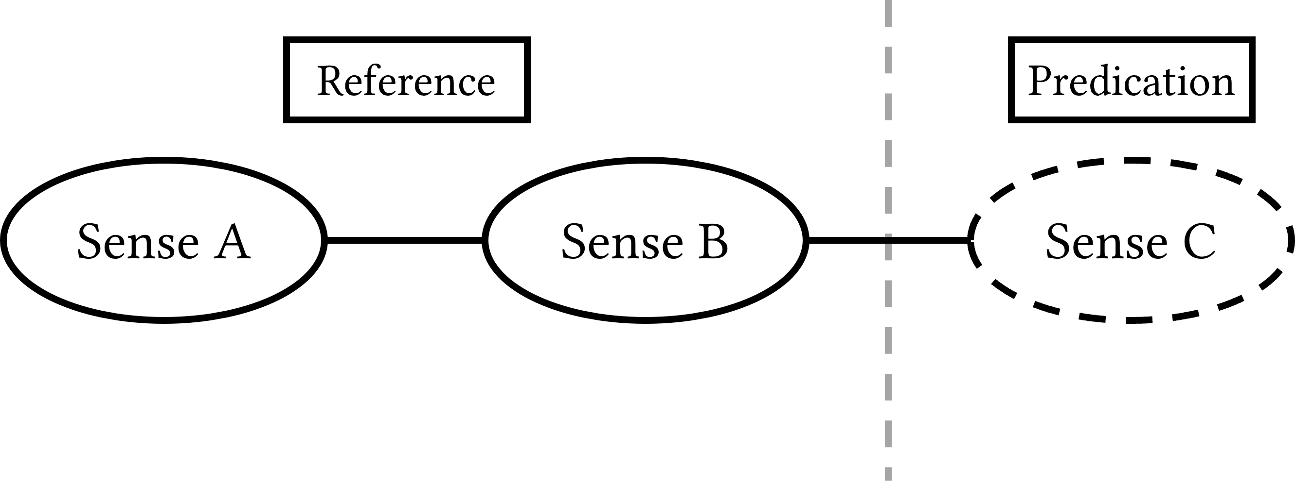

In some cases of semantic expansion, the new meaning seems predictable from the existing meanings: the meaning of the form in the new discourse function can be inferred from a combination of the local context and the conventional definition of the word. In other words, the semantic changes that occur in some cases of functional expansion appear to be *flexible*, as described in Section 2.3.1.1. The new meaning does not seem to require conventionalization. Examples (51)–(53) show some such seemingly flexible cases in Nuuchahnulth. In Nuuchahnulth, numerals consistently show the same semantic patterns when used in reference, predication, or modification. When used to modify a referent, numerals always quantify the referent, as in (51).

1. Nuuchahnulth (Wakashan > Southern Wakashan)

hiiɬtqyaap̓ up hiɬ‑tqya·p̓ i‑up there‑back‑momcaus put.on.the.back

**ʔaƛa ʔaƛa two two**

qʷayac̓iik. qʷayac̓iːk wolf

wolf

‘Two wolves put [the dead wolf] on their back.’ (Little 2003: FoodThief 046)

When used as a predicate, numerals ascribe a quantity to the subject, meaning ‘to be X in number’. This is often translated with the existential construction *there are* in English. Examples are in (52).

1. Nuuchahnulth (Wakashan > Southern Wakashan)
   1. ʔaƛin

ʔaƛa‑in two‑come two.came

Toshi, Toshi NAME

Toshi

ɬuucmaak. ɬuːcma‑ʔa·k wife‑poss his.wife

**ʔaƛaʔaɬ**

**ʔaƛa‑ʔa·ɬ two‑pl**

**two.of.them**

‘Toshi came with another person, his wife. They were two.’ (Louie 2003: GL 166)

* 1. wik̓aƛ

wik‑ʼaƛ not‑fin didnt

haʔukšiƛ, haʔuk‑ši(ƛ) eat‑mom ate

**ʔaƛiičiƛ**. **ʔaƛa‑ʽi·čiƛ**

**two‑incep became.two**

‘He (Mink) didn’t eat them and the crabs became two.’ (Louie 2003: Mink 266)

* 1. suutšiʔaƛ suːt‑ši(ƛ)‑ʼaƛ drill‑mom‑fin drilled

qʷaaƛaa, qʷaːƛaː also

also

**qacc̓aquu**, **qacc̓a‑quː**

**three‑cond.3 could.be.three**

‘Then you drill holes, maybe three’ (literally: ‘they could be three’)

(Louie 2003: Canoe 067)

* 1. watqšiʔaƛƛa, watq‑ši(ƛ)‑ʼaƛ‑ƛa· swallow‑mom‑fin‑again swallowed.again

**ʔaƛakʷaɬšiƛ**.

**ʔaƛakʷaɬ‑ši(ƛ) eight‑mom became.eight**

‘He swallowed [stones] again and it (the number of stones in his stomach) became eight.’ (Louie 2003: Qawiqaalth 066)

When used for reference, numerals anaphorically identify an already-established referent in the discourse. In example (53a), *muu* ‘four’ refers to the currently in focus discourse topic— the chiefs. In example (53b), *ʔaƛimt* ‘two’ refers to an already activated discourse topic—the rocks.

1. Nuuchahnulth (Wakashan > Southern Wakashan)

|  |  |  |
| --- | --- | --- |
| a. hišuk | **muu**. | muu. |
| hiš‑uk | **muː** | muː |
| all‑duR | **four** | four |
| all | **four** | four |

‘There are four [chiefs] in total.’ (Louie 2003: Wolf 198)

b. watqšiƛ watq‑ši(ƛ) swallow‑mom

completely.swallowed

**ʔaƛimt ʔaƛ‑imt**

**two‑past two**

‘He swallowed two of them.’ (Louie 2003: Qawiqaalth 057)

I have not found any deviations from these semantic patterns in the corpus. This fact suggests that the meanings of numerals when used in different discourse functions are predictable and, arguably, flexible. Importantly, however, these different uses would not be predictable if Nuuchahnulth did not have the broader *convention* governing the use of numerals in different discourse functions. One could imagine, for example, that numerals used as referents in Nuuchahnulth always referred to the abstract concept for that numeral; this is not the case. The fact that the numerals used for reference in Nuuchahnulth refer anaphorically back to an activated discourse topic instead of to the abstract number is a *convention* of Nuuchahnulth. Although the use of numerals in Nuuchahnulth appears at first glance to be flexible, we see that this impression is merely superficial. The fact that numerals *consistently* produce the same kinds of meanings in different discourse functions is strong evidence that these semantic patterns are a matter of convention rather than creative and novel uses by speakers, i.e. flexibility.

It should be emphasized here that these different uses of numerals are only *synchronically* predictable, by virtue of being conventionalized. Diachronically, it is impossible to predict the meaning that will become conventionally associated with the new discourse function as a result of semantic expansion, and whether that meaning will follow some general pragmatic principle be idiosyncratic.

Interestingly, as will be discussed in Section 4.6.3, numerals in Nuuchahnulth are also consistently among the most functionally diverse lexical items in the language. This suggests a potential correlation in which semantic classes that have predictable (i.e. well-conventionalized) semantic interpretations in different discourse functions exhibit a greater degree of functional diversity. This stands to reason: if a lexical item acquires a new meaning that is particularly idiosyncratic, there is no broader semantic pattern that speakers can rely upon to analogously expand the meaning of other lexical items in the same way.

There are many other cases of functional expansion where semantic expansion does not follow any general pattern. Knowing the meaning of the form in that discourse function

requires that the meaning be conventionalized. Consider for example the lexical items *work*, *order*, and *transfer* in English. Uses of these words in the three discourse contexts are provided below.

1. English (Indo-European > Germanic)

**Reference**

* 1. I didn’t want to learn nothing about no laundry **work**!

(Ide & Suderman 2005: MillsJanie)

* 1. So Friday morning right I’m at **work**.
  2. I can appreciate Milne’s **work**.

(Ide & Suderman 2005: FeberAngelina) (Ide & Suderman 2005: GregoryAvis)

* 1. I think Gorbachev would like to see a one world **order**

(Ide & Suderman 2005: sw2410-ms98-a-trans)

* 1. I said I wanna cancel my **order**

(Ide & Suderman 2005: sw2733-ms98-a-trans)

* 1. […] being foul because an **order** took longer than they may have liked

(Ide & Suderman 2005: sw2733-ms98-a-trans)

* 1. an hour and a half of three different bus **transfers**

(Ide & Suderman 2005: sw2458-ms98-a-trans)

* 1. last year we took a transfer and so therefore we had the boost in income

(Ide & Suderman 2005: sw3192-ms98-a-trans)

**Predication**

1. Because my whole first year I didn’t **work**.
2. All my digits um still **work**.
3. That will **work**.

(Ide & Suderman 2005: AverittShannon) (Ide & Suderman 2005: BorelRaymondHydeII) (Ide & Suderman 2005: LeakJeffrey)

1. they can sit and **work** puzzles and read books for a long time

(Ide & Suderman 2005: sw4095-ms98-a-trans)

1. I think you can even **order** a magazine that keeps you up to date

(Ide & Suderman 2005: sw2718-ms98-a-trans)

1. […] whose unit was **ordered** up and he refused to go

(Ide & Suderman 2005: sw2245-ms98-a-trans)

1. I would **transfer** but I’m happy with school here

(Ide & Suderman 2005: sw2245-ms98-a-trans)

1. I can **transfer** data back and forth.

(Ide & Suderman 2005: sw2245-ms98-a-trans)

**Modification**

1. […] have a three car garage but he has a big **work** area in it

(Ide & Suderman 2005: sw3317-ms98-a-trans)

1. the way it works usually the **ordering** person doesn’t pay

(Ide & Suderman 2005: sw4372-ms98-a-trans)

1. what they refer to as **transfer** payments

(Ide & Suderman 2005: sw2327-ms98-a-trans)

Each of these lexical items differ in the kinds of meanings available in each discourse function. When *work* is used for reference, it can refer to an action, a location, or a product. When *order* is used for reference, it can refer to an abstract concept, a product, or an action. When *transfer* is used for reference, it can refer to an action or a product. There does not appear to be a general pattern for determining the meanings that these words have when used for reference. In the predication function, each of these words have multiple senses. Yet only some of these senses are available to either the modification function or the reference function. *Not all senses of a word appear in all discourse functions.* Speakers must memorize which senses are available in which functions. In other words, *one cannot characterize the semantic changes that occur during functional expansion in any general way* (Mithun 2017). Functional expansion has a wide array of diverse semantic effects.

In conclusion, even “predictable” semantic expansions are not in fact predictable. One can never know with certainty whether a given lexical item will undergo semantic expansion in a way that follows some general semantic principle, or in a way that results in an idiosyncratic meaning. Even those resultant meanings which adhere to patterns or principles must be a matter of convention, because speakers must have item-specific knowledge about which lexical items follow certain general semantic principles and which ones are idiosyncratic. We can conclude, then, that cases of polyfunctionality cannot be truly flexible in the sense typically intended by those who describe polyfunctionality as lexical flexibility.

### **English**

In this section and the next, I attempt to determine whether some semantic domains or classes are more polyfunctional than others. As mentioned above, this section is highly exploratory and should not be taken as a definitive analysis.

The first observation about the semantics of lexical polyfunctionality in English is purely anecdotal but nonetheless merits comment: the second most polyfunctional word in the 100item sample of English is *back*, used 272 times for reference, 54 times for predication, and 143 times for modification, with a functional diversity rating of *.*844. Going into this study, I postulated that body part terms would display a high degree of polyfunctionality. The motivation for this hypothesis is that body part terms commonly undergo metaphorical extension into other domains, and in general make themselves available for all sorts of extensions of meaning. This is undoubtedly due to the fact that our experience of the world is necessarily mediated through our own bodies (Lakoff & Johnson 1980). The methods I chose to adopt in this dissertation prevented any detailed exploration of this hypothesis, but it is notable that the only body part term in either of the 100-item samples is one of the single most polyfunctional items in this study, anecdotally supporting the hypothesis that body part terms are in general highly polyfunctional.

Several semantic classes stand out as being among the least polyfunctional words in the

100-item English sample: indefinites; adult human animates (less so for non-adult humans, as the data for *child* shows); property words denoting size, age, or physical properties; and words of cognition and perception generally have functional diversity ratings lower than 0*.*100, and most are within the 25 least functionally diverse words in the sample (exceptions are *feel*, *need*, and *wonder*). Indefinites in particular rank lowest among the ratings (all with a functional diversity rating of 0). Table 4.6 shows the statistical data from the sample for each of the semantic classes just discussed, and their rank in terms of functional diversity (out of the 100 items sampled). (Note that there are some ties for rank.)

|  |  |  |  |  |  |  |
| --- | --- | --- | --- | --- | --- | --- |
| need 0.833 | 0.501 | 0.220 | 164 | 2,475 | 3 | 43 |
| wonder 0.206 | 0.793 | 0.194 | 26 | 589 | 4 | 46 |
| feel 0.832 | 0.529 | 0.135 | 73 | 2,382 | 5 | 51 |
| decide 0.242 | 0.752 | 0.097 | 3 | 652 | 10 | 57 |
| think 6.477 | 0.262 | 0.060 | 162 | 20,089 | 58 | 66 |
| consider 0.146 | 0.834 | 0.058 | 0 | 336 | 4 | 67 |
| see 2.540 | 0.343 | 0.056 | 46 | 5,563 | 11 | 68 |
| understand 0.275 | 0.724 | 0.053 | 4 | 752 | 3 | 71 |
| want 1.552 | 0.374 | 0.037 | 7 | 4,899 | 23 | 75 |
| know 13.729 | 0.214 | 0.030 | 7 | 11,496 | 51 | 76 |
| hate 0.140 | 0.840 | 0.026 | 0 | 442 | 2 | 78 |
| believe 0.312 | 0.709 | 0.014 | 0 | 953 | 2 | 81 |
| enjoy 0.481 | 0.677 | 0.005 | 0 | 1,485 | 1 | 90 |
| like 1.158 | 0.447 | 0.003 | 1 | 3,105 | 0 | 94 |
| Human Animates |  |  |  |  |  |  |
| child 0.784 | 0.677 | 0.326 | 2,165 | 0 | 283 | 28 |
| woman 0.342 | 0.827 | 0.146 | 969 | 0 | 38 | 50 |
| man 0.287 | 0.765 | 0.101 | 752 | 1 | 16 | 56 |
| father 0.137 | 0.867 | 0.040 | 401 | 0 | 3 | 74 |
| person 0.360 | 0.690 | 0.013 | 1,011 | 1 | 1 | 84 |
| friend 0.390 | 0.653 | 0.012 | 1,237 | 1 | 1 | 85 |
| husband 0.424 | 0.668 | 0.011 | 1,281 | 0 | 2 | 86 |
| Indefinites |  |  |  |  |  |  |
| anything 0.755 | 0.449 | 0.000 | 2081 | 0 | 0 | 94 |
| everything 0.606 | 0.518 | 0.000 | 1960 | 0 | 0 | 94 |
| something 1.665 | 0.341 | 0.000 | 5092 | 0 | 0 | 94 |
| thing 3.277 | 0.267 | 0.000 | 10649 | 0 | 0 | 94 |
| Property Words |  |  |  |  |  |  |
| little 1.738 | 0.362 | 0.511 | 1,345 | 0 | 4,062 | 15 |
| pretty 1.170 | 0.440 | 0.170 | 1 | 1 | 51 | 49 |
| old 0.607 | 0.565 | 0.054 | 5 | 3 | 838 | 70 |
| big 0.830 | 0.474 | 0.046 | 21 | 0 | 2,381 | 72 |
| large 0.156 | 0.845 | 0.042 | 2 | 1 | 428 | 73 |
| hard 0.486 | 0.587 | 0.000 | 0 | 0 | 380 | 94 |

**Table 4.6:** Low functional diversity stems in English

Stem Rel. Freq. Disp. Divers. Ref. Pred. Mod. Rank Cognition & Perception

It is easy to see why some of these classes of words would have such low functional diversity ratings: each is highly prototypical of one particular discourse function. Adult human animates are one of the most prototypical classes of nouns crosslinguistically, while *thing* and its variants are the most generic terms there are for referents. Words denoting size, age, or physical properties are among the core semantic classes for modifiers crosslinguistically (Dixon 1977). It is entirely unsurprising that these categories of words would nearly always be construed by speakers in the discourse functions that they are the most prototypical exemplars of. At the same time, these data show that such classification is not absolute. Even words that are strongly prototypical of a given discourse function are still occasionally used for other functions.

It is less clear why words of cognition or perception have low functional diversity ratings, except that in most cases there are corresponding overtly-derived referential terms which potentially block or *pre-empt* (Clark & Clark 1979: 798) the use of the word as a referent: *enjoy* is blocked by *enjoyment*; *believe* is blocked by *belief* ; *hate* is blocked by *hatred*; *know* is blocked by *knowledge*; and so on. In fact, the most functionally diverse words in this category are ones which do not have morphologically-derived counterparts: *feel*, *need*, and *wonder*. Farrell (2001: 111) reports finding the same pattern for English: unless a word is pre-empted or blocked, it generally exhibits polyfunctional behavior. The referential counterparts do not *necessarily* pre-empt the use of these stems as referents (e.g. *to be in the* ***know***), but they are likely a significant contributing factor. Clark & Clark (1979: 798) explain that pre-emption occurs whenever the functional expansion to a new discourse context would be synonymous with a well-established word (the *principle of pre-emption by synonymy* [Clark & Clark 1979: 798]). Cases where the resulting meaning is *not* synonymous with a well-established word (e.g. *friend* as a predicate as compared to *befriend*) will not pre-empt the new use.

**Table 4.7:** Highly functionally diverse stems in Nuuchahnulth

|  |  |  |  |  |  |  |  |  |
| --- | --- | --- | --- | --- | --- | --- | --- | --- |
| Stem | Gloss | Rel. Freq. | Disp. | Divers. | Ref. | Pred. | Mod. | Rank |
| Property Words |  |  |  |  |  |  |  |  |
| hiš | all | 0.956 | 0.580 | 0.985 | 3 | 3 | 2 | 1 |
| ʔaƛakʷaɬ | eight | 0.956 | 0.614 | 0.921 | 2 | 3 | 1 | 2 |
| muː | four | 0.837 | 0.755 | 0.921 | 2 | 3 | 1 | 3 |
| čamiḥta | proper(ly) | 0.717 | 0.566 | 0.921 | 2 | 3 | 1 | 4 |
| ʔuːš | some | 2.391 | 0.556 | 0.920 | 9 | 8 | 3 | 5 |
| c̓awaːk | one | 1.673 | 0.437 | 0.842 | 3 | 8 | 2 | 6 |
| ƛaʔuː | another | 2.271 | 0.322 | 0.835 | 11 | 6 | 2 | 7 |
| hiːtkin | strange | 0.717 | 0.773 | 0.790 | 1 | 4 | 1 | 8 |
| ʔaƛa | two | 1.434 | 0.423 | 0.783 | 1 | 7 | 3 | 9 |
| ʔiːḥ | big | 1.554 | 0.561 | 0.719 | 1 | 9 | 3 | 12 |
| ʔaya | many | 4.064 | 0.424 | 0.652 | 2 | 23 | 6 | 14 |
| mixt | aged | 0.478 | 0.886 | 0.631 | 2 | 2 | 0 | 21 |
| ʔiːč̓im | old | 0.598 | 0.801 | 0.613 | 2 | 3 | 0 | 29 |
| Deictic Words |  |  |  |  |  |  |  |  |
| ḥaːɬ | there | 2.510 | 0.506 | 0.761 | 5 | 14 | 2 | 10 |
| ʔaḥ | this | 12.551 | 0.317 | 0.732 | 73 | 16 | 14 | 11 |
| ʔaḥʔaː | that | 12.790 | 0.275 | 0.672 | 55 | 48 | 1 | 13 |
| ʔaḥku· | right.here | 0.717 | 0.688 | 0.631 | 3 | 3 | 0 | 20 |
| hiɬ | there | 6.216 | 0.393 | 0.606 | 20 | 32 | 0 | 30 |

### **Nuuchahnulth**

When we look at the semantic classes that align with high and low functional diversity in Nuuchahnulth, certain classes in particular stand out as being especially polyfunctional: numerals and quantifiers such as ‘all’ and ‘eight’, as well as property-denoting words like ‘big’ and ‘old’. 12 of the top 20 most functionally diverse stems in Nuuchahnulth are of these types. With few exceptions, numerals, quantifiers, and property-denoting words in Nuuchahnulth have high functional diversity ratings, above 0*.*5. All of the core deictic stems in Nuuchahnulth also feature in the top 25 most functionally diverse words. The statistical data for both these classes of stems, along with their rank in terms of functional diversity, are listed in Table 4.7.

What accounts for the consistently high functional diversity rating for quantifiers and

property words? Why is it that similar property words are so rigid in English yet so polyfunctional in Nuuchahnulth? First, Nuuchahnulth does not have any morphological strategies dedicated to expressing the function of modification. Nuuchahnulth does have a syntactic strategy1 for expressing modification wherein modifiers precede their head and take now inflectional affixes when they do so, but its use is fairly uncommon. Instead, speakers avail themselves of two strategies for communicating quantification and property concepts:

a) lexical affixation, and b) construing quantifiers and property concepts as either referents or predicates.

Wakashan languages and the languages of the Pacific Northwest in general are well known for their use of *lexical affixes*, affixes with concrete lexical meanings rather than grammatical

/ functional ones (Mithun 1997). Nuuchahnulth’s large set of lexical suffixes allows speakers to use property-denoting roots in complex stems, where the root denotes the property being attributed, and the lexical suffix denotes the referent being modified. Example (55) shows two such uses of property-denoting roots.

1. Nuuchahnulth (Wakashan > Southern Wakashan)
   1. niyasu

ni‑yasu· dip‑in.water sink.under.water

hihiqtup **hihiq**‑tu·p **all**‑thing

everything

‘everything was under the water’ (Little 2003: Flood 027)

* 1. ʔaƛc̓iq

**ʔaƛ**‑c̓iq

**two**‑canoe two.canoes

‘there were two boats’ (Louie 2003: GL 099)

The use of quantityor property-denoting roots with lexical affixes is by far the most common strategy for attributing quantitities or properties to referents in Nuuchahnulth. The choice between a bare modifier and the use of lexical affixes is intimately connected with information flow in discourse. Already-activated discourse referents are typically expressed through

1On the difference between a *strategy* and a *construction*, see Croft (2014: 537; 2016: 380).

lexical affixes, whereas newly-introduced discourse referents are presented as independent noun phrases (Mithun 1984: 887–889). Nakayama (2001: 144) also shows that referentiality is a key deciding factor between the two constructions.

The other manner by which speakers express quantifiers and property concepts is with either referring or predicating constructions. The fact that speakers use *either* referring or predicating constructions (as opposed to just referring constructions or just predicating constructions) likely has to do with the dual function of property concepts identified by Thompson (1989). In a corpus analysis of English and Mandarin, Thompson finds that property words have primarily two functions in discourse: to introduce new discourse-manipulable referents, and to predicate attributes of an already-known referent. In English these two functions are realized via attributive (modifier) constructions and predicative constructions respectively. Nuuchahnulth appears to follow a similar pattern: when a property word is used to introduce a new referent into the discourse, it typically appears as an independent word modifying a nominal head (a modifier construction). As with the English data from Thompson’s (1989) study, the head is typically a semantically empty or generic referent whose primary function is to serve as a carrier of the property word. Example (56) demonstrates this phenomenon in Nuuchahnulth.

1. Nuuchahnulth (Wakashan > Southern Wakashan)
   1. ʔatquu

ʔat‑quː even.if‑cond.3 although

**čamiḥta čamiḥta proper proper**

quuʔas quːʔas person person

qawiqaaɬ qawiqaːɬ Qawiqaalth Qawiqaalth

‘although Qawiqaalth was a proper person’ (Louie 2003: Qawiqaalth 011)

* 1. ʔucḥinƛ ʔu‑cḥinƛ she‑marry.to get.married.to

ƛuɬaqakʔi

**ƛuɬ**‑aq‑ak‑ʔi·

**nice**‑very‑duR‑def very.beautiful

ḥakʷaaƛ ḥaːkʷaːƛ girl

girl

muuḥinƛas muːḥinƛ‑as sawbill‑female Sawbill.woman

‘He got married to very beautiful Sawbill Woman’ (Louie 2003: Mink 287)

By contrast, when a property is being predicated of an already-established discourse referent, the lexical affix strategy is used instead.

Returning to the discussion of semantic classes, if we focus on just the numerals, we find a potential trend: for the numerals 1–3, the functional diversity of the stems decrease as their numeric values increase. The cardinal numbers and their functional diversity ratings are shown in numeric order in Table 4.8 for those stems that occur in the corpus. Given the low frequencies involved for these stems, it would be unwise to make strong claims about the potential trend in this table. The irregularity here is of course for the numerals ‘four’ and ‘eight’. However, since all the instances of ‘four’ and ‘eight’ appear in the same text, the values for these stems may not be representative. As such, the data are potentially suggestive of the idea that cardinal numerals—in Nuuchahnulth specifically but potentially in other languages as well—adhere to an implicational hierarchy, wherein the functional diversity of a numeral decreases as its numeric value increases. If true, this trend would be in line with other welldocumented implicational universals for cardinal numerals (Dehaene & Mehler 1992; Croft 2003: 141).

**Table 4.8:** Functional diversity of numerals in Nuuchahnulth

|  |  |  |  |  |  |  |  |
| --- | --- | --- | --- | --- | --- | --- | --- |
| Stem | Gloss | Rel. Freq. | Disp. | Divers. | Ref. | Pred. | Mod. |
| c̓awaːk | one | 1.673 | 0.437 | 0.842 | 3 | 8 | 2 |
| ʔaƛa | two | 1.434 | 0.423 | 0.783 | 1 | 7 | 3 |
| qacc̓a | three | 0.598 | 0.694 | 0.512 | 0 | 3 | 1 |
| muː | four | 0.837 | 0.755 | 0.921 | 2 | 3 | 1 |
| ʔaƛakʷaɬ | eight | 0.956 | 0.614 | 0.921 | 2 | 3 | 1 |

Much as in English, animate human beings are generally among the less functionally diverse stems in Nuuchahnulth (below 0*.*5), although their ratings are still higher than those for English. The animate human stems and their functional diversity ratings are shown in Table 4.9. Of particular note is the fact that the word *quːʔas* ‘person, man’ has one of the lowest functional diversity ratings in the Nuuchahnulth corpus (excluding those with ratings of zero). Yet this was the very stem that Swadesh (1939b) used to demonstrate Nuuchahnulth’s extreme polyfunctionality! This is an excellent example of why we need more empirical coverage for the study of lexical polyfunctionality—this claim about the polyfunctionality of the

**Table 4.9:** Less functionally diverse stems in Nuuchahnulth

|  |  |  |  |  |  |  |  |
| --- | --- | --- | --- | --- | --- | --- | --- |
| Stem | Gloss | Rel. Freq. | Disp. | Divers. | Ref. | Pred. | Mod. |
| ɬuːcma | wife | 2.988 | 0.559 | 0.477 | 18 | 5 | 0 |
| ḥaw̓ iɬ | chief | 4.184 | 0.549 | 0.417 | 26 | 6 | 0 |
| ḥaːkʷa·ƛ | girl | 2.869 | 0.868 | 0.158 | 23 | 1 | 0 |
| quːʔas | person | 9.682 | 0.341 | 0.106 | 78 | 2 | 0 |

word ‘person, man’ in Nuuchahnulth has been repeated verbatim for nearly a century, but entirely unbacked by the kind of comprehensive data needed to support it. The marginal polyfunctionality of ‘person, man’ and other human animates does however illustrate that even highly prototypical referents exhibit degrees of polyfunctionality.

Because the Nuuchahnulth corpus is a fully glossed interlinear corpus, it is possible to answer certain questions that cannot be as easily answered for the English corpus. In particular, it is a fairly straightforward task to analyze relationships between specific kinds of morphemes and discourse function. Nuuchahnulth has a definite suffix *‑ʔi·*, for example, which is sometimes said to have a disambiguating function (Mithun 1999: 60-63; Nakayama 2001: 48). In most cases, context and the meaning of the stem serve to disambiguate referential versus predicative uses of the same stem. However, in cases where a stem is non-prototypically serving as a referent, the definite suffix is more likely to appear.

I set out to investigate the possible connection between the use of the definite marker and non-prototypical uses of stems by examining the frequency with which the definite marker occurs with stems marked for different aspects. (Note that in Nuuchahnulth, aspect markers are not limited to just predicative stems. They may appear with referential uses of stems as well [Nakayama 2001: 47–48].) The intuition behind this procedure is that some Nuuchahnulth aspects, like the continuative or progressive aspects, are more prototypically predicative in their meaning than others, such as the durative or momentaneous aspects. Thus, I hypothesized that the definite marker would occur more frequently on continuative and progressive aspects than the durative or momentaneous aspects.

Unfortunately, there were insufficient data to answer this question. The reason the data

are insufficient is telling, however. To begin with, the definite marker appears on 213 of the 1935 attested stems in the corpus (11.01%). However, only 17 of those stems (7.98%) also ever appear with an aspect marker (either continuative, durative, momentaneous, or telic). The dataset is simply too small to draw any conclusions about the interaction of definiteness and aspect. That said, the *near* mutually exclusive distribution of aspect markers and the definite marker in Nuuchahnulth is noteworthy precisely because it provides additional support for Hopper & Thompson’s (1984) claim that the prototypical uses of lexical items exhibit inflectional behaviors characteristic of their class. Even in a language with extensive polyfunctionality like Nuuchahnulth, that polyfunctionality is constrained by typological universals.

# **Chapter 5 Conclusion**

This chapter summarizes the methods and main findings of this study, and considers the implications of those results for theories of lexical categories. I argue that the data provide compelling evidence in favor of functional approaches to lexical categorization, most especially cognitive prototype theory and Croft’s theory of lexical categories as typological markedness patterns. I also argue for a reversal of the canonical position on parts of speech: instead of working from the default assumption that all languages have clearly-defined or even loosely-defined parts of speech, we should begin from the understanding that dedicated referring, predicating, or modifying constructions develop diachronically, and that even when they do, they do not do so for the entire lexicon, or in all areas of the grammar equally. Even languages like English, whose lexemes pattern strongly with the standard prototypes of noun, verb, and adjectives, nonetheless exhibit varying degrees of polyfunctionality for different lexemes. Lexical categories are not a given in grammar. I conclude by discussing some limitations of the present study and avenues for future research, followed by closing remarks.

## **Introduction**

This chapter presents a summary of the study and its major findings (Section 5.2). It provides a discussion of the theoretical implications of those findings (Section 5.3) and directions for future research (Section 5.4). I conclude that researchers should shift from treating lexical polyfunctionality as an exotic analytical problem to a foundational feature of language (Section 5.5).

Lexical polyfunctionality—the use of a lexical item in more than one discourse function

(reference, predication, or modification) with zero coding—has historically been an intractable problem for theories of parts of speech. The Classical tradition inherited from Ancient Greek and Latin requires that each lexeme be sorted into mutually exclusive lexical categories defined by a clear set of necessary and sufficient conditions. Forms that seem to cross-cut these categorial boundaries thus present a theoretical quandry.

One common solution to this problem is to analyze any form used for more than one discourse function as a case of heterosemy—a special case of homonymy in which two lexemes share the same form but belong to distinct word classes (Lichtenberk 1991). A second common solution is to adjust the features that define the relevant word classes so as to preserve the traditional classification scheme. This always involves privileging certain kinds of evidence for lexical categories over others, or excluding certain morphosyntactic evidence entirely. However, both of these responses shift the focus away from the interesting ways in which categories differ across languages. Even when subtle evidence for categorical distinctions in polyfunctional languages is found, there remain drastic and qualitative differences in the way that those categorise are realized as compared to other languages with more clearly demarcated categories. Typologists should not be satisfied to gloss over these differences. Instead, differences in the strength of expression of lexical categories in a language should be taken as a dimension of variation to mapped out and explored in a robust empirical way, as has been attempted here.

Another response to the existence of lexical polyfunctional is to define new kinds of lexical categories such as “contentives”, “flexibles”, or “non-verbs” (Hengeveld & Rijkhoff 2005; Luuk 2010) for the purpose of accommodating the polyfunctional forms. What all the above approaches have in common is their commitment to a small set of well-defined word classes. They also generally agree on the empirical facts of the matter. Disagreements over the analysis of polyfunctional forms arise primarily from disagreements over the relative importance of different pieces of evidence rather than the accuracy of the evidence itself (Wetzer 1992: 235; Stassen 1997: 32; Croft & van Lier 2012: 58). Yet, though researchers have debated the

definitional criteria for lexical categories for as long as modern linguistics has existed, there is still no consensus. Analyses of lexical polyfunctional depend primarily on the theoretical commitments of the researcher rather than any crucial pieces of evidence. Methodological opportunism, in which researchers select the definitional criteria for lexical categories that best support their theoretical commitments while dismissing or deemphasizing contradictory criteria (Croft 2001b: 30), is a rampant problem in research on word classes.

A consequence of this methodological opportunism is that until recently lexical polyfunctionality was not appreciated as the interesting phenomenon it is. Polyfunctional forms were placed into one lexical category or another and the problem was considered solved. But to lump polyfunctional forms in with overtly derived forms ignores the fact that that they can appear in different discourse functions with no overt morphological indicator of their discourse function. Just how prevalent is this phenomenon? Why do these words in particular behave this way while others do not? How productive is it? Are the meaning shifts that occur in functional shift different from or the same as the meaning shifts that occur in cases of overt derivation? An attitude that treats polyfunctional forms as a problem to be solved preempts these kinds of questions—or at least shifts focus away from them. Regardless of one’s theoretical analysis of polyfunctional forms, their morphological behavior is different from monofunctional, and this fact merits investigation.

In the past three decades, however, more and more researchers have come to treat lexical polyfunctionality as an object of study in its own right and attempted to answer questions like the ones above. The theoretical perspectives on lexical polyfunctionality remain every bit as varied as before, with some researchers fitting polyfunctional forms into the Classical categories (M. C. Baker 2003; Dixon 2004; Floyd 2011; Chung 2012; Palmer 2017), other researchers proposing new ones (Hengeveld & Rijkhoff 2005; Luuk 2010), and still other researchers abandoning the commitment to lexical categories entirely (Gil 1994; Broschart 1997; Gil 2005). Nonetheless, more and more scholars are interested in how lexical polyfunctionality operates within and across languages, as evidenced by the growing number of edited volumes

on the topic (Vogel & Comrie 2000; Lois & Vapnarsky 2003; Evans & Osada 2005; Ansaldo, Don & Pfau 2010; Rijkhoff & van Lier 2013; Simone & Masini 2014; Błaszczak, Klimek-Jankowska & Migdalski 2015; van Lier 2017; Vapnarsky & Veneziano 2017b,a; Cuyckens, Heyvaert & Hartmann 2019).

Our understanding of lexical polyfunctionality is, however, still quite limited. In particular, we know little about the extent of lexical polyfunctionality within and across languages. This dissertation makes a first contribution to addressing this question, as described in the following section.

## **Summary of the study**

This dissertation is a quantitative corpus-based study of lexical polyfunctionality in English (Indo-European > Germanic) and Nuuchahnulth (Wakashan > Southern Wakashan). It has focused on answering the following four research questions using corpora of naturalistic spoken data from each language:

**R1:** How polyfunctional are lexical items in English and Nuuchahnulth?

**R2:** Is there a correlation between degree of lexical polyfunctionality and size of the corpus?

**R3:** Is there a correlation between degree of lexical polyfunctionality for a lexical item and frequency (or corpus dispersion)?

**R4:** How do the semantic properties of lexical items pattern with respect to their lexical polyfunctionality?

Answering R1 required establishing a means of measuring the degree of lexical polyfunctionality for individual lexical items in a language. This metric needed to be able to capture the intuition that lexical items which are used equally as frequently for different discourse functions are maximally polyfunctional, while lexical items which are used for only one discourse function are minimally polyfunctional. To do this, I first counted the number of times

each stem was used for the discourse functions of reference, predication, and modification in samples of spoken discourse from English and Nuuchahnulth. I then used a statistical diversity measure (the Shannon diversity index [Shannon 1948; 1951]) to calculate how evenly the three discourse functions are distributed across its tokens. This resulted in a functional diversity rating for each stem ranging from 0 (functionally non-diverse) to 1 (maximally functionally diverse). These ratings are provided for each stem in both samples in Appendix A.

Determining the functional diversity ratings for the lexical items in a corpus allows us for the first time to study the extent of lexical polyfunctionality in a comprehensive and empirically accountable way. It was found for the 100-item English sample that most stems exhibit some degree of polyfunctionality. That degree of polyfunctionality is generally small (*∼* 0*.*2). English stems are usually slightly functionally diverse. They tend to have clear prototypes focused around a single discourse function, but regularly display marginal uses in other discourse functions as well. English shows the greatest degree of polyfunctionality between reference and modification, with many lexical items sitting somewhere on a cline between prototypical referents and prototypical modifiers. These data present a more complicated picture of English than has previously been claimed. It is not wholly accurate to say that English has clear and rigid lexical categories (Rijkhoff 2007: 710; Schachter & Shopen 2007: 4, 11, 12; Velupillai 2012: 122, 126), but nor is it accurate to say that English exhibits rampant polyfunctionality between different discourse functions (Crystal 1967: 47–48; Vonen 1994; Croft 2000: 75–76; 2001b: 69; Farrell 2001; Cannon 1985).

Lexical items in Nuuchahnulth differ from English both in their average degree of polyfunctionality and the way that polyfunctionality is realized. While most stems in the Nuuchahnulth corpus do not occur frequently enough to get a clear assessment of their functional diversity (see Section 4.4), those that do often have a high degree of polyfunctionality (*∼* 0*.*6). They have a strong tendency to be used for multiple discourse functions, primarily reference and predication. Most Nuuchahnulth stems that exhibit any polyfunctionality sit somewhere on a spectrum between all referential uses and all predicative uses, with a rel-

atively smooth cline of attested cases between. Nuuchahnulth stems are infrequently used for modification. These findings align well with existing claims about the language. Many have analyzed Nuuchahnulth as lacking an adjective class (or as having a subclass of verbs called “adjectives”) (Swadesh 1939b; Jacobsen 1979; Nakayama 2001), and the fact that Nuuchahnulth does not show a clean division between predicating stems and referring stems is precisely what has garnered the language (and other, similar languages of the Pacific Northwest) so much attention in the literature.

The second question addressed in this dissertation is whether the degree of lexical polyfunctionality for a language or its lexemes correlates with the size of the corpus examined (R2). The motivation for this question stems from the intuition, advanced by some researchers (Mosel & Hovdhaugen 1992), that all lexical items exhibit polyfunctionality if one examines enough tokens of that lexeme in a corpus. Larger corpora could potentially exhibit more polyfunctionality than smaller corpora. If true, this could mean that the functional diversity metric developed in Section 3.4.1 needs to be adjusted for corpus size.

To investigate this question, I determined the cumulative functional diversity for individual stems in English and Nuuchahnulth as the number of tokens encountered increased. I also ran this procedure in the aggregate, calculating the cumulative functional diversity for the entire language as the size of the corpus used grew. No notable correlations were found in either case. Functional diversity ratings for both stems and languages remained flat as the size of the corpus grew. However, this procedure did reveal that it takes a certain minimal number of tokens for one to be certain that they are getting a reliable functional diversity rating, and that this minimum varies from word to word. Some stems show notable stochasticity in their functional diversity ratings up to *∼*2,000 tokens, whereas others show a smooth and consistent functional diversity rating as early as *∼*50 tokens. The reason for this variation is not entirely clear, but may be due to the fact that some stems occur in a wider range of syntactic contexts than others, and therefore it takes a larger sample for their average functional diversity across these uses to become clear.

In sum, the functional diversity of a language or lexeme does not vary as a function of corpus size. Lexical polyfunctionality is synchronically fixed on a per-lexeme basis. This fact is likely a result of the fact that the different discourse contexts in which a lexical item can appear are largely conventionalized. Speakers have item-specific knowledge about which discourse functions a stem can (or cannot) be used in. Some stems have a greater proportion of contexts for one discourse function over others, thus explaining inter-word variation in functional diversity ratings.

For R3, I explored the interactions among lexical polyfunctionality, relative frequency (per 1,000 words), and corpus dispersion (how evenly distributed a lexical item is in the corpus, measured using Deviation of Proportions; [Gries 2008]). There are multiple ways in which polyfunctionality might be hypothesized to correlate with frequency. First, it might be that a higher degree of polyfunctionality makes stems available to a greater number of discourse contexts, thus leading to increased frequency. Conversely, high frequency words are more cognitively accessible and therefore might make themselves available for more novel uses in different discourse functions. Alternatively, high frequency could also result in a greater degree of entrenchment, such that high frequency words are less functionally diverse than low frequency ones. We have no apriori reason for assuming one of these positions to be true—this is an empirical question requiring an empirical answer.

Corpus frequency itself, however, is perhaps not the best way to capture the idea of how regularly a speaker encounters lexical items. The main reason for this is that tokens of a lexeme may be clustered in just a small number of places in a corpus rather than evenly distributed throughout the corpus. Corpus dispersion—how evenly a word is distributed in a corpus—more closely aligns with our intuitions about what we are attempting to capture when we talk about frequency of exposure. Corpus dispersion has been shown to correlate more closely with various experimental results than does token frequency (Gries 2008; 2010; forthcoming). In this study I therefore examined the interactions among all three of functional diversity, frequency, and dispersion.

Unfortunately, no conclusions can be drawn regarding the interactions of the three variables on the basis of the available data. Using Generalized Additive Models (GAMs), no significant correlations were found between functional diversity, frequency, and corpus dispersion, and the models had very little explanatory value overall.

Finally, R4 is a preliminary exploration of the semantics of lexical polyfunctionality. Since the stems in either sample were not annotated in any comprehensive way for semantic class, these results should be taken as preliminary observations in need of further empirical support. With this caveat in mind, human animates were consistently among the less functionally diverse items in both languages, undoubtedly a reflection of their highly prototypical status as discourse referents. Quantifiers and prototypical property words, however, showed opposite patterns in the two languages. In English, property words having to do with size, age, or physical attributes have consistently low functional diversity ratings, yet in Nuuchahnulth property words are by far the most functionally diverse items.

An explanation in terms of prototypicality cannot account for this difference. Instead, it seems that the discrepancy has to do with the existence or non-existence of dedicated morphological strategies for modification in each language. While not robustly marked, English does have morphological constructions specific to modification (comparatives and superlatives). Nuuchahnulth, on the other hand, has no morphology dedicated to modification, just a conventionalized syntactic construction in which the modifier precedes its head. This is the likely impetus behind various researchers analyzing Nuuchahnulth as lacking an Adjective class. Since English has dedicated morphological strategies for indicating modification, speakers make use of those constructions for prototypical property words. But since Nuuchahnulth does not have dedicated morphological strategies for modification, speakers avail themselves of other strategies that vary depending on the discourse context. When property words are used to introduce a new referent into the discourse, referring constructions are used (usually with the definite suffix *‑ʔi·* in Nuuchahnulth and the definite article in English); when property words are used to attribute a property to an existing referent, predicate constructions

are used (often with the durative aspect marker), and the referent serves as the subject of the predicate. This dichotomy nicely parallels the dual discourse function of property words described by Thompson (1989) for English and Mandarin. Building on the predicate strategy, Nuuchahnulth speakers also have the option of attributing properties to referents via a combination of a root indicating a property and a lexical affix indicating the referent that the property is being attributed to. This strategy is most common when the referent is indefinite or non-identifiable (Nakayama 2001: 144).

A last observation for Nuuchahnulth is that, while object words *may* take aspect markers and action words *may* take the definite suffix *‑ʔi·*, these two inflectional markers are almost entirely mutually exclusive, co-occurring on only 17 wordforms out of the 1,935 attested wordforms in the corpus (0.88%). Despite Nuuchahnulth’s extensive polyfunctionality, the language still adheres to the crosslinguistic tendency described by Hopper & Thompson (1984) for prototypical uses of a lexical item to exhibit inflectional behaviors characteristic of its class. This shows that there are still principled limits on lexical polyfunctionality, even in highly polyfunctional languages like Nuuchahnulth.

## **Discussion**

The primary motivation behind this study was to expand the empirical coverage on lexical polyfunctionality. Much has been written about lexical polyfunctionality in the last three decades especially, but as yet there have been few attempts at comprehensive empirical reporting on the phenomenon (exceptions being Croft [1984], Cannon [1985], Evans & Osada [2005], Mithun [2017]). This dissertation is a first quantitative report on lexical polyfunctionality in discourse. What have we learned?

First, it is possible to quantify the degree of lexical polyfunctionality for both languages and individual lexical items in a way that maps to our conception of what lexical polyfunctionality is. By using a diversity index like Shannon’s *H* we can compare lexical polyfunctionality

across lexical items and languages in a meaningful way.

Second, we have seen that lexical polyfunctionality is a matter of degree at both the word and language level. The difference between English and Nuuchahnulth in terms of their polyfunctionality is a matter of degree rather than a difference in kind. Ultimately, both English and Nuuchahnulth display a prominent degree of polyfunctionality—Nuuchahnulth merely displays it to a greater extent than English. The two languages also display that polyfunctionality in different ways. English shows a relatively marginal degree of polyfunctionality for most of its lexemes, whereas Nuuchahnulth shows a relatively high degree of polyfunctionality for most of its lexemes, but primarily between reference and predication, not modification. At a high level, what this also shows is that languages differ in the degree to which individual lexemes are associated with specific, mutually exclusive discourse functions. In a language like English, lexemes tend to be strongly associated with a single discourse function, while less commonly but still frequently allowing for use in other functions. In a language like Nuuchahnulth, lexemes sit anywhere on a continuum of associating more strongly with reference versus predication, but few show a strong degree of association with modification.

The data presented in this dissertation therefore provide strong empirical support of Nakayama’s (2001: 50) claim that lexical categories in Nuuchahnulth are best described as statistical tendencies in discourse rather than clearly-defined morphosyntactic classes. Yet this analysis is equally valid for English and Nuuchahnulth: English lexemes merely display a stronger statistical tendency towards a single discourse function than do Nuuchahnulth lexemes. In fact, given the fact that mental categorization is prototypal and that morphosyntactic constructions dedicated to specific discourse functions take time to develop (see Chapter 2), it is sensible to assume that *all* languages operate in this way. Lexemes should be described in terms of the range of contexts they appear in, how frequently they appear in those contexts, and the semantic shifts they undergo in different context, rather than as rigidly belonging to one class of words or another.

A third finding from this dissertation is that there are also principled limits on polyfunc-

tionality. For starters, the degree of polyfunctionality for any given lexical item appears to be synchronically fixed. Speakers know the range of contexts that a given form may appear in and generally operate within that range of conventionally-established uses. To put it another way, speakers know which form-function pairings are conventionalized, and the semantic shifts associated with them. They do not appear to be productively using forms for new discourse contexts all the time as the situation dictates. If this were the case, we would a) expect a higher overall degree of polyfunctionality even for a language like Nuuchahnulth, and b) might expect to see a great deal more stochasticity in the cumulative functional diversity ratings for a form (see Section 4.4). It would also be difficult to explain why some forms display greater or lesser polyfunctionality than others. Instead, it appears that forms are conventionally used for certain functions, with individual lexemes varying as to which and what range of functions they are conventionalized in.

Lexical polyfunctionality also adheres to well-established crosslinguistic patterns. The fact that human animates are among the least functionally diverse items in both English and Nuuchahnulth is consistent with the hypothesis of frequential markedness, wherein lexemes are used most frequently in their most prototypical function (Croft 1991; 2000; 2001b; Croft & van Lier 2012). Additionally, the near-mutually exclusive nature of definite marking and aspect marking in Nuuchahnulth shows that even extremely polyfunctional languages nonetheless adhere to the pattern that prototypical uses of a word are more likely to exhibit inflectional marking characteristic of their class (and by extension, that non-prototypical uses are less likely to show such inflection) (Hopper & Thompson 1984).

Overall, the findings in this dissertation confirm much of what we thought we knew about lexical polyfunctionality and its behavior in individual languages. Researchers have noted the polyfunctionality of Nuuchahnulth—particularly between reference and predication—for almost a century, and the data have shown this impression to be true. Researchers generally see English lexical categories as fairly well defined, but acknowledge the many cases of functional shift as well. Again, the data show this impression to be correct. We can now say for

the first time that these impressions are indeed backed by quantitative empirical evidence. The methods in this dissertation open the door to exploring all sorts of other questions about lexical polyfunctionality in an empirically rigorous way, which I now turn to in the following section.

## **Limitations & future research**

By far the biggest limitation of this study was the size of the two corpora utilized. For English, the limiting factor was how large the corpus is, while for Nuuchahnulth the limiting factor was how small the corpus is. In total I manually annotated approximately 380,000 tokens of English for the 100-item sample, a process which took about three months of regular work. Obviously, scaling this to additional words or corpora would require a huge investment of person-hours, but this is the logical next step. We could gain a much more comprehensive picture of English by looking at a 1,000-item sample, for example, perhaps carefully sampled from different semantic classes of words.

While the Nuuchahnulth corpus is sizeable for a documentary corpus (*∼*8,300 tokens), Zipf’s law entails that the frequencies of most items in a corpus of that size will nonetheless be quite low. Fortunately, other corpora of Nuuchahnulth exist. Nakayama (2001) mentions that he recorded other texts not included in Little (2003) or Louie (2003). Sapir & Swadesh (1939) also collected an extensive collection of texts in Nuuchahnulth. Typing up this corpus for digital annotation and searching would only take a few weeks (it took me approximately four weeks to type the entire Nakayama corpus), and would result in a significantly larger corpus, and a more accurate picture of polyfunctionality in Nuuchahnulth.

The fact that the Nuuchahnulth corpus contains interlinear glossing also makes it possible to investigate a wide range of research questions unavailable to flat corpora like the OANC. Thanks to Nakayama’s detailed analysis, future research can explore the correlations between polyfunctionality or discourse function and any kind of morphological marking. One could

explore, for example, whether different kinds of aspect marking correlate more strongly with certain discourse functions over others. For many languages, it is also possible to do some automated annotation of discourse function based purely on morphological criteria. If it is known that a given morpheme in a language is only ever used in one discourse function, then researchers can programmatically annotate every token containing that morpheme, saving a good deal of manual annotation. Interlinearized glossed documentary corpora are thus highly compatible with research into lexical polyfunctionality.

There are a few other obvious ways in which to expand the empirical coverage on lexical polyfunctionality. First, we can examine additional languages. It is my hope that other researchers will adopt the quantitative methods presented in Chapter 3 and apply them to the investigation of a range of languages. In particular, it would be good to empirically verify the claims that have been made about polyfunctionality in the following languages:

* + - **Cayuga** has been the center of a debate on lexical polyfunctionality (Sasse 1988; 1993; Mithun 2000).
    - **Classical Nahuatl** is famously claimed to exhibit omnipredicativity (Launey 1994; 2004). It is worth investigating this empirically to see just how often stems are used to predicate in the language.
    - **Latin** is the idealized model of a language with rigid parts of speech. It would be interesting to see whether lexical categories are as monofunctional in the language has is generally assumed.
    - **Mandarin** is a strongly isolating language with few morphological indications of discourse function, sometimes claimed to lack parts of speech (McDonald 2013; Sun 2020).
    - **Riau Indonesian** is claimed to have no parts of speech whatsoever (Gil 1994), but this has not yet been shown in a comprehensive way.
    - **Swahili** and other Bantu languages seem to show a great deal of referent-predicate polyfunctionality for stems, but have never to my knowledge been discussed in the literature on lexical polyfunctionality.
    - **Spanish and French** are both generally thought to display little to no polyfunctionality, but hardly any work has been done to show this (though see [Kihm 2017]).
    - **Pacific Northwest** languages all show similar tendencies to Nuuchahnulth according to the existing literature. It would be interesting to see whether they do in fact pattern in similar ways.

Of course, if we are interested in generating crosslinguistic generalizations and/or implicational universals regarding lexical polyfunctionality, a balanced sample of languages worldwide would be more appropriate.

Examining a range of languages like this also allows for the investigation of any correlations between lexical polyfunctionality and morphological type, potentially answering such questions as, “Are isolating languages more polyfunctional than synthetic ones?”. (Vonen [1994] argues, for example, that typological similarities between English and Tokelau account for the fact that both languages are fairly polyfunctional.)

Another way that, in retrospect, I wish I had extended the empirical coverage for this study is to include adverbial (predicate modifying) uses of stems as well. I suspect that the overall polyfunctionality rating of English may have been significantly lower had predicate modifiers been included in the analysis. I recommend that any future researchers include this category in their analysis as well. This does not affect the calculation of the functional diversity rating for each stem in any meaningful way: the number of levels will simply be 4

instead of 3. Shannon’s *H* should still be an accurate representation of the functional diversity

of each stem when applied in this way.

Other research desiderata would require additional coding beyond what was done here. For example, a more thorough investigation of the semantics of lexical polyfunctionality would require tagging each stem for its semantic class(es) and/or features. One could also investigate the effect of blocking (the existence of an overtly-derived form which pre-empts the use of a stem in that discourse function) by annotating each stem for whether an overtlyderived counterpart exists. I suspect that the functional diversity ratings for blocked forms will be very low but not necessarily zero (as evidenced by the fact that one can use *know* as a referent in English despite the existence of the potential blocker *knowledge*).

I also believe that one of the most important areas in need of investigation is the diachrony of lexical polyfunctionality. Since competing diachronic forces can change the overall polyfunctionality of a language in either direction, it is important to understand exactly how these

changes take place. Studies that examine the trajectory of individual lexemes and how their polyfunctionality evolved over time would be especially valuable. The long history of written documentation for English and other European languages also makes it possible to determine whether languages change significantly in their overall polyfunctionality over time. One could study this by comparing the polyfunctionality of corpora of Old English with Modern English, or Old French with Modern French. Some work has already been done in this area (Cannon 1985: 414; Kastovsky 1996), suggesting that English has become more polyfunctional over time, starting with the paradigm leveling that took place in Middle English. Within English, one could also compare the polyfunctionality of words of Germanic origin with words of Romance origin, to see if there are notable effects on functional diversity based on source language.

The number of research questions this project spawned is vastly greater than the ones addressed in this dissertation itself. However, I hope to have shown that it is possible to answer these questions in an empirically adequate way, using the methodological foundations set forth here.

## **Conclusion**

This dissertation makes three primary contributions, one methodological, one theoretical, and one empirical. The methodological contribution is the creation of a metric for measuring the lexical polyfunctionality of individual lexemes in a language, using the Shannon diversity index. This metric nicely captures the intuition behind lexical polyfunctionality in a way that can be consistently applied across lexemes and languages. Theoretically, I have argued for a reversal of the canonical position on parts of speech. Rather than viewing lexical polyfunctionality as something exotic, and as a problem for theories of lexical categories, I argue that lexical polyfunctionality is a fundamental design feature of language. Lexical polyfunctionality exists in all cases where a language has yet to develop dedicated morphological strategies

for different discourse functions, or where diachronic changes in the language have leveled such distinctions over time, or where multiple zero-coded constructions have developed for the same function. Finally, the empirical contribution of this thesis is a first comprehensive understanding of just how lexical polyfunctionality operates in English and Nuuchahnulth.

**Appendices**

184

**Appendix A**

**100-item samples**

Table A.1 and Table A.2 list various statistics for each lexical item in the 100-item samples of English and Nuuchahnulth, respectively. See Chapter 3 for how these samples were selected and their accompanying statistics calculated.

## **English**

**Table A.1:** Corpus statistics for the 100-item English sample

|  |  |  |  |
| --- | --- | --- | --- |
| Stem | Frequencies Functional Diversity Dispersion Raw Relative (Shannon’s *H*) (*DP* ) | Frequencies Ref. Pred. Mod. | Dispersions (*DP* )  Ref. Pred. Mod. |

|  |  |  |  |  |  |  |  |  |  |  |
| --- | --- | --- | --- | --- | --- | --- | --- | --- | --- | --- |
| able | 1207 | 0.371 | 0.000 | 0.650 | 0 | 0 | 5 | — | — | 0.998 |
| anything | 2458 | 0.755 | 0.000 | 0.449 | 2081 | 0 | 0 | 0.488 | — | — |
| area | 1544 | 0.474 | 0.027 | 0.652 | 1526 | 0 | 7 | 0.656 | — | 0.997 |
| away | 1208 | 0.371 | 0.000 | 0.636 | 5 | 0 | 0 | 0.997 | — | — |
| back | 3757 | 1.154 | 0.844 | 0.411 | 272 | 54 | 143 | 0.886 | 0.974 | 0.941 |
| believe | 1014 | 0.312 | 0.014 | 0.709 | 0 | 953 | 2 | — | 0.723 | 0.999 |
| best | 777 | 0.239 | 0.537 | 0.742 | 201 | 0 | 526 | 0.915 | — | 0.807 |
| big | 2701 | 0.830 | 0.046 | 0.474 | 21 | 0 | 2381 | 0.991 | — | 0.489 |
| bill | 328 | 0.101 | 0.127 | 0.920 | 310 | 10 | 0 | 0.923 | 0.997 | — |
| business | 629 | 0.193 | 0.517 | 0.818 | 460 | 0 | 158 | 0.852 | — | 0.945 |

*Draft as of May 24, 2021*

185

v0.12.0

**Table A.1:** Corpus statistics for the 100-item English sample

|  |  |  |  |
| --- | --- | --- | --- |
| Stem | Frequencies Functional Diversity Dispersion Raw Relative (Shannon’s *H*) (*DP* ) | Frequencies Ref. Pred. Mod. | Dispersions (*DP* )  Ref. Pred. Mod. |

|  |  |  |  |  |  |  |  |  |  |  |
| --- | --- | --- | --- | --- | --- | --- | --- | --- | --- | --- |
| central | 53 | 0.016 | 0.091 | 0.977 | 1 | 0 | 48 | 0.999 | — | 0.978 |
| certain | 733 | 0.225 | 0.018 | 0.767 | 2 | 0 | 706 | 0.999 | — | 0.775 |
| child | 2551 | 0.784 | 0.326 | 0.677 | 2165 | 0 | 283 | 0.682 | — | 0.954 |
| come | 5446 | 1.673 | 0.255 | 0.330 | 64 | 4528 | 263 | 0.969 | 0.351 | 0.881 |
| consider | 474 | 0.146 | 0.058 | 0.834 | 0 | 336 | 4 | — | 0.874 | 0.998 |
| day | 3082 | 0.947 | 0.329 | 0.478 | 2577 | 0 | 343 | 0.491 | — | 0.945 |
| decide | 789 | 0.242 | 0.097 | 0.752 | 3 | 652 | 10 | 0.999 | 0.780 | 0.996 |
| different | 2130 | 0.654 | 0.012 | 0.524 | 3 | 0 | 1705 | 0.999 | — | 0.580 |
| difficult | 380 | 0.117 | 0.000 | 0.868 | 0 | 0 | 54 | — | — | 0.978 |
| door | 430 | 0.132 | 0.093 | 0.866 | 420 | 0 | 9 | 0.868 | — | 0.996 |
| down | 3369 | 1.035 | 0.277 | 0.457 | 1 | 0 | 10 | 0.999 | — | 0.995 |
| end | 1368 | 0.420 | 0.721 | 0.614 | 604 | 693 | 34 | 0.781 | 0.766 | 0.987 |
| enjoy | 1565 | 0.481 | 0.005 | 0.677 | 0 | 1485 | 1 | — | 0.686 | 0.999 |
| everybody | 1228 | 0.377 | 0.302 | 0.635 | 1044 | 120 | 0 | 0.671 | 0.939 | — |
| everything | 1971 | 0.606 | 0.000 | 0.518 | 1960 | 0 | 0 | 0.520 | — | — |
| fan | 217 | 0.067 | 0.067 | 0.942 | 211 | 0 | 3 | 0.942 | — | 0.998 |
| father | 447 | 0.137 | 0.040 | 0.867 | 401 | 0 | 3 | 0.875 | — | 0.999 |
| feel | 2707 | 0.832 | 0.135 | 0.529 | 73 | 2382 | 5 | 0.971 | 0.549 | 0.997 |
| figure | 577 | 0.177 | 0.378 | 0.788 | 50 | 384 | 5 | 0.977 | 0.840 | 0.998 |
| first | 2130 | 0.654 | 0.328 | 0.498 | 178 | 0 | 1345 | 0.924 | — | 0.609 |
| five | 2222 | 0.683 | 0.302 | 0.512 | 141 | 0 | 1226 | 0.938 | — | 0.631 |
| four | 1757 | 0.540 | 0.301 | 0.578 | 140 | 0 | 1223 | 0.939 | — | 0.660 |
| friend | 1270 | 0.390 | 0.012 | 0.653 | 1237 | 1 | 1 | 0.658 | 0.999 | 1.000 |
| fun | 913 | 0.280 | 0.594 | 0.761 | 267 | 0 | 149 | 0.895 | — | 0.943 |
| good | 6868 | 2.110 | 0.175 | 0.355 | 196 | 0 | 3888 | 0.925 | — | 0.410 |
| grow | 1227 | 0.377 | 0.310 | 0.701 | 3 | 885 | 96 | 0.999 | 0.757 | 0.950 |
| hard | 1583 | 0.486 | 0.000 | 0.587 | 0 | 0 | 380 | — | — | 0.868 |
| hate | 455 | 0.140 | 0.026 | 0.840 | 0 | 442 | 2 | — | 0.845 | 0.999 |
| here | 4859 | 1.493 | 0.055 | 0.425 | 451 | 5 | 0 | 0.841 | 0.997 | — |
| house | 2159 | 0.663 | 0.182 | 0.668 | 1994 | 3 | 98 | 0.682 | 0.998 | 0.964 |
| husband | 1381 | 0.424 | 0.011 | 0.668 | 1281 | 0 | 2 | 0.679 | — | 0.999 |
| idea | 826 | 0.254 | 0.009 | 0.736 | 823 | 0 | 1 | 0.737 | — | 1.000 |
| important | 590 | 0.181 | 0.063 | 0.839 | 2 | 0 | 151 | 0.999 | — | 0.942 |

*Draft as of May 24, 2021*

186

v0.12.0

**Table A.1:** Corpus statistics for the 100-item English sample

|  |  |  |  |
| --- | --- | --- | --- |
| Stem | Frequencies Functional Diversity Dispersion Raw Relative (Shannon’s *H*) (*DP* ) | Frequencies Ref. Pred. Mod. | Dispersions (*DP* )  Ref. Pred. Mod. |

|  |  |  |  |  |  |  |  |  |  |  |
| --- | --- | --- | --- | --- | --- | --- | --- | --- | --- | --- |
| job | 1283 | 0.394 | 0.239 | 0.693 | 1185 | 0 | 94 | 0.701 | — | 0.971 |
| know | 44687 | 13.729 | 0.030 | 0.214 | 7 | 11496 | 51 | 0.998 | 0.265 | 0.977 |
| large | 509 | 0.156 | 0.042 | 0.845 | 2 | 1 | 428 | 0.999 | 0.999 | 0.868 |
| like | 3768 | 1.158 | 0.003 | 0.447 | 1 | 3105 | 0 | 0.999 | 0.505 | — |
| little | 5657 | 1.738 | 0.511 | 0.362 | 1345 | 0 | 4062 | 0.610 | — | 0.409 |
| live | 3399 | 1.044 | 0.349 | 0.480 | 132 | 2626 | 148 | 0.946 | 0.529 | 0.938 |
| look | 3614 | 1.110 | 0.263 | 0.432 | 89 | 2713 | 103 | 0.965 | 0.470 | 0.945 |
| make | 5712 | 1.755 | 0.129 | 0.352 | 25 | 4029 | 91 | 0.991 | 0.387 | 0.960 |
| man | 933 | 0.287 | 0.101 | 0.765 | 752 | 1 | 16 | 0.805 | 0.999 | 0.994 |
| manage | 150 | 0.046 | 0.195 | 0.943 | 1 | 119 | 5 | 0.999 | 0.953 | 0.997 |
| money | 2293 | 0.704 | 0.066 | 0.622 | 2220 | 1 | 29 | 0.625 | 1.000 | 0.988 |
| more | 6191 | 1.902 | 0.545 | 0.355 | 1294 | 12 | 3500 | 0.606 | 0.994 | 0.429 |
| move | 1267 | 0.389 | 0.236 | 0.678 | 41 | 948 | 18 | 0.982 | 0.738 | 0.994 |
| much | 5470 | 1.680 | 0.429 | 0.330 | 3240 | 15 | 640 | 0.406 | 0.993 | 0.765 |
| name | 922 | 0.283 | 0.485 | 0.755 | 755 | 66 | 70 | 0.781 | 0.971 | 0.969 |
| need | 2711 | 0.833 | 0.220 | 0.501 | 164 | 2475 | 3 | 0.943 | 0.517 | 0.999 |
| never | 3024 | 0.929 | 0.725 | 0.441 | 2 | 10 | 2 | 0.999 | 0.995 | 0.999 |
| old | 1977 | 0.607 | 0.054 | 0.565 | 5 | 3 | 838 | 0.998 | 0.998 | 0.749 |
| one | 13052 | 4.010 | 0.571 | 0.245 | 8384 | 1 | 3944 | 0.310 | 1.000 | 0.368 |
| order | 300 | 0.092 | 0.691 | 0.893 | 92 | 65 | 3 | 0.969 | 0.973 | 0.999 |
| other | 4845 | 1.488 | 0.441 | 0.338 | 895 | 0 | 3841 | 0.683 | — | 0.370 |
| paint | 490 | 0.151 | 0.919 | 0.954 | 131 | 139 | 47 | 0.981 | 0.976 | 0.986 |
| pay | 2979 | 0.915 | 0.322 | 0.648 | 89 | 1789 | 80 | 0.971 | 0.701 | 0.975 |
| person | 1171 | 0.360 | 0.013 | 0.690 | 1111 | 1 | 1 | 0.698 | 1.000 | 1.000 |
| pretty | 3808 | 1.170 | 0.170 | 0.440 | 1 | 1 | 51 | 1.000 | 1.000 | 0.978 |
| problem | 2429 | 0.746 | 0.016 | 0.548 | 2422 | 0 | 6 | 0.549 | — | 0.997 |
| put | 3571 | 1.097 | 0.109 | 0.458 | 16 | 2288 | 36 | 0.994 | 0.522 | 0.980 |
| real | 3500 | 1.075 | 0.010 | 0.434 | 0 | 1 | 655 | — | 0.999 | 0.765 |
| right | 9104 | 2.797 | 0.680 | 0.308 | 312 | 7 | 305 | 0.918 | 0.997 | 0.880 |
| run | 1662 | 0.511 | 0.509 | 0.608 | 97 | 1038 | 106 | 0.964 | 0.702 | 0.955 |
| say | 8784 | 2.699 | 0.095 | 0.303 | 45 | 7385 | 96 | 0.981 | 0.324 | 0.956 |
| see | 8267 | 2.540 | 0.056 | 0.343 | 46 | 5563 | 11 | 0.991 | 0.395 | 0.994 |
| seven | 695 | 0.214 | 0.361 | 0.767 | 54 | 0 | 344 | 0.976 | — | 0.868 |

*Draft as of May 24, 2021*

187

v0.12.0

**Table A.1:** Corpus statistics for the 100-item English sample

|  |  |  |  |
| --- | --- | --- | --- |
| Stem | Frequencies Functional Diversity Dispersion Raw Relative (Shannon’s *H*) (*DP* ) | Frequencies Ref. Pred. Mod. | Dispersions (*DP* )  Ref. Pred. Mod. |

|  |  |  |  |  |  |  |  |  |  |  |
| --- | --- | --- | --- | --- | --- | --- | --- | --- | --- | --- |
| six | 1185 | 0.364 | 0.288 | 0.648 | 81 | 0 | 760 | 0.960 | — | 0.733 |
| something | 5418 | 1.665 | 0.000 | 0.341 | 5092 | 0 | 0 | 0.347 | — | — |
| sound | 1150 | 0.353 | 0.268 | 0.679 | 54 | 1048 | 24 | 0.974 | 0.702 | 0.992 |
| stick | 377 | 0.116 | 0.670 | 0.853 | 33 | 182 | 28 | 0.985 | 0.922 | 0.987 |
| take | 6186 | 1.900 | 0.066 | 0.341 | 21 | 4570 | 34 | 0.991 | 0.374 | 0.985 |
| talk | 3308 | 1.016 | 0.247 | 0.420 | 58 | 1974 | 70 | 0.975 | 0.528 | 0.969 |
| thing | 10666 | 3.277 | 0.003 | 0.267 | 10649 | 4 | 0 | 0.267 | 0.998 | — |
| think | 21082 | 6.477 | 0.060 | 0.262 | 162 | 20089 | 58 | 0.930 | 0.267 | 0.970 |
| three | 2560 | 0.786 | 0.338 | 0.477 | 269 | 1 | 1964 | 0.897 | 0.999 | 0.524 |
| time | 7523 | 2.311 | 0.071 | 0.309 | 7310 | 11 | 93 | 0.313 | 0.996 | 0.957 |
| transfer | 80 | 0.025 | 0.662 | 0.968 | 7 | 49 | 9 | 0.996 | 0.978 | 0.997 |
| try | 3814 | 1.172 | 0.195 | 0.407 | 28 | 2764 | 109 | 0.986 | 0.454 | 0.951 |
| two | 4232 | 1.300 | 0.419 | 0.383 | 648 | 0 | 3106 | 0.764 | — | 0.424 |
| understand | 896 | 0.275 | 0.053 | 0.724 | 4 | 752 | 3 | 0.998 | 0.756 | 0.999 |
| want | 5053 | 1.552 | 0.037 | 0.374 | 7 | 4899 | 23 | 0.997 | 0.379 | 0.989 |
| watch | 2134 | 0.656 | 0.226 | 0.730 | 36 | 1329 | 40 | 0.986 | 0.793 | 0.980 |
| way | 3962 | 1.217 | 0.004 | 0.376 | 3730 | 1 | 1 | 0.388 | 1.000 | 0.999 |
| week | 1493 | 0.459 | 0.013 | 0.627 | 1476 | 0 | 3 | 0.629 | — | 0.999 |
| whole | 1753 | 0.539 | 0.102 | 0.546 | 41 | 0 | 1682 | 0.980 | — | 0.551 |
| woman | 1112 | 0.342 | 0.146 | 0.827 | 969 | 0 | 38 | 0.837 | — | 0.993 |
| wonder | 669 | 0.206 | 0.194 | 0.793 | 26 | 589 | 4 | 0.988 | 0.814 | 0.998 |
| work | 6368 | 1.956 | 0.707 | 0.423 | 1381 | 3698 | 323 | 0.645 | 0.475 | 0.905 |
| worst | 152 | 0.047 | 0.484 | 0.937 | 32 | 0 | 111 | 0.986 | — | 0.955 |
| year | 6773 | 2.081 | 0.006 | 0.355 | 6728 | 2 | 3 | 0.355 | 0.999 | 0.999 |

*Draft as of May 24, 2021*

188

v0.12.0

## **Nuuchahnulth**

**Table A.2:** Corpus statistics for the 100-item Nuuchahnulth sample

|  |  |  |  |
| --- | --- | --- | --- |
| Stem Gloss | Frequencies Functional Diversity Dispersion Raw Relative (Shannon’s *H*) (*DP* ) | Frequencies Ref. Pred. Mod. | Dispersions (*DP* )  Ref. Pred. Mod. |

|  |  |  |  |  |  |  |  |  |  |  |  |
| --- | --- | --- | --- | --- | --- | --- | --- | --- | --- | --- | --- |
| ƛ̓aːq | fat | 7 | 0.837 | 0.000 | 0.830 | 7 | 0 | 0 | 0.830 | — | — |
| ƛ̓ay̓ ix | swift | 6 | 0.717 | 0.000 | 0.773 | 0 | 6 | 0 | — | 0.773 | — |
| ƛaʔuː | another | 19 | 2.271 | 0.835 | 0.322 | 11 | 6 | 2 | 0.505 | 0.614 | 0.784 |
| ƛaqmis | oil | 5 | 0.598 | 0.000 | 0.843 | 5 | 0 | 0 | 0.843 | — | — |
| ƛatw̓ a | paddling.steadily | 4 | 0.478 | 0.000 | 0.710 | 0 | 4 | 0 | — | 0.710 | — |
| ƛawa | hear | 7 | 0.837 | 0.000 | 0.909 | 0 | 7 | 0 | — | 0.909 | — |
| ƛuɬ | nice | 7 | 0.837 | 0.545 | 0.631 | 2 | 5 | 0 | 0.895 | 0.736 | — |
| ɬuːcsaːmiːḥ | women | 5 | 0.598 | 0.000 | 0.613 | 5 | 0 | 0 | 0.613 | — | — |
| ʔaḥku· | right.here | 6 | 0.717 | 0.631 | 0.688 | 3 | 3 | 0 | 0.881 | 0.807 | — |
| ʔac | go.out.hunting | 6 | 0.717 | 0.000 | 0.614 | 0 | 6 | 0 | — | 0.614 | — |
| ʔac‑yu· | go.out.hunting‑done | 14 | 1.673 | 0.000 | 0.693 | 0 | 14 | 0 | — | 0.693 | — |
| ʔana | only | 12 | 1.434 | 0.410 | 0.462 | 0 | 10 | 2 | — | 0.482 | 0.863 |
| ʔana‑’i·c | only‑eat | 4 | 0.478 | 0.000 | 0.640 | 0 | 4 | 0 | — | 0.640 | — |
| ʔatḥ | night | 4 | 0.478 | 0.000 | 0.678 | 0 | 4 | 0 | — | 0.678 | — |
| ʔaya | many | 34 | 4.064 | 0.652 | 0.424 | 2 | 23 | 6 | 0.801 | 0.496 | 0.669 |
| ʔiːqḥ | telling | 19 | 2.271 | 0.000 | 0.494 | 0 | 19 | 0 | — | 0.494 | — |
| ʔu‑(w)aƛ | it‑find | 4 | 0.478 | 0.000 | 0.788 | 0 | 4 | 0 | — | 0.788 | — |
| ʔu‑ḥta· | it‑doing.to | 7 | 0.837 | 0.000 | 0.776 | 0 | 7 | 0 | — | 0.776 | — |
| ʔu‑ca‑ḥta | it‑go.to‑apart | 11 | 1.315 | 0.000 | 0.659 | 0 | 11 | 0 | — | 0.659 | — |
| ʔu‑kɬa· | it‑having.as.name | 21 | 2.510 | 0.000 | 0.542 | 0 | 21 | 0 | — | 0.542 | — |
| ʔu‑na·k | it‑having | 28 | 3.347 | 0.140 | 0.448 | 1 | 27 | 0 | 0.887 | 0.478 | — |
| ʔu‑y̓ i·ḥa | it‑because.of | 7 | 0.837 | 0.000 | 0.589 | 0 | 7 | 0 | — | 0.589 | — |
| ʔuːš | some | 20 | 2.391 | 0.920 | 0.556 | 9 | 8 | 3 | 0.647 | 0.603 | 0.857 |
| ʔuːš‑ckʷi· | some‑remains.of | 5 | 0.598 | 0.000 | 0.634 | 0 | 5 | 0 | — | 0.634 | — |
| ʔuḥ | being.it | 28 | 3.347 | 0.000 | 0.312 | 0 | 28 | 0 | — | 0.312 | — |
| ʔucq | foggy | 4 | 0.478 | 0.000 | 0.957 | 0 | 4 | 0 | — | 0.957 | — |
| ʔunic | how.much.time.spent | 9 | 1.076 | 0.625 | 0.601 | 4 | 5 | 0 | 0.794 | 0.693 | — |
| ʔunw̓ iːƛ | there.is.a.reason | 13 | 1.554 | 0.000 | 0.620 | 0 | 13 | 0 | — | 0.620 | — |
| ʕaʔuk | lake | 4 | 0.478 | 0.512 | 0.755 | 3 | 1 | 0 | 0.887 | 0.868 | — |

*Draft as of May 24, 2021*

189

v0.12.0

**Table A.2:** Corpus statistics for the 100-item Nuuchahnulth sample

|  |  |  |  |
| --- | --- | --- | --- |
| Stem Gloss | Frequencies Flexibility Dispersion Raw Relative (Shannon’s *H*) (*DP* ) | Frequencies Ref. Pred. Mod. | Dispersions (*DP* )  Ref. Pred. Mod. |

|  |  |  |  |  |  |  |  |  |  |  |  |
| --- | --- | --- | --- | --- | --- | --- | --- | --- | --- | --- | --- |
| ḥaːɬ | there | 21 | 2.510 | 0.761 | 0.506 | 5 | 14 | 2 | 0.803 | 0.559 | 0.759 |
| ḥaːḥuːp | instructing | 8 | 0.956 | 0.000 | 0.827 | 0 | 8 | 0 | — | 0.827 | — |
| ḥaːkʷaːƛ | girl | 6 | 0.717 | 0.000 | 0.721 | 6 | 0 | 0 | 0.721 | — | — |
| ḥacw̓ aḥs | bowl | 5 | 0.598 | 0.000 | 0.978 | 5 | 0 | 0 | 0.978 | — | — |
| ḥamip | knowing | 7 | 0.837 | 0.000 | 0.650 | 0 | 7 | 0 | — | 0.650 | — |
| ḥaw̓ iɬ | chief | 35 | 4.184 | 0.417 | 0.549 | 29 | 6 | 0 | 0.594 | 0.649 | — |
| ḥuː | over.there | 25 | 2.988 | 0.400 | 0.489 | 4 | 21 | 0 | 0.778 | 0.477 | — |
| ḥuːɬ | over.there | 15 | 1.793 | 0.455 | 0.385 | 3 | 12 | 0 | 0.887 | 0.398 | — |
| ḥumiːs | red.cedar | 7 | 0.837 | 0.373 | 0.859 | 6 | 1 | 0 | 0.859 | 0.891 | — |
| č̓aʔak | water | 4 | 0.478 | 0.000 | 0.759 | 4 | 0 | 0 | 0.759 | — | — |
| č̓aḥ | adze | 4 | 0.478 | 0.000 | 0.891 | 0 | 3 | 0 | — | 0.891 | — |
| č̓apac | canoe | 38 | 4.542 | 0.113 | 0.579 | 36 | 1 | 0 | 0.576 | 0.891 | — |
| č̓iːq | sing | 11 | 1.315 | 0.277 | 0.728 | 1 | 10 | 0 | 0.990 | 0.728 | — |
| č̓u | move | 5 | 0.598 | 0.000 | 0.920 | 0 | 5 | 0 | — | 0.920 | — |
| camaqƛ | take.time | 4 | 0.478 | 0.000 | 0.891 | 0 | 4 | 0 | — | 0.891 | — |
| ciq | speak | 16 | 1.913 | 0.213 | 0.467 | 1 | 15 | 0 | 0.957 | 0.499 | — |
| haʔukʷ | eat | 4 | 0.478 | 0.000 | 0.842 | 0 | 4 | 0 | — | 0.842 | — |
| hapt | hide | 12 | 1.434 | 0.261 | 0.597 | 1 | 11 | 0 | 0.957 | 0.597 | — |
| hiɬ | there | 52 | 6.216 | 0.606 | 0.393 | 20 | 32 | 0 | 0.512 | 0.374 | — |
| hiɬ‑’a·ʔa | here‑on.the.rock | 6 | 0.717 | 0.579 | 0.628 | 2 | 4 | 0 | 0.954 | 0.651 | — |
| hiʔiːs | there.on.the.ground | 10 | 1.195 | 0.296 | 0.514 | 1 | 9 | 0 | 0.868 | 0.503 | — |
| hiːhiːq‑šaḥap | various‑doing | 4 | 0.478 | 0.000 | 0.912 | 0 | 4 | 0 | — | 0.912 | — |
| hiːnip | obtain | 4 | 0.478 | 0.000 | 0.967 | 0 | 4 | 0 | — | 0.967 | — |
| hiːtkin | strange | 6 | 0.717 | 0.790 | 0.773 | 1 | 4 | 1 | 0.920 | 0.853 | 0.887 |
| hicnup | couple | 5 | 0.598 | 0.613 | 0.699 | 3 | 2 | 0 | 0.863 | 0.836 | — |
| hin‑ʔaɬ | there‑aware.of | 5 | 0.598 | 0.000 | 0.867 | 0 | 5 | 0 | — | 0.867 | — |
| hin‑in | there‑come | 9 | 1.076 | 0.000 | 0.577 | 0 | 9 | 0 | — | 0.577 | — |
| hiniːp | take.long | 6 | 0.717 | 0.000 | 0.821 | 0 | 6 | 0 | — | 0.821 | — |
| his | beat | 8 | 0.956 | 0.000 | 0.643 | 0 | 8 | 0 | — | 0.643 | — |
| his‑i·k | there‑going.along | 9 | 1.076 | 0.625 | 0.743 | 4 | 5 | 0 | 0.755 | 0.743 | — |
| his‑taq | there‑come.from | 19 | 2.271 | 0.188 | 0.432 | 1 | 18 | 0 | 0.886 | 0.470 | — |
| hiš‑umɬ | all‑in.a.bunch | 4 | 0.478 | 0.000 | 0.960 | 0 | 4 | 0 | — | 0.960 | — |
| huːʔak | long.ago | 29 | 3.466 | 0.137 | 0.421 | 0 | 28 | 1 | — | 0.449 | 0.868 |

*Draft as of May 24, 2021*

190

v0.12.0

**Table A.2:** Corpus statistics for the 100-item Nuuchahnulth sample

|  |  |  |  |
| --- | --- | --- | --- |
| Stem Gloss | Frequencies Flexibility Dispersion Raw Relative (Shannon’s *H*) (*DP* ) | Frequencies Ref. Pred. Mod. | Dispersions (*DP* )  Ref. Pred. Mod. |

|  |  |  |  |  |  |  |  |  |  |  |  |
| --- | --- | --- | --- | --- | --- | --- | --- | --- | --- | --- | --- |
| huḥtak | know | 32 | 3.825 | 0.000 | 0.356 | 0 | 32 | 0 | — | 0.356 | — |
| kʷis | different | 10 | 1.195 | 0.296 | 0.627 | 1 | 9 | 0 | 0.920 | 0.605 | — |
| kʷis‑tu·p | different‑thing | 8 | 0.956 | 0.000 | 0.899 | 0 | 8 | 0 | — | 0.899 | — |
| k̓ʷac | hit.the.right.spot | 6 | 0.717 | 0.000 | 0.561 | 0 | 6 | 0 | — | 0.561 | — |
| k̓aḥ‑kʷa | split‑in.pieces | 5 | 0.598 | 0.000 | 0.886 | 0 | 5 | 0 | — | 0.886 | — |
| kamatq | running | 23 | 2.749 | 0.000 | 0.792 | 0 | 23 | 0 | — | 0.792 | — |
| kuːciɬ | filleting.fish | 4 | 0.478 | 0.000 | 0.809 | 0 | 4 | 0 | — | 0.809 | — |
| kuːkuḥʷ’isa | hair.seal | 15 | 1.793 | 0.223 | 0.831 | 14 | 1 | 0 | 0.826 | 0.977 | — |
| m̓ uksy̓ i | stone | 11 | 1.315 | 0.000 | 0.763 | 11 | 0 | 0 | 0.763 | — | — |
| ma‑maɬ‑n̓ i· | dwell‑move‑come | 6 | 0.717 | 0.000 | 0.664 | 6 | 0 | 0 | 0.664 | — | — |
| maːʔak | gray.whale | 12 | 1.434 | 0.000 | 0.852 | 12 | 0 | 0 | 0.852 | — | — |
| maːmaːti | bird | 6 | 0.717 | 0.410 | 0.708 | 5 | 1 | 0 | 0.708 | 0.977 | — |
| mamaɬn̓ i | white.man | 16 | 1.913 | 0.213 | 0.476 | 15 | 1 | 0 | 0.465 | 0.886 | — |
| muː‑ci·ɬ | four‑days.long | 9 | 1.076 | 0.602 | 0.721 | 3 | 5 | 0 | 0.755 | 0.853 | — |
| muː‑qʔicḥ | four‑year | 6 | 0.717 | 0.613 | 0.875 | 2 | 3 | 0 | 0.988 | 0.886 | — |
| n̓ aːs | day | 7 | 0.837 | 0.000 | 0.511 | 7 | 0 | 0 | 0.511 | — | — |
| n̓ up‑ci·ɬ | one‑days.long | 10 | 1.195 | 0.613 | 0.610 | 2 | 3 | 0 | 0.759 | 0.744 | — |
| naʔaː | hear | 21 | 2.510 | 0.000 | 0.532 | 0 | 21 | 0 | — | 0.532 | — |
| nani·qsu | grandparent | 10 | 1.195 | 0.556 | 0.873 | 7 | 3 | 0 | 0.873 | 0.907 | — |
| nas | try.in.vain | 6 | 0.717 | 0.000 | 0.793 | 0 | 6 | 0 | — | 0.793 | — |
| nunuːk | singing | 13 | 1.554 | 0.562 | 0.824 | 4 | 9 | 0 | 0.944 | 0.790 | — |
| piḥ | observe | 9 | 1.076 | 0.000 | 0.734 | 0 | 9 | 0 | — | 0.734 | — |
| qʷayač̓iːk‑štaqumɬ | wolf‑groups | 13 | 1.554 | 0.000 | 0.901 | 13 | 0 | 0 | 0.901 | — | — |
| qʷis | do.so | 60 | 7.172 | 0.476 | 0.294 | 13 | 47 | 0 | 0.517 | 0.372 | — |
| qaɬaːtik | younger.brother | 5 | 0.598 | 0.000 | 0.671 | 4 | 0 | 0 | 0.671 | — | — |
| qaḥ | dead | 29 | 3.466 | 0.228 | 0.491 | 2 | 27 | 0 | 0.834 | 0.512 | — |
| qiː‑sasa | for.a.long.time‑precisely | 5 | 0.598 | 0.000 | 0.566 | 0 | 5 | 0 | — | 0.566 | — |
| quːʔas | person | 81 | 9.682 | 0.106 | 0.341 | 78 | 2 | 0 | 0.355 | 0.834 | — |
| qum̓ aː | amount | 8 | 0.956 | 0.602 | 0.481 | 5 | 3 | 0 | 0.565 | 0.704 | — |
| siːḥ‑iɬ | you.all‑to | 4 | 0.478 | 0.000 | 0.943 | 0 | 4 | 0 | — | 0.943 | — |
| sukʷiƛ | take | 8 | 0.956 | 0.000 | 0.785 | 0 | 8 | 0 | — | 0.785 | — |
| sut‑(c)iɬ | you‑doing.to | 13 | 1.554 | 0.000 | 0.469 | 0 | 13 | 0 | — | 0.469 | — |
| t̓aːtn̓ a | children | 9 | 1.076 | 0.318 | 0.653 | 8 | 1 | 0 | 0.764 | 0.868 | — |

*Draft as of May 24, 2021*

191

v0.12.0

**Table A.2:** Corpus statistics for the 100-item Nuuchahnulth sample

|  |  |  |  |
| --- | --- | --- | --- |
| Stem Gloss | Frequencies Flexibility Dispersion Raw Relative (Shannon’s *H*) (*DP* ) | Frequencies Ref. Pred. Mod. | Dispersions (*DP* )  Ref. Pred. Mod. |

|  |  |  |  |  |  |  |  |  |  |  |  |
| --- | --- | --- | --- | --- | --- | --- | --- | --- | --- | --- | --- |
| t̓an̓ a | child | 9 | 1.076 | 0.000 | 0.659 | 9 | 0 | 0 | 0.659 | — | — |
| tup̓ aɬ | sea | 4 | 0.478 | 0.000 | 0.750 | 4 | 0 | 0 | 0.750 | — | — |
| wa· | say | 273 | 32.632 | 0.120 | 0.261 | 6 | 199 | 0 | 0.844 | 0.306 | — |
| wa·ɬ‑’aqstuƛ | word‑inside | 4 | 0.478 | 0.000 | 0.929 | 0 | 4 | 0 | — | 0.929 | — |
| wik | not | 139 | 16.615 | 0.039 | 0.190 | 1 | 138 | 0 | 0.920 | 0.188 | — |

# **References**

Aarts, Bas. 2007. *Syntactic gradience: The nature of grammatical indeterminacy*. Oxford University Press.

Andrade, Manuel J. 1933. Quileute. In Franz Boas (ed.), *Handbook of American Indian languages*, vol. 3, 151–292. Columbia University Press.

Ansaldo, Umberto, Jan Don & Roland Pfau (eds.). 2010. *Parts of speech: Empirical and theoretical advances* (Benjamins Current Topics 25). John Benjamins. doi:[10.1075/bct.25](https://doi.org/10.1075/bct.25).

Anward, Jan. 2000. A dynamic model of part-of-speech differentiation. In Petra M. Vogel & Bernard Comrie (eds.), *Approaches to the typology of word classes* (Empirical Approaches to Language Typology 23), 3–46. Mouton de Gruyter. doi:[10.1515/9783110806120](https://doi.org/10.1515/9783110806120).

Arad, Maya. 2005. *Roots and patterns: Hebrew morpho-syntax* (Studies in Natural Language & Linguistic Theory 63). Springer. doi:[10.1007/1-4020-3244-7](https://doi.org/10.1007/1-4020-3244-7).

Audring, Jenny & Geert Booij. 2016. Cooperation and coercion. *Linguistics* 54(4). 617–637. doi:[10.1515/ling-2016-0012](https://doi.org/10.1515/ling-2016-0012).

Austin, J. L. 1962. *How to do things with words*. Clarendon Press.

Avolio, Meghan L., Jeremy M. Beaulieu, Eugenia Y. Y. Lo & Melinda D. Smith. 2012. Measuring genetic diversity in ecological studies. *Plant Ecology* 213(7). 1105–1115. doi:[10 . 1007 /](https://doi.org/10.1007/s11258-012-0069-6) [s11258-012-0069-6](https://doi.org/10.1007/s11258-012-0069-6).

Bai, Junwei. 2019. *A grammar of Munya*. James Cook University. (Ph.D. thesis). doi:[10.25903/](https://doi.org/10.25903/2shv-x307) [2shv-x307](https://doi.org/10.25903/2shv-x307).

Baker, Mark C. 2003. *Lexical categories: Verbs, nouns, and adjectives* (Cambridge Studies in Linguistics 102). Cambridge University Press. doi:[10.1017/CBO9780511615047](https://doi.org/10.1017/CBO9780511615047).

Baker, Mark C. 2015. Nouns, verbs, and verbal nouns: Their structures and their structural cases. In Joanna Błaszczak, Dorota Klimek-Jankowska & Krzysztof Migdalski (eds.), *How categorical are categories?: New approaches to the old questions of noun, verb, and adjective* (Studies in Generative Grammar 122), 13–46. Mouton de Gruyter. doi:[10 . 1515 /](https://doi.org/10.1515/9781614514510-003) [9781614514510-003](https://doi.org/10.1515/9781614514510-003).

Baker, Paul. 2018. Corpus methods in linguistics. In Lia Litosseliti (ed.), *Research methods in linguistics*, 2nd edn., 167–192. Bloomsbury.

Beck, David. 2002. *The typology of parts of speech systems: The markedness of adjectives* (Outstanding Dissertations in Linguistics). Routledge. doi:[10.4324/9780203475201](https://doi.org/10.4324/9780203475201).

192

Beck, David. 2013. Unidirectional flexibility and the noun-verb distinction in Lushootseed. In Jan Rijkhoff & Eva van Lier (eds.), *Flexible word classes: Typological studies of underspecified parts of speech*, 185–220. Oxford University Press. doi:10.1093/acprof:oso/ 9780199668441.003.0007.

Berez-Kroeker, Andrea L., Helene N. Andreassen, Lauren Gawne, Gary Holton, Susan Smythe Kung, Peter Pulsifer, Lauren B. Collister & The Data Citation & Attribution in Linguistics Group. 2018. *The Austin principles of data citation in linguistics*. [https://site.uit.](https://site.uit.no/linguisticsdatacitation/austinprinciples) [no/linguisticsdatacitation/austinprinciples](https://site.uit.no/linguisticsdatacitation/austinprinciples).

Bickel, Balthasar, Bernard Comrie & Martin Haspelmath. 2015. *The Leipzig glossing rules: Conventions for interlinear morpheme-by-morpheme glosses*. Max Planck Institute for Evolutionary Anthropology. Leipzig: Department of Linguistics. [https://www.eva.mpg.](https://www.eva.mpg.de/lingua/resources/glossing-rules.php) [de/lingua/resources/glossing-rules.php](https://www.eva.mpg.de/lingua/resources/glossing-rules.php).

Bird, Steven, Ewan Klein & Edward Loper. 2009. *Natural language processing with Python: Analyzing text with the Natural Language Toolkit*. O’Reilly.

Bisang, Walter. 2008. Precategoriality and syntax-based parts of speech: The case of Late Archaic Chinese. *Studies in Language* 32(3). 568–589. doi:[10.1075/sl.32.3.05bis](https://doi.org/10.1075/sl.32.3.05bis).

Bisang, Walter. 2013. Word class systems between flexibility and rigidity: An integrative approach. In Jan Rijkhoff & Eva van Lier (eds.), *Flexible word classes: Typological studies of underspecified parts of speech*, 275–303. Oxford University Press. doi:10.1093/acprof: oso/9780199668441.003.0010.

Błaszczak, Joanna, Dorota Klimek-Jankowska & Krzysztof Migdalski (eds.). 2015. *How categorical are categories?: New approaches to the old questions of noun, verb, and adjective* (Studies in Generative Grammar 122). Mouton de Gruyter. doi:[10.1515/9781614514510](https://doi.org/10.1515/9781614514510).

Bloomfield, Leonard. 1933. *Language*. George Allen & Unwin.

Boas, Franz. 1911. Introduction. In Franz Boas (ed.), *Handbook of American Indian languages*, vol. 1 (Bureau of American Ethnology Bulletin 40), 1–84. Smithsonian Institution.

Bolinger, Dwight & Donald A. Sears. 1981. *Aspects of language*. 3rd edn. Harcourt Brace. Booij, Geert & Jenny Audring. 2018. Category change in construction morphology. In Kris-

tel Van Goethem, Muriel Norde, Evie Coussé & Gudrun Vanderbauwhede (eds.), *Category change from a constructional perspective* (Constructional Approaches to Language 20), 209–228. John Benjamins. doi:[10.1075/cal.20.08boo](https://doi.org/10.1075/cal.20.08boo).

Bowerman, Melissa & Soonja Choi. 2001. Shaping meanings for language: Universal and language-specific in the acquisition of spatial semantic categories. In Melissa Bowerman & Stephen C. Levinson (eds.), *Language acquisition and conceptual development* (Language, Culture & Cognition 3). Cambridge University Press. doi:[10.1017/CBO9780511620669.](https://doi.org/10.1017/CBO9780511620669.018) [018](https://doi.org/10.1017/CBO9780511620669.018).

Boydstun, Amber E., Shaun Bevan & Herschel F. Thomas. 2014. The importance of attention diversity and how to measure it. *Policy Studies Journal* 42(2). 173–196. doi:[10.1111/psj.](https://doi.org/10.1111/psj.12055) [12055](https://doi.org/10.1111/psj.12055).

Braithwaite, Ben. 2015. Nuu-chah-nulth nouns and verbs revisited: Root allomorphy and the structure of nominal predicates. In Joanna Błaszczak, Dorota Klimek-Jankowska & Krzysztof Migdalski (eds.), *How categorical are categories?: New approaches to the old questions of noun, verb, and adjective* (Studies in Generative Grammar 122), 47–74. Mouton de Gruyter. doi:[10.1515/9781614514510-003](https://doi.org/10.1515/9781614514510-003).

Broschart, Jürgen. 1997. Why Tongan does it differently: Categorial distinctions in a language without nouns and verbs. *Linguistic Typology* 1(2). 123–165. doi:[10.1515/lity.1997.](https://doi.org/10.1515/lity.1997.1.2.123) [1.2.123](https://doi.org/10.1515/lity.1997.1.2.123).

Bybee, Joan L. 1985. *Morphology: A study of the relation between meaning and form* (Typological Studies in Language 9). John Benjamins. doi:[10.1075/tsl.9](https://doi.org/10.1075/tsl.9).

Bybee, Joan L. 2007. *Frequency of use and the organization of language*. Oxford University Press. doi:10.1093/acprof:oso/9780195301571.001.0001.

Bybee, Joan L. 2010. *Language, usage and cognition*. Cambridge University Press. doi:[10 .](https://doi.org/10.1017/CBO9780511750526)

[1017/CBO9780511750526](https://doi.org/10.1017/CBO9780511750526).

Cannon, Garland. 1985. Functional shift in English. *Linguistics* 23(3). 411–432. doi:[10.1515/](https://doi.org/10.1515/ling.1985.23.3.411) [ling.1985.23.3.411](https://doi.org/10.1515/ling.1985.23.3.411).

Carter, Richard. 2006. Polycategoriality and predictability: Problems and prospects. In Ximena Lois & Valentina Vapnarsky (eds.), *Lexical categories and root classes in Amerindian languages*, 343–390. Peter Lang.

Chafe, Wallace L. 1976. Givenness, contrastiveness, definiteness, subjects, topics and points of view. In Charles Li (ed.), *Subject and Topic*, 25–56. Academic Press.

Chafe, Wallace L. 1987. Cognitive constraints on information flow. In Russell S. Tomlin (ed.), *Coherence and grounding in discourse* (Typological Studies in Language 11), 21–52. John Benjamins. doi:[10.1075/tsl.11.03cha](https://doi.org/10.1075/tsl.11.03cha).

Chafe, Wallace L. 2012. Are adjectives universal?: The case of Northern Iroquoian. *Linguistic Typology* 16(1). 1–39. doi:[10.1515/lingty-2012-0001](https://doi.org/10.1515/lingty-2012-0001).

Chung, Sandra. 2012. Are lexical categories universal?: The view from Chamorro. *Theoretical Linguistics* 38(1-2). 1–56. doi:[10.1515/tl-2012-0001](https://doi.org/10.1515/tl-2012-0001).

Clark, Eve V. & Herbert H. Clark. 1979. Whens nouns surface as verbs. *Language* 55(4). 767– 811. doi:[10.2307/412745](https://doi.org/10.2307/412745).

Comrie, Bernard. 1976. *Aspect: An introduction to the study of verbal aspect and related problems*

(Cambridge Textbooks in Linguistics). Cambridge University Press.

Corbett, Greville G. 1978. Universals in the syntax of cardinal numerals. *Lingua* 46. 355–368. doi:[10.1016/0024-3841(78)90054-2](https://doi.org/10.1016/0024-3841(78)90054-2).

Corbett, Greville G. 2000. *Number* (Cambridge Textbooks in Linguistics). Cambridge University Press. doi:[10.1017/CBO9781139164344](https://doi.org/10.1017/CBO9781139164344).

Corbett, Greville G. 2005. The canonical approach in typology. In Zygmunt Frajzyngier, Adam Hodges & David S. Rood (eds.), *Linguistic diversity and language theories* (Studies in Language Companion Series 72), 25–50. John Benjamins. doi:[10.1075/slcs.72.03cor](https://doi.org/10.1075/slcs.72.03cor).

Corbett, Greville G. 2010. Canonical derivational morphology. *Word Structure* 3(2). 141–155. doi:[10.3366/word.2010.0002](https://doi.org/10.3366/word.2010.0002).

Creissels, Denis. 2017. The flexibility of the noun/verb distinction in the lexicon of Mandinka. In Valentina Vapnarsky & Edy Veneziano (eds.), *Lexical polycategoriality: Cross-linguistic, cross-theoretical and language acquisition approaches* (Studies in Language Companion Series 182). John Benjamins. doi:[10.1075/slcs.182.02cre](https://doi.org/10.1075/slcs.182.02cre).

Croft, William. 1984. Semantic and pragmatic correlates to syntactic categories. *Chicago Linguistic Society* 20. 53–71.

Croft, William. 1991. *Syntactic categories and grammatical relations: The cognitive organization of information*. University of Chicago Press.

Croft, William. 1995. Modern syntactic typology. In Masayoshi Shibatani & Theodora Bynon (eds.), *Approaches to language typology*, 85–144. Oxford University Press.

Croft, William. 2000. Parts of speech as typological universals and language particular categories. In Petra M. Vogel & Bernard Comrie (eds.), *Approaches to the typology of word classes* (Empirical Approaches to Language Typology 23), 65–102. Mouton de Gruyter. doi:[10.1515/9783110806120.65](https://doi.org/10.1515/9783110806120.65).

Croft, William. 2001a. Grammar: Functional approaches. In *International encyclopedia of the social & behavioral sciences*, 6323–6330. Elsevier. doi:[10 . 1016 / b0 08 043076 7 /](https://doi.org/10.1016/b0-08-043076-7/02946-6) [02946-6](https://doi.org/10.1016/b0-08-043076-7/02946-6).

Croft, William. 2001b. *Radical Construction Grammar: Syntactic theory in typological perspective*. Oxford University Press. doi:10 . 1093 / acprof : oso / 9780198299554 . 001 . 0001.

Croft, William. 2003. *Typology and universals*. 2nd edn. (Cambridge Textbooks in Linguistics).

Cambridge University Press. doi:[10.1017/CBO9780511840579](https://doi.org/10.1017/CBO9780511840579).

Croft, William. 2005. Word classes, parts of speech, and syntactic argumentation. *Linguistic Typology* 9(3). 431–441. doi:[10.1515/lity.2005.9.3.391](https://doi.org/10.1515/lity.2005.9.3.391).

Croft, William. 2007. Beyond Aristotle and gradience: A reply to Aarts. *Studies in Language*

31(2). 409–430. doi:[10.1075/sl.31.2.05cro](https://doi.org/10.1075/sl.31.2.05cro).

Croft, William. 2010. The origins of grammaticalization in the verbalization of experience.

*Linguistics* 48(1). 1–48. doi:[10.1515/LING.2010.001](https://doi.org/10.1515/LING.2010.001).

Croft, William. 2014. Comparing categories and constructions crosslinguistically (again): The diversity of ditransitives. *Linguistic Typology* 18(3). 533–551. doi:[10 . 1515 / lingty -](https://doi.org/10.1515/lingty-2014-0021) [2014-0021](https://doi.org/10.1515/lingty-2014-0021).

Croft, William. 2016. Comparative concepts and language-specific categories: Theory and practice. *Linguistic Typology* 20(2). 377–393. doi:[10.1515/lingty-2016-0012](https://doi.org/10.1515/lingty-2016-0012).

Croft, William. Forthcoming. Word classes in Radical Construction Grammar. In Eva van Lier (ed.), *The Oxford handbook of word classes*. Oxford University Press.

Croft, William & D. Alan Cruse. 2004. *Cognitive linguistics* (Cambridge Textbooks in Linguistics). Cambridge University Press.

Croft, William & Eva van Lier. 2012. Language universals without universal categories. *Theoretical Linguistics* 38(1-2). 57–72. doi:[10.1515/tl-2012-0002](https://doi.org/10.1515/tl-2012-0002).

Crystal, David. 1967. English. *Lingua* 17(3-4). 24–56. doi:[10.1016/0024-3841(66)90003-](https://doi.org/10.1016/0024-3841(66)90003-9)

[9](https://doi.org/10.1016/0024-3841(66)90003-9).

Crystal, David. 2008. *A dictionary of linguistics and phonetics*. 6th edn. (The Language Library).

Blackwell. doi:[10.1002/9781444302776](https://doi.org/10.1002/9781444302776).

Culicover, Peter W. 1999. *Syntactic nuts: Hard cases, syntactic theory, and language acquisition*

(Foundations of Syntax 1). Oxford University Press.

Cuyckens, Hubert, Liesbet Heyvaert & Stefan Hartmann (eds.). 2019. *Language Sciences* 73:

*Categorial shift: From description to theory and back again*.

Davis, Henry, Carrie Gillon & Lisa Matthewson. 2014. How to investigate linguistic diversity: Lessons from the Pacific Northwest. *Language* 90(4). e180–e226. doi:[10 . 1353 / lan .](https://doi.org/10.1353/lan.2014.0076) [2014.0076](https://doi.org/10.1353/lan.2014.0076).

De Smet, Hendrik. 2012. The course of actualization. *Language* 88(3). 601–633. doi:[10.1353/](https://doi.org/10.1353/lan.2012.0056) [lan.2012.0056](https://doi.org/10.1353/lan.2012.0056).

Dehaene, Stanislas & Jacques Mehler. 1992. Cross-linguistic regularities in the frequency of number words. *Cognition* 43(1). 1–29. doi:[10.1016/0010-0277(92)90030-L](https://doi.org/10.1016/0010-0277(92)90030-L).

Denison, David. 2001. Gradience and linguistic change. In Laurel J. Brinton (ed.), *Historical linguistics 1999* (Current Issues in Linguistic Theory 215), 119–144. John Benjamins. doi:[10.1075/cilt.215.10den](https://doi.org/10.1075/cilt.215.10den).

Denison, David. 2018. Why would anyone *take long*?: Word classes and Construction Grammar in the history of *long*. In Kristel Van Goethem, Muriel Norde, Evie Coussé & Gudrun Vanderbauwhede (eds.), *Category change from a constructional perspective* (Constructional Approaches to Language 20), 119–148. John Benjamins. doi:[10.1075/cal.20.05den](https://doi.org/10.1075/cal.20.05den).

Diessel, Holger. 2019. *The grammar network: How linguistic structure is shaped by language use*. Cambridge University Press. doi:[10.1017/9781108671040](https://doi.org/10.1017/9781108671040).

Dixon, R. M. W. 1977. Where have all the adjectives gone? *Studies in Language* 1(1). 19–80. doi:[10.1075/sl.l.l.04dix](https://doi.org/10.1075/sl.l.l.04dix).

Dixon, R. M. W. 2004. Adjective classes in typological perspective. In R. M. W. Dixon & Alexandra Y. Aikhenvald (eds.), *Adjective classes: A cross-linguistic typology* (Explorations in Linguistic Typology 1), 1–49. Oxford University Press.

Dixon, R. M. W. 2010. *Basic Linguistic Theory, Vol. 1: Methodology*. Oxford University Press. Dixon, R. M. W. 2011. *I am a linguist*. Brill. doi:[10.5749/j.ctv6zd95b.13](https://doi.org/10.5749/j.ctv6zd95b.13).

Don, Jan & Eva van Lier. 2013. Derivation and categorization in flexible and differentiated languages. In Jan Rijkhoff & Eva van Lier (eds.), *Flexible word classes: Typological studies of underspecified parts of speech*. Oxford University Press.

Dryer, Matthew S. 2013. Coding of nominal plurality. In Matthew S. Dryer & Martin Haspelmath (eds.), *The World Atlas of Language Structures Online*. Max Planck Institute for Evolutionary Anthropology. <http://wals.info/chapter/33>.

Du Bois, John W. 1987. The discourse basis of ergativity. *Language* 63(4). 805–855. doi:[10.](https://doi.org/10.2307/415719)

[2307/415719](https://doi.org/10.2307/415719).

Duncan, Philip T., Valerie (Lamxayat) Switzler & Henry B. Zenk. Forthcoming. Chinookan. In Carmen Jany, Marianne Mithun & Keren Rice (eds.), *The languages and linguistics of indigenous North America: A comprehensive guide* (The World of Linguistics 13). Mouton de Gruyter.

van Eijk, Jan P. & Thom Hess. 1986. Noun and verb in Salish. *Lingua* 69(4). 319–331. doi:[10.](https://doi.org/10.1016/0024-3841(86)90061-6)

[1016/0024-3841(86)90061-6](https://doi.org/10.1016/0024-3841(86)90061-6).

Evans, Nicholas. 2007. Insubordination and its uses. In Irina Nikolaeva (ed.), *Finiteness: Theoretical and empirical advances*, 366–431. Oxford University Press.

Evans, Nicholas & Toshiki Osada. 2005. Mundari: The myth of a language without word classes. *Linguistic Typology* 9(3). 351–390. doi:[10.1515/lity.2005.9.3.351](https://doi.org/10.1515/lity.2005.9.3.351).

Evans, Nicholas & Honoré Watanabe. 2016. The dynamics of insubordination: An overview. In Nicholas Evans & Honoré Watanabe (eds.), *Insubordination* (Typological Studies in Language 115), 1–38. John Benjamins. doi:[10.1075/tsl.115.01eva](https://doi.org/10.1075/tsl.115.01eva).

Evans, Vyvyan & Melanie Green. 2006. *Cognitive linguistics: An introduction*. Edinburgh University Press.

Farrell, Patrick. 2001. Functional shift as category underspecification. *English Language & Linguistics* 5(1). 109–130. doi:[10.1017/S1360674301000156](https://doi.org/10.1017/S1360674301000156).

Fillmore, Charles J., Paul Kay & Mary Catherin O’Connor. 1988. Regularity and idiomaticity in grammatical constructions: The case of *let alone*. *Language* 64(3). 501–538. doi:[10.2307/](https://doi.org/10.2307/414531) [414531](https://doi.org/10.2307/414531).

Floyd, Simeon. 2011. Re-discovering the Quechua adjective. *Linguistic Typology* 15(2011). 25– 63. doi:[10.1515/LITY.2011.003](https://doi.org/10.1515/LITY.2011.003).

Frachtenberg, Leo J. 1922. Coos. In Franz Boas (ed.), *Handbook of American Indian languages*, vol. 2 (Bureau of American Ethnology Bulletins 40), 297–430. Smithsonian Institution.

Franchetto, Bruna & Mara Santos. 2017. The ontology of roots and the emergence of nouns and verbs in Kuikuro: Adult speech and children’s acquisition. In Valentina Vapnarsky & Edy Veneziano (eds.), *Lexical polycategoriality: Cross-linguistic, cross-theoretical and language acquisition approaches* (Studies in Language Companion Series 182), 275–306. John Benjamins. doi:[10.1075/slcs.182.10fra](https://doi.org/10.1075/slcs.182.10fra).

Gallatin, Albert. 1836. *A synopsis of the Indian tribes within the United States* (Transactions of the American Antiquarian Society 2).

Genetti, Carol & Kristine Hildebrandt. 2004. The two adjective classes in Manange. In R. M. W. Dixon & Alexandra Y. Aikhenvald (eds.), *Adjective classes: A cross-linguistic typology* (Explorations in Linguistic Typology 1), 74–76. Oxford University Press.

Gil, David. 1994. The structure of Riau Indonesian. *Nordic Journal of Linguistics* 17(2). 179–200. doi:[10.1017/S0332586500003000](https://doi.org/10.1017/S0332586500003000).

Gil, David. 1995. Parts of speech in Tagalog. *Southeast Asian Linguistics Society* 3. 67–90.

Gil, David. 2001. Escaping Eurocentrism: Fieldwork as a process of unlearning. In Paul Newman & Martha Ratliff (eds.), *Linguistic fieldwork*. Cambridge University Press.

Gil, David. 2005. Isolating-monocategorial-associational language. In Henri Cohen & Claire Lefebvre (eds.), *Handbook of categorization in cognitive science*, 348–380. Elsevier. doi:[10.](https://doi.org/10.1016/B978-008044612-7/50070-6) [1016/B978-008044612-7/50070-6](https://doi.org/10.1016/B978-008044612-7/50070-6).

Gil, David. 2006. Early human language was isolating-monocategorial-associational. In Angelo Cangelosi, Andrew D. M. Smith & Kenny Smith (eds.), *The evolution of language*, vol. 6, 91–98. World Scientific. doi:[10.1142/9789812774262_0012](https://doi.org/10.1142/9789812774262_0012).

Gil, David. 2012. Where does predication come from? *Canadian Journal of Linguistics* 57(2).

32–36. doi:[10.1353/cjl.2012.0030](https://doi.org/10.1353/cjl.2012.0030).

Goldberg, Adele E. 1995. *Constructions: A Construction Grammar approach to argument structure* (Cognitive Theory of Language & Culture). University of Chicago Press.

Goldberg, Adele E. 2006. *Constructions at work: The nature of generalization in language*. Oxford University Press. doi:10.1093/acprof:oso/9780199268511.001.0001.

Greenberg, Joseph H. 1966. *Language universals, with special reference to feature hierarchies*.

Mouton de Gruyter. doi:[10.1515/9783110899771](https://doi.org/10.1515/9783110899771).

Gries, Stefan Th. 2006. Corpus-based methods and cognitive semantics: The many senses of *to run*. In Stefan Th. Gries & Anatol Stefanowitsch (eds.), *Corpora in cognitive linguistics: Corpus-based approaches to syntax and lexis* (Trends in Linguistics: Studies & Monographs 172), 57–100. Mouton de Gruyter. doi:[10.1515/9783110197709.57](https://doi.org/10.1515/9783110197709.57).

Gries, Stefan Th. 2008. Dispersions and adjusted frequencies in corpora. *International Journal of Corpus Linguistics* 13(4). 403–437. doi:[10.1075/ijcl.13.4.02gri](https://doi.org/10.1075/ijcl.13.4.02gri).

Gries, Stefan Th. 2010. Dispersions and adjusted frequencies in corpora: Further explorations. In Stefan Th. Gries, Stefanie Wulff & Mark Davies (eds.), *Corpus-linguistic applications: Current studies, new directions* (Language & Computers: Studies in Practical Linguistics 71), 197–212. Rodopi. doi:[10.1163/9789042028012](https://doi.org/10.1163/9789042028012).

Gries, Stefan Th. 2013. *Statistics for linguistics with R*. 2nd edn. Mouton de Gruyter. doi:[10.](https://doi.org/10.1515/9783110216042)

[1515/9783110216042](https://doi.org/10.1515/9783110216042).

Gries, Stefan Th. 2021. Analyzing dispersion. In Magali Paquot & Stefan Th. Gries (eds.), *A practical handbook of corpus linguistics*, 99–118. Springer. doi:[10.1007/9783030-](https://doi.org/10.1007/978-3-030-46216-1_5) [46216-1_5](https://doi.org/10.1007/978-3-030-46216-1_5).

Gries, Stefan Th. Forthcoming. On, or against?, (just) frequency. In Hans C. Boas (ed.), *Applications of cognitive linguistics*. Mouton de Gruyter.

Gries, Stefan Th. & Dagmar Divjak. 2009. Behavioral profiles: A corpus-based approach to cognitive semantic analysis. In Vyvyan Evans & Stéphanie Pourcel (eds.), *New directions in cognitive linguistics* (Human Cognitive Processing 24). John Benjamins.

Gross, Maurice. 1979. On the failure of generative grammar. *Language* 55(4). 859–885. doi:[10.](https://doi.org/10.2307/412748)

[2307/412748](https://doi.org/10.2307/412748).

Haag, Marcia. 2017. What determines constraints on the relationships between roots and lexical categories?: Evidence from Choctaw and Cherokee. In Valentina Vapnarsky & Edy Veneziano (eds.), *Lexical polycategoriality: Cross-linguistic, cross-theoretical and language*

*acquisition approaches* (Studies in Language Companion Series 182). John Benjamins. doi:[10.](https://doi.org/10.1075/slcs.182.07haa) [1075/slcs.182.07haa](https://doi.org/10.1075/slcs.182.07haa).

Halle, Morris & Alec Marantz. 1994. Some key features of Distributed Morphology. *MIT Working Papers in Linguistics* 21. 275–288.

Hammarström, Harald, Robert Forkel & Martin Haspelmath. 2019. *Glottolog 4.0*. Max Planck Institute for the Science of Human History. [https://glottolog.org](https://glottolog.org/).

Hardjadibrata, R. R. 1985. *Sundanese: A syntactical analysis* (Pacific Linguistics Series D 65).

Australian National University.

Harris, Zellig S. 1951. *Methods in structural linguistics*. University of Chicago Press. Haspelmath, Martin. 2001. *Word classes and parts of speech*. doi:[10.1016/B0-08-043076-](https://doi.org/10.1016/B0-08-043076-7/02959-4)

[7/02959-4](https://doi.org/10.1016/B0-08-043076-7/02959-4).

Haspelmath, Martin. 2003. The geometry of grammatical meaning: Semantic maps and crosslinguistic comparison. In Michael Tomasello (ed.), *The new psychology of language*, vol. 2, 211–242. Lawrence Erlbaum.

Haspelmath, Martin. 2005. Defining vs. diagnosing linguistic categories: A case study of clitic phenomena. In Joanna Błaszczak (ed.), *How categorical are categories?: New approaches to the old questions of noun, verb, and adjective* (Studies in Generative Grammar 122). Mouton de Gruyter. doi:[10.1515/9781614514510-009](https://doi.org/10.1515/9781614514510-009).

Haspelmath, Martin. 2007. Pre-established categories don’t exist: Consequences for language description and typology. *Linguistic Typology* 11(1). 119–132. doi:[10 . 1515 / LINGTY .](https://doi.org/10.1515/LINGTY.2007.011) [2007.011](https://doi.org/10.1515/LINGTY.2007.011).

Haspelmath, Martin. 2010a. Comparative concepts and descriptive categories in crosslinguistic studies. *Language* 86(3). 663–687. doi:[10.1353/lan.2010.0021](https://doi.org/10.1353/lan.2010.0021).

Haspelmath, Martin. 2010b. Framework-free grammatical theory. In Bernd Heine & Heiko Narrog (eds.), *The Oxford handbook of linguistic analysis* (Oxford Handbooks in Linguistics), 341–366. Oxford University Press. doi:[10 . 1093 / oxfordhb / 9780199544004 .](https://doi.org/10.1093/oxfordhb/9780199544004.013.0014) [013.0014](https://doi.org/10.1093/oxfordhb/9780199544004.013.0014).

Haspelmath, Martin. 2010c. The interplay between comparative concepts and descriptive categories (Reply to Newmeyer). *Language* 86(3). 696–699. doi:[10.1353/lan.2010.0021](https://doi.org/10.1353/lan.2010.0021).

Haspelmath, Martin. 2012. Escaping ethnocentrism in the study of word-class universals. *Theoretical Linguistics* 38(1-2). 91–102. doi:[10.1515/tl-2012-0004](https://doi.org/10.1515/tl-2012-0004).

Haspelmath, Martin. 2017. Some principles for language names. *Language Documentation & Conservation* 11. 81–93. doi:[10125/24725](https://doi.org/10125/24725).

Haspelmath, Martin. 2019. How comparative concepts and descriptive linguistic categories are different. In Daniël Van Olmen, Tanja Mortelmans & Frank Brisard (eds.), *Aspects of linguistic variation* (Trends in Linguistics: Studies & Monographs 324). Mouton de Gruyter. doi:[10.1515/9783110607963-004](https://doi.org/10.1515/9783110607963-004).

Hébert, Yvonne M. 1983. Noun and Verb in a Salishan language. *Kansas Working Papers in Linguistics* 8(2). 31–82. doi:[10.17161/KWPL.1808.478](https://doi.org/10.17161/KWPL.1808.478).

Hengeveld, Kees. 1992. *Non-verbal predication: Theory, typology, diachrony* (Functional Grammar Series 15). Mouton de Gruyter. doi:[10.1515/9783110883282](https://doi.org/10.1515/9783110883282).

Hengeveld, Kees. 2007. Parts-of-speech systems and morphological types. *ACLC Working Papers* 2(1). 34–48. doi:[11245/1.270937](https://doi.org/11245/1.270937).

Hengeveld, Kees. 2013. Parts-of-speech systems as a basic typological determinant. In Jan Rijkhoff & Eva van Lier (eds.), *Flexible word classes: Typological studies of underspecified parts of speech*. Oxford University Press. doi:10.1093/acprof:oso/9780199668441. 003.0002.

Hengeveld, Kees & Eva van Lier. 2012. An implicational map of parts of speech. *Linguistic Discovery* 8(1). 129–156. doi:[10.1349/ps1.1537-0852.a.348](https://doi.org/10.1349/ps1.1537-0852.a.348).

Hengeveld, Kees & Jan Rijkhoff. 2005. Mundari as a flexible language. *Linguistic Typology* 9(3).

406–431. doi:[10.1515/lity.2005.9.3.391](https://doi.org/10.1515/lity.2005.9.3.391).

Hengeveld, Kees, Jan Rijkhoff & Anna Siewierska. 2004. Parts-of-speech systems and word order. *Journal of Linguistics* 40(3). 527–570. doi:[10.1017/S0022226704002762](https://doi.org/10.1017/S0022226704002762).

Hengeveld, Kees & Marieke Valstar. 2010. Parts-of-speech systems and lexical subclasses. *Linguistics in Amsterdam* 3(1). 1–24. doi:[11245/1.325466](https://doi.org/11245/1.325466).

Hieber, Daniel W. 2013. On linguistics, linguists, and our times: A linguist’s personal narrative reviewed. *Linguistic Typology* 17(2). 291–321. doi:[10.1515/lity-2013-0013](https://doi.org/10.1515/lity-2013-0013).

Hieber, Daniel W. 2021a. *Scription*. doi:[10.5281/zenodo.2595548](https://doi.org/10.5281/zenodo.2595548).

Hieber, Daniel W. 2021b. *The Data Format for Digital Linguistics (DaFoDiL)*. doi:[10.5281/](https://doi.org/10.5281/zenodo.1438589) [zenodo.1438589](https://doi.org/10.5281/zenodo.1438589).

Hieber, Daniel W. Forthcoming. Word classes. In Carmen Jany, Marianne Mithun & Keren Rice (eds.), *The languages and linguistics of indigenous North America: A comprehensive guide* (The World of Linguistics 13). Mouton de Gruyter.

Hopper, Paul J. & Sandra A. Thompson. 1980. Transitivity in grammar and discourse. *Language*

56(2). 251. doi:[10.2307/413757](https://doi.org/10.2307/413757).

Hopper, Paul J. & Sandra A. Thompson. 1984. The discourse basis for lexical categories in Universal Grammar. *Language* 60(4). 703–752. doi:[10.2307/413797](https://doi.org/10.2307/413797).

Hopper, Paul J. & Elizabeth Closs Traugott. 2003. *Grammaticalization*. 2nd edn. (Cambridge Textbooks in Linguistics). Cambridge University Press. doi:[10.1017/CBO9781139165525](https://doi.org/10.1017/CBO9781139165525).

Ide, Nancy & Keith Suderman. 2005. *Open American National Corpus*. [http://www.anc.](http://www.anc.org/) [org/](http://www.anc.org/).

Jacobsen, Jr., William H. 1979. Noun and verb in Nootkan. In Barbara S. Efrat (ed.), *The Victoria conference on northwestern languages* (Heritage Record 4), 83–153. British Columbia Provincial Museum.

Jacobson, Steven A. 2012. *Yup’ik Eskimo dictionary*. 2nd edn. Alaska Native Language Center. Jelinek, Eloise & Richard A. Demers. 1994. Predicates and prenominal arguments in Straits

Salish. 70(4). 68–111. doi:[10.4324/9780203068236](https://doi.org/10.4324/9780203068236).

Kastovsky, Dieter. 1996. Verbal derivation in English: A historical survey, or, much ado about nothing. In Derek Britton (ed.), *English historical linguistics 1994* (Current Issues in Linguistic Theory 135), 93–118. John Benjamins. doi:[10.1075/cilt.135.09kas](https://doi.org/10.1075/cilt.135.09kas).

Kibrik, Andrej. 2011. *Reference in discourse* (Oxford Studies in Typology & Linguistic Theory).

Oxford University Press. doi:10.1093/acprof:oso/9780199215805.001.0001.

Kihm, Alain. 2017. Categorial flexibility as an emergent phenomenon: A comparison of Arabic, Wolof, and French. In Valentina Vapnarsky & Edy Veneziano (eds.), *Lexical polycategoriality: Cross-linguistic, cross-theoretical and language acquisition approaches* (Studies in Language Companion Series 182), 79–99. John Benjamins. doi:[10.1075/slcs.182.04lio](https://doi.org/10.1075/slcs.182.04lio).

Kinkade, M. Dale. 1983. Salish evidence against the universality of ‘noun’ and ‘verb’. *Lingua*

60(1). 25–39. doi:[10.1016/0024-3841(83)90045-1](https://doi.org/10.1016/0024-3841(83)90045-1).

Kuipers, Aert H. 1968. The categories verb-noun and transitive-intransitive in English and Squamish. *Lingua* 21. 610–626. doi:[10.1016/0024-3841(68)90080-6](https://doi.org/10.1016/0024-3841(68)90080-6).

Lakoff, George. 1987. *Women, fire, and dangerous things: What categories reveal about the mind*.

University of Chicago Press.

Lakoff, George & Mark Johnson. 1980. *Metaphors we live by*. Chicago: University of Chicago Press.

Langacker, Ronald W. 1987. Nouns and verbs. *Language* 63(1). 53–94. doi:[10.2307/415384](https://doi.org/10.2307/415384).

Langacker, Ronald W. 1988. A usage-based model. In B. Rudzka-Ostyn (ed.), *Topics in cognitive linguistics*, 127–161. John Benjamins. doi:[10.1075/cilt.50.06lan](https://doi.org/10.1075/cilt.50.06lan).

LaPolla, Randy J. 2016. On categorization: Stick to the facts of the languages. *Linguistic Typology* 20(2). 365–375. doi:[10.1515/lingty-2016-0011](https://doi.org/10.1515/lingty-2016-0011).

Launey, Michel. 1994. *Une grammaire omniprédicative: Essai sur la morphosyntaxe du nahuatl classique* (Sciences du Langage). CNRS.

Launey, Michel. 2004. The features of omnipredicativity in Classical Nahuatl. *STUF* 57(1). 49– 69. doi:[10.1524/stuf.2004.57.1.49](https://doi.org/10.1524/stuf.2004.57.1.49).

Lewandowska-Tomaszczyk, Barbara. 2007. Polysemy, prototypes, and radial categories. In Dirk Geeraerts & Hubert Cuyckens (eds.), *The Oxford handbook of cognitive linguistics*, 139–169. Oxford University Press. doi:[10.1093/oxfordhb/9780199738632.013.](https://doi.org/10.1093/oxfordhb/9780199738632.013.0006) [0006](https://doi.org/10.1093/oxfordhb/9780199738632.013.0006).

Lichtenberk, Frantisek. 1991. Semantic change and heterosemy in grammaticalization. *Language* 67(3). 475–509. doi:[10.1353/lan.1991.0009](https://doi.org/10.1353/lan.1991.0009).

van Lier, Eva. 2006. Parts-of-speech systems and dependent clauses: A typological study. *Folia Linguistica* 40(3-4). 239–304. doi:[10.1515/flin.40.3-4.239](https://doi.org/10.1515/flin.40.3-4.239).

van Lier, Eva. 2012. Reconstructing multifunctionality. *Theoretical Linguistics* 38(1-2). 119–135. doi:[10.1515/tl-2012-0006](https://doi.org/10.1515/tl-2012-0006).

van Lier, Eva. 2016. Lexical flexibility in Oceanic languages. *Linguistic Typology* 20(2). 197– 232. doi:[10.1515/lingty-2016-0005](https://doi.org/10.1515/lingty-2016-0005).

van Lier, Eva. 2017. The typology of property words in Oceanic languages. *Linguistics* 55(6).

1237–1280. doi:[10.1515/ling-2017-0027](https://doi.org/10.1515/ling-2017-0027).

van Lier, Eva & Jan Rijkhoff. 2013. Flexible word classes in linguistic typology and grammatical theory. In Jan Rijkhoff & Eva van Lier (eds.), *Flexible word classes: Typological studies of underspecified parts of speech*, 1–30. Oxford University Press. doi:10 . 1093 / acprof : oso/9780199668441.001.0001.

Little, Caroline. 2003. *Caroline Little’s Nuu-chah-nulth (Ahousaht) texts with grammatical analysis*. Toshihide Nakayama (ed.) (Endangered Languages of the Pacific Rim A2-27). Nakanishi Press.

Lois, Ximena & Valentina Vapnarsky. 2003. *Polyvalence of root classes in Yukatekan Mayan languages* (LINCOM Studies in Native American Linguistics). LINCOM Europa.

Lois, Ximena, Valentina Vapnarsky, Cédric Becquey & Aurore Monod Becquelin. 2017. Polycategoriality and hybridity across Mayan languages: Action nouns and ergative splits. In Valentina Vapnarsky & Edy Veneziano (eds.), *Lexical polycategoriality: Cross-linguistic, cross-theoretical and language acquisition approaches* (Studies in Language Companion Series 182), 101–154. John Benjamins. doi:[10.1075/slcs.182.05loi](https://doi.org/10.1075/slcs.182.05loi).

Louie, George. 2003. *George Louie’s Nuu-chah-nulth (Ahousaht) texts with grammatical analysis*. Toshihide Nakayama (ed.) (Endangered Languages of the Pacific Rim A2-028). Nakanishi Press.

Luuk, Erkki. 2010. Nouns, verbs and flexibles: Implications for typologies of word classes.

*Language Sciences* 32(3). 349–365. doi:[10.1016/j.langsci.2009.02.001](https://doi.org/10.1016/j.langsci.2009.02.001).

Malouf, Robert P. 1999. *Mixed categories in the hierarchical lexicon* (Studies in ConstraintBased Lexicalism). CSLI Publications.

Marchand, Haus. 1969. *The categories and types of present-day English word-formation: A synchronicdiachronic approach*. 2nd edn. Verlag C. H.

Matthews, Peter. 2001. *A short history of structural linguistics*. Cambridge University Press. doi:[10.1017/CBO9780511612596](https://doi.org/10.1017/CBO9780511612596).

Matthews, Peter H. 2014. *The concise Oxford dictionary of linguistics*. 3rd edn. Oxford University Press. doi:[10.1093/acref/9780199675128.001.0001](https://doi.org/10.1093/acref/9780199675128.001.0001).

Mattina, Nancy J. 1996. *Aspect and category in Okanagan word formation*. Simon Fraser University. (Ph.D. thesis).

Mattiola, Simone. 2020. Pluractionality: A cross-linguistic perspective. *Language & Linguistics Compass* 14(3). 1–35. doi:[10.1111/lnc3.12366](https://doi.org/10.1111/lnc3.12366).

McDonald, Edward. 2013. The creation of ‘parts of speech’ for Chinese: ‘Translingual practice’ across Graeco-Roman and Sinitic traditions. *History & Philosophy of the Language Sciences*. [https://hiphilangsci.net/2013/06/12/thecreationofpartsof-](https://hiphilangsci.net/2013/06/12/the-creation-of-parts-of-speech-for-chinese-translingual-practice-across-graeco-roman-and-sinitic-traditions/) [speech for chinese translingual practice across graeco roman -](https://hiphilangsci.net/2013/06/12/the-creation-of-parts-of-speech-for-chinese-translingual-practice-across-graeco-roman-and-sinitic-traditions/) [and-sinitic-traditions/](https://hiphilangsci.net/2013/06/12/the-creation-of-parts-of-speech-for-chinese-translingual-practice-across-graeco-roman-and-sinitic-traditions/).

McGinnis-Archibald, Martha. 2016. Distributed Morphology. In Andrew Hippisley & Gregory Stump (eds.), *The Cambridge handbook of morphology* (Cambridge Handbooks in Language & Linguistics). Cambridge: Cambridge University Press. doi:[10.1017/9781139814720.](https://doi.org/10.1017/9781139814720.015) [015](https://doi.org/10.1017/9781139814720.015).

McGregor, William B. 2013. Lexical categories in Gooniyandi, Kimberley, Western Australia. In Jan Rijkhoff & Eva van Lier (eds.), *Flexible word classes: Typological studies of underspecified parts of speech*, 221–246. Oxford University Press. doi:10.1093/acprof:oso/ 9780199668441.003.0008.

Mithun, Marianne. 1984. The evolution of noun incorporation. *Language* 60(4). 847–894. doi:[10.](https://doi.org/10.1353/lan.1984.0038)

[1353/lan.1984.0038](https://doi.org/10.1353/lan.1984.0038).

Mithun, Marianne. 1988. Lexical categories and the evolution of number marking. In Michael Hammond & Michael Noonan (eds.), *Theoretical morphology: Approaches in modern linguistics*, 211–234. Academic Press.

Mithun, Marianne. 1997. Lexical affixes and morphological typology. In Joan Bybee, John Haiman & Sandra A. Thompson (eds.), *Essays on language function and language type: Dedicated to T. Givón*, 357–372. John Benjamins. doi:[10.1075/z.82.20mit](https://doi.org/10.1075/z.82.20mit).

Mithun, Marianne. 1999. *The languages of Native North America* (Cambridge Language Surveys). Cambridge University Press.

Mithun, Marianne. 2000. Noun and verb in Iroquoian: Multicategorisation from multiple criteria. In Petra M. Vogel & Bernard Comrie (eds.), *Approaches to the typology of word classes*, 397–420. Mouton de Gruyter. doi:[10.1515/9783110806120.397](https://doi.org/10.1515/9783110806120.397).

Mithun, Marianne. 2008. The extension of dependency beyond the sentence. *Language* 84(1).

69–119. doi:[10.1353/lan.2008.0054](https://doi.org/10.1353/lan.2008.0054).

Mithun, Marianne. 2017. Polycategoriality and zero derivation: Insights from Central Alaskan Yup’ik Eskimo. In Valentina Vapnarsky & Edy Veneziano (eds.), *Lexical polycategoriality: Cross-linguistic, cross-theoretical and language acquisition approaches* (Studies in Language Companion Series 182), 155–176. John Benjamins. doi:[10.1075/slcs.182.06mit](https://doi.org/10.1075/slcs.182.06mit).

Mithun, Marianne. 2019. Categorial shift: Foundations, extensions, and consequences. *Language Sciences* 73. 10–31. doi:[10.1016/j.langsci.2018.08.014](https://doi.org/10.1016/j.langsci.2018.08.014).

Montler, Timothy. 2003. Auxiliaries and other categories in Straits Salishan. *International Journal of American Linguistics* 69(2). 103–134. doi:[10.1086/379680](https://doi.org/10.1086/379680).

Morgan, Lawrence. 1991. *A description of the Kutenai language*. University of California, Berkeley. (Ph.D. thesis). <https://escholarship.org/uc/item/0f76g7f2>.

Mosel, Ulrike & Even Hovdhaugen. 1992. *Samoan reference grammar*. Scandanavian University Press.

Nakayama, Toshihide. 2001. *Nuuchahnulth (Nootka) morphosyntax* (University of California Publications in Linguistics 134). University of California Press.

Newmeyer, Frederick J. 2010. On comparative concepts and descriptive categories: A reply to Haspelmath. *Language* 86(3). 688–695. doi:[10.1353/lan.2010.0000](https://doi.org/10.1353/lan.2010.0000).

Nikolaeva, Irina & Andrew Spencer. 2020. *Mixed categories: The morphosyntax of noun modification* (Cambridge Studies in Linguistics). Cambridge University Press. doi:[10.1017/](https://doi.org/10.1017/9781108233903) [9781108233903](https://doi.org/10.1017/9781108233903).

Palmer, Bill. 2017. Categorial flexibility as an artefact of the analysis: Pronouns, articles, and the DP in Hoava and Standard Fijian. *Studies in Language* 41(2). 408–444. doi:[10.1075/](https://doi.org/10.1075/sl.41.2.05pal) [sl.41.2.05pal](https://doi.org/10.1075/sl.41.2.05pal).

Panther, Klaus-Uwe & Linda L. Thornburg. 2007. Metonymy. In Dirk Geeraerts & Hubert Cuyckens (eds.), *The Oxford handbook of cognitive linguistics*, 236–263. Oxford University Press.

Payne, Thomas E. 1997. *Describing morphosyntax: A guide for field linguists*. Cambridge University Press. doi:[10.1017/CBO9780511805066](https://doi.org/10.1017/CBO9780511805066).

Pfeiler, Barbara. 2017. The acquisition of action nouns in Yucatec Maya. In Valentina Vapnarsky & Edy Veneziano (eds.), *Lexical polycategoriality: Cross-linguistic, cross-theoretical and language acquisition approaches* (Studies in Language Companion Series 182), 443–

466. John Benjamins. doi:[10.1075/slcs.182.15pfe](https://doi.org/10.1075/slcs.182.15pfe).

Plag, Ingo. 2003. *Word-formation in English* (Cambridge Textbooks in Linguistics). Cambridge University Press. doi:[10.1017/9781316771402](https://doi.org/10.1017/9781316771402).

Plank, Frans (ed.). 2016. *Linguistic Typology* 20(2): *Of categories: Language-particular – comparative – universal*.

Pustejovsky, James. 1991. The generative lexicon. *Computational Linguistics* 17(4). 409–441. doi:[10.5555/176321.176324](https://doi.org/10.5555/176321.176324).

Pustet, Regina. 2003. *Copulas: Universals in the categorization of the lexicon* (Oxford Studies in Typology & Linguistic Theory). Oxford University Press. doi:10.1093/acprof:oso/ 9780199258505.001.0001.

Rauh, Gisa. 2010. *Syntactic categories: Their identification and description in linguistic theories*

(Oxford Surveys in Syntax & Morphology 7). Oxford University Press.

Rijkhoff, Jan. 2000. When can a language have adjectives?: An implicational universal. In Petra M. Vogel & Bernard Comrie (eds.), *Approaches to the typology of word classes* (Empirical Approaches to Language Typology 23), 217–258. Mouton de Gruyter. doi:[10.1515/](https://doi.org/10.1515/9783110806120.217) [9783110806120.217](https://doi.org/10.1515/9783110806120.217).

Rijkhoff, Jan. 2002. Verbs and nouns from a cross-linguistic perspective. *Italian Journal of Linguistics* 14(1). 115–147.

Rijkhoff, Jan. 2003. When can a language have nouns and verbs? *Acta Linguistica Hafniensia*

35(1). 7–38. doi:[10.1080/03740463.2003.10416072](https://doi.org/10.1080/03740463.2003.10416072).

Rijkhoff, Jan. 2007. Word classes. *Language & Linguistics Compass* 1(6). 709–726. doi:[10 .](https://doi.org/10.1111/j.1749-818x.2007.00030.x%20Word)

[1111/j.1749-818x.2007.00030.xWord](https://doi.org/10.1111/j.1749-818x.2007.00030.x%20Word).

Rijkhoff, Jan & Eva van Lier (eds.). 2013. *Flexible word classes: Typological studies of underspeci-*

*fied parts of speech*. Oxford University Press. doi:10.1093/acprof:oso/9780199668441. 001.0001.

Robert, Stéphane (ed.). 2003. *Perspectives synchroniques sur la grammaticalisation* (Afrique et Langage 5). Peeters.

Robins, R. H. 1968. Basic sentence structures in Sundanese. *Lingua* 21(C). 351–358. doi:[10.](https://doi.org/10.1016/0024-3841(68)90061-2)

[1016/0024-3841(68)90061-2](https://doi.org/10.1016/0024-3841(68)90061-2).

Rogers, Phillip. 2016. *Illustrating the prototype structures of parts of speech: A multidimensional scaling analysis*. University of New Mexico. (M.A. thesis).

Rosch, Eleanor. 1973. Natural categories. *Cognitive Psychology* 4. 328–350. doi:[10 . 1016 /](https://doi.org/10.1016/0010-0285(73)90017-0)

[0010-0285(73)90017-0](https://doi.org/10.1016/0010-0285(73)90017-0).

Rosch, Eleanor. 1975. Cognitive representations of semantic categories. *Journal of Experimental Psychology: General* 104(3). 192–233. doi:[10.1037/0096-3445.104.3.192](https://doi.org/10.1037/0096-3445.104.3.192).

Rosch, Eleanor. 1978. Principles of categorization. In Eleanor Rosch & B. B. Lloyd (eds.), *Cognition and categorization*. Lawrence Erlbaum.

Rosch, Eleanor H. 1973. On the internal structure of perceptual and semantic categories. In *Cognitive development and the acquisition of language*, 111–144. Academic Press. doi:[10.](https://doi.org/10.1016/b978-0-12-505850-6.50010-4) [1016/b978-0-12-505850-6.50010-4](https://doi.org/10.1016/b978-0-12-505850-6.50010-4).

Rosch, Eleanor H., Carolyn B. Mervis, Wayne D. Gray, David M. Johnson & Penny BoyesBraem. 1976. Basic objects in natural categories. *Cognitive Psychology* 8. 382–439. doi:[10.](https://doi.org/10.1016/B978-0-12-505850-6.50010-4) [1016/B978-0-12-505850-6.50010-4](https://doi.org/10.1016/B978-0-12-505850-6.50010-4).

Rosch, Eleanor & Carolyn B. Mervis. 1975. Family resemblances: Studies in the internal structure of categories. *Cognitive Psychology* 7(4). 573–605. doi:[10.1016/00100285(75)](https://doi.org/10.1016/0010-0285(75)90024-9) [90024-9](https://doi.org/10.1016/0010-0285(75)90024-9).

Ross, John Robert. 1972. The category squish: Endstation Hauptwort. *Chicago Linguistic Society* 8. 316–328.

Sadock, Jerrold M. 1999. The nominalist theory of Eskimo: A case study in scientific selfdeception. *International Journal of American Linguistics* 65(4). 383–406. doi:[10 . 1086 /](https://doi.org/10.1086/466400) [466400](https://doi.org/10.1086/466400).

Sapir, Edward. 1911. Some aspects of Nootka language and culture. *American Anthropologist*

13(1). 15–28. doi:[10.1525/aa.1911.13.1.02a00030](https://doi.org/10.1525/aa.1911.13.1.02a00030).

Sapir, Edward. 1921. *Language: An introduction to the study of speech*. Harcourt Brace.

Sapir, Edward & Morris Swadesh. 1939. *Nootka texts: Tales and ethnological narratives, with grammatical notes and lexical materials*. Linguistic Society of America.

Sasse, Hans-Jürgen. 1988. Der irokesische Sprachtyp. *Zeitschrift für Sprachwissenschaft* 7. 173– 213. doi:[10.1515/ZFSW.1988.7.2.173](https://doi.org/10.1515/ZFSW.1988.7.2.173).

Sasse, Hans-Jürgen. 1993. Das Nomen – eine universale Kategorie? *STUF* 46(3). 187–221. doi:[10.1524/stuf.1993.46.14.187](https://doi.org/10.1524/stuf.1993.46.14.187).

Schachter, Paul & Timothy Shopen. 2007. Parts-of-speech systems. In Timothy Shopen (ed.), *Language typology and syntactic description, Vol. 1: Clause structure*, 2nd edn., 1–60. Cambridge University Press. doi:[10.1017/CBO9780511619427.001](https://doi.org/10.1017/CBO9780511619427.001).

Searle, John R. 1969. *Speech acts: An essay in the philosophy of language*. Cambridge University Press.

Shannon, Claude E. 1948. A mathematical theory of communication. *The Bell System Technical Journal* 27(3). 379–423. doi:[10.1002/j.1538-7305.1948.tb01338.x](https://doi.org/10.1002/j.1538-7305.1948.tb01338.x).

Shannon, Claude E. 1951. Prediction and entropy of printed English. *The Bell System Technical Journal* 30(1). 50–64. doi:[10.1002/j.1538-7305.1951.tb01366.x](https://doi.org/10.1002/j.1538-7305.1951.tb01366.x).

Siddiqi, Daniel. 2018. Distributed Morphology. In Jenny Audring & Francesca Masini (eds.), *The Oxford handbook of morphological theory* (Oxford Handbooks in Linguistics), 143–165. Oxford University Press. doi:[10.1093/oxfordhb/9780199668984.013.15](https://doi.org/10.1093/oxfordhb/9780199668984.013.15).

Simon, Walter. 1937. Has the Chinese language parts of speech? *Transactions of the Philological Society* 36(1). 99–119. doi:[10.1111/j.1467-968X.1937.tb00675.x](https://doi.org/10.1111/j.1467-968X.1937.tb00675.x).

Simone, Raffaele & Francesca Masini (eds.). 2014. *Word classes: Nature, typology and representations* (Current Issues in Linguistic Theory 332). John Benjamins. doi:[10.1075/cilt.](https://doi.org/10.1075/cilt.332) [332](https://doi.org/10.1075/cilt.332).

Song, Jae Jung. 2001. *Linguistic typology: Morphology and syntax* (Longman Linguistics Library). Routledge. doi:[10.4324/9781315840628](https://doi.org/10.4324/9781315840628).

Song, Jae Jung. 2018. *Linguistic typology* (Oxford Textbooks in Linguistics). Oxford University Press.

Stassen, Leon. 1997. *Intransitive predication* (Oxford Studies in Typology & Linguistic Theory).

Clarendon Press.

Stassen, Leon. 2011. The problem of cross-linguistic identification. In Jae Jung Song (ed.), *The Oxford handbook of linguistic typology* (Oxford Handbooks in Linguistics), 90–99. Oxford University Press. doi:[10.1093/oxfordhb/9780199281251.013.0006](https://doi.org/10.1093/oxfordhb/9780199281251.013.0006).

Stevick, Robert D. 1968. *English and its history: The evolution of a language*. Allyn & Bacon.

Suárez, Jorge A. 1983. *The Mesoamerican Indian languages* (Cambridge Language Surveys).

Cambridge University Press. doi:[10.1017/CBO9780511554445](https://doi.org/10.1017/CBO9780511554445).

Sun, Linlin. 2020. *Flexibility in the parts-of-speech system of Classical Chinese* (Trends in Linguistics: Studies & Monographs 334). Mouton de Gruyter. doi:[10.1515/9783110660791](https://doi.org/10.1515/9783110660791).

Swadesh, Morris. 1939a. *Chitimacha-English dictionary (Copy 1)* (American Council of Learned Societies Committee on Native American Languages Mss.497.3 B63c G6.5). American Philosophical Society Library.

Swadesh, Morris. 1939b. Nootka internal syntax. *International Journal of American Linguistics*

9(2). 77–102. doi:[10.1086/463820](https://doi.org/10.1086/463820).

Taylor, John R. 2003. *Linguistic categorization*. 3rd edn. (Oxford Textbooks in Linguistics).

Oxford University Press.

Thalbitzer, William. 1922. Eskimo. In Franz Boas (ed.), *Handbook of American Indian languages*, vol. 2 (Bureau of American Ethnology Bulletins 40), 971–1069. Smithsonian Institution.

Thompson, Sandra A. 1989. A discourse approach to the cross-linguistic category ‘Adjective’. In Roberta Corrigan, Fred R. Eckman & Michael Noonan (eds.), *Linguistic categorization* (Current Issues in Linguistic Theory 61), 245–266. John Benjamins. doi:[10.1075/cilt.](https://doi.org/10.1075/cilt.61.16tho) [61.16tho](https://doi.org/10.1075/cilt.61.16tho).

Tomasello, Michael. 2003. *Constructing a language: A usage-based theory of language acquisition*. Harvard University Press.

Traugott, Elizabeth Closs & Graeme Trousdale (eds.). 2010. *Gradience, gradualness and grammaticalization* (Typological Studies in Language 90). John Benjamins. doi:[10.1075/tsl.](https://doi.org/10.1075/tsl.90) [90](https://doi.org/10.1075/tsl.90).

Traugott, Elizabeth Closs & Graeme Trousdale. 2013. *Constructionalization and constructional changes* (Oxford Studies in Diachronic & Historical Linguistics 6). Oxford University Press. doi:10.1093/acprof:oso/9780199679898.001.0001.

Tuggy, David. 1993. Ambiguity, polysemy, and vagueness. *Cognitive Linguistics* 4(3). 273–290. doi:[10.1515/cogl.1993.4.3.273](https://doi.org/10.1515/cogl.1993.4.3.273).

Vapnarsky, Valentina & Edy Veneziano (eds.). 2017a. *Lexical polycategoriality: Cross-linguistic, cross-theoretical and language acquisition approaches* (Studies in Language Companion Series 182). John Benjamins. doi:[10.1075/slcs.182](https://doi.org/10.1075/slcs.182).

Vapnarsky, Valentina & Edy Veneziano. 2017b. Lexical polycategoriality – Cross-linguistic, cross-theoretical and language acquisition approaches: An introduction. In Valentina Vapnarsky & Edy Veneziano (eds.), *Lexical polycategoriality: Cross-linguistic, cross-theoretical and language acquisition approaches* (Studies in Language Companion Series 182), 1–33. John Benjamins. doi:[10.1075/slcs.182.01val](https://doi.org/10.1075/slcs.182.01val).

Velupillai, Viveka. 2012. *An introduction to linguistic typology*. John Benjamins. doi:[10.1075/](https://doi.org/10.1075/z.176) [z.176](https://doi.org/10.1075/z.176).

Vogel, Petra M. 2000. Grammaticalisation and part-of-speech systems. In Petra M. Vogel & Bernard Comrie (eds.), *Approaches to the typology of word classes* (Empirical Approaches to Language Typology 23), 259–284. Mouton de Gruyter. doi:[10.1515/9783110806120](https://doi.org/10.1515/9783110806120).

Vogel, Petra M. & Bernard Comrie (eds.). 2000. *Approaches to the typology of word classes* (Empirical Approaches to Language Typology 23). Mouton de Gruyter. doi:[10 . 1515 /](https://doi.org/10.1515/9783110806120) [9783110806120](https://doi.org/10.1515/9783110806120).

Vonen, Arnfinn M. 1994. Multifunctionality and morphology in Tokelau and English. *Nordic Journal of Linguistics* 17(2). 155–178. doi:[10.1017/S0332586500002997](https://doi.org/10.1017/S0332586500002997).

de Vries, Lourens. 1989. *Studies in Wambon and Kombai*. University of Amsterdam. (Ph.D. thesis).

Wetzer, Harrie. 1992. “Nouny” and “verby” adjectivals: A typology of predicative adjectival constructions. In Michel Kefer & Johan van der Auwera (eds.), *Meaning and grammar: Cross-linguistic perspectives* (Empirical Approaches to Language Typology 10), 223–263. Mouton de Gruyter. doi:[10.1515/9783110851656.223](https://doi.org/10.1515/9783110851656.223).

Wetzer, Harrie. 1996. *The typology of adjectival predication* (Empirical Approaches to Language Typology 17). Mouton de Gruyter. doi:[10.1515/9783110813586](https://doi.org/10.1515/9783110813586).

Whaley, Lindsay J. 1997. *Introduction to typology: The unity and diversity of language*. SAGE Publications. doi:[10.4135/9781452233437](https://doi.org/10.4135/9781452233437).

Young, Robert W. 1989. Lexical elaboration in Navajo. In Mary Ritchie Key & Henry M. Hoenigswald (eds.), *General and Amerindian ethnolinguistics: In remembrance of Stanley Newman* (Contributions to the Sociology of Language 55), 303–320. De Gruyter. doi:[10.](https://doi.org/10.1515/9783110862799-027) [1515/9783110862799-027](https://doi.org/10.1515/9783110862799-027).

# **Language Index**

Arabic, 46

Basque, 31

Cayuga, 7, 55, 63, 80, 82, 90, 179

Central Alaskan Yup’ik, 52, 54, 56, 57, 59,

62, 64, 79

Chamorro, 6, 44

Cherokee, 45

Chimakuan, 20

Chinookan, 20

Chitimacha, 55, 82, 83

Classical Greek, 28

Classical Nahuatl, 52

Coosan, 20

Dutch, 31, 41, 42

English, xxiii, 2, 4, 10, 12, 13, 19, 21, 31,

34–36, 46, 52, 53, 59, 63, 66–70,

80–83, 90, 92, 95–97, 99, 100, 103,

127–130, 133–138, 140, 142, 145,

146, 149–151, 156, 158–160, 164,

167, 170–172, 174, 176–178,

180–182, 184–187

French, 30, 35, 38, 179

German, 30

Gooniyandi, 45

Indo-European, 6, 20, 29, 32

Indonesian, 21, 47, 179

Irish, 29, 30

Iroquoian, 7

Kuikuro, 45

Kutenai, 20

Latin, 28, 29, 179

Mandarin, 6, 12, 13, 28, 179

Mandinka, 3, 54, 56, 58, 59, 64

Middle English, 46, 181

Mixtec, 31

Mundari, 3, 7, 11, 12, 21, 60, 62

Munya, 75

Nahuatl, 6, 21, 29, 31, 179

Narragansett, 31

Navajo, 55

North Efate, 13

Nuuchahnulth, 3, 19–21, 23, 52, 76, 92, 95,

96, 98–100, 103–106, 108–113, 128,

131, 134–140, 142, 145, 146, 150,

151, 153, 154, 161–166, 170–172,

174–179, 182, 188–191

Nuuchahnulth (Wakashan > Southern Wakashan), 104

Occitan, 30

Old English, 46, 181

Old French, 181

Quechua, 3, 6, 7, 31

Quiché Maya, 13

Riau Indonesian, 6

Romance, 29, 52

Russian, 10, 35, 37

Sahaptian, 20

Salishan, 20

Soddo, 13

Spanish, 29, 30, 179

Standard Arabic, 47

Sundanese, 7

Swahili, 179

Tagalog, 6, 47

Tarascan, 31

Timucua, 31

Tongan, 4, 6, 63

Totonac, 31

Tsimshianic, 20

Tuscan, 30

Tzeltal Maya, 31

Ute, 13

Wakashan, 90, 162

Wambon, 41, 42

Welsh, 30

Wolof, 64

Yucatec Maya, 45

Yup’ik, 4, 11, 12, 21

Zapotec, 31